#### 21.4.4 Current-Voltage Characteristics

**Ideal Current-Voltage Characteristics**

Now, the currents in thermodynamical equilibrium (

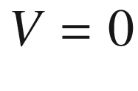

) and under bias are discussed. A diode characteristic will be obtained. We work at first with the following assumptions: abrupt junction, Boltzmann approximation, low injection, i.e. the injected minority carrier density is small compared to the majority carrier density, and zero generation current in the depletion layer, i.e. the electron and hole currents are constant throughout the depletion layer. In the presence of a bias, electrons and holes have quasi-Fermi levels and the carrier densities are given by (cf. (7.55a, b))

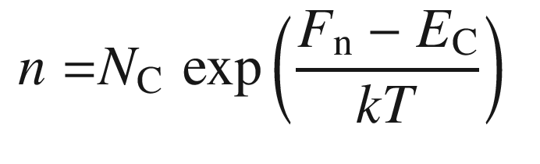

(21.119a)

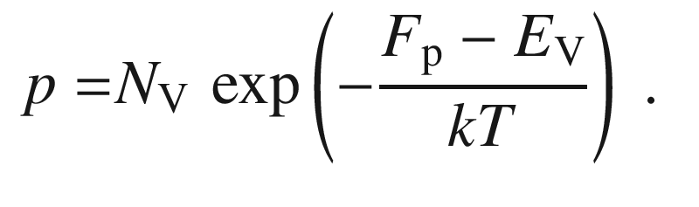

(21.119b)

Using the intrinsic carrier concentration ([7.​19](The_Physics_of_Semiconductors00003.docx#u116076_4_En_7_Chapter),[7.​20](The_Physics_of_Semiconductors00003.docx#u116076_4_En_7_Chapter)), we can write

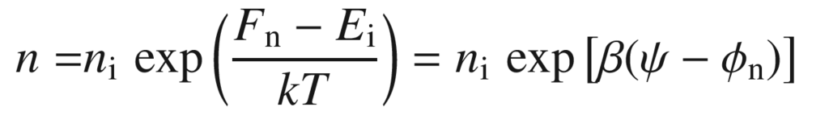

(21.120a)

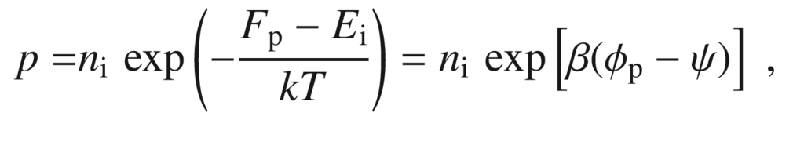

(21.120b)

where

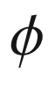

and

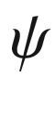

are the potentials related to the (quasi-) Fermi level and the intrinsic Fermi levels,

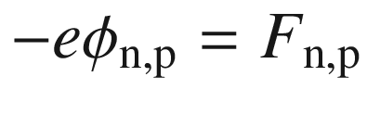

and

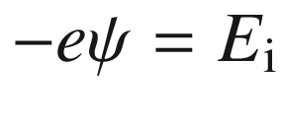

. The potentials

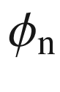

and

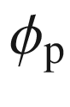

can also be written as

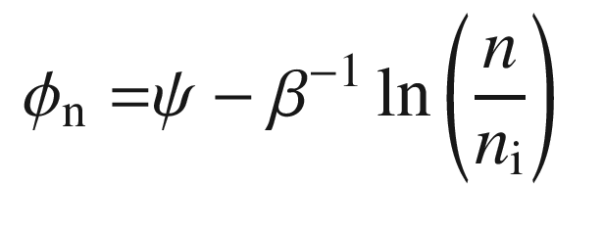

(21.121a)

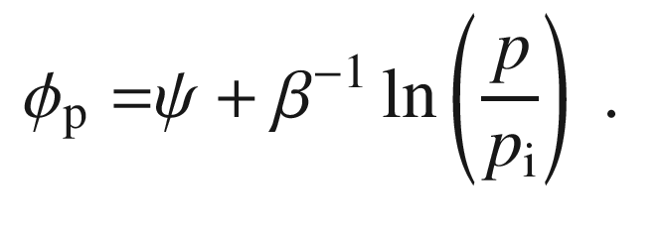

(21.121b)

The product *np* is given by

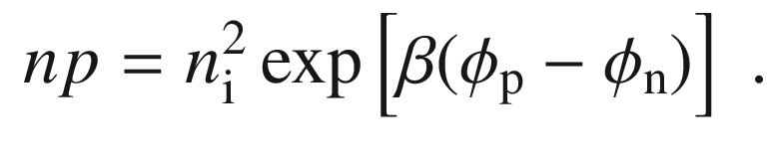

(21.122)

Of course, at thermodynamical equilibrium (zero bias)

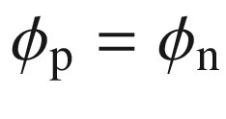

and

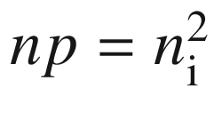

. For forward bias

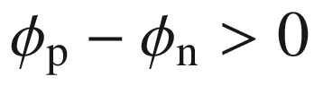

(Fig. [21.45](#u116076_4_En_21_Chapter-Fig45)a) and

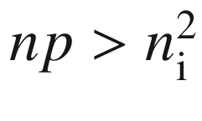

. For reverse bias

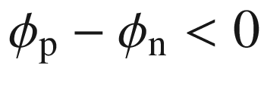

(Fig. [21.45](#u116076_4_En_21_Chapter-Fig45)b) and

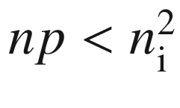

.

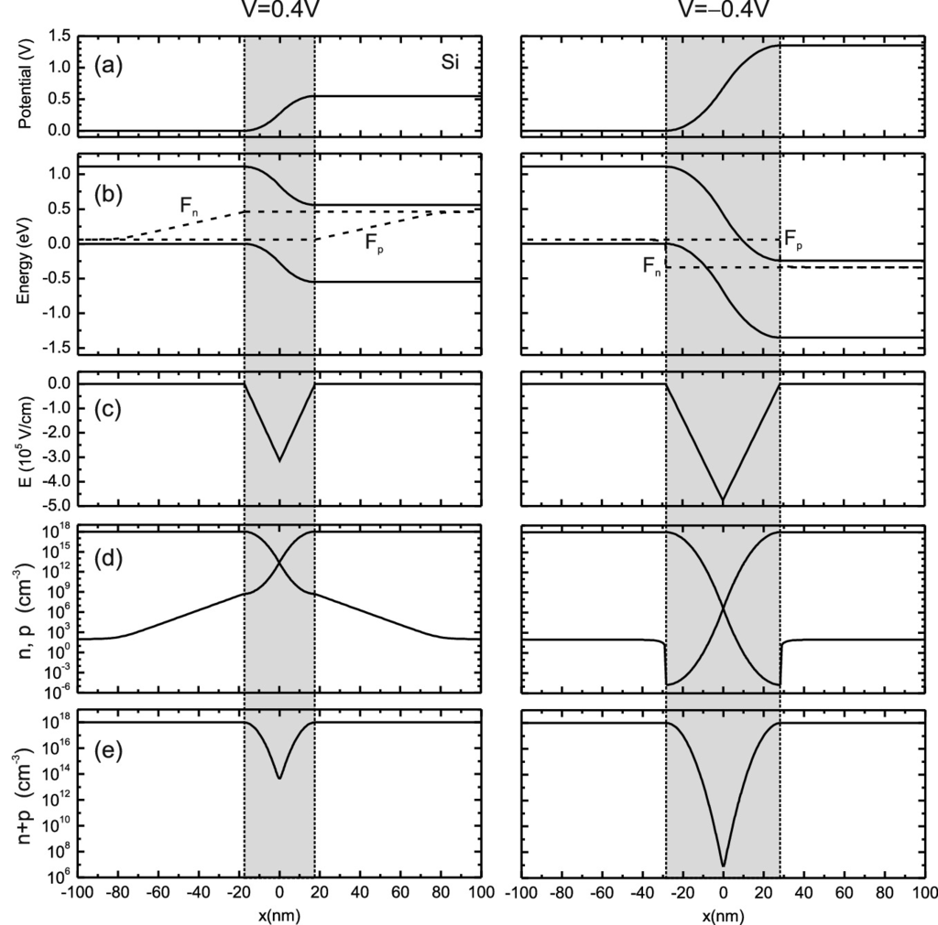

Fig. 21.45

**a** Diffusion potential, **b** band diagram, **c** electric field, **d** electron and hole concentrations and **e**

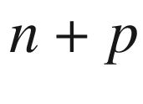

under forward bias

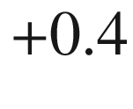

 V (*left panel*) and reverse bias (*right panel*)

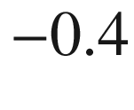

 V for a silicon pn diode at room temperature with

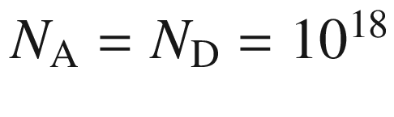

 cm

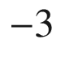

(same as in Fig. [21.41](The_Physics_of_Semiconductors00007.docx#u116076_4_En_21_Chapter-Fig41)). The *dashed lines* in (**b**) are the electron and hole quasi-Fermi levels

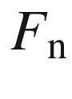

and

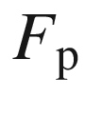

. The depletion layer is shown as the *grey area*. The diffusion length in the n- and p-type material is taken as 4 nm. This value is much smaller than the actual diffusion length ( µm-range) and is chosen here only to show the carrier concentration in the depletion layer and the neutral region in a single graph

The electron current density (per unit area) is given by ([8.​60a](The_Physics_of_Semiconductors00004.docx#u116076_4_En_8_Chapter)) that reads here with

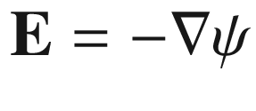

and *n* given by ([21.120a](#u116076_4_En_21_Chapter-Equ132)) as[23](#u116076_4_En_21_Chapter-Fn23)

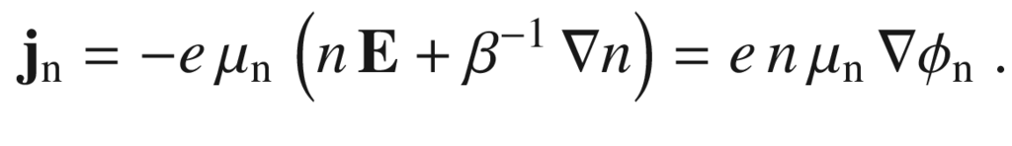

(21.123)

Similarly, we obtain for the hole current density (using ([8.​60b](The_Physics_of_Semiconductors00004.docx#u116076_4_En_8_Chapter)) and ([21.120b](#u116076_4_En_21_Chapter-Equ133)))

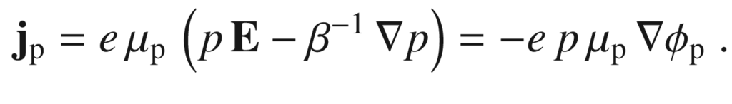

(21.124)

Both these currents through the depletion/space-charge region are constant since no recombination/generation is assumed for now. The gradient of the quasi-Fermi levels in the depletion layer is very small and the quasi-Fermi levels

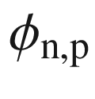

are practically constant. The electron and hole currents are shown in Fig. [21.46](#u116076_4_En_21_Chapter-Fig46) together with the carrier densities; a more detailed calculation of currents than presented here can be found in [1763]. The change of carrier density in the depletion layer is mostly due to the variation of

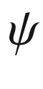

(or

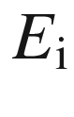

).

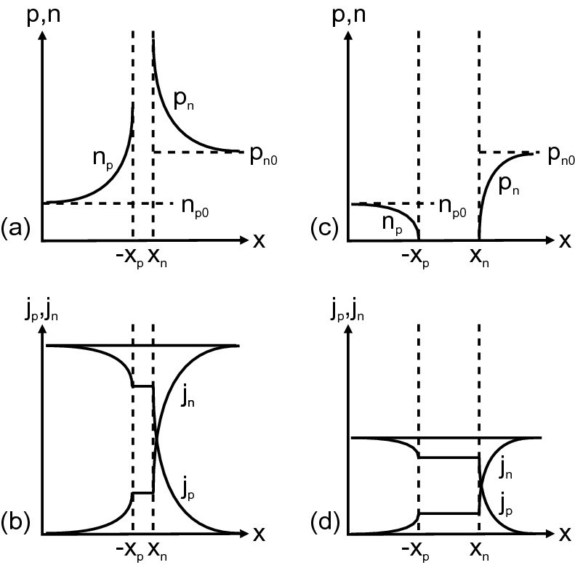

Fig. 21.46

Carrier densities (**a**, **c**) and current densities (**b**, **d**) (linear scales) in a pn diode under (**a**, **b**) forward bias and (**c**, **d**) reverse bias

Therefore, the voltage drop across the depletion layer is

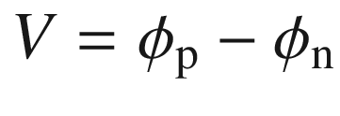

and ([21.122](#u116076_4_En_21_Chapter-Equ136)) reads

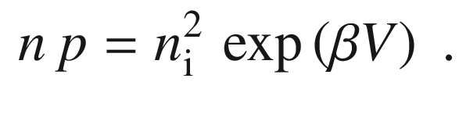

(21.125)

The electron density at the boundary of the depletion layer on the p-side (at

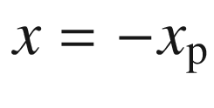

) is (using ([21.125](#u116076_4_En_21_Chapter-Equ139)))

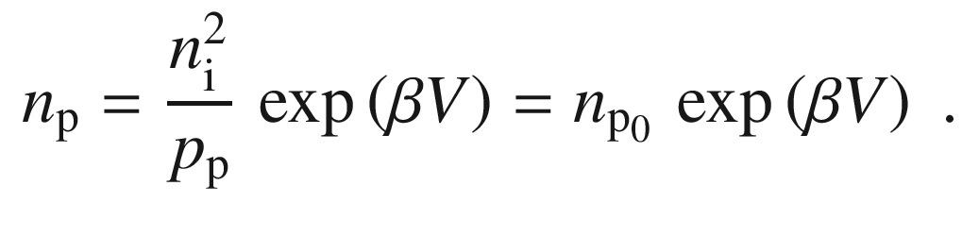

(21.126)

Similarly, the hole density on the n-side at

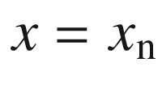

is given by

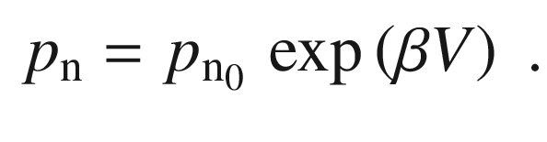

(21.127)

From the continuity equation and the boundary condition that far away from the depletion layer the hole density is

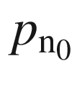

, the hole density on the n-side is given by

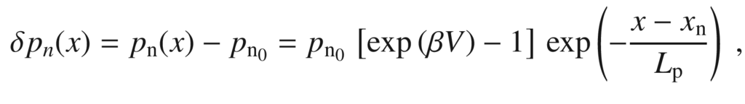

(21.128)

where

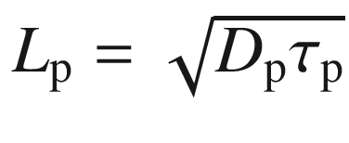

is the hole (minority carrier) diffusion length. In [1763] it is argued from analytical and numerical analysis that the majority carrier density follows

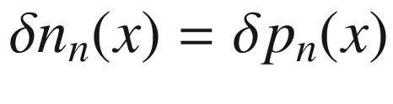

.

The hole current density at the boundary of the depletion layer on the n-side is

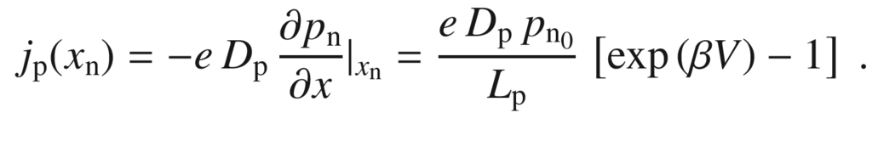

(21.129)

Similarly, the electron current (again

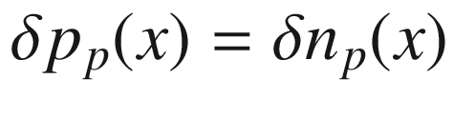

in the neutral region [1763]) in the depletion layer is

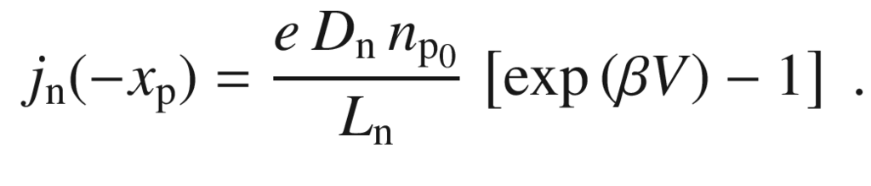

(21.130)

The total current due to diffusion is

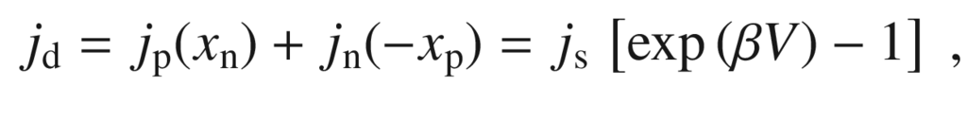

(21.131)

with the saturation current given by

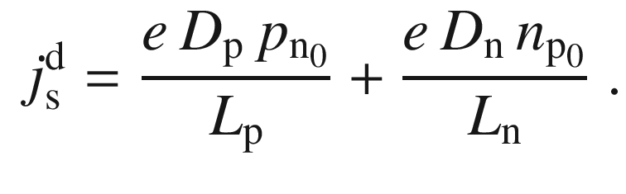

(21.132)

This dependence represents the ideal diode characteristic and the famous result from Shockley. Here, only the minority diffusion currents have been considered; a more in-depth discussion is delivered in [1763] where also the majority carrier density and majority carrier drift and diffusion currents are analyzed (minority drift currents can be neglected altogether). However, the analysis leads to the same result ([21.131](#u116076_4_En_21_Chapter-Equ145)) and ([21.132](#u116076_4_En_21_Chapter-Equ146)).

For a one-sided (p

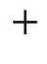

n-) diode, the saturation current is (here

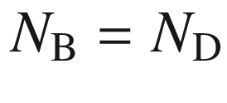

)

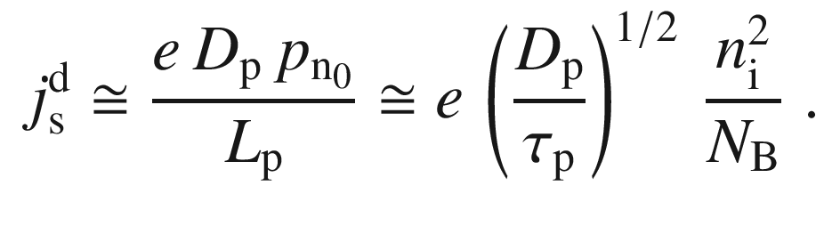

(21.133)

The saturation depends via

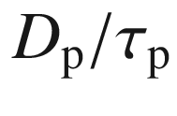

weakly on the temperature. The term

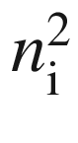

depends on *T*, proportional to

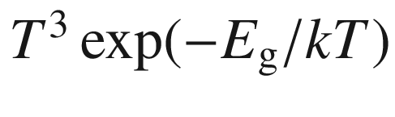

, which is dominated by the exponential function.

If the minority carrier lifetime is given by the radiative recombination ([10.​19](The_Physics_of_Semiconductors00005.docx#u116076_4_En_10_Chapter)), the hole diffusion length is

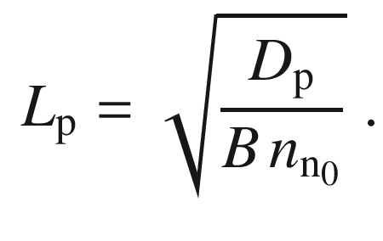

(21.134)

For GaAs (Tables [8.​2](The_Physics_of_Semiconductors00004.docx#u116076_4_En_8_Chapter-Tab2) and [10.​1](The_Physics_of_Semiconductors00005.docx#u116076_4_En_10_Chapter-Tab1)) with

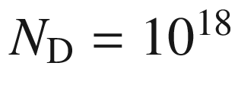

 cm

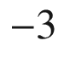

, we find

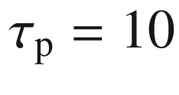

 ns and

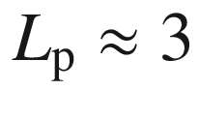

  µm. For

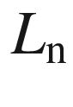

we find 14  µm, however, the lifetime at room temperature can be significantly shorter due to nonradiative recombination and subsequently also the diffusion length will be shorter (by about a factor of 10). For

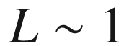

  µm, the diffusion saturation current is

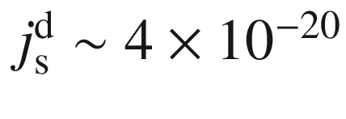

 A/cm

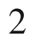

.

The radiative recombination rate (band-band recombination, b–b) in the neutral n-region (as relevant for LEDs, see Sect. [23.​3](#u116076_4_En_23_Chapter)) is

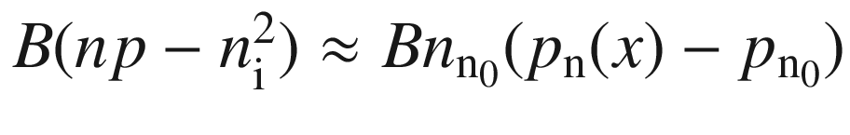

. Therefore, the recombination current

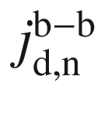

in the neutral n-region is (using ([21.128](#u116076_4_En_21_Chapter-Equ142)))

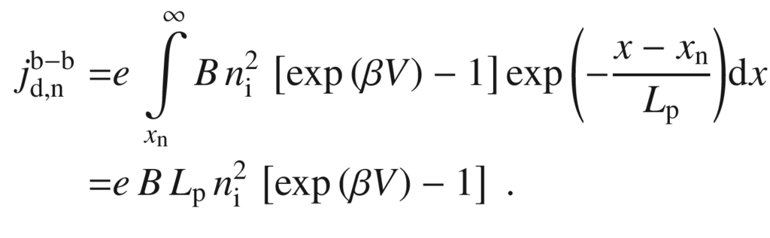

(21.135)

For the neutral region on the p-side a similar expression results. The total radiative recombination current from the neutral regions is

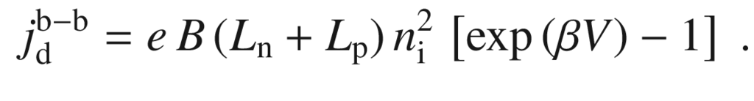

(21.136)

For GaAs, the saturation current for the radiative recombination in the neutral region

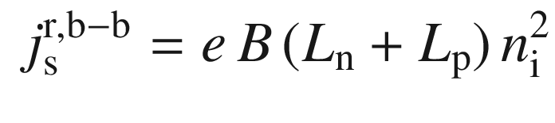

(21.137)

is (Tables [7.​1](The_Physics_of_Semiconductors00003.docx#u116076_4_En_7_Chapter-Tab1) and [10.​1](The_Physics_of_Semiconductors00005.docx#u116076_4_En_10_Chapter-Tab1)) for a diffusion length of 1  µm of

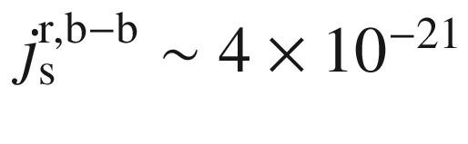

 A/cm

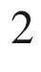

.

Since the (radiative) minority carrier lifetime is inversely proportional to the majority carrier density, the relevant diffusion length is that of the side with the lower doping level and is given by

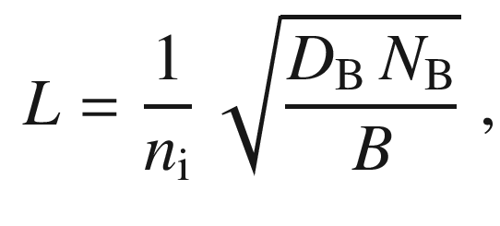

(21.138)

where

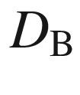

is the minority carrier diffusion coefficient on the lowly doped side. The radiative recombination current from the neutral region can be written as

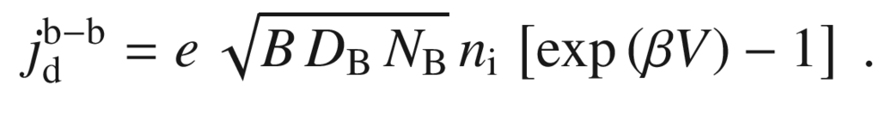

(21.139)

The *I*–*V* characteristic for pn diodes from two semiconductors with different band gap are shown in Fig. [21.47](#u116076_4_En_21_Chapter-Fig47)a (for Ge and Si). The Si diode has the much smaller saturation current. The saturation current increases at higher temperature (Fig. [21.48](#u116076_4_En_21_Chapter-Fig48)). A wide-gap pn diode (GaN) exhibits small saturation currents (The

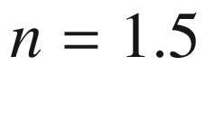

part of the GaN in Fig. [21.47](#u116076_4_En_21_Chapter-Fig47)b belongs to a saturation current density of

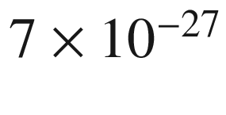

 A/cm

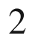

, the

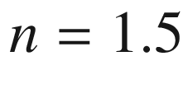

part to

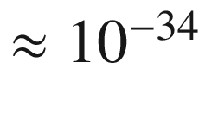

 A/cm

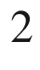

) and displays sizable current (density) only for larger voltages.

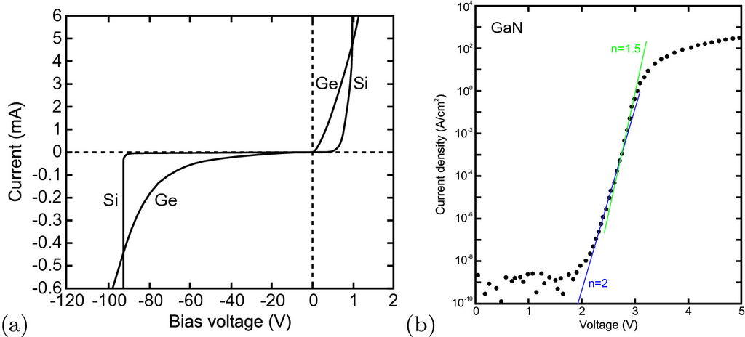

Fig. 21.47

Comparison of the characteristics of **a** Ge and Si and **b** GaN pn diodes at room temperature. Note the different scales in the forward and reverse regime in (**a**). The *lines* in (**b**) are related to ideality factors 2 and 1.5 as labeled.

Adapted from [1764]

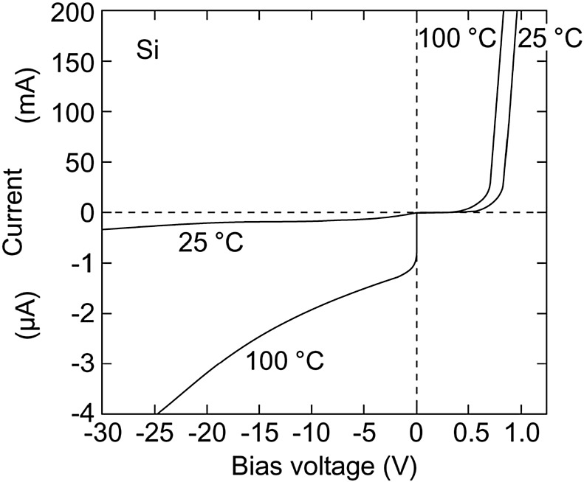

Fig. 21.48

Characteristics of a Si power diode at two temperatures, 25

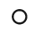

C and 100

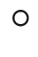

C

**Real** *I*–*V* **Characteristics**

Besides the ideal *I*–*V* characteristics due to diffusion several effects contribute to the characteristics of real bipolar diodes:

a generation-recombination (G–R) current is present due to traps in the depletion layer

already for fairly small forward voltages, high injection conditions are present, i.e.

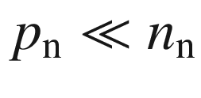

is no longer valid

the series resistance

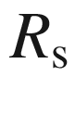

of the diode is finite (ideally

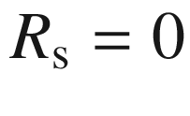

)

the diode has a finite parallel (shunt) resistance

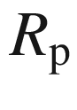

(ideally

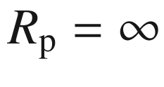

)

at high reverse voltage the junction breaks down; this phenomenon is treated in Sect. [21.4.5](#u116076_4_En_21_Chapter-Sec20)

First, we consider the generation-recombination current due to band-impurity (b–i) processes (see Sect. [10.​9](The_Physics_of_Semiconductors00005.docx#u116076_4_En_10_Chapter)). Such recombination is nonradiative or at least does not produce photons with an energy close to the band gap. The impact on the *I*–*V* diode characteristic has first been considered in [1765].

The net b–i recombination rate is given by ([10.​52](The_Physics_of_Semiconductors00005.docx#u116076_4_En_10_Chapter)). For reverse voltage, the generation dominates the G–R current. For

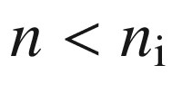

and

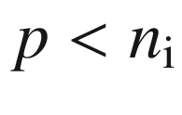

, the net recombination rate *r* is

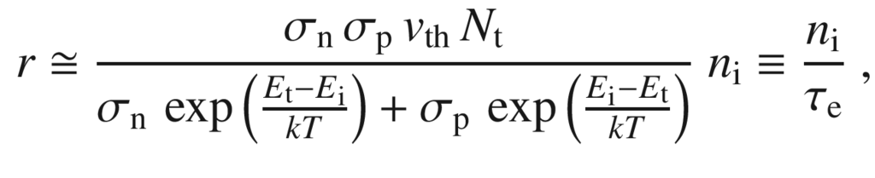

(21.140)

where

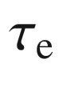

is the effective electron lifetime. The generation current density is given by

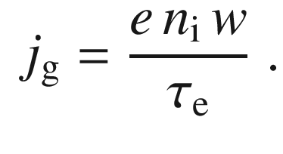

(21.141)

Since the width of the depletion layer varies with the applied reverse bias *V*, we expect a dependence

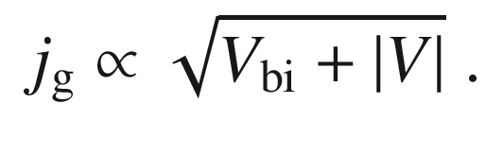

(21.142)

The saturation current is given by the sum of the diffusion and generation parts

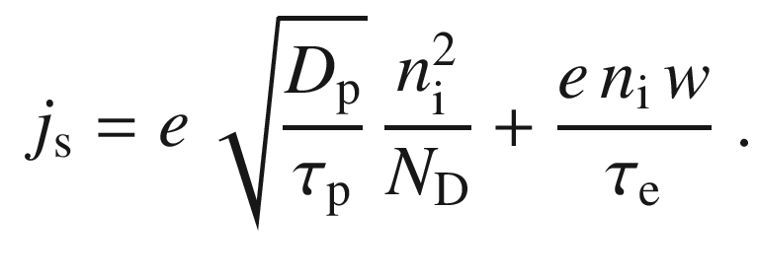

(21.143)

In semiconductors with large

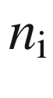

(narrow band gap, e.g. Ge) the diffusion current will dominate; in Si (larger band gap) the generation current can dominate.

The maximum of the recombination rate is present for

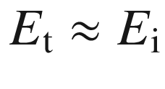

([10.​57](The_Physics_of_Semiconductors00005.docx#u116076_4_En_10_Chapter)). Then

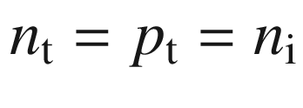

in ([10.​52](The_Physics_of_Semiconductors00005.docx#u116076_4_En_10_Chapter)). Assuming

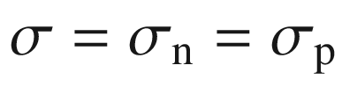

, the recombination rate is

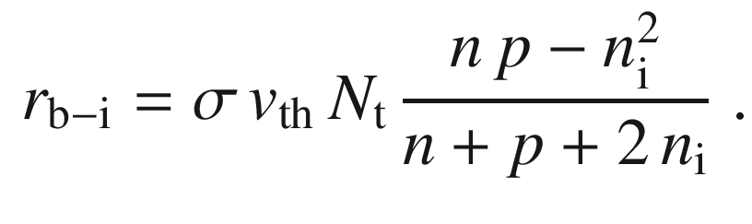

(21.144)

Using ([21.122](#u116076_4_En_21_Chapter-Equ136)) we can write

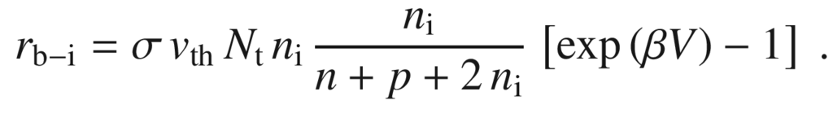

(21.145)

The term

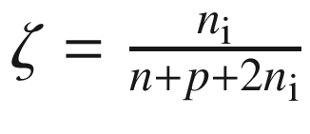

is maximal for

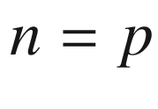

, which is given (from ([21.125](#u116076_4_En_21_Chapter-Equ139))) by

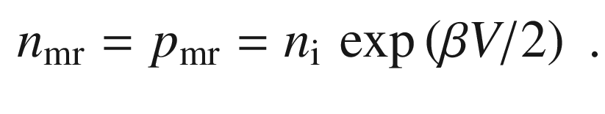

(21.146)

The function

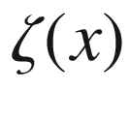

cannot be integrated analytically. In order to evaluate the integral of

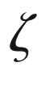

over the depletion layer

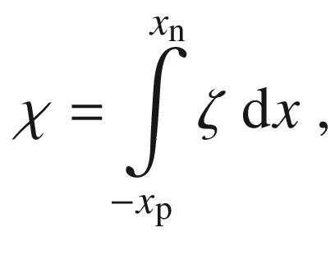

(21.147)

the maximum rate

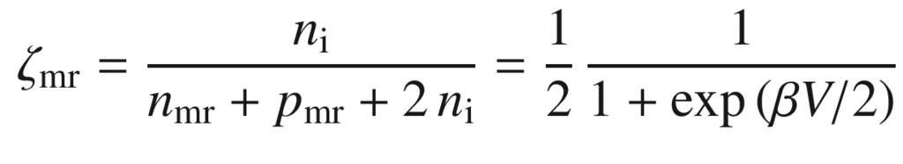

(21.148)

can be integrated over the depletion layer as an approximation [574],

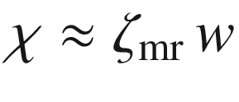

. This approach yields a recombination current

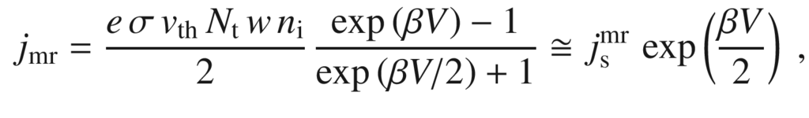

(21.149)

with

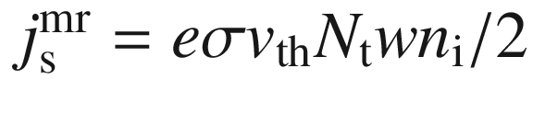

and the approximation being valid for

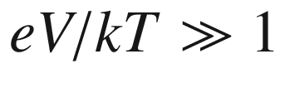

. Thus the nonradiative band-impurity recombination is often said to cause an ideality factor of

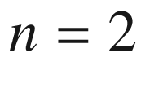

.

For a better approximation of

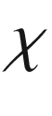

, the dependence of the potential

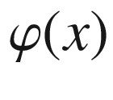

can be approximated as linear (constant-field approximation), i.e. using the local field

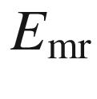

at the position where

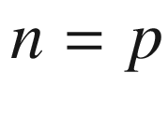

[1766]. For a symmetric diode with

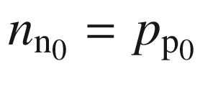

, this position is at

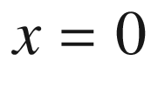

; for a one-sided junction on the lower-doped side.

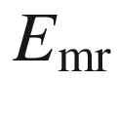

is given for

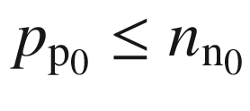

 by

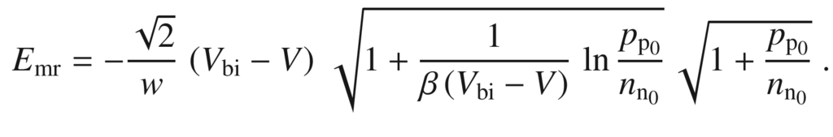

(21.150)

For a symmetric diode ([21.151a](#u116076_4_En_21_Chapter-Equ165)) holds, for a one-sided diode the approximation in ([21.151b](#u116076_4_En_21_Chapter-Equ166)) holds

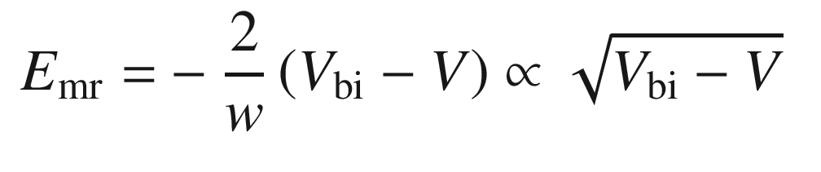

(21.151a)

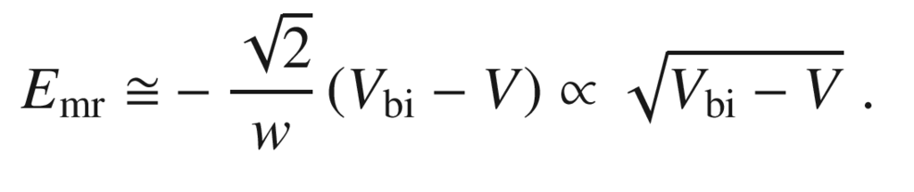

(21.151b)

We note that for zero bias (

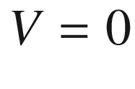

), ([21.108](The_Physics_of_Semiconductors00007.docx#u116076_4_En_21_Chapter-Equ118)) is recovered from ([21.151a](#u116076_4_En_21_Chapter-Equ165)). Using the above approximation

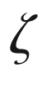

is given by

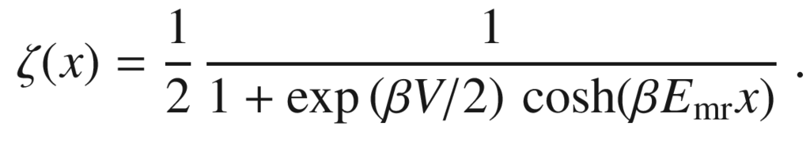

(21.152)

Since

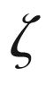

decreases sufficiently fast within the depletion layer, the integration over the depletion layer can be extended to

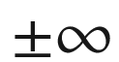

and we obtain

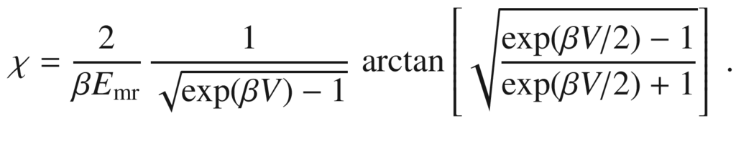

(21.153)

We note that for

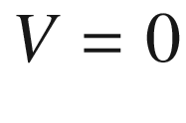

, the integral takes the value

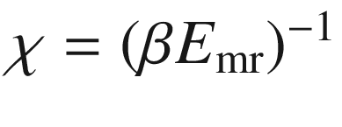

. The recombination current is now given by [1766]

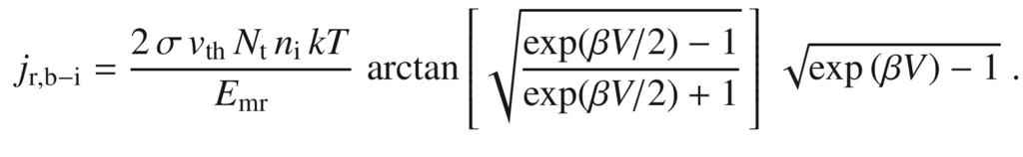

(21.154)

For large voltage the

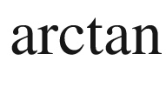

term becomes

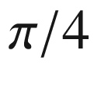

. For

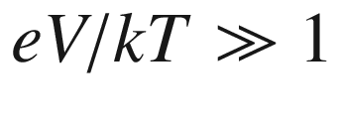

the nonradiative recombination current can be written as

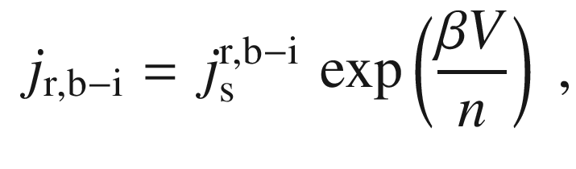

(21.155)

with

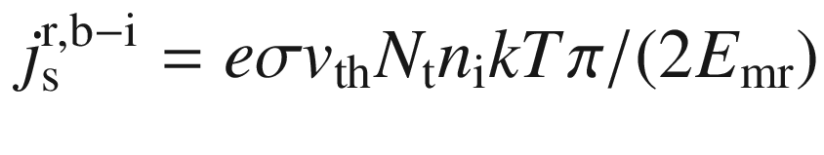

. The voltage-dependent ideality factor *n* (semilogarithmic slope

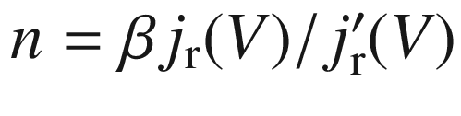

) is close but not identical to 2 and is shown in Fig. [21.49](#u116076_4_En_21_Chapter-Fig49) for various values of

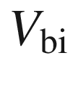

. The built-in voltage influences the logarithmic slope via the factor

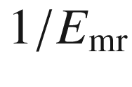

in ([21.154](#u116076_4_En_21_Chapter-Equ169)).

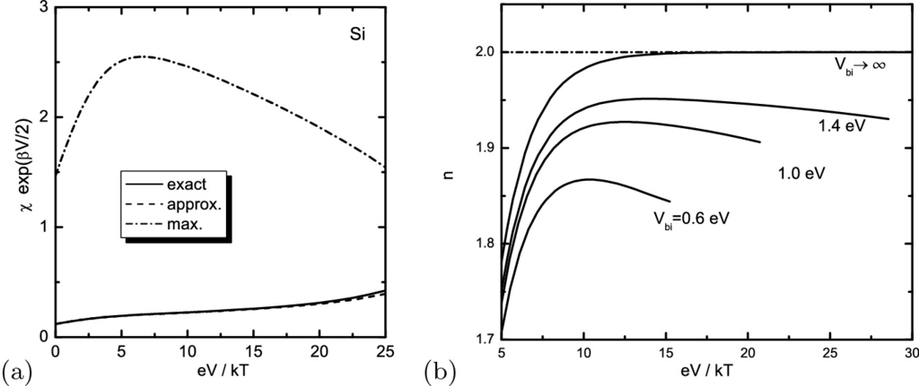

Fig. 21.49

**a** Integral

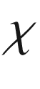

([21.147](#u116076_4_En_21_Chapter-Equ161)) multiplied by

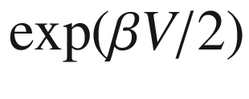

in order to extract the differences on a linear scale. *Solid line*: Exact numerical calculation, *dash-dotted line*: standard approximation with constant maximum rate, *dashed line*: this work (approximation with constant field). As material parameters we have used room temperature and

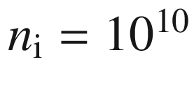

 cm

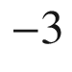

(Si),

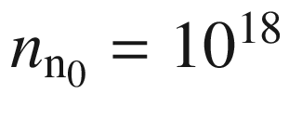

 cm

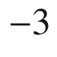

and

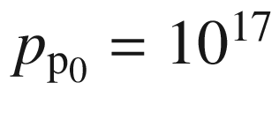

 cm

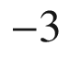

. **b** Logarithmic slope of band-impurity recombination current in the forward bias regime for various values of the built-in voltage

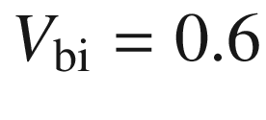

, 1.0, and 1.4 eV and in the limit

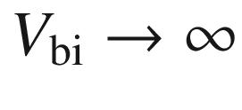

.

Adapted from [1766]

In the case of radiative band-band (b–b) recombination, the recombination rate is given by ([10.​14](The_Physics_of_Semiconductors00005.docx#u116076_4_En_10_Chapter)). Together with ([21.125](#u116076_4_En_21_Chapter-Equ139)) and integrated over the depletion layer, the recombination current in the depletion layer is given by (cf. ([21.136](#u116076_4_En_21_Chapter-Equ150)))

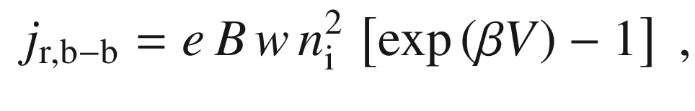

(21.156)

and exhibits an ideality factor of

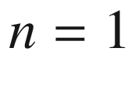

. Comparing ([21.136](#u116076_4_En_21_Chapter-Equ150)) and ([21.156](#u116076_4_En_21_Chapter-Equ171)), the dominating radiative-recombination current is determined by the ratio of *w* and

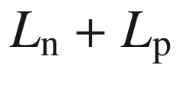

. Since in the forward direction, the depletion-layer width tends towards zero (for flat-band conditions), the radiative-recombination current is dominated by the recombination in the neutral region(s).

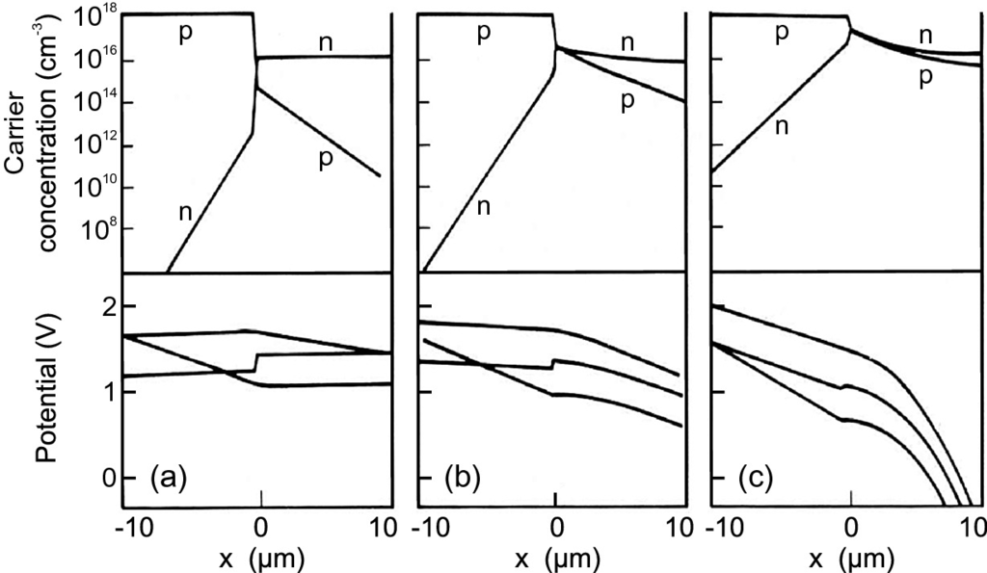

Fig. 21.50

Theoretical modeling of charge-carrier concentration, intrinsic Fermi level (potential)

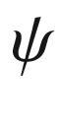

and quasi-Fermi levels (with arbitrary offset) for a Si p

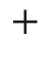

n diode for various current densities: **a** 10 A cm

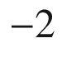

, **b** 10

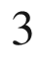

 A cm



and **c** 10

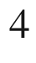

 A cm

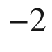

.

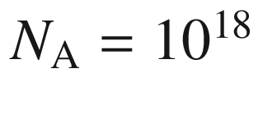

 cm

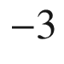

,

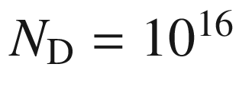

 cm

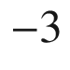

,

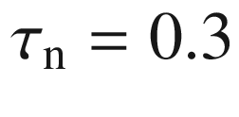

 ns,

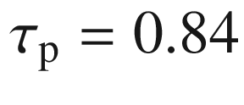

 ns.

Adapted from [1767]

For high injection current (under forward bias), the injected minority carrier density can become comparable with the majority carrier density. In this case, diffusion *and* drift need to be considered. At large current density, the voltage drop across the junction is small compared to the ohmic voltage drop across the current path. In the simulation (Fig. [21.50](#u116076_4_En_21_Chapter-Fig50)), the high-injection effects start on the n-doped side because it has been modeled with the lower doping (

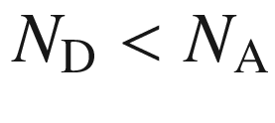

).

The series resistance

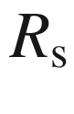

(typically a few Ohms) also effects the characteristic at low injection. The voltage drop across the junction is reduced by

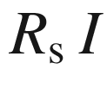

. Thus, the *I*–*V* characteristic taking into account the effect of the series resistance is

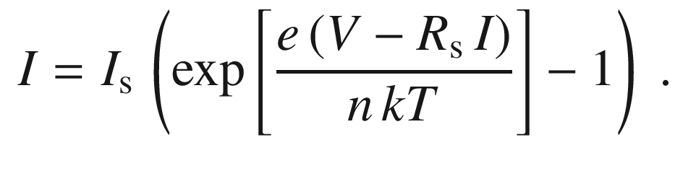

(21.157)

This equation is implicit with regard to *I* and can only be solved numerically. At high current, the resistance of the junction becomes very small (Fig. [21.51](#u116076_4_En_21_Chapter-Fig51)a); then the *I*–*V* characteristic deviates from the exponential behavior (Fig. [21.52](#u116076_4_En_21_Chapter-Fig52)a); finally it is dominated by the series resistance and becomes linear (Fig. [21.52](#u116076_4_En_21_Chapter-Fig52)b). Sometimes the extrapolated voltage from the linear range (1.19 V in Fig. [21.52](#u116076_4_En_21_Chapter-Fig52)b) is called ’threshold’ voltage, but this is a wrong term for this behavior.

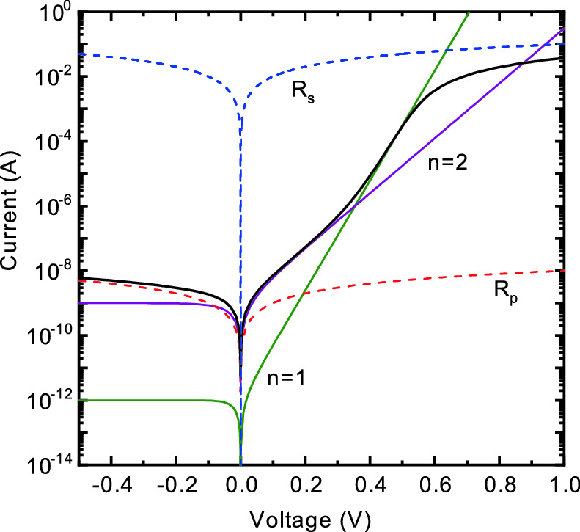

Fig. 21.51

Theoretical *I*–*V* characteristic of a diode at room temperature with saturation currents for the

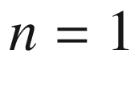

and



processes of

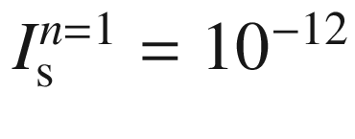

 A and

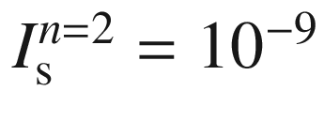

 A and resistances

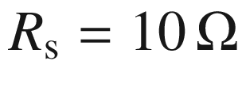

,

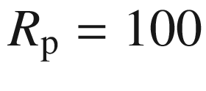

 M

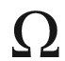

. *Green line*: Ideal diode with

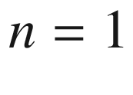

characteristic only, *Purple line*: only

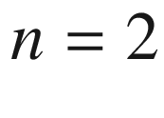

process, *dashed red line*: only parallel ohmic resistance

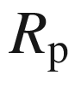

, *dashed blue line*: only series ohmic resistance



, *solid black line*: all effects combined as in ([21.159](#u116076_4_En_21_Chapter-Equ174))

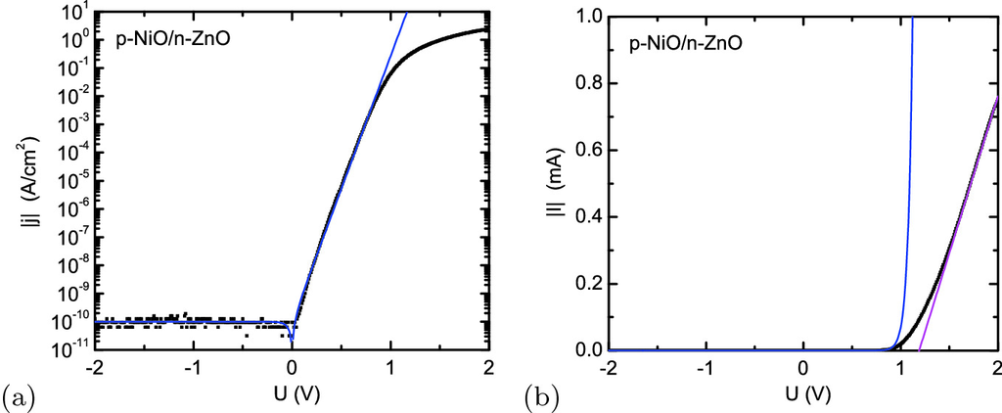

Fig. 21.52

**a** *jV*-characteristic of NiO/ZnO bipolar diode (cmp. Sect. [21.4.6](#u116076_4_En_21_Chapter-Sec21)) in half-logarithmic plot. The *blue line* is a fit with ideality factor

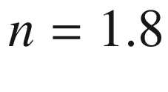

. **b** *IV*-characteristic in linear plot. The *purple line* in (**b**) is a linear fit (with

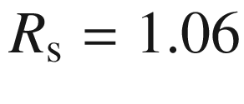

 k

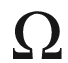

) for the range where the series resistance dominates

The diode can also exhibit a parallel (shunt) resistance

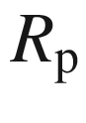

, e.g. due to surface conduction between the contacts. Including the shunt resistance, the diode characteristic is

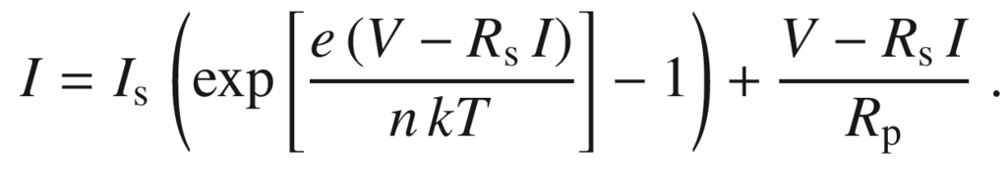

(21.158)

The shunt resistance can be evaluated best from the differential conductance in the reverse-voltage regime [1725]. Due to a high surface-state density, the passivation of GaAs diodes can be difficult. Si can be very well passivated with low leakage current and high reliability.

Often, a clear distinction between the

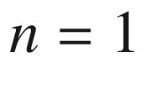

and



regimes cannot be made. In this case, an intermediate ideality factor

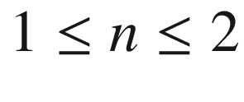

is fitted to the *I*–*V* characteristic as in ([21.158](#u116076_4_En_21_Chapter-Equ173)). If the current can be separated into a

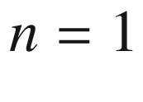

(diffusion) and a

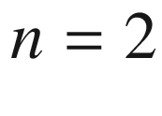

(recombination-generation) process, the characteristic is given by (see Fig. [21.51](#u116076_4_En_21_Chapter-Fig51))

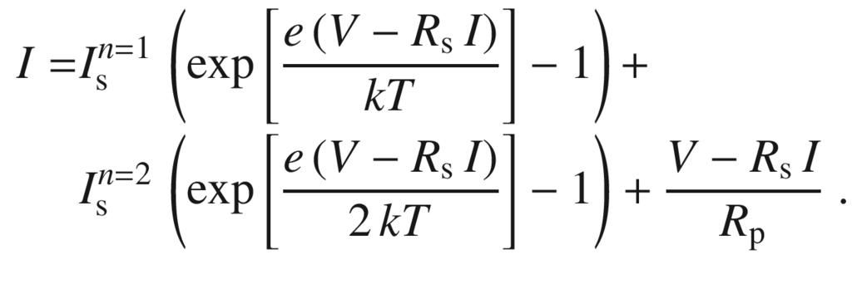

(21.159)

In summary, the pn diode has the equivalent circuit given in Fig. [21.53](#u116076_4_En_21_Chapter-Fig53); the photocurrent source

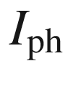

is discussed below in Sect. [22.​3](#u116076_4_En_22_Chapter).

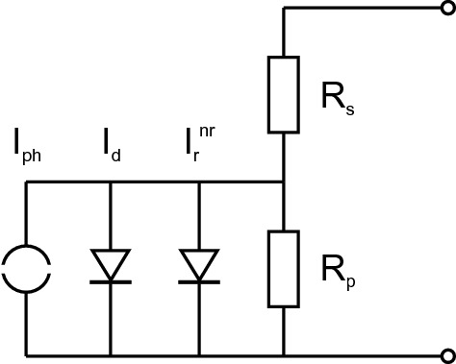

Fig. 21.53

Equivalent circuit of a pn diode. Serial (



) and parallel (

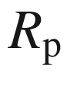

) resistance and diode currents:

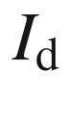

(due to diffusion,

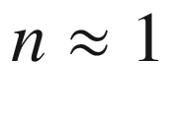

),

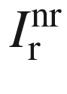

(nonradiative recombination due to band-impurity recombination,

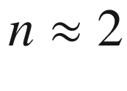

) and an ideal current source due to photogeneration (as discussed in Sect. [22.​3](#u116076_4_En_22_Chapter))

#### 21.4.5 Breakdown

If a large voltage is applied in the reverse direction, the pn junction breaks down. At breakdown, a small voltage increase leads to a dramatic increase of the current. There are three mechanisms that lead to breakdown: thermal instability, tunneling, and avalanche multiplication [1768–1770]. Defects cause localized pre-breakdown sites [1770, 1771].

**Thermal Instability**

The reverse current at large applied voltage leads to a power dissipation and heating of the junction. This temperature increase leads to a further increase of the saturation current ([21.133](#u116076_4_En_21_Chapter-Equ147)). If the heat sink, e.g. the mounting of the chip, is not able to transport the heat away from the device, the current increases indefinitely. If not limited by a resistor, such a current can destroy the device. The thermal instability is particularly important for diodes with high saturation current, e.g. Ge at room temperature.

**Tunneling**

At large reverse bias, charge carriers can tunnel between conduction and valence band through the junction. A more detailed discussion will be given below in Sect. [21.5.9](#u116076_4_En_21_Chapter-Sec32) about the tunneling diode. Since for the tunneling effect a thin barrier is necessary, breakdown due to tunneling is important for diodes where both sides are highly doped. For Si and Ge diodes, tunneling dominates the breakdown if the breakdown voltage

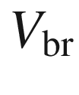

is

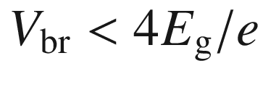

. For

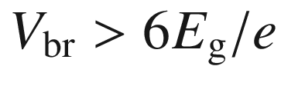

avalanche multiplication dominates. The intermediate regime is a mixed case.

With increasing temperature, the tunneling current can be achieved already with a smaller field (since the band gap decreases with increasing temperature), thus the breakdown voltage *decreases* (negative temperature coefficient).

**Avalanche Multiplication**

Avalanche multiplication due to impact ionization is the most important mechanism for the breakdown of pn diodes. It limits the maximum reverse voltage for most diodes and also the collector voltage in a bipolar transistor or the drain voltage in a field-effect transistor. Avalanche multiplication can be used for the generation of microwave radiation or for photon counting (cf. Sect. [22.​3.​6](#u116076_4_En_22_Chapter)).

Impact ionization was discussed in Sect. [8.​4.​4](The_Physics_of_Semiconductors00004.docx#u116076_4_En_8_Chapter). The most important parameters are the electron and hole ionization coefficients

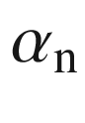

and

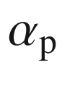

. For discussion of the diode breakdown, we assume that at

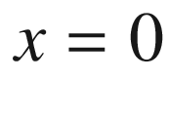

a hole current

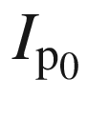

enters the depletion layer. This current is amplified by the field in the depletion layer and impact ionization. At the end of the depletion layer (

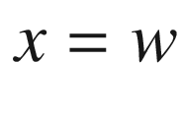

), it is

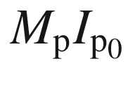

, i.e.

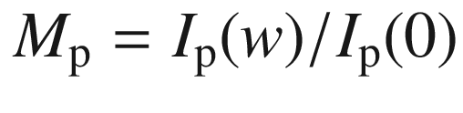

. Similarly, an electron current is increased on its way from *w* to

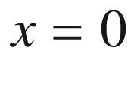

. The incremental change of the hole current due to electron-hole pairs generated along a line element

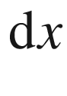

 is

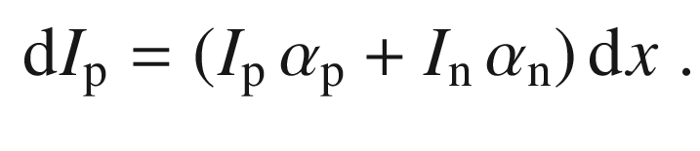

(21.160)

The total current in the depletion layer is

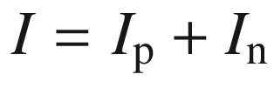

and is constant in stationary equilibrium. Therefore,

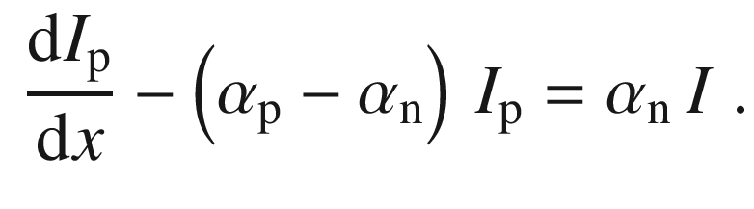

(21.161)

The solution is

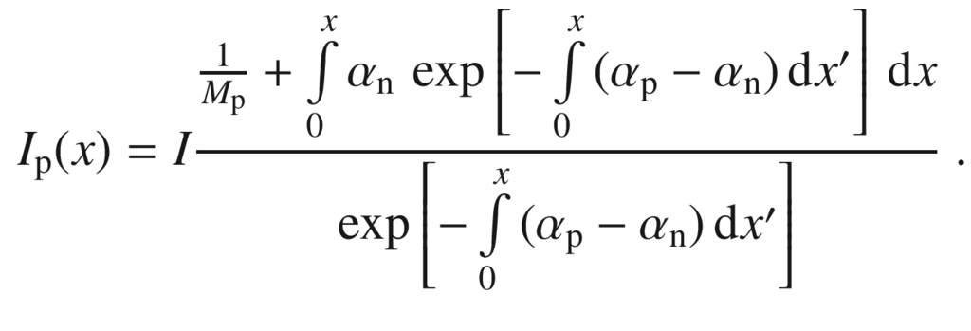

(21.162)

For

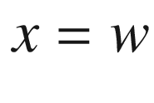

we find for the multiplication factor

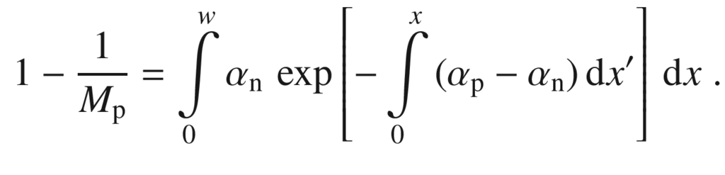

(21.163)

Avalanche breakdown is reached for

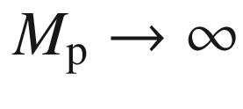

, i.e. when

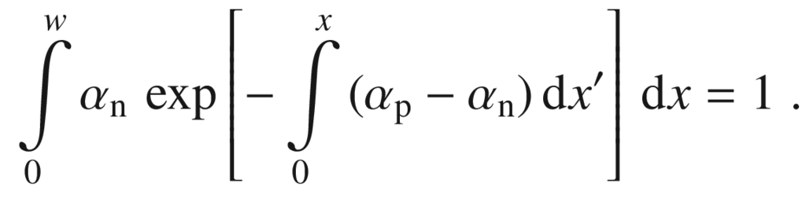

(21.164)

A corresponding and equivalent equation is obtained when the consideration is started with the electron current. If

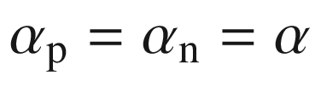

, ([21.164](#u116076_4_En_21_Chapter-Equ179)) simplifies to

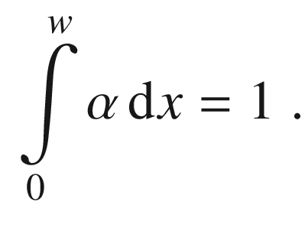

(21.165)

This means that per transit of one carrier through the depletion layer, on average another carrier is created such that the process just starts to diverge. The breakdown voltage for various semiconductor materials is shown in Fig. [21.54](#u116076_4_En_21_Chapter-Fig54)a as a function of the doping level. The depletion-layer width *w* at breakdown and the maximum electric field

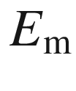

are depicted in Fig. [21.54](#u116076_4_En_21_Chapter-Fig54)b.

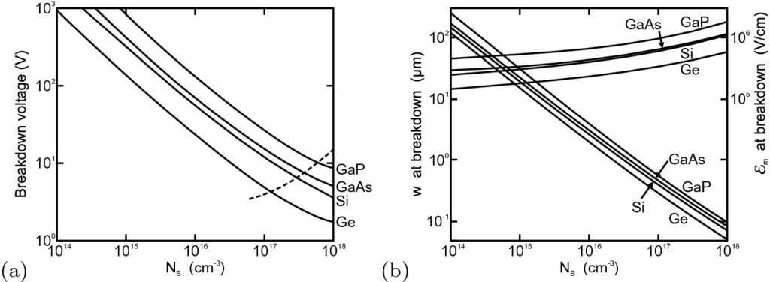

Fig. 21.54

**a** Avalanche breakdown voltage for one-sided abrupt junctions in Ge, Si, (100)-GaAs and GaP at

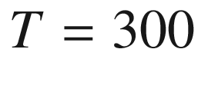

 K. The *dashed line* indicates the limit of avalanche breakdown at high doping due to tunneling breakdown. **b** Depletion-layer width *w* at breakdown and maximum electric field

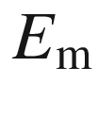

for the same junctions.

Adapted from [1772]

The average impact ionization coefficient

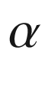

has been given as [1773]

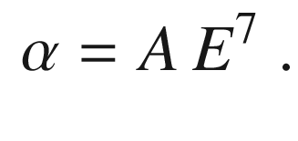

(21.166)

for silicon with

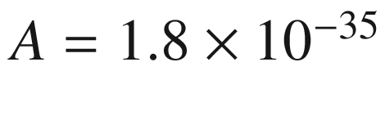

 (cm/V)

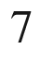

  cm

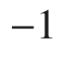

. For the breakdown condition ([21.165](#u116076_4_En_21_Chapter-Equ180)), using ([21.9](The_Physics_of_Semiconductors00007.docx#u116076_4_En_21_Chapter-Equ9)) and ([21.166](#u116076_4_En_21_Chapter-Equ181)) the depletion layer width at breakdown



(



in cm,

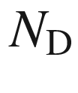

in cm

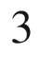

) is found to be

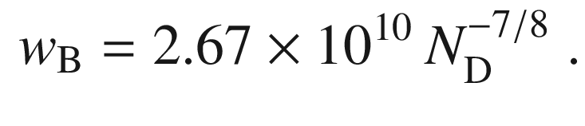

(21.167)

From this the breakdown voltage can be calculated with ([21.15](The_Physics_of_Semiconductors00007.docx#u116076_4_En_21_Chapter-Equ15)) (

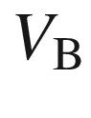

in V,

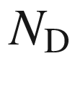

in cm

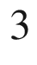

) [1774]

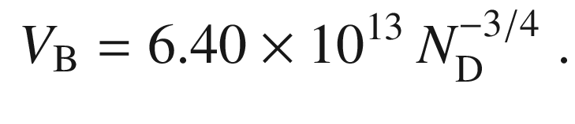

(21.168)

In GaAs, the impact-ionization coefficients and therefore the breakdown voltage are direction dependent. At a doping of

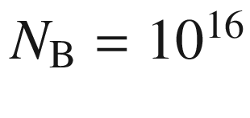

 cm



, the breakdown voltage is the same for (001) and (111) orientation; for smaller doping the breakdown voltage of (001)-oriented GaAs is smaller, for larger doping that of GaAs (111) [1775].

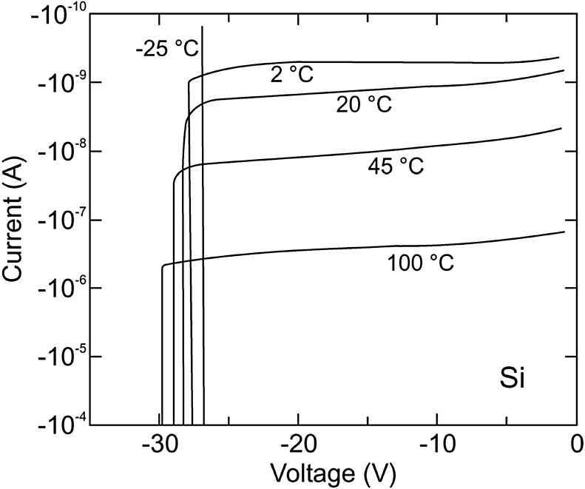

Fig. 21.55

Temperature dependence of a n

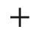

p Si-diode with

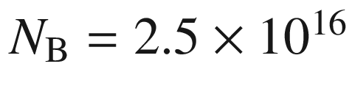

 cm



and a guard-ring structure (see Fig. [21.56](#u116076_4_En_21_Chapter-Fig56)d). The temperature coefficient

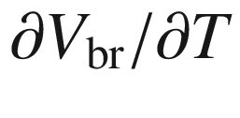

is 0.024 V/K.

Adapted from [1776]

At higher temperatures, the charge carriers release their excess energy faster to the lattice.[24](#u116076_4_En_21_Chapter-Fn24) Thus, less energy is available for impact ionization and the required electric field is higher. Therefore, the breakdown voltage *increases* with the temperature (Fig. [21.55](#u116076_4_En_21_Chapter-Fig55)). This behavior is opposite to tunneling diodes and the two processes can be distinguished in this way.

In planar structures (Fig. [21.56](#u116076_4_En_21_Chapter-Fig56)a), high electric fields as present in high power devices will occur at the parts with large curvature. At these sites breakdown will occur first and at much lower voltages than expected for a perfectly planar (infinite) structure [1777, 1778]. For devices that require high breakdown voltage, design changes have to be made. These include deep junctions (Fig. [21.56](#u116076_4_En_21_Chapter-Fig56)b) with a smaller curvature, a field-ring structure  (Fig. [21.56](#u116076_4_En_21_Chapter-Fig56)c) in which an additional depletion layer is used to smooth the field lines and the often used guard ring (Fig. [21.56](#u116076_4_En_21_Chapter-Fig56)d) for which a circular region of low doping (and thus high breakdown voltage) is incorporated.

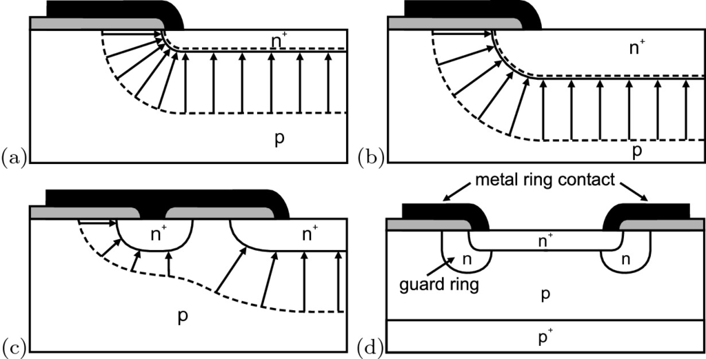

Fig. 21.56

**a** Large electric fields at large curvatures in a shallow junction. Avoidance of regions with large electric fields by **b** deep junction and **c** field-ring structure. **d** shows a guard-ring structure with circular, low-doped n region. *Grey area* denotes insulating material, arrows indicate field lines and the *dashed lines* indicate the extension of the depletion layers

The decrease of breakdown voltage in a junction with cylindrical and spherical geometry has been numerically calculated as a function of curvature [1779] (Fig. [21.57](#u116076_4_En_21_Chapter-Fig57)). Analytical formulas in terms of the ratio of radius of curvature and the depletion layer width at breakdown for a plane junction

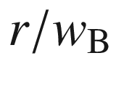

have been given later [1774].

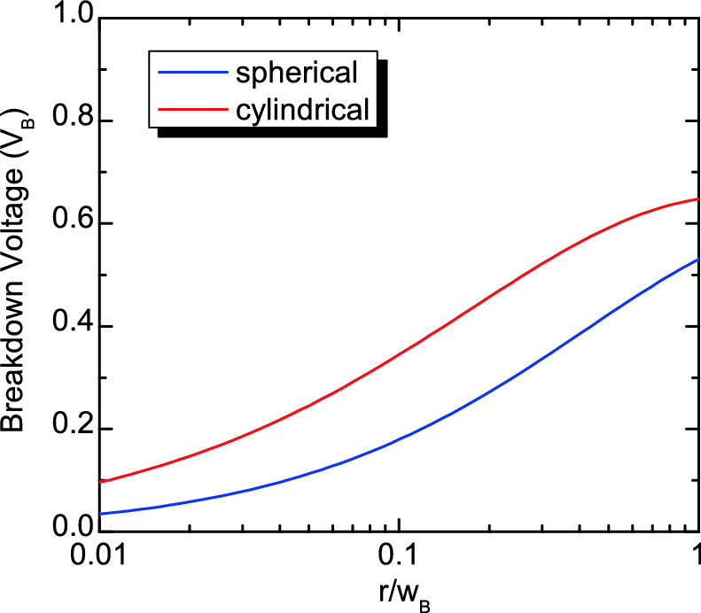

Fig. 21.57

Breakdown voltage (in units of the breakdown voltage

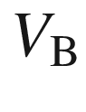

of a plane junction) for cylindrical and spherical junctions as a function of the curvature radius (in units of the depletion layer width at breakdown



for a plane junction).

Data from [1774]

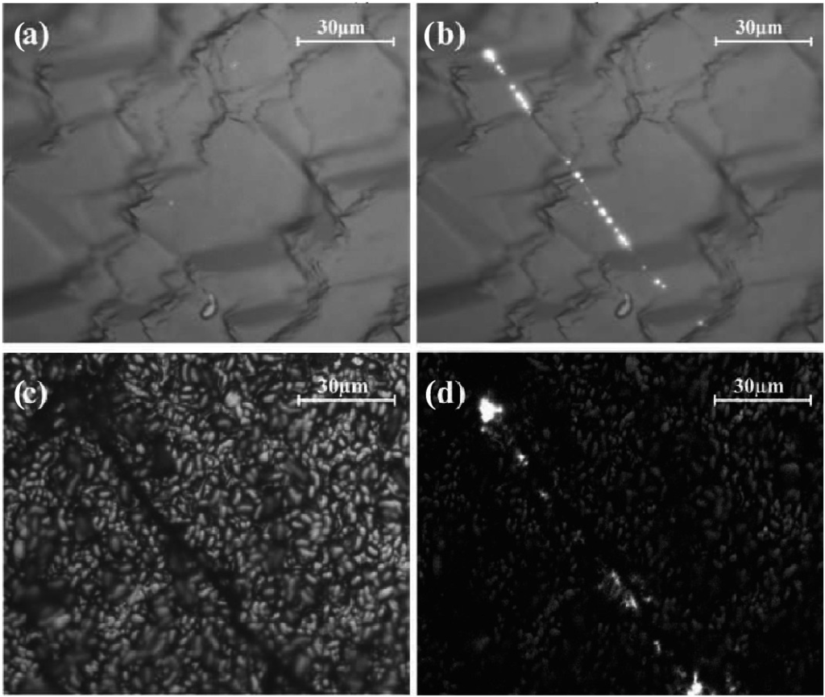

Fig. 21.58

Microscopic (**a**) forward bias electroluminescence and (**b**) microscopic reverse bias electroluminescence ( µ-ReBEL) image of an alkaline texturized solar cell (cmp. Fig. [22.​61](#u116076_4_En_22_Chapter-Fig61)) in a region without specific surface features at

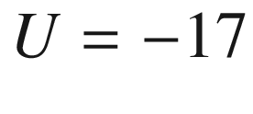

 V. The bulk defects at these positions are revealed topographically in the neighboring acidic texturized solar cell in the microscopic (**c**) image. Their ReBEL pattern appears similarly in the corresponding EL image (**d**).

Adapted from [1771]

**Defects**

In material with extended defects such as polycrystalline silicon breakdown can occur locally at lower voltage than in the corresponding defect-free bulk material (‘pre-breakdown’) [1771]. This effect typically occurs at certain grain boundaries and probably involves mid-gap states. It is also accompanied with electroluminescence by which it can be detected with high spatial resolution (Fig. [21.58](#u116076_4_En_21_Chapter-Fig58)).

#### 21.4.6 Heterostructure Diodes

In a heterostructure diode, the n- and p-regions are made of different semiconductors. Such structures are discussed in detail in [1780].

**Type-I Heterostructure Diodes**

In Fig. [21.59](#u116076_4_En_21_Chapter-Fig59), the band diagram is shown for a type-I heterostructure with the n (p) region having the larger (smaller) band gap. Additionally to the built-in voltage, the barrier in the valence band is increased. Such a diode finds application in particular as an injection (emitter-base) diode in heterostructure bipolar transistors (Sect. [24.​2.​7](The_Physics_of_Semiconductors00009.docx#u116076_4_En_24_Chapter)). In such diode the (mostly undesired) hole current from the p- to the n-side is reduced. The peak in the conduction band poses potentially a greater barrier for electron transport across the interface than the diffusion potential itself. The spike can be reduced by grading the materials across the heterojunction and creating a smooth transition of

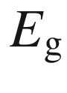

between the materials. The effect of grading on the properties of the heterojunction is discussed in detail in [1781].

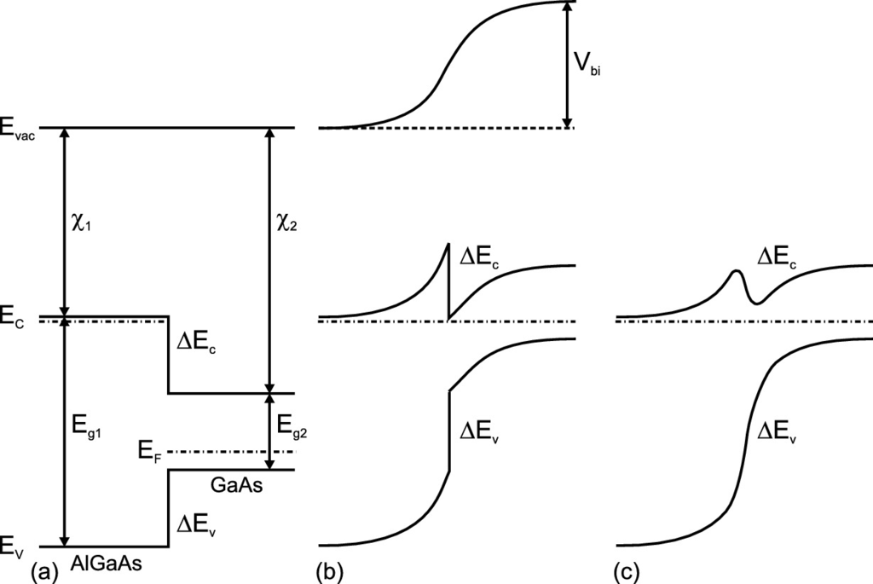

Fig. 21.59

Schematic band diagram of a n-AlGaAs/p-GaAs diode **a** without contact of the n- and p-materials, **b** in thermodynamic equilibrium, and **c** with graded Al composition at the heterointerface

**Type-II Heterostructure Diodes**

Many semiconductors can only be doped n-type or p-type (cmp. Sect. [7.​4.​2](The_Physics_of_Semiconductors00003.docx#u116076_4_En_7_Chapter)). Bipolar heterostructures can be formed and, depending on the position of the bands relativ to the vacuum level, can form a type-II heterostructure. Examples are p-NiO/n-ZnO or p-CuI/n-ZnO; the band diagram of the latter is depicted in Fig. [21.60](#u116076_4_En_21_Chapter-Fig60)a for a typical situation (p

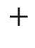

-n diode) [568, 1782]. Rectification for such device can be very high (

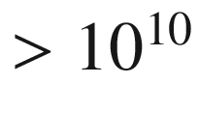

, Fig. [21.60](#u116076_4_En_21_Chapter-Fig60)b). Minority carrier injection is excluded due to the high barriers. The current across the interface is a recombination current, presumably via interface defects, which exhibits an ideality factor around 2 [1783].

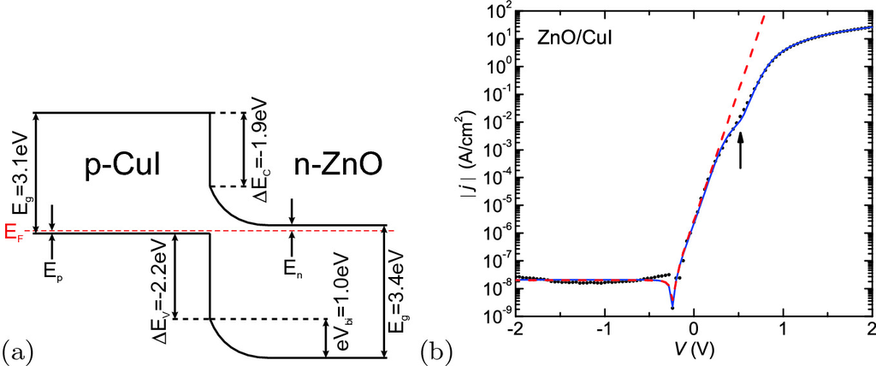

Fig. 21.60

**a** Schematic band diagram of a p-CuI/n-ZnO diode. Adapted from [1782]. **b** *jV*-characteristics (room temperature) of type-II epitaxial CuI/ZnO heterojunction bipolar diode (*symbols*) and fit (*red dashed line*) with

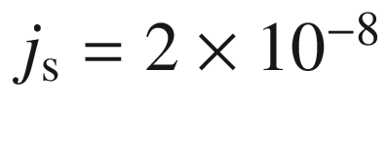

 A/cm

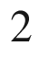

and ideality factor

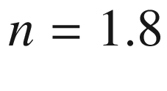

. The other fit (*blue line*) takes into account additionally a barrier inhomogeneity and the series resistance.

Adapted from [1784]

#### 21.4.7 Organic Semiconductor Diodes

A bipolar diode from organic semiconductors consists of the p-conductive hole transport layer (HTL) and the n-conductive electron transport layer (ETL). The low conductivity of organic semiconductors causes the applied voltage to drop over the entire structure [1785–1787] (Fig. [21.61](#u116076_4_En_21_Chapter-Fig61)c) while in a typical silicon diode for sufficient forward bias (and moderate injection, cmp. Fig. [21.50](#u116076_4_En_21_Chapter-Fig50)) flat-band conditions are present (Fig. [21.61](#u116076_4_En_21_Chapter-Fig61)b). The first organic homodiode was reported only in 2005 for zinc-phthalocyanine (ZnPc) doped with [Ru(terpy)



]

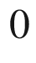

(n-type) and F



-TCNQ (p-type, cmp. Fig. [18.​7](The_Physics_of_Semiconductors00007.docx#u116076_4_En_18_Chapter-Fig7)b) [1788]. Deviation from ideal Shockley behavior is discussed in this report.

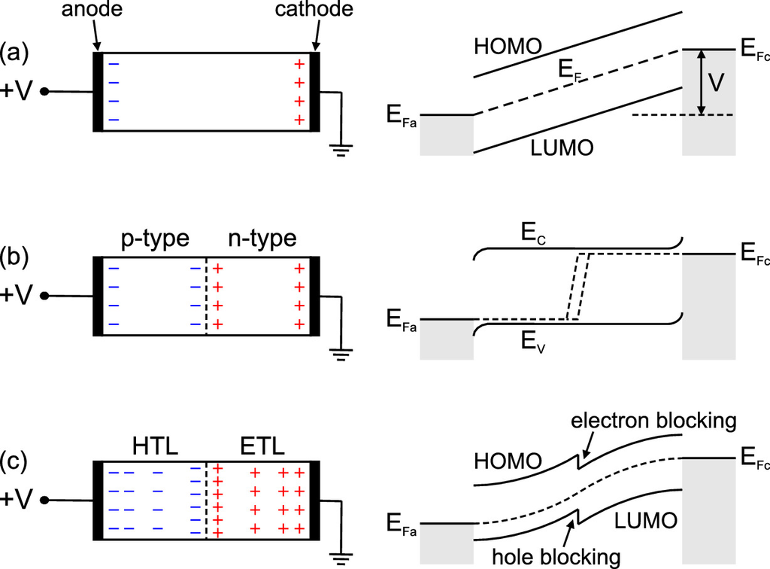

Fig. 21.61

Schematic sample geometry and charge distribution (*left*) and energy diagram (*right*) for **a** an ideal insulator, **b** a typical inorganic semiconductor pn diode and **c** a double layer organic diode under forward bias *V*.

Adapted from [1787]

The hole injecting contact is often made from ITO, the electron injection contact from low work function metals such as Al, Mg or Ca. Specially designed layers for efficient charge injection (HIL, hole injection layer [1789] and EIL, electron injection layer [1790]) can be introduced between the contact metal and the transport layers (Fig. [21.62](#u116076_4_En_21_Chapter-Fig62)c). The particular level lineup of the HTL and HTL as shown in Fig. [21.61](#u116076_4_En_21_Chapter-Fig61)c (also Fig. [21.62](#u116076_4_En_21_Chapter-Fig62)a) leads to a barrier for electrons and holes. The hole and/or electron blocking is beneficial for recombination in the vicinity of the interface and prevents exciton diffusion to the contacts. In organic light emitting diodes (Sect. [23.​3.​7](#u116076_4_En_23_Chapter)) an additional layer (EML, emission layer) designed for efficient radiative recombination (Sect. [18.​6](The_Physics_of_Semiconductors00006.docx#u116076_4_En_18_Chapter)) is introduced between HTL and ETL (Fig. [21.62](#u116076_4_En_21_Chapter-Fig62)b).

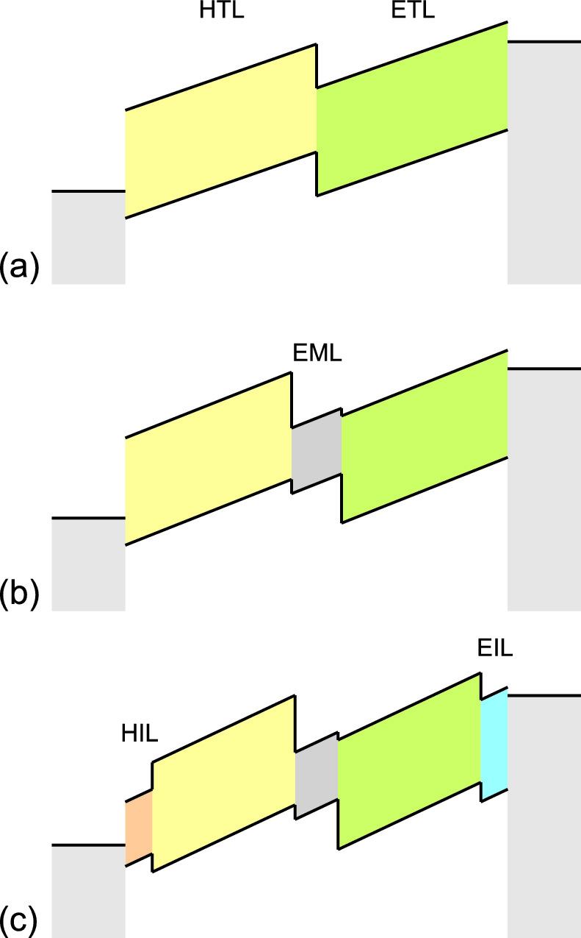

Fig. 21.62

Schematic energy diagram for **a** dual layer organic diode (HTL, ETL), **b** with additional emission layer (EML) and **c** with further hole and electron injection layers (HIL, EIL)

### 21.5 Applications and Special Diode Devices

In the following, various electronic applications of diodes are discussed. The most important special diode types are introduced. Optoelectronic applications (involving absorption and emission of photons) are treated below (Sect. [22](#u116076_4_En_22_Chapter)). The applications of Schottky diodes are discussed in [1791].

#### 21.5.1 Rectification

In a rectifier, the diode has to supply a high resistivity for one polarity of the bias and a low one to the other polarity. In Fig. [21.63](#u116076_4_En_21_Chapter-Fig63)a, a single-path rectification method is shown. Only the positive half-wave can pass the load resistor

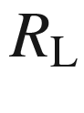

(Fig. [21.63](#u116076_4_En_21_Chapter-Fig63)b). In Fig. [21.63](#u116076_4_En_21_Chapter-Fig63)c, the characteristic of a Si diode is shown. Of course, the voltage drop across the diode can only range in the 1-V regime. In order to make the setup work, the load resistor has to be considered. The total current is given by

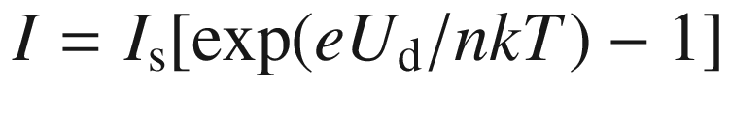

. The total voltage *U* is split between the voltage drop across the diode

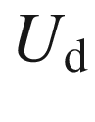

and that over the load resistance

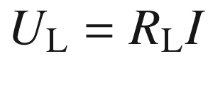

. The current is therefore given by

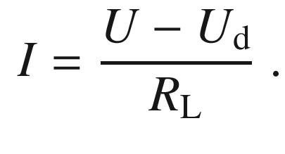

(21.169)

For sizeable currents the voltage drop across the diode

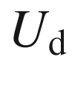

is between 0.7 and 1 V. The characteristic is linear between about 1 and 220 V (Fig. [21.63](#u116076_4_En_21_Chapter-Fig63)d). Typically, the voltage

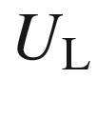

is low-pass filtered with a capacitor parallel to the load resistor. The effective voltage is the peak voltage divided by 2.

The drawback of the single diode rectifier is that only the positive half-wave contributes to a dc signal. The setup in Fig. [21.63](#u116076_4_En_21_Chapter-Fig63)e (bridge rectifier) allows both half-waves to contribute to the dc signal. The effective voltage in this case is the peak voltage divided by

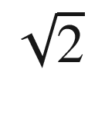

.

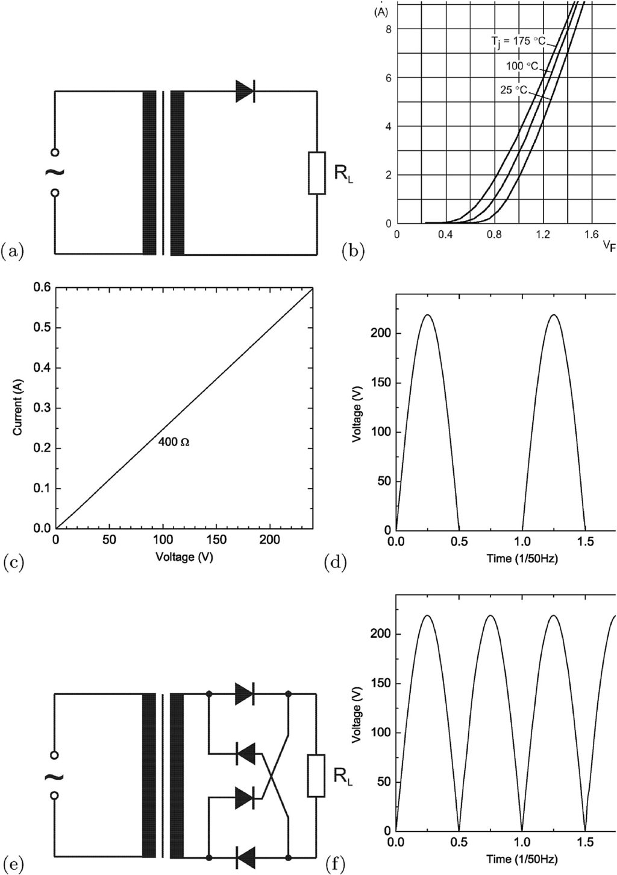

Fig. 21.63

**a** Single-path mains rectifier, **b** characteristics of Si diode (BYD127, Philips), **c** load characteristics of the mains rectifier (

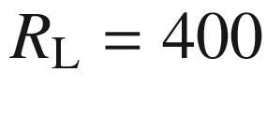

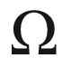

), **d** voltage output of single-path mains rectifier. **e** depicts the schematic circuit of a bridge rectifier that works for both half-waves, **f** the resulting voltage output

The forward resistance in the static (

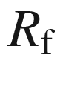

) and dynamic (

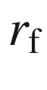

) case are (for

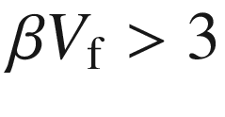

)

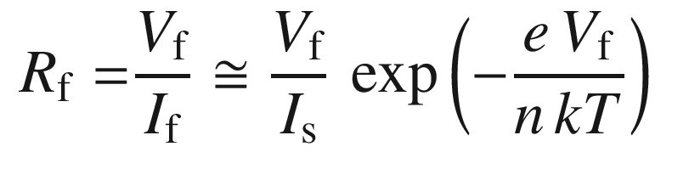

(21.170a)

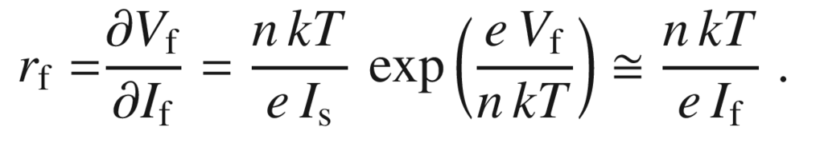

(21.170b)

For reverse bias we have (

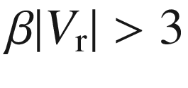

)

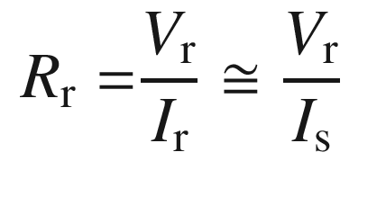

(21.171a)

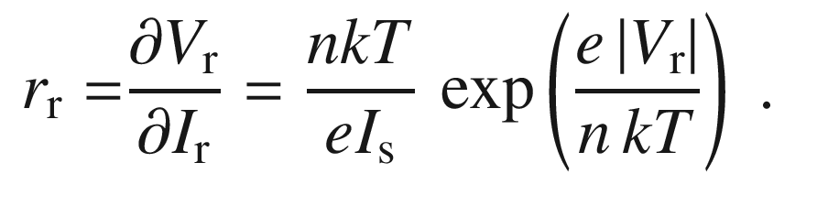

(21.171b)

Thus, the dc and ac rectifications ratios are given by

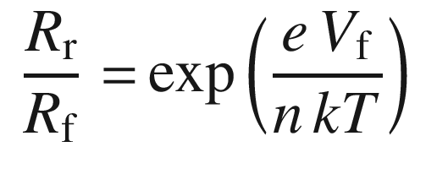

(21.172a)

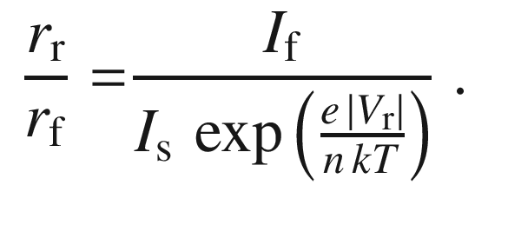

(21.172b)

Rectifiers generally have slow switching speeds. A significant time delay arises from the necessary charge-carrier recombination when the diode switches from low (forward) to high (reverse) impedance. This poses typically no problem for line-frequency (50–60 Hz) applications. For fast applications, however, the minority carrier lifetime needs to be reduced, e.g. by doping Si with Au (see Sect. [10.​9](The_Physics_of_Semiconductors00005.docx#u116076_4_En_10_Chapter)).

#### 21.5.2 Frequency Mixing

The nonlinear characteristic of the diode allows the mixing of frequencies, e.g. for second- (or higher-) harmonic generation, upconversion or demodulating of radio-frequency (RF) signals. A single balanced mixer is shown in Fig. [21.64](#u116076_4_En_21_Chapter-Fig64)a, b. The RF signal consists of a RF carrier frequency

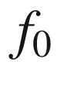

modulated with an intermediate frequency (IF) signal

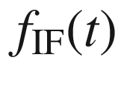

. It is mixed with a local oscillator (LO) that has a constant frequency

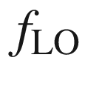

outside the RF modulation bandwidth

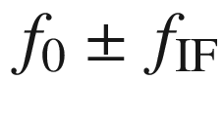

. The IF signal can be detected from the setup in Fig. [21.64](#u116076_4_En_21_Chapter-Fig64)a if filtered through a low-pass filter to avoid loss of power to the IF amplifier. The temperature dependence of the diode characteristic (via

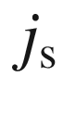

and

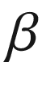

) on mixing efficiency is typically less than 0.5 dB for a 100-K change in temperature.

Problems of single-diode mixers are the radiation of local-oscillator power from the RF input port,[25](#u116076_4_En_21_Chapter-Fn25) loss of sensitivity by absorption of input power in the local oscillator circuit, loss of input power in the intermediate frequency amplifier, and the generation of spurious output frequencies by harmonic mixing. Some of these problems can be solved by circuit techniques, but these circuits often introduce new problems. Most mixers therefore use multiple-diode techniques to provide a better solution of these problems. In Fig. [21.64](#u116076_4_En_21_Chapter-Fig64)c, the circuit diagram of a double balance mixer is shown. Even-order harmonics of both the LO and the signal frequency are rejected. This mixer does not require a low-pass filter to isolate the IF circuit. The three ports are isolated from each other by the symmetry of the circuit. These mixers usually cover a broader frequency band than the others. Ratios as high as 1000:1 are available. Microwave equivalents (working at

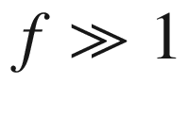

 GHz) of such mixer circuits are available. Bandwidth ratios as high as 40:1 are available at microwave frequencies in MMICs (millimeter-wave integrated circuits).

The common drawback of MMIC diodes is that they are obtained from the Schottky barriers used in field-effect transistors, that have inferior performance compared to discrete diodes. The use of pHEMT technology[26](#u116076_4_En_21_Chapter-Fn26) for millimeter-wave applications provides diodes that differently from regular Schottky diodes, since they consist of a Schottky barrier in series with a heterojunction. In Fig. [21.64](#u116076_4_En_21_Chapter-Fig64)d, a MMIC 45 GHz mixer is shown using fast GaAs-based pHEMTs.

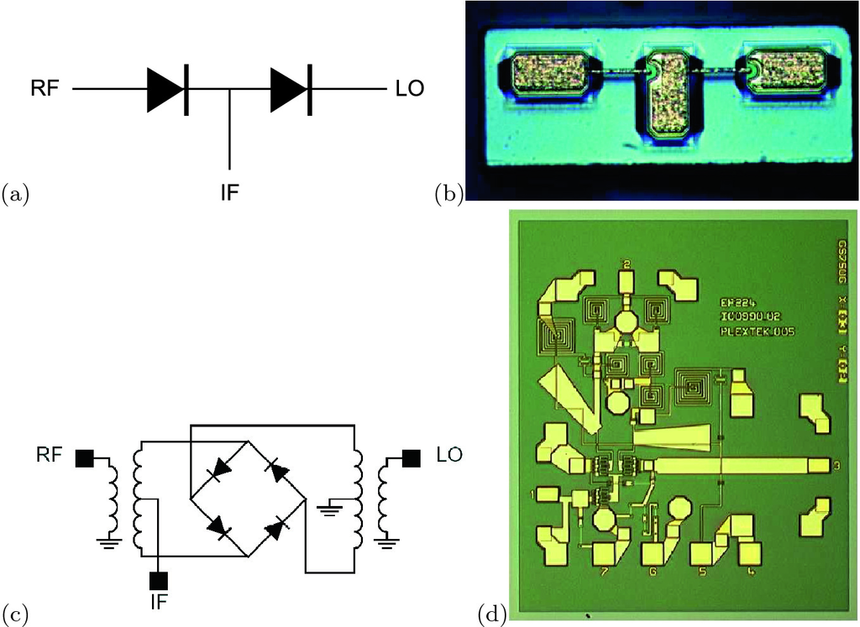

Fig. 21.64

**a** Schematic circuit of single balanced mixer with input (RF: radio frequency, LO: local oscillator) and output (IF: intermediate frequency). **b** Optical plan-view image (

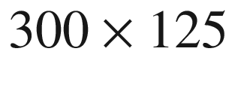

  µm



) of a high-speed single balanced mixer with two GaAs Schottky diodes with opposite poling. The device properties are

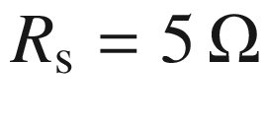

, for

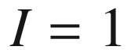

  µA a forward and reverse voltage of 0.7 and 6 V, respectively; the capacitance of each diode is 8 fF. Reprinted with permission from [1792]. **c** Schematic circuit of a double balanced mixer. **d** Optical image (1.65 mm



) of 40–45 GHz MMIC (Gilbert cell) mixer on GaAs basis using pHEMTs. Reprinted with permission from [1793]

#### 21.5.3 Voltage Regulator

In a voltage regulator, the large variation of resistance with applied bias is used. This effect occurs in the forward direction and close to the breakdown voltage.

In Fig. [21.65](#u116076_4_En_21_Chapter-Fig65)a, a simple circuit is shown. When the input voltage

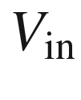

is increased, the current increases. The preresistor

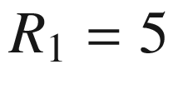

 k

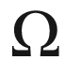

and the load resistor represent a voltage divider with

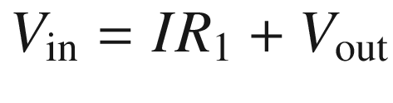

. The total current *I* is given by the two currents through the diode and the load resistor

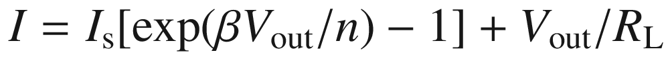

. Therefore, the output voltage is implicitly given by

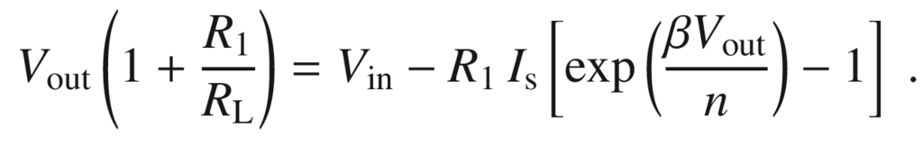

(21.173)

A large current change is related to a fairly small change of the voltage across the diode, which at the same time is the output voltage. Therefore, a change in the input voltage causes only a small change in the output voltage.

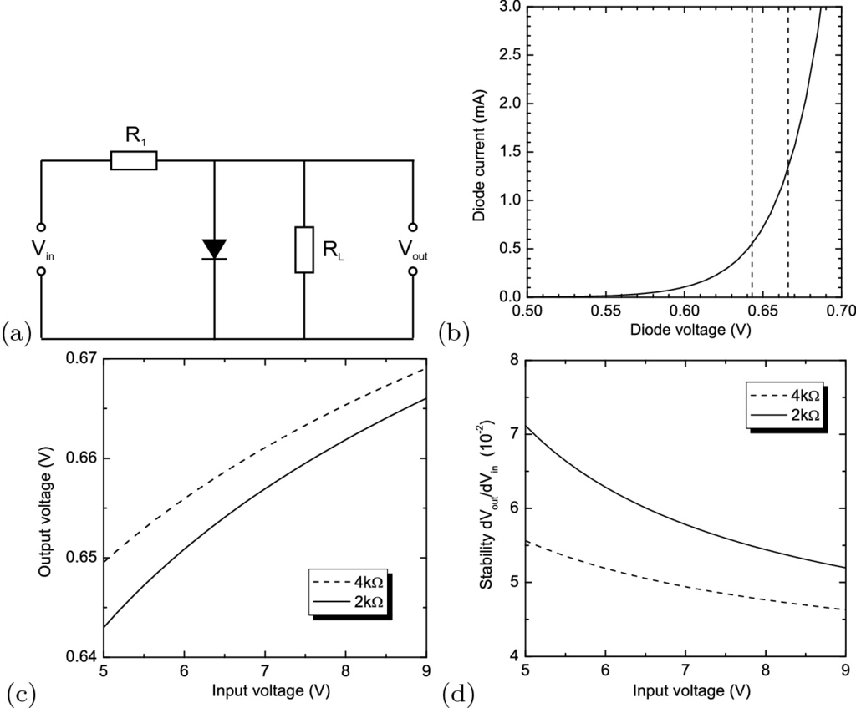

Fig. 21.65

**a** Circuit diagram of a voltage regulator, **b** diode characteristic (

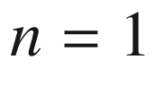

). The *vertical dashed lines* show the operation conditions for

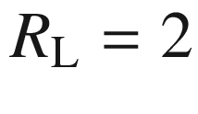

 k

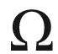

and

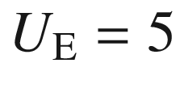

and 9 V and thus the principle of voltage stabilization. **c** Output versus input voltage and **d** stability (differential voltage ratio

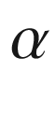

, see text) for input voltage between 5 and 9 V

We assume a diode with



and

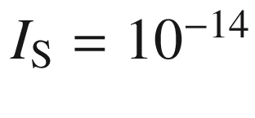

 A with the characteristic shown in Fig. [21.65](#u116076_4_En_21_Chapter-Fig65)a. The numerical example in Fig. [21.65](#u116076_4_En_21_Chapter-Fig65)c is calculated for



 k



and 4 k

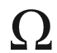

, respectively. The output voltage varies by about 0.02 V if the input varies between 5 and 9 V. In Fig. [21.65](#u116076_4_En_21_Chapter-Fig65)d, the differential voltage change

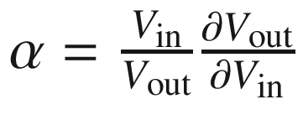

is shown.

In this way, voltage peaks can be filtered from the input voltage. If two antiparallel diodes are used, this principle works for both polarities. Instead of a diode in the forward direction, the very steep slope of the diode *I*–*V* characteristic at the breakdown can be used. Just before breakdown, the diode has a high resistance and the voltage drops at the load resistor. If the input voltage increases a little, the diode becomes conductive and shorts the additional voltage (the maximum allowed breakdown current needs to be observed!). Due to its small saturation current, typically Si diodes are used. The breakdown voltage can be designed via the diode parameters. Such diodes with defined breakdown voltage are called Z- or Zener diodes (see next section).

If the breakdown is due to tunneling (avalanche multiplication), the breakdown voltage decreases (increases) with temperature. If two diodes with positive and negative temperature coefficient are put in series, a very good temperature stability of the breakdown voltage of 0.002%/K can be achieved. Such diodes can be used to realize a reference voltage.

#### 21.5.4 Zener Diodes

A Zener diode is designed to have a defined breakdown voltage. Zener diodes are available with a number of different standard breakdown voltages. Their characteristic is shown for reverse bias with the current shown positive. The characteristics of various Zener diodes for different breakdown voltages are shown in Fig. [21.66](#u116076_4_En_21_Chapter-Fig66).

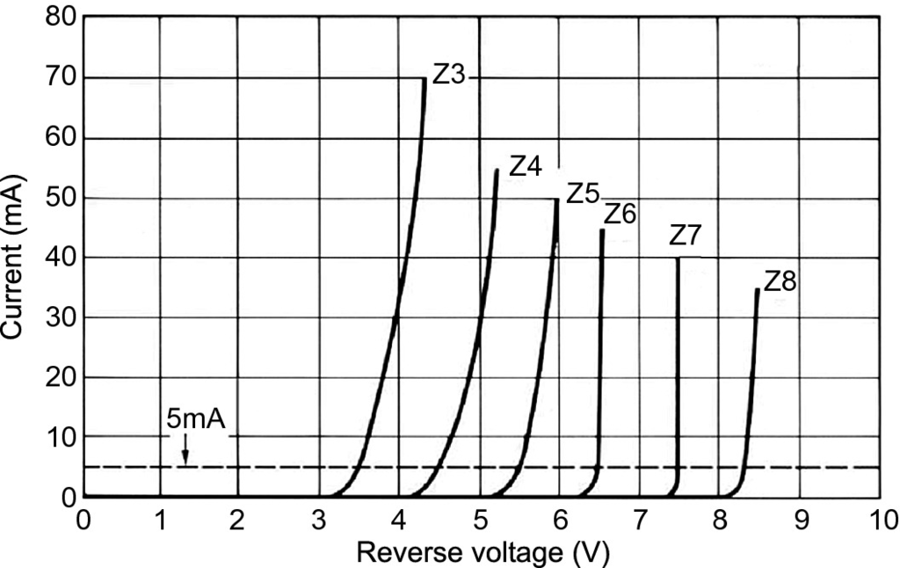

Fig. 21.66

Characteristics of a field of Zener diodes (at room temperature)

#### 21.5.5 Varactors

A diode exhibits a voltage-dependent capacitance. This effect can be used to tune an oscillator using the diode bias (voltage-controlled oscillator, VCO). The equivalent circuit is shown in Fig. [21.67](#u116076_4_En_21_Chapter-Fig67). The capacitance consists of a parasitic capacitance

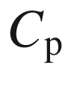

due to mounting and bonding. This effect also causes a parasitic inductance. The series resistance due to mounting can typically be neglected. The variable junction capacitance

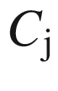

and the ohmic resistance



are bias dependent.

The *C*(*V*) dependence has generally a power law with an exponent

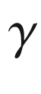

(which itself may depend on the bias voltage)

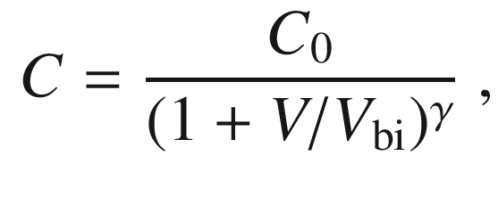

(21.174)

where

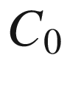

is the-zero bias capacitance. Since the frequency *f* of an LC oscillator circuit depends on

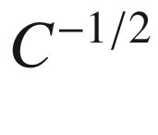

the frequency, *f* depends on the voltage as

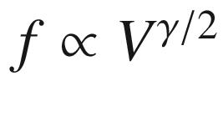

. Therefore, a

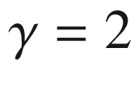

dependence is most desirable.

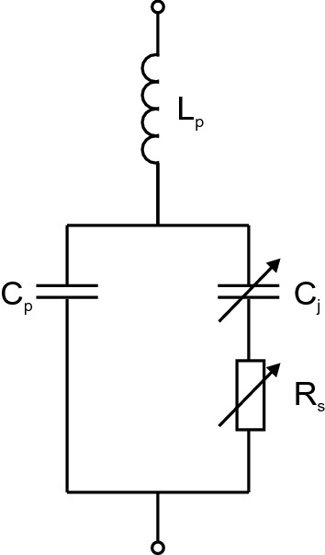

Fig. 21.67

Equivalent circuit of a varactor diode with parasitic capacitance

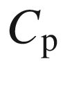

and inductance

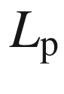

and variable capacitance

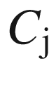

and resistance

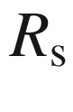

For uniformly doped profiles, the capacitance depends with an inverse square root law on the applied voltage ([21.117](The_Physics_of_Semiconductors00007.docx#u116076_4_En_21_Chapter-Equ128)), i.e.

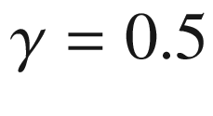

. Hyperabrupt junctions are typically made by ion implantation or epitaxy with graded impurity incorporation to create a special nonuniform doping profile (Fig. [21.68](#u116076_4_En_21_Chapter-Fig68)a). For a doping profile

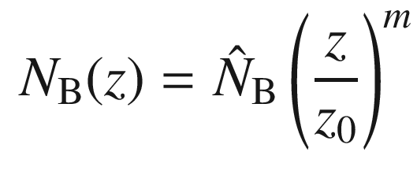

(21.175)

the capacitance is given as

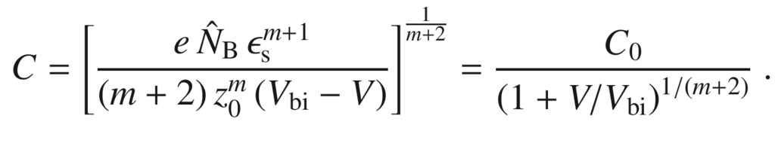

(21.176)

Ideally,

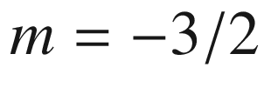

results is a linear frequency versus voltage relation. The *C*–*V* characteristic of an implanted, hyperabrupt diode exhibits a part that has an exponent

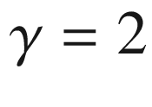

(Fig. [21.68](#u116076_4_En_21_Chapter-Fig68)b). A

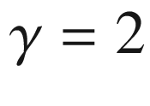

*C*(*V*) dependence and therefore a linear *f*(*V*) curve can be achieved over more than one octave using computer-controlled variable epitaxial-layer doping (Fig. [21.68](#u116076_4_En_21_Chapter-Fig68)c).

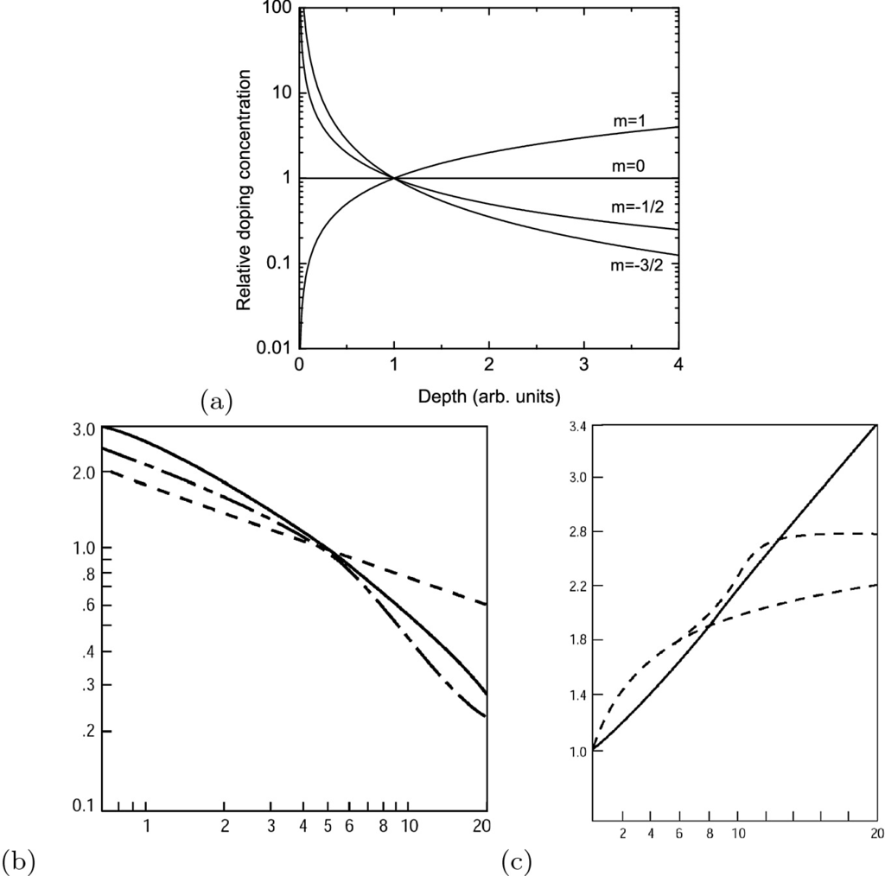

Fig. 21.68

**a** Donor-doping profile according to ([21.175](#u116076_4_En_21_Chapter-Equ193)) in p

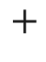

n or Schottky diodes for

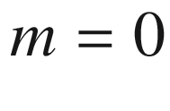

(abrupt junction),

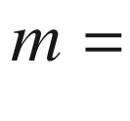

1 (linearly graded junction) and two values with

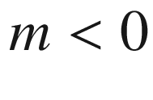

(hyperabrupt junctions). **b** Bias dependence of capacitance for diodes with abrupt junction (‘A’,

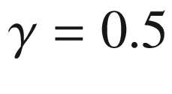

), hyperabrupt junction (‘H’,

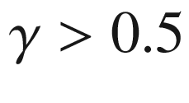

) and ‘epilinear’ junction (‘L’,

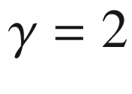

). **c** Frequency-voltage tuning characteristics (scaled to 1.0 for



) for the three diode types. Parts (**b**) and (**c**) adapted from [1794], reprinted with permission

#### 21.5.6 Fast-Recovery Diodes

Fast-recovery diodes are designed for high switching speeds. The switching speed from the forward to the reverse regime is given by the time

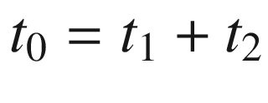

with

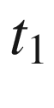

being the time to reduce the minority carrier density to the equilibrium value (e.g.

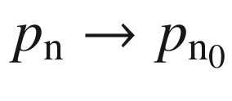

) and

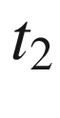

being the time in which the current decreased exponentially (Fig. [21.69](#u116076_4_En_21_Chapter-Fig69)). The time

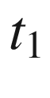

can be drastically reduced by incorporation of deep levels that act as recombination centers. A prominent example is Si:Au. However, this concept is limited since the reverse generation current, e.g. ([21.154](#u116076_4_En_21_Chapter-Equ169)), depends on the trap density. For direct semiconductors, recombination times are short, e.g. 0.1 ns or less for GaAs. In silicon, they can be extremely long (up to ms) or at least 1–5 ns. Schottky diodes are suitable for high-speed applications since they are majority carrier devices and minority charge carrier storage can be neglected.

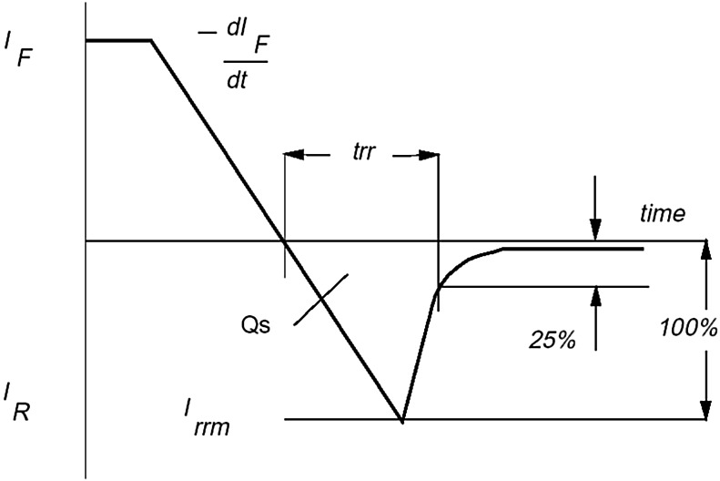

Fig. 21.69

Current versus time trace for a (soft) fast-recovery diode. Reprinted with permission from [1795]

#### 21.5.7 Step-Recovery Diodes

This type of diode is designed to store charge in the forward direction. If polarity is reversed, the charge will allow conductance for a short while, ideally until a current peak is reached (Fig. [21.70](#u116076_4_En_21_Chapter-Fig70)a), and then cutoff the current very rapidly during the so-called snapback time

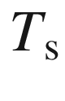

(Fig. [21.70](#u116076_4_En_21_Chapter-Fig70)b). The cutoff can be quite rapid, in the ps regime. These properties are used for pulse (comb) generation or as a gate in fast sampling oscilloscopes. In Si, only 0.5–5  µs are reached (fast-recovery diode, see previous section) while GaAs diodes can be used in the several tens of GHz regime.

Using a heterostructure GaAs/AlGaAs diode (cf. Sect. [21.4.6](#u116076_4_En_21_Chapter-Sec21)), as shown schematically in Fig. [21.71](#u116076_4_En_21_Chapter-Fig71)a, a steepening of a 15-V, 70-ps (10% to 90%) pulse to a fall time of 12 ps was observed (Fig. [21.71](#u116076_4_En_21_Chapter-Fig71)c). The forward current of the diode was 40 mA, supplied via a bias tee.

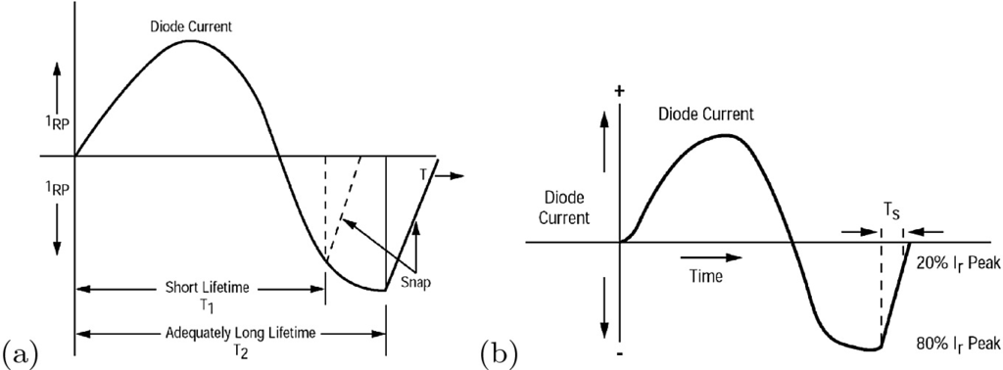

Fig. 21.70

**a** Current versus time trace for a step-recovery diode and sinusoidal voltage input. The lifetime must be sufficiently large such that a current peak is reached. **b** Definition of the snapback time

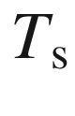

.

Reprinted with permission from [1796]

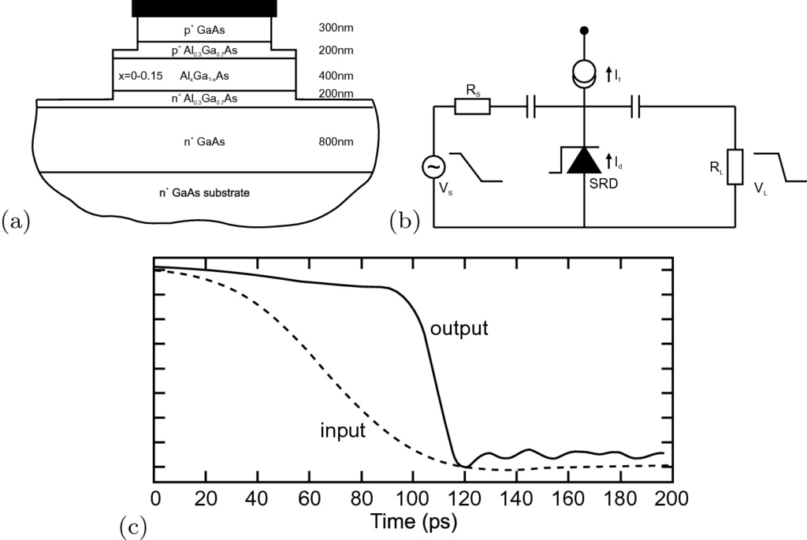

Fig. 21.71

**a** Schematic layer sequence for fast GaAs/AlGaAs step-recovery diode. **b** Circuit with input and output pulse. **c** Input (*dashed line*) and output (*solid line*) waveforms. Vertical division is 2 V.

Adapted from [1797]

#### 21.5.8 Pin-Diodes

In a pin-diode, an intrinsic (i), i.e. undoped region (with higher resistivity) is located between the n- and the p-regions. Often, also a region with low n- or p-doping is used. In this case, the center region is denoted as a

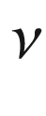

- or

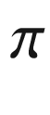

-region, respectively. The fabrication of arbitrary doping profiles and an intrinsic region poses little problem for epitaxial diodes.

Via the Poisson equation, the charge in the intrinsic layer is related to the electric field. If no dopants are present, there is a constant (maximum) field in the i-region at zero bias. If there is low doping, a field gradient exists.

The capacitance for reverse bias is

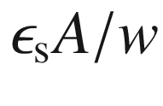

and is constant starting at fairly small reverse bias (10 V). The series resistance is given by

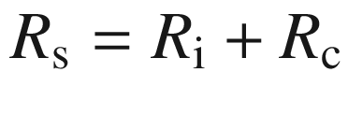

. The contact resistance

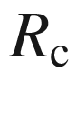

dominates the series resistance for large forward bias (Fig. [21.72](#u116076_4_En_21_Chapter-Fig72)).

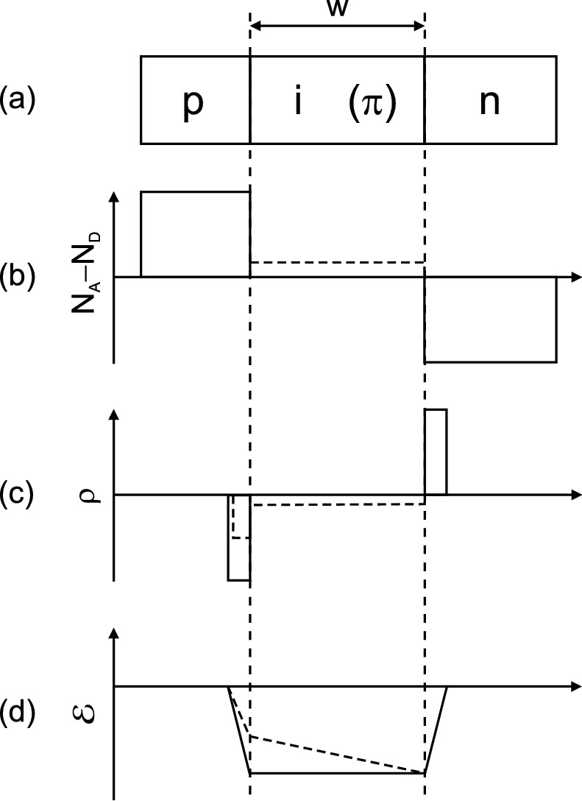

Fig. 21.72

**a** Schematic layer sequence of pin-diode (‘i’: intrinsic, ‘

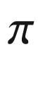

’: lowly p-doped), **b** net impurity distribution

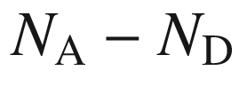

, **c** space charge and **d** electric field in a pin (*solid lines*) and a p–

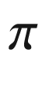

–n (*dashed lines*) diode

#### 21.5.9 Tunneling Diodes

For the invention of the tunneling diode and the explanation of its mechanism the 1973 Nobel Prize in Physics was awarded to Esaki [1798]. Eventually, the tunneling diode did not make the commercial breakthrough due to its high basis capacitance. It is used for special microwave applications with low power consumption, for frequency stabilization and possibly in tunneling field-effect transistors (Sect. [24.​5.​6](The_Physics_of_Semiconductors00009.docx#u116076_4_En_24_Chapter)). Reviews can be found in [1799, 1800].

First, the tunneling diode is a pn diode. While the tunnel effect [1801] has already been discussed for Schottky diodes, it has not yet been considered by us for pn diodes. We expect the tunnel effect to be important if the depletion-layer is thin, i.e. when the doping of both sides is high.

The doping is so high that the quasi-Fermi levels lie within the respective bands (Fig. [21.73](#u116076_4_En_21_Chapter-Fig73)). The degeneracy is typically several *kT* and the depletion layer width is in the 10 nm range.

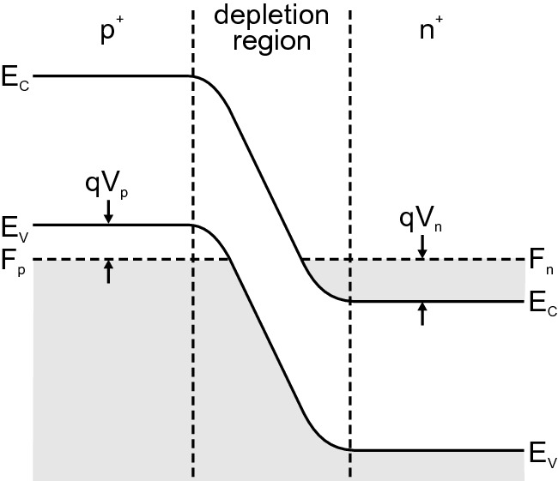

Fig. 21.73

Band diagram of a tunneling diode in thermodynamic equilibrium (

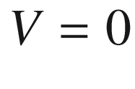

).

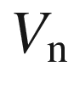

and

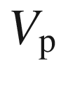

characterize the degeneracies on the n- and p-side, respectively

In the forward direction, the *I*–*V* characteristic of the tunneling diode exhibits a maximum followed by a minimum and subsequently an exponential increase (Fig. [21.74](#u116076_4_En_21_Chapter-Fig74)a). As shown in Fig. [21.74](#u116076_4_En_21_Chapter-Fig74)b, the total current consists of three currents, the band-to-band tunneling current, the excess current and the thermal (normal thermionic diode) current.

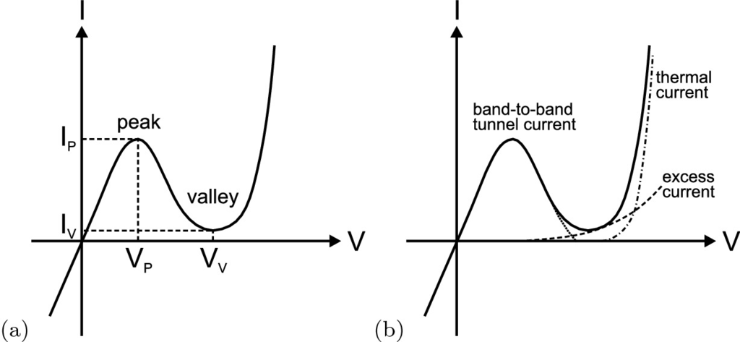

Fig. 21.74

**a** Static current-voltage characteristics of a typical tunneling diode. Peak and valley current and voltage are labeled. **b** The three components of the current (*short dashed*: band-to-band tunnel current, *dashed*: excess current, *dash-dotted*: thermal current) are shown separately.

Adapted from [574], ©1981 Wiley

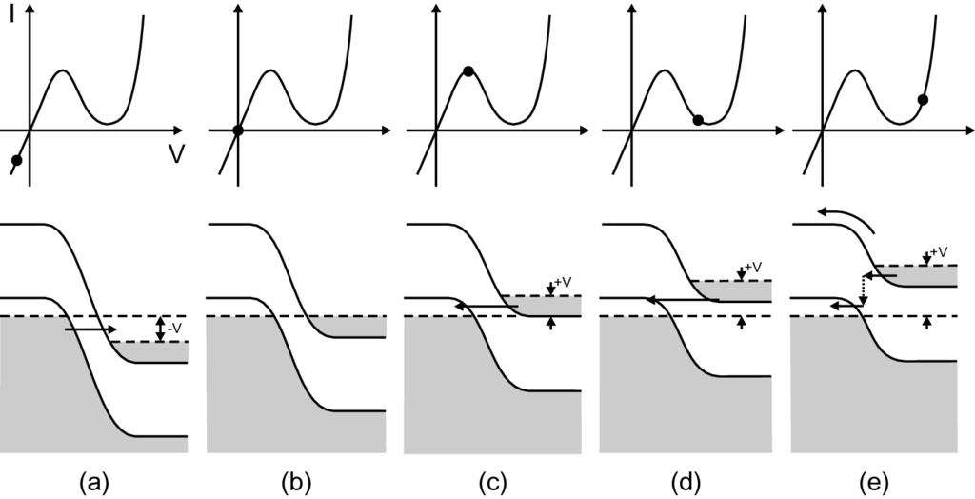

Fig. 21.75

*I*–*V* characteristics (*upper row*) and simplified band structure (*lower row*) of a tunneling diode at various bias voltages as indicated with a *dot* in the *I*–*V* plot. **a** Reverse bias, **b** in thermodynamic equilibrium (

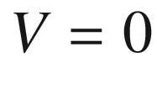

), **c** in the maximum of the tunneling current, **d** close to the valley and **e** forward bias with dominating thermal current. The tunneling current is indicated with *straight arrows*. In (**e**) the thermionic emission current (*curved arrow*) and the excess current with inelastic tunneling (*dotted arrow*) are shown

The

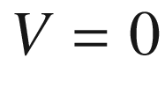

situation is again shown in Fig. [21.75](#u116076_4_En_21_Chapter-Fig75)b. Upon application of a small forward bias, electrons can tunnel from populated conduction-band states on the n-doped side into empty valance-band states (filled with holes) on the p-doped side (Fig. [21.75](#u116076_4_En_21_Chapter-Fig75)c). We note that this tunneling process is usually considered elastic. However, signatures at characteristic phonon and multi-phonon energies are found (at low temperature) in the forward current [1802, 1803] and are best seen in a

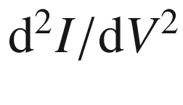

-plot [1804, 1805] (Fig. [21.76](#u116076_4_En_21_Chapter-Fig76)). Peaks appear at typical phonon energies of silicon.[27](#u116076_4_En_21_Chapter-Fn27)

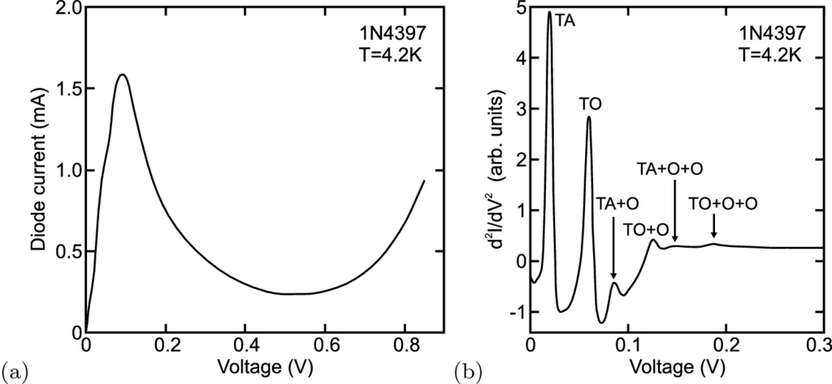

Fig. 21.76

**a** Current-voltage characteristic of silicon tunneling diode (model 1N4397 from American Microsemiconductor [1807]) at low temperature (

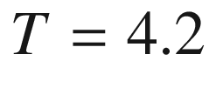

 K). **b**

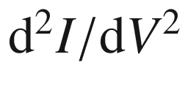

for small forward voltages, exhibiting characteristic phonon energies. Adapted from [1805]

A similar situation, now with electrons tunneling for the valence band on the p-side into the conduction band on the n-side, is present for small reverse bias (Fig. [21.75](#u116076_4_En_21_Chapter-Fig75)a). Thus the rectifying behavior of the diode is lost. This property makes it suitable for the monolithic ohmic connection of two pn diodes which is technologically used e.g. in multi-junction solar cells (cmp. Sect. [22.​4.​6](#u116076_4_En_22_Chapter)).

For larger forward bias, the bands are separated so far that the electrons coming from the n-doped side do not find final states on the p-doped side. Thus the tunneling current ceases (Fig. [21.75](#u116076_4_En_21_Chapter-Fig75)d). The current minimum is at a voltage

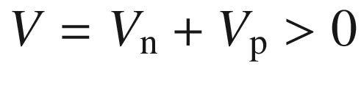

. The thermal current is the normal diode diffusion current (Fig. [21.75](#u116076_4_En_21_Chapter-Fig75)e). Therefore, a minimum is present in the *I*–*V* characteristic. The excess current is due to inelastic tunneling processes through states in the band gap and causes the minimum to not drop down to almost zero current.

The peak (

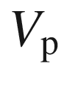

,

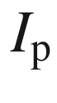

) and valley (

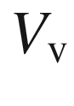

,

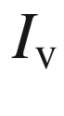

) structure of the characteristic leads to a region of negative differential resistance (NDR).

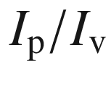

is termed the peak-to-valley ratio (Fig. [21.77](#u116076_4_En_21_Chapter-Fig77)). Peak-to-valley ratios of 8 (Ge), 12 (GaSb, GaAs), 4 (Si), 5 (InP) or 2 (InAs) have been reported (all at room temperature).

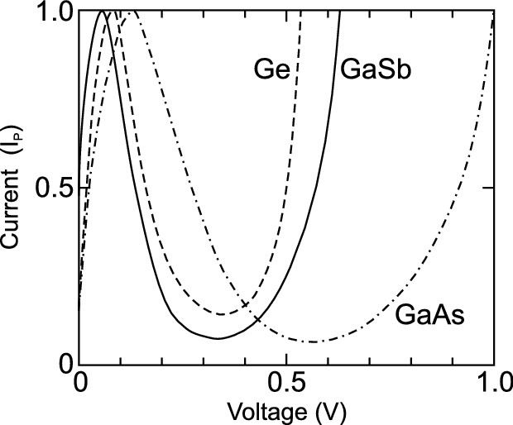

Fig. 21.77

Comparison of tunneling characteristic (room temperature) of diodes based on Ge, GaSb and GaAs. Peak-to-valley ratios are 8 (Ge) and 12 (GaSb, GaAs). Adapted from [574]

#### 21.5.10 Backward Diodes

When the doping in a tunneling diode is nearly or not quite degenerate, the peak-to-valley ratio can be very small. Then the tunnel current flows mostly in the reverse direction (low resistance) and the forward direction has a higher resistance (with or without the NDR regime). Such diodes are called backward diodes. Since there is no minority charge carrier storage, such diodes are useful for high-frequency applications.

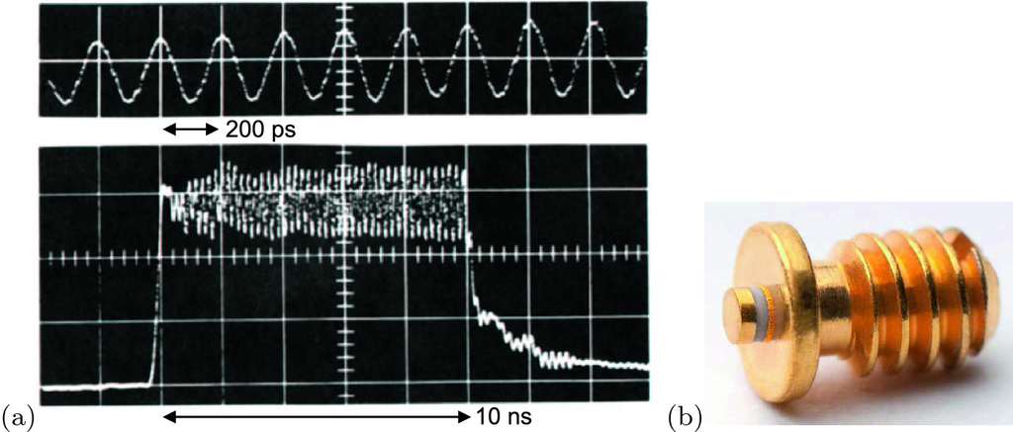

Fig. 21.78

**a** Current traces upon excitation of a 25  µm thick piece of n-type GaAs with a voltage pulse (amplitude 16 V and duration 10 ns). The upper trace is an expanded view of the lower trace. The oscillation period is 4.5 GHz. Adapted from [134]. **b** Image of packaged Gunn diode (Linwave DC1276G-T for 26–40 GHz), outer diameter 3 mm

#### 21.5.11 Gunn Diodes

The Gunn diode is not really a diode and thus more appropriately called *Gunn element*. It allows to generate microwave radiation in the frequency range of 1–100 GHz [1808] and beyond [1809] using GaAs and in the THz-regime using GaN [1810]. Extracting higher harmonics, frequencies of several 100 GHz can be realized [1811, 1812].

The Gunn element relies on the negative differential resistance (NDR) occurring in semiconductors with two valleys of different mobility such as GaAs or InP (cmp. Sect. [8.​4.​2](The_Physics_of_Semiconductors00004.docx#u116076_4_En_8_Chapter)). At high fields, the electrons are scattered from the

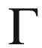

-valley into the upper valley (L-valley for most materials). Accordingly, the Gunn element is also called *transferred electron device* (TED). Details on Gunn elements can be found in [1813].

The Gunn effect was discovered by and named after J.B. Gunn [134]. The spontaneous oscillation of current in a n-type semiconductor occurs when a sufficiently large voltage (pulse) is applied that causes the electric field in the semiconductor to reach the NDR regime (Fig. [21.78](#u116076_4_En_21_Chapter-Fig78)). The applied average field of

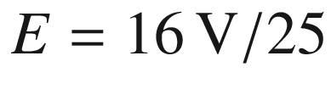

 µ

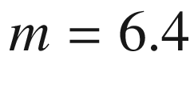

 kV/cm [134] is larger than the threshold field of

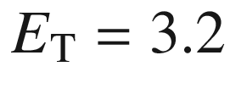

 kV/cm for NDR in GaAs (Table [8.​4](The_Physics_of_Semiconductors00004.docx#u116076_4_En_8_Chapter-Tab4)).

The self-started oscillations are due the inherent instability introduced by NDR. A homogeneous (uniform) electric field and electron distribution is unstable and a thin high-field domain with bipolar charge distribution (Gunn domain, predicted in [764]) can develop and drift through the device. After reaching the anode, another domain can form, causing a periodically fluctuating current. The highest frequencies can be achieved with the so-called limited-space-charge accumulation (LSA) mode which operates without domains. Optimal performance requires non-homogeneous doping profiles. A detailed discussion of the various oscillation mechanisms can be found in [765, 1808, 1814].

Discussion of further microwave diode devices such as the IMPATT diode can be found in [574, 1815].

Footnotes

[1](The_Physics_of_Semiconductors00007.docx#u116076_4_En_21_Chapter-Fn1_source)

The simplest device is a resistor made from a homogeneous piece of semiconductor, used, e.g., as a part of an integrated circuit or as a photoresistor as discussed in Sect. [22.​2](#u116076_4_En_22_Chapter).

[2](The_Physics_of_Semiconductors00007.docx#u116076_4_En_21_Chapter-Fn2_source)

This distinction is not only made for diodes but also many other semiconductor devices such as transistors, see Chap. [24](The_Physics_of_Semiconductors00009.docx#u116076_4_En_24_Chapter).

[3](The_Physics_of_Semiconductors00007.docx#u116076_4_En_21_Chapter-Fn3_source)

This situation is similar to the heterostructure interface (Sect. [12.​3.​4](The_Physics_of_Semiconductors00005.docx#u116076_4_En_12_Chapter)), with the metal, however, having a very short screening length.

[4](The_Physics_of_Semiconductors00007.docx#u116076_4_En_21_Chapter-Fn4_source)

We denote the energy barrier height with

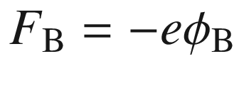

.

[5](The_Physics_of_Semiconductors00007.docx#u116076_4_En_21_Chapter-Fn5_source)

The functional integration method is limited to bijective potentials

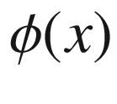

, i.e. strictly monotonously falling or rising potentials [1697] and thus covers monotonously varying doping density within the depletion layer.

[6](The_Physics_of_Semiconductors00007.docx#u116076_4_En_21_Chapter-Fn6_source)

The term

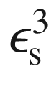

is technically

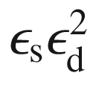

where

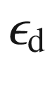

is the image-force dielectric constant.

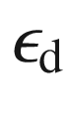

is equal to

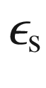

if the transit time of an electron from the metal to the maximum of the potential energy is sufficiently long to build up the dielectric polarization of the semiconductor [1681].

[7](The_Physics_of_Semiconductors00007.docx#u116076_4_En_21_Chapter-Fn7_source)

Probing the capacitance as a function of the ac frequency is called admittance spectroscopy.

[8](The_Physics_of_Semiconductors00007.docx#u116076_4_En_21_Chapter-Fn8_source)

This is valid as long as

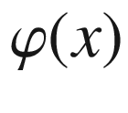

is strictly monotonous.

[9](The_Physics_of_Semiconductors00007.docx#u116076_4_En_21_Chapter-Fn9_source)

Obviously

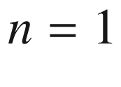

for the ideal characteristic ([21.48](The_Physics_of_Semiconductors00007.docx#u116076_4_En_21_Chapter-Equ48)). Otherwise

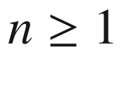

.

[10](The_Physics_of_Semiconductors00007.docx#u116076_4_En_21_Chapter-Fn10_source)

This phenomenon is similar to the red-shift of luminescence lines (Stokes shift) due to thermalization in the presence of disorder, see Sect. [12.​4](The_Physics_of_Semiconductors00005.docx#u116076_4_En_12_Chapter).

[11](The_Physics_of_Semiconductors00007.docx#u116076_4_En_21_Chapter-Fn11_source)

Reconstructions are accompanied by redistributions of the valence charge with respect to the undisturbed bulk (Sect. [11.​4](The_Physics_of_Semiconductors00005.docx#u116076_4_En_11_Chapter)). The subsequent extra interface dipoles alter the barrier heights of reconstructed interfaces [1728].

[12](The_Physics_of_Semiconductors00007.docx#u116076_4_En_21_Chapter-Fn12_source)

Also a Schottky diode has an Ohmic back contact.

[13](The_Physics_of_Semiconductors00007.docx#u116076_4_En_21_Chapter-Fn13_source)

For transport in vacuum where the electron motion is accelerated,

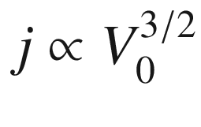

was found earlier, [1745, 1746]

[14](The_Physics_of_Semiconductors00007.docx#u116076_4_En_21_Chapter-Fn14_source)

This poling is a forward bias of the respective Schottky diode since the positive pole is at the p-type semiconductor.

[15](The_Physics_of_Semiconductors00007.docx#u116076_4_En_21_Chapter-Fn15_source)

We note that in order to reach the situations shown in Fig. [21.35](The_Physics_of_Semiconductors00007.docx#u116076_4_En_21_Chapter-Fig35) from the zero bias case of Fig. [21.30](The_Physics_of_Semiconductors00007.docx#u116076_4_En_21_Chapter-Fig30), a current must have flowed since charge carriers are redistributed. Figure [21.35](The_Physics_of_Semiconductors00007.docx#u116076_4_En_21_Chapter-Fig35) depicts the stationary equilibrium after transient voltage switch-on effects have subsided. The time, however, that is needed in order to reach such stationary equilibrium from zero bias (thermal equilibrium) may be very long (e.g. days, cf. Sect. [22.​3.​8](#u116076_4_En_22_Chapter)).

[16](The_Physics_of_Semiconductors00007.docx#u116076_4_En_21_Chapter-Fn16_source)

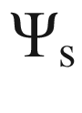

represents the voltage drop across the semiconductor that will be discussed in more detail in Sect. [21.3.3](The_Physics_of_Semiconductors00007.docx#u116076_4_En_21_Chapter-Sec13). In this sense,



for the MIS diode is related to

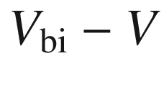

for the Schottky contact.

[17](The_Physics_of_Semiconductors00007.docx#u116076_4_En_21_Chapter-Fn17_source)

The donor and acceptor ionization energies do not change upon

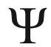

.

[18](The_Physics_of_Semiconductors00007.docx#u116076_4_En_21_Chapter-Fn18_source)

We note that we discuss the space-charge region now only with regard to

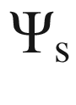

, the voltage drop across the semiconductor, and the dependence of

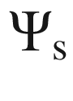

on the bias of the diode will be discussed in the next section.

[19](The_Physics_of_Semiconductors00007.docx#u116076_4_En_21_Chapter-Fn19_source)

For

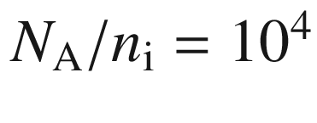

,

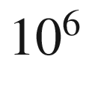

and

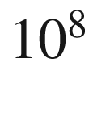

, we find

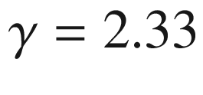

, 2.25 and 2.20, respectively.

[20](The_Physics_of_Semiconductors00007.docx#u116076_4_En_21_Chapter-Fn20_source)

Typically, a dc bias voltage *V* is set and the capacitance is sampled with a small ac voltage of amplitude

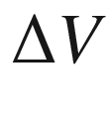

, with

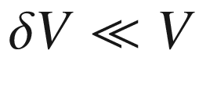

.

[21](The_Physics_of_Semiconductors00007.docx#u116076_4_En_21_Chapter-Fn21_source)

The choices of dopants and the growth conditions, in particular the temperature, need to be made such that no or negligible interdiffusion of the dopants takes place.

[22](The_Physics_of_Semiconductors00007.docx#u116076_4_En_21_Chapter-Fn22_source)

An abrupt decrease of the majority carrier density at the border of the space-charge region corresponds to zero temperature.

[23](#u116076_4_En_21_Chapter-Fn23_source)

We remind the reader that

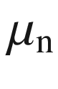

was defined as a negative number.

[24](#u116076_4_En_21_Chapter-Fn24_source)

The scattering rate becomes higher with increasing temperature and, e.g., the mobility decreases, see Sect. [8.​3.​11](The_Physics_of_Semiconductors00004.docx#u116076_4_En_8_Chapter), and the drift saturation velocity decreases, see Sect. [8.​4.​1](The_Physics_of_Semiconductors00004.docx#u116076_4_En_8_Chapter).

[25](#u116076_4_En_21_Chapter-Fn25_source)

That in military applications could make the mixer detectable by the enemy.

[26](#u116076_4_En_21_Chapter-Fn26_source)

Pseudomorphic high electron mobility transistors, cf. Sect. [24.​5.​8](The_Physics_of_Semiconductors00009.docx#u116076_4_En_24_Chapter).

[27](#u116076_4_En_21_Chapter-Fn27_source)

We note that for the 1N4396 silicon tunneling diode [1806] the phonon structure of germanium was found in [1805].

© Springer Nature Switzerland AG 2021

M. Grundmann

The Physics of Semiconductors

Graduate Texts in Physics

<https://doi.org/10.1007/978-3-030-51569-0_22>

## 22. Light-to-Electricity Conversion

Marius Grundmann[1](#u116076_4_En_22_Chapter-Aff11)

(1)

Felix Bloch Institute for Solid State Physics, Universität Leipzig, Leipzig, Germany

Marius Grundmann

Email:

[grundmann@physik.uni-leipzig.de](mailto:grundmann@physik.uni-leipzig.de)

## Abstract

The use of diodes for the conversion of electromagnetic radiation (light) into electrical signals is discussed with many examples for devices such as photoconductors, pn-, pin-, MSM- and avalanche photodiodes and charge-coupled devices. Energy conversion with solar cells is explained and standard and advanced solar cells concepts are introduced.

### 22.1 Photocatalysis

The absorption of light in a semiconductor across the band gap creates free electrons and holes. In particular, for small particle size in powders[1](#u116076_4_En_22_Chapter-Fn1) these charge carriers can reach the surface of the semiconductor. At the surface they can react with chemicals. The hole can form



OH radicals from OH

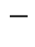

attached to the bead. The electron can form O

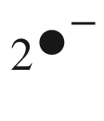

. These radicals can subsequently attack and detoxify, e.g., noxious organic pollutants in the solution surrounding the semiconductor. Such photocatalytic activity has been found, e.g., for TiO



and ZnO powders. A review of photocatalysis, in particular with TiO



particles and their surface modifications with metals and other semiconductors, is found in [1816].

The efficiency of the photocatalytic activity depends on the efficiency of the charge separation (Fig. [22.1](#u116076_4_En_22_Chapter-Fig1)). Any electron-hole pair that recombines within the bulk or the surface of the particle is lost for the catalytic activity. Thus, surfaces must exhibit a small density of recombination centers. Surface traps, however, can be beneficial for charge-carrier separation when they ‘store’ the charge-carrier rather than letting it recombine. Small particles are expected to exhibit more efficient charge-carrier separation than larger ones. Electrons at the surface can be donated and reduce an electron acceptor, typically oxygen, A

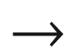

A

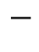

. A hole at the surface can oxidize a donor species, D



D

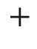

.

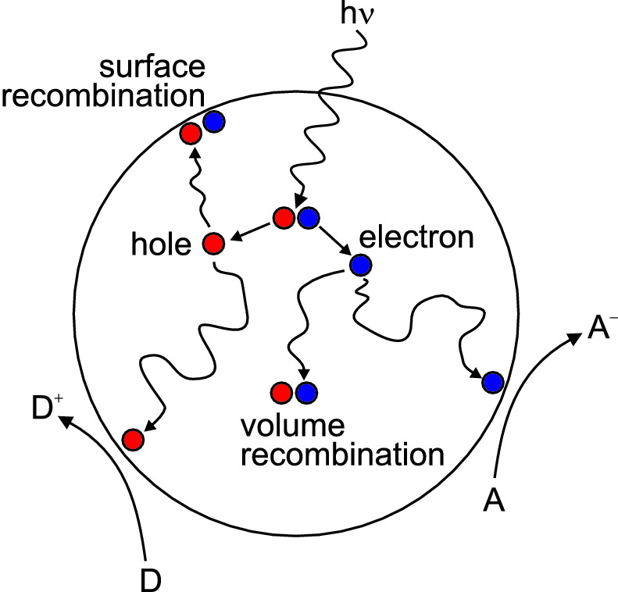

Fig. 22.1

Principle of photocatalytic activity. Light absorption creates an electron-hole pair. The electron and hole diffuse and can recombine in the bulk or at the surface. Free carriers can react at the surface with species from the surrounding solution, reducing an electron acceptor or oxidizing a donor species.

Adapted from [1816]

An example of increased photocatalytic activity are TiO



powders with deposited metal particles (such as Pt) for H



evolution and metal-oxide particles (such as RuO



) for O



evolution. Such a system behaves as a short-circuited microscopic photoelectrochemical cell in which Pt is the cathode and RuO



is the anode [1817]. Excitation with light energy above the band gap in the TiO



particle (3.2 eV) injects electrons into the Pt particles and holes into the RuO



particles. Trapped electrons in Pt reduce water to hydrogen and trapped holes in RuO



oxidize water to oxygen.

The photocatalytic activity is also tied to the geometrical shape of the semiconductor. Generally, powders with nanosized grains have much higher activity than those with microsized particles [1818]. In Fig. [22.2](#u116076_4_En_22_Chapter-Fig2) it is shown that nanosized objects with high surface-to-volume ratio are more effective catalysts than rather compact surfaces.

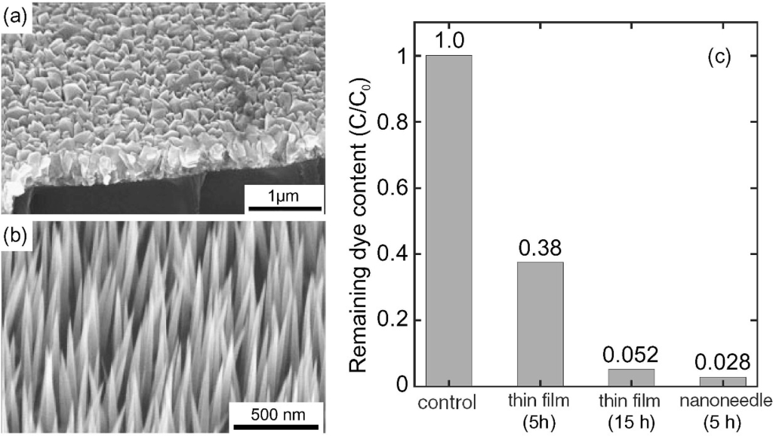

Fig. 22.2

SEM images of MOCVD-grown **a** ZnO thin film and **b** ZnO nanoneedle layer. **c** Comparison of the photocatalytic activity (decoloration of the dye Orange II in aqueous solution) of the ZnO thin film (irradiation with a Hg lamp for 5 h and 15 h) and the ZnO nanoneedles (irradiation 5 h). The sample labeled ‘control’ (scaled to 100%) is the start situation (absorption of the dye Orange II) without photocatalytic process.

Adapted from [1819], reprinted with permission

In sun-protection cream only the UV absorption is wanted in UVA (330–420 nm) and UVB (260–330 nm) ranges. Subsequent photocatalysis on the skin and the presence of radicals are unwanted. Thus the semiconductor particles (



10–200 nm diameter) are encapsulated in microbeads (



1–10 µm diameter) of silica, PMMA or urethane, also improving ease of dispersion, aggregation, stability and skin feel.

### 22.2 Photoconductors

#### 22.2.1 Introduction

Charge carriers can be generated in the semiconductor through the absorption of light with a photon energy above or below the band gap (Fig. [22.3](#u116076_4_En_22_Chapter-Fig3)). Absorption involving impurities occurs typically in the mid- and far-infrared spectral regimes (cf. Sect. [9.​8](The_Physics_of_Semiconductors00004.docx#u116076_4_En_9_Chapter)). The additional charge carriers cause an increase in the conductivity ([8.​11](The_Physics_of_Semiconductors00004.docx#u116076_4_En_8_Chapter)).

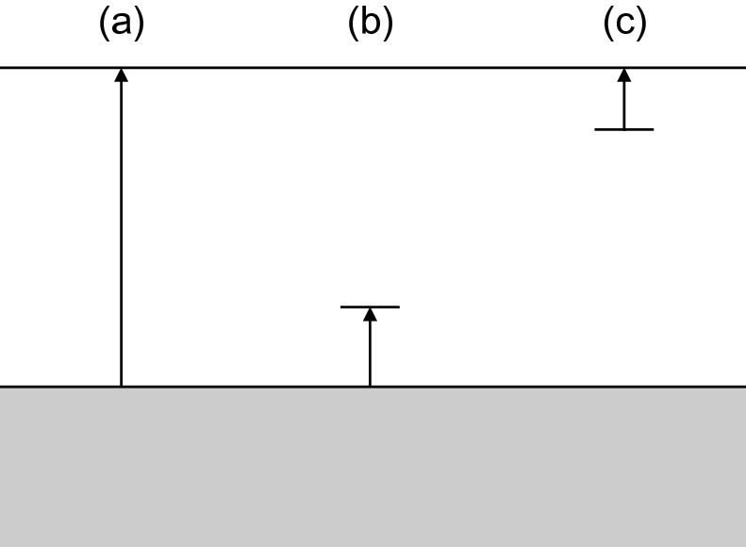

Fig. 22.3

Absorption and charge-carrier generation in a photoconductor: **a** band-band transition, **b** valence-band to acceptor and **c** donor to conduction-band transition

#### 22.2.2 Photoconductivity Detectors

In stationary equilibrium for constant illumination of power

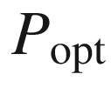

and photon energy

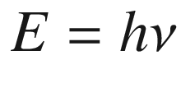

the generation rate *G* is given by

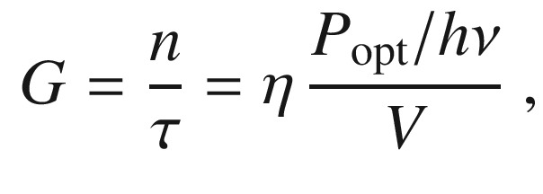

(22.1)

where *V* is the volume (

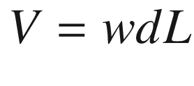

, see Fig. [22.4](#u116076_4_En_22_Chapter-Fig4)) and



denotes the charge-carrier lifetime.

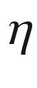

is the quantum efficiency, i.e. the average number of electron-hole pairs generated per incoming photon. The photocurrent between the electrodes is

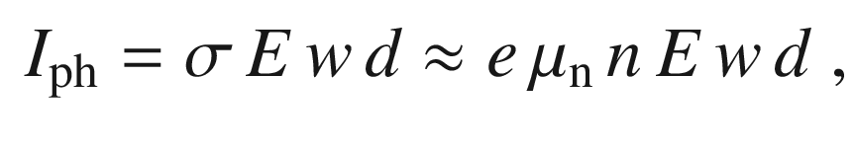

(22.2)

assuming that

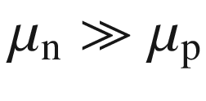

and with

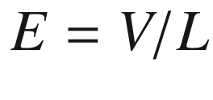

denoting the electric field in the photoconductor, *V* being the voltage across the photoconductor. We can then also write

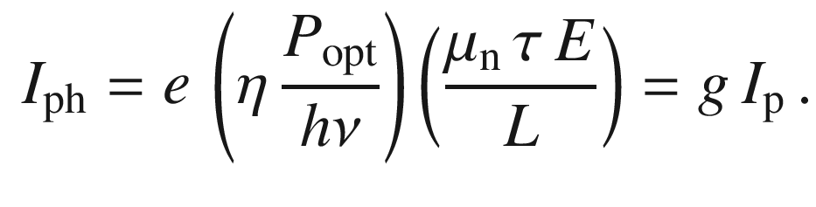

(22.3)

With the primary photocurrent

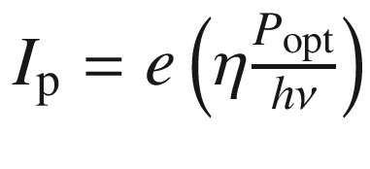

we deduce a gain

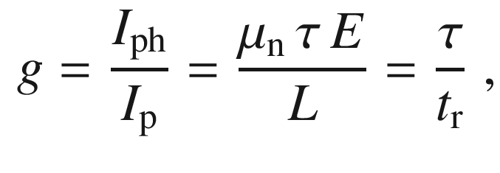

(22.4)

where

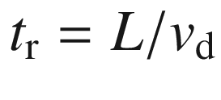

is the transit time through the photoconductor.

Now we consider a modulated light intensity

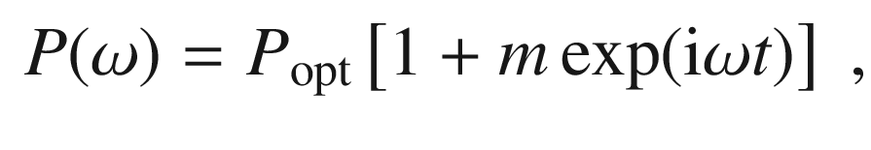

(22.5)

where *m* is between 0 and 1. For

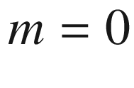

it is a constant light power, for

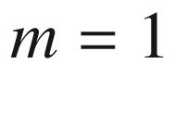

the intensity is sinusoidally modulated between 0 and

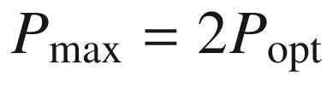

. The rms optical power[2](#u116076_4_En_22_Chapter-Fn2) is given by

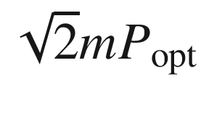

. In the case of

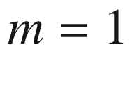

this is equal to

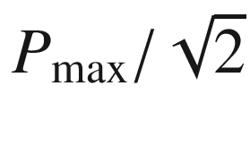

.

The rms photocurrent (

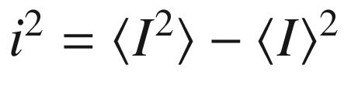

) is

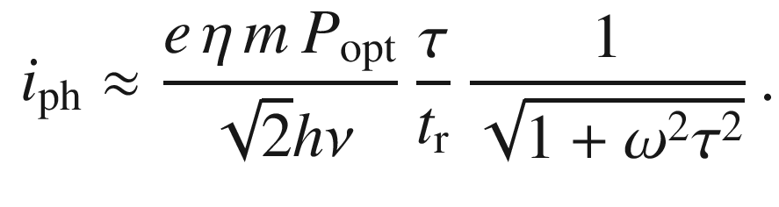

(22.6)

Besides the photocurrent which is considered the signal, several sources of noise must be considered. Noise is in this case a fluctuation current

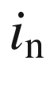

with

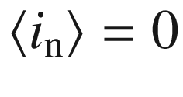

(see Appendix K).

The thermal noise (Appendix K.3.1) at a conductivity

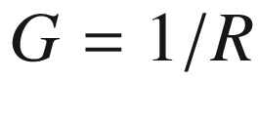

is[3](#u116076_4_En_22_Chapter-Fn3)

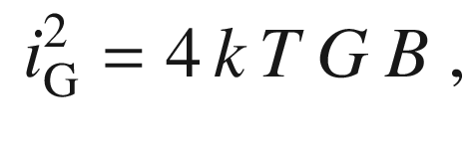

(22.7)

with *B* being the bandwidth over which the noise spectrum is integrated. The thermal noise at a resistor was experimentally found by Johnson [1820, 1821] and theoretically explained by Nyquist [1822].[4](#u116076_4_En_22_Chapter-Fn4)

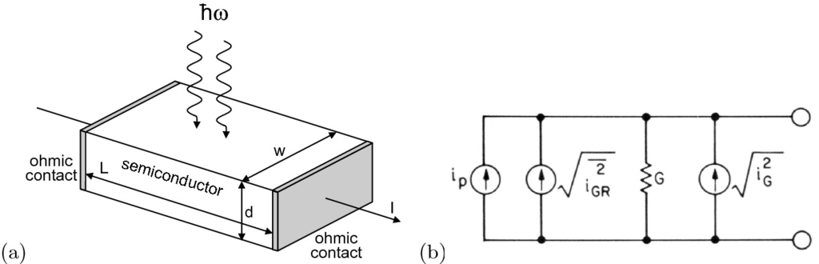

Fig. 22.4

**a** Scheme of photoconductor. **b** Equivalent circuit of photoconductor

The statistical nature (Poisson statistics) of photon arrival (and absorption) and equally that of recombination of (photo-) excited electrons leads to fluctuations of the carrier density and consequently to fluctuating conductivity and gain. This so-called generation-recombination noise (Appendix K.3.4) is given by [1823]

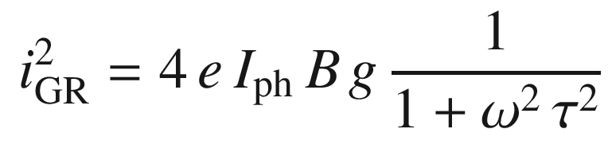

(22.8)

for the modulation frequency

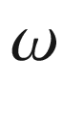

,

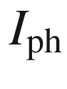

being the photocurrent in steady state ([22.3](#u116076_4_En_22_Chapter-Equ3)). The equivalent circuit with the ideal photocurrent source and the noise currents is depicted in Fig. [22.4](#u116076_4_En_22_Chapter-Fig4)b. A detailed treatment can be found in [1824].

The signal-to-noise ratio of the power is then given by

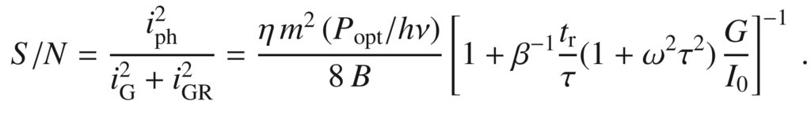

(22.9)

An important quantity is the noise equivalent power (NEP). This is the light power (

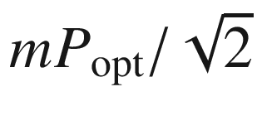

) for which the S/N ratio is equal to 1 (for

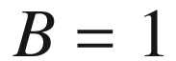

). The responsivity of a detector to light has been termed ’detectivity’ and is the inverse of the noise equivalent power. It typically depends on the square root of the detector area *A* and the bandwidth *B* [1825]. Thus the detectivity

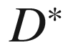

 (D star) has been introduced defined by [1826]

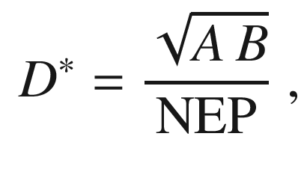

(22.10)

in order to make various detectors comparable. The unit of

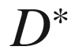

is cm Hz

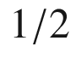

 W

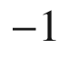

, also known as Jones. The detectivity should be stated together with the modulation frequency. It can be given for monochromatic radiation of a particular wavelength

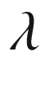

or a blackbody spectrum of given temperature *T*. As refined measure for detectivity,



(D double star) has been defined to take into account the solid angle

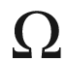

from which radiation can reach the detector [1827],

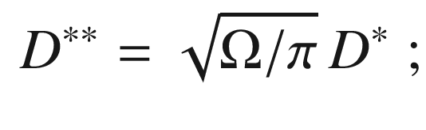

(22.11)

for a Lambertian characteristic

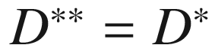

.

#### 22.2.3 Electrophotography

The principle of the Xerox copy machine is based on a photoconductive layer (Fig. [22.5](#u116076_4_En_22_Chapter-Fig5)). This layer is normally insulating such that both sides of the layer can be oppositely charged. If light hits the layer it becomes photoconductive and neutralizes locally. This requires a small lateral diffusion of charge carriers. Initially amorphous selenium (

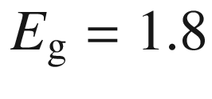

 eV) was used. The conductivity in the dark of a-Se is 10

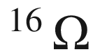

/cm. Se was subsequently replaced by organic material. The highest performance is currently achieved with amorphous silicon.

On the charged areas of the photo-sensitive layer toner can be attached. The toner pattern is subsequently transferred to the copy sheet and fixated. A copy takes typically more than one rotation of the drum. The principle was invented in 1938 by Chester F. Carlson (1906–1968) with sulfur as the photoconductor.[5](#u116076_4_En_22_Chapter-Fn5)

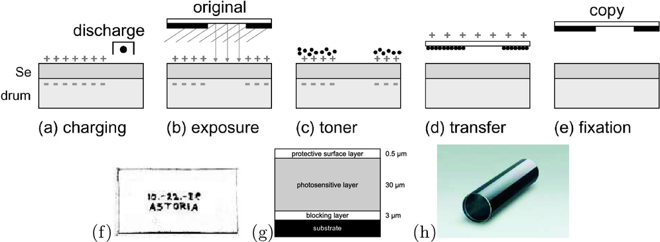

Fig. 22.5

Principle of xerography: **a** charging of the selenium-covered drum, **b** (reflection) exposure of the Se, exposed areas become uncharged, **c** toner addition, **d** toner transfer to paper for copy, and **e** fixation of the toner on the copy and preparation of drum for the next cycle. **f** First xerox copy (Oct. 22nd 1938). **g** Schematic cross section of coating of photo-sensitive drum. The indicated thicknesses are approximate. **h** Image of drum with photo-sensitive layer made from amorphous silicon. Part (**h**) from [1828]

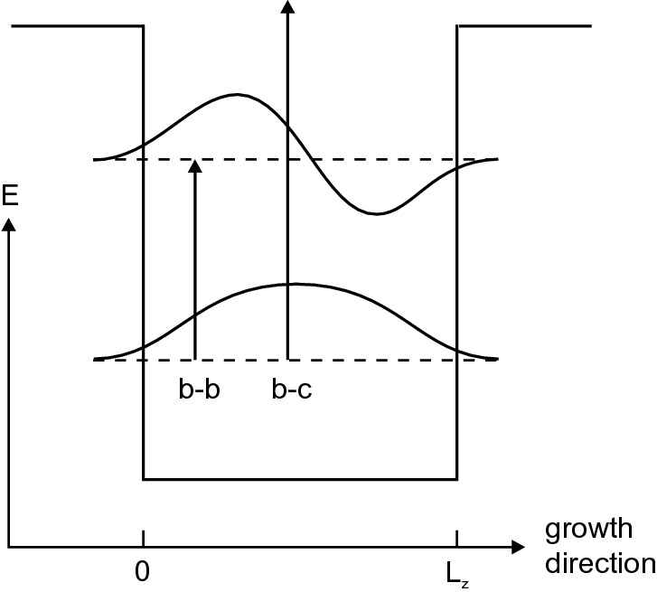

Fig. 22.6

Schematic level diagram of a quantum well. Optical intersubband transitions between the first and second quantized level (b–b) and the ground state and the continuum (b–c)

#### 22.2.4 QWIPs

Quantum-well intersubband photodetectors (QWIPs) are based on the absorption of photons between two quantum well subbands (Fig. [22.6](#u116076_4_En_22_Chapter-Fig6)). A review can be found in [1829]. Quantized electron or hole states can be used. Besides an oscillator strength for this transition, the lower level must be populated and the upper level must be empty in order to allow this process. The Fermi level is typically chosen by appropriate doping such that the lower subband is populated.

For infinite barrier height the energy separation between the first and second quantized levels (in the effective-mass theory) is (cf. ([12.​6](The_Physics_of_Semiconductors00005.docx#u116076_4_En_12_Chapter)))

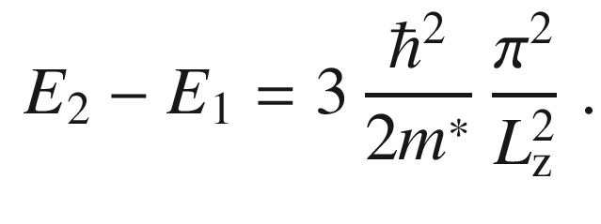

(22.12)

For real materials the barrier height determines the maximum transition energy. Typical absorption and transmission spectra of a QWIP structure are shown in Fig. [22.7](#u116076_4_En_22_Chapter-Fig7). The spectral response is in the mid- or far-infrared.

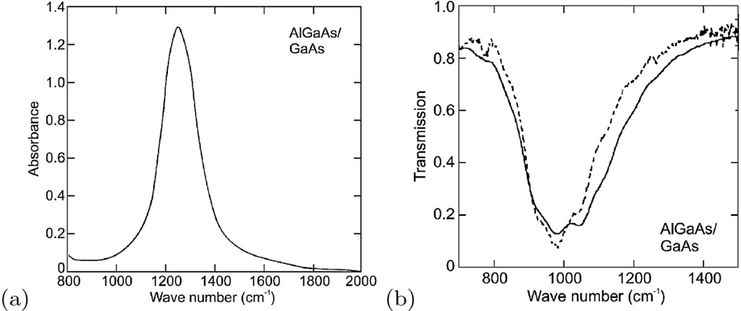

Fig. 22.7

**a** AlGaAs/GaAs QWIP absorption spectrum for multiple reflection geometry. Adapted from [1829]. **b** Transmission of AlGaAs/GaAs QWIP (100 QWs) in double reflection geometry (45

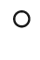

angle of incidence). The well doping is

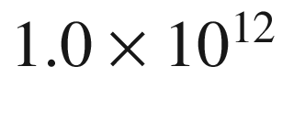

 cm

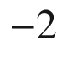

(*dashed line*) and

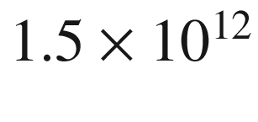

 cm

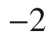

(*solid line*).

Adapted from [1830]

The dipole matrix element

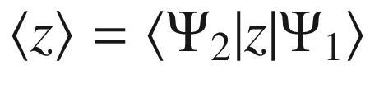

can be easily calculated to be

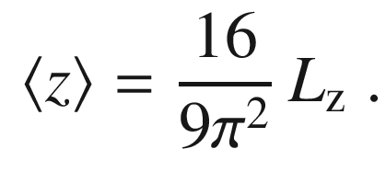

(22.13)

The oscillator strength is about 0.96. The polarization selection rule causes the absorption  to vary

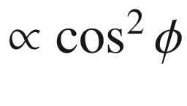

, where

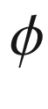

is the angle between the electric-field vector and the *z* direction (Fig. [22.8](#u116076_4_En_22_Chapter-Fig8)). This means that for vertical incidence (

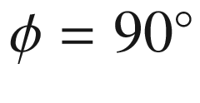

) the absorption vanishes. Thus schemes have been developed to allow for skew entry of the radiation (Fig. [22.9](#u116076_4_En_22_Chapter-Fig9)a). The strict selection rule can be relaxed by using asymmetric potential wells (breaking of mirror symmetry/parity), strained materials (band mixing) or quantum dots (lateral confinement). Also, a grating can be used to create a finite angle of incidence (Fig. [22.9](#u116076_4_En_22_Chapter-Fig9)b).

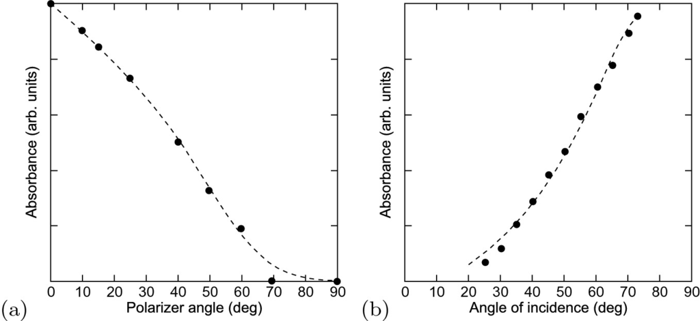

Fig. 22.8

Dependence of the QWIP response on **a** polarization and **b** angle of incidence. *Dashed lines* are guides to the eye.

Adapted from [1829]

Besides a useful detectivity (

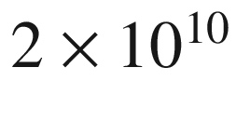

 cm Hz

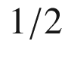

/W at 77 K) QWIPs have the advantage, e.g. against HgCdTe interband absorbers, that the highly developed GaAs planar technology is available for the fabrication of focal plane arrays (FPA) as shown in Fig. [22.10](#u116076_4_En_22_Chapter-Fig10). A FPA is an image sensor (in the focal plane of an imaging infrared optics) and is used, e.g., for the detection of heat leaks in buildings or night surveillance. In particular, night vision support in cars may become a major market. A competing technology are bolometric arrays with thermally insulated pixels based on MEMS technology. A review of FPA technologies can be found in [1831].

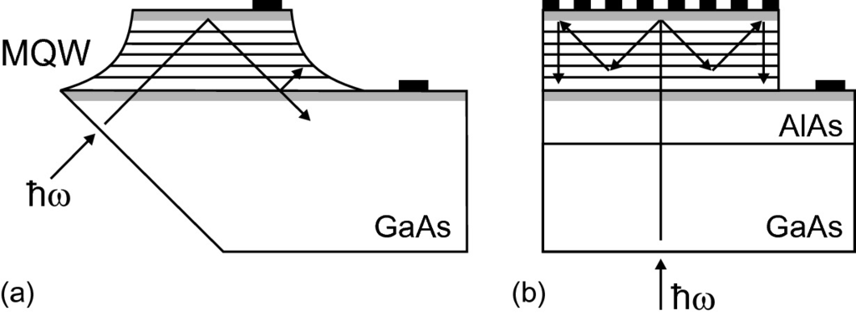

Fig. 22.9

QWIP geometries: **a** 45

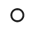

edge coupled with multiple quantum-well (MQW) absorber and **b** grating coupled with GaAs substrate, AlAs reflector and metal grating on top. *Grey areas* are highly n-doped contact layers

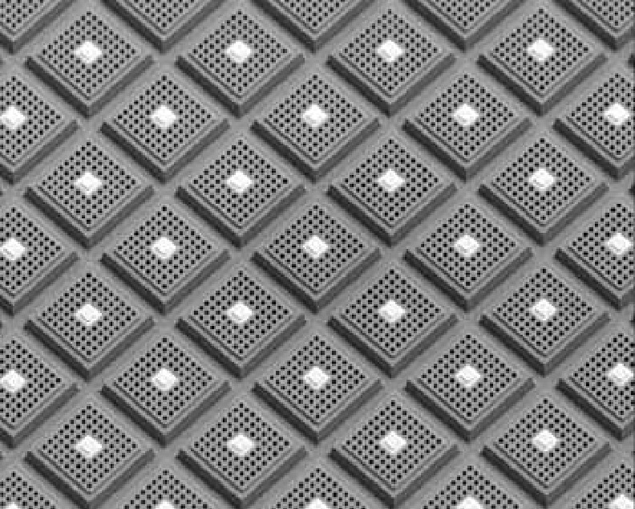

Fig. 22.10

Part of a

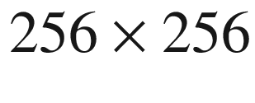

QWIP focal plane array (FPA) with grating coupler (area of one pixel: 37  µ m

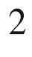

).

From [1832]

The carriers that have been optically excited into the upper state leave the QW by tunneling or thermionic emission. Also, a QWIP can be made based on the direct transfer from the (populated) subband into the continuum.

The incoming infrared radiation creates a photocurrent density of

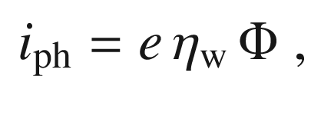

(22.14)

where

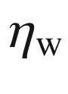

is the quantum efficiency of a single quantum well (including the escape rate) and

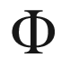

is the photon flux per time and unit area. During the transport of the charge carriers through the barrier they can be (re-)captured by the QW with the probability

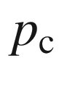

. The capture probability decreases exponentially with the applied bias. The total photocurrent (including generation and recapture) is

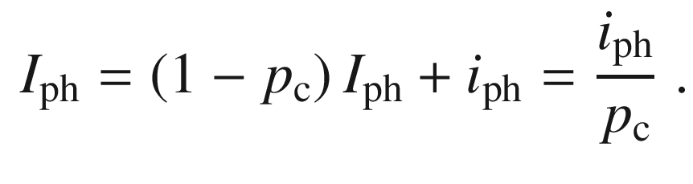

(22.15)

If the quantum efficiency is small, the efficiency of

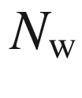

quantum wells

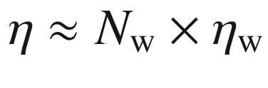

. With this approximation the total photocurrent of

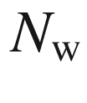

quantum wells is given by

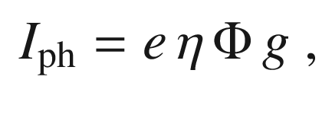

(22.16)

where *g* is termed the gain of the structure and is given by

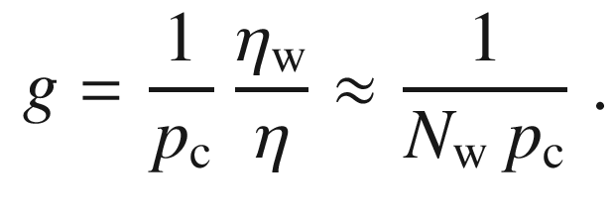

(22.17)

The dark current can be calculated from thermionic emission and agrees fairly well with experiment (Fig. [22.11](#u116076_4_En_22_Chapter-Fig11)a). When the voltage is increased further, avalanche multiplication can occur while the carriers are transported through the barrier(s). This mechanism provides further gain as shown in Fig. [22.11](#u116076_4_En_22_Chapter-Fig11)b.

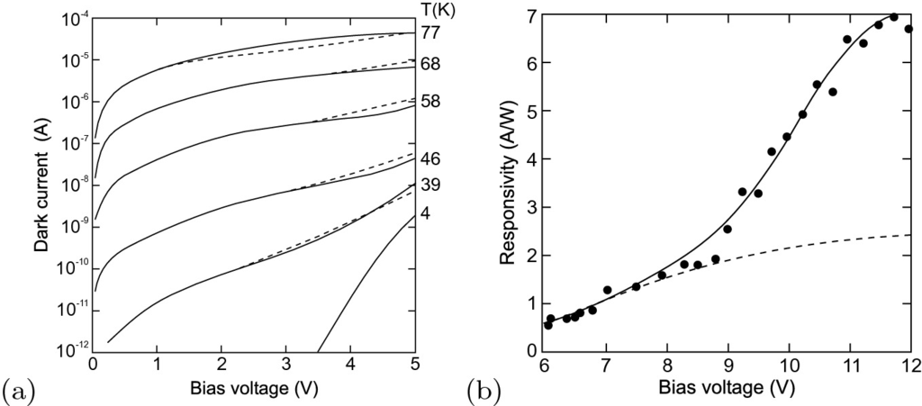

Fig. 22.11

**a** Dark current of a QWIP at 10.7  µ m, experimental (*solid lines*) and theoretical (*dashed lines*) response. **b** QWIP responsivity as a function of the applied voltage. The *solid line* (*dashed line*) is the theoretical dependence with (without) the effect of avalanche multiplication.

Adapted from [1829]

#### 22.2.5 Blocked Impurity-Band Detectors

Impurity absorption allows photoconductivity detectors in the mid- and far-infrared regions to be made. In particular, for THz spectroscopy in medicine and astronomy the extension to longer wavelengths is interesting. For conventional photoconductors the impurity concentration is well below the critical dopant concentration (cf. Sect. [7.​5.​7](The_Physics_of_Semiconductors00003.docx#u116076_4_En_7_Chapter)). Long-wavelength response can be achieved by going to impurity/host systems with smaller ionization energy, such as Si:B (45 meV)

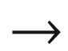

Ge:As (12.7 meV)

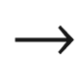

GaAs:Te (5.7 meV). By applying stress to Ge the energy separation between impurity and conduction bands can be lowered and subsequently the detector response is shifted towards longer wavelengths.

For high doping the impurity level broadens to an impurity band and thus allows smaller ionization energy and thus stronger long-wavelength detector response. However, conduction in the impurity band leads to dark current and makes such detectors unfeasible. In a blocked impurity band (BIB) detector [1833–1835] an additional intrinsic blocking layer is sandwiched between the absorption layer and the contact (Fig. [22.12](#u116076_4_En_22_Chapter-Fig12)a). Such a structure is similar to a MIS diode, the insulator being the intrinsic semiconductor. We assume in the following an n-type semiconductor, such as Si:As or GaAs:Te, but also p-type BIBs can be made, e.g., from Ge:Ga.

The semiconductor is highly doped (

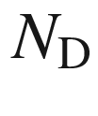

) and partly compensated (

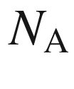

). Typically, the acceptor concentration must be small, about

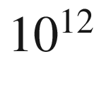

 cm

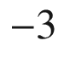

, and controls the formation of the electric field as shown below. The doping is so high that the impurities form an impurity band. Some of the electrons recombine with the acceptors

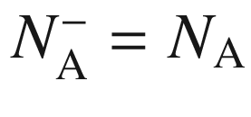

and leave some donors charged

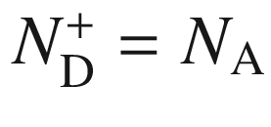

. For GaAs, e.g., the donor concentration in the doped semiconductor is

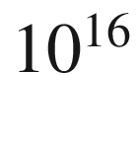

 cm

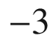

and



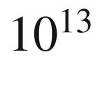

 cm



in the i-layer.

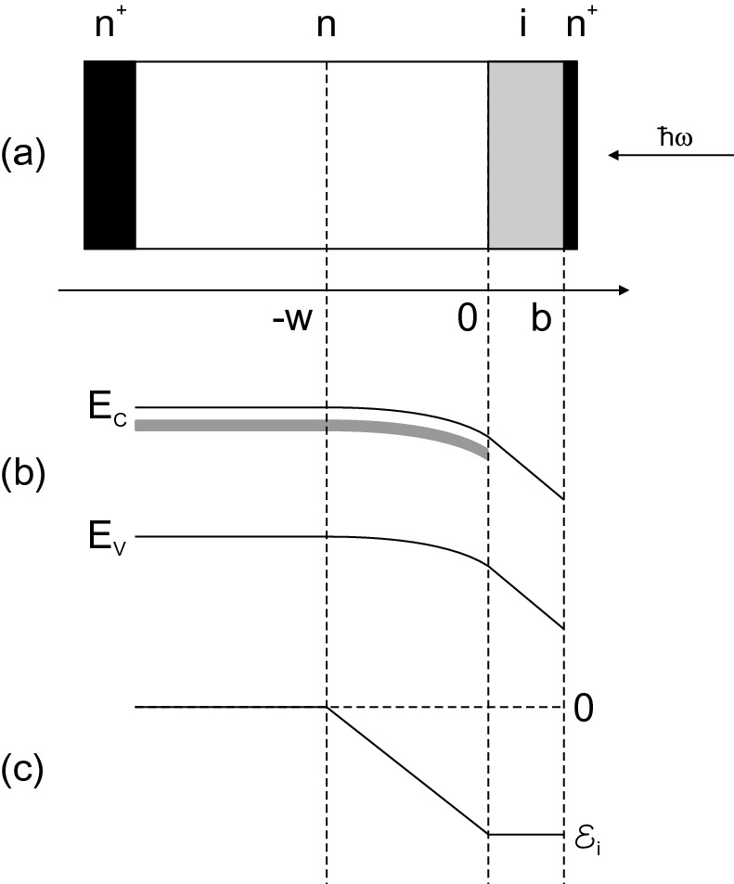

Fig. 22.12

**a** Structure of BIB photodetectors. Highly doped contact layers (*black*), doped semiconductor (*white*) and blocking (intrinsic) layer (*grey*). **b** Band diagram under small forward bias. *Shaded area* represents the donor impurity band. **c** Electric field in the structure

Under an external forward bias *V*, i.e. the positive pole is at the insulator, part of the applied voltage drops over the blocking layer of thickness *b*. If ideally no charges are present here, the electric field is constant. In the n-doped material electrons move in the impurity band towards the insulator, forming neutral donors in an electron accumulation layer of thickness *w* in the presence of the charged acceptors

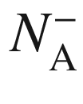

. This layer is the absorption layer. The mechanism can also be considered as if positive charge (the charged donors,

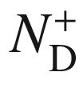

) moves (via hopping conduction) towards the back contact. In the literature the layer close to the insulator is thus also termed a ‘depletion layer’. The band diagram and the electric field are shown in Fig. [22.12](#u116076_4_En_22_Chapter-Fig12)b, c. Due to the blocking layer the carriers on the donors in the n-type material cannot spill via the impurity band into the contact but must be lifted (by photoabsorption) into the conduction band.

From the Poisson equation the electric field is given by

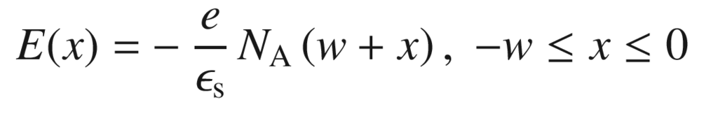

(22.18a)

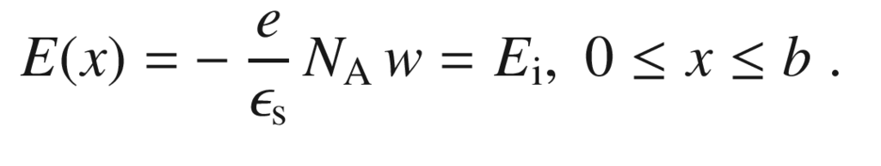

(22.18b)

The voltage drops across the blocking layer

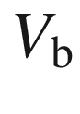

and the doped semiconductor

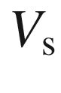

fulfill

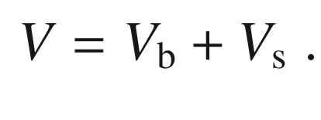

(22.19)

Integration of the fields yields

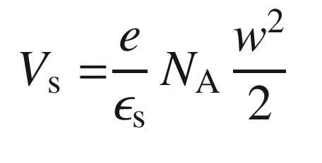

(22.20a)

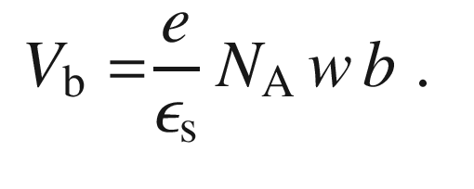

(22.20b)

Substituting ([22.20a](#u116076_4_En_22_Chapter-Equ21),b) into ([22.19](#u116076_4_En_22_Chapter-Equ20)) results in the width of the ‘depletion layer’

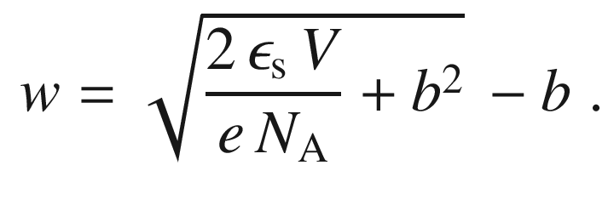

(22.21)

The high dopant concentration allows for much thinner absorption layers than in a conventional photoconductivity detector, making it less susceptible to background high-energy cosmic radiation. The recombination in the depletion layer is negligible. Detector performance is modeled in [1836].

### 22.3 Photodiodes

#### 22.3.1 Introduction

The principle of the photodiode is the interband absorption of light in the depletion layer of a diode (or the i-zone of a pin-diode) and the subsequent separation of electrons and holes by the electric field. There are opposite requirements for fast detectors (thin depletion layer) and efficient detectors (complete light absorption, sufficiently thick depletion layer). For this reason generally semiconductors with high absorption coefficient are most suited (Fig. [22.13](#u116076_4_En_22_Chapter-Fig13)). In Fig. [22.14](#u116076_4_En_22_Chapter-Fig14) the quantum efficiency and detectivity



of various semiconductor detectors are compared.

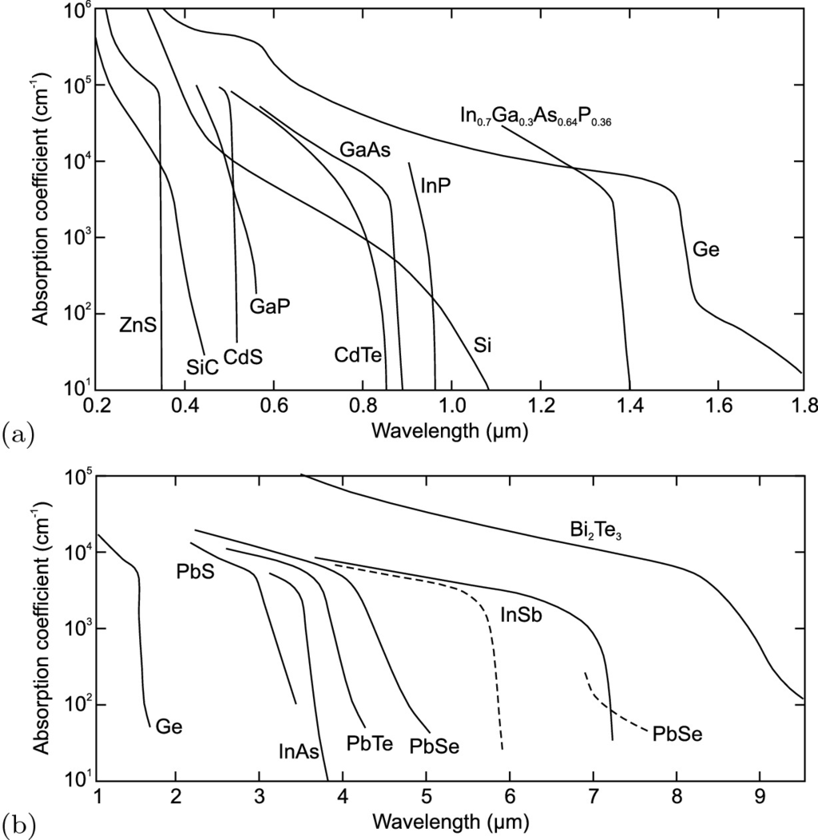

Fig. 22.13

Optical absorption coefficient of various semiconductor materials (as labeled) used for photodetectors **a** in the UV, visible and near-infrared range (at room temperature) and **b** in the mid-infrared spectral range at room temperature (*solid lines*) and at 77 K (*dashed lines*). Based on [1837]

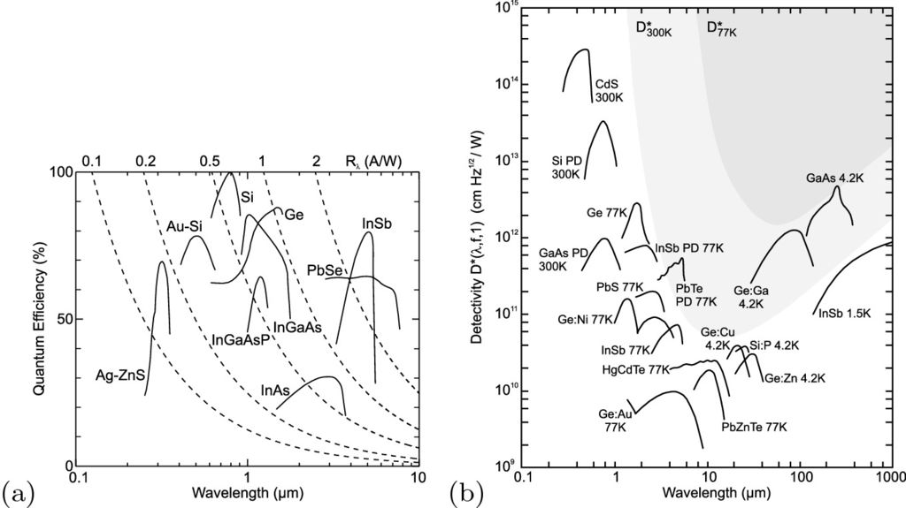

Fig. 22.14

**a** Quantum efficiency of various photodetectors. The *dashed lines* depict lines of equal responsivity (

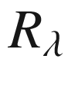

in A/W) as labeled on top of the panel. **b** Detectivity

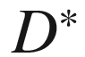

of various photoconductors and photodiodes (PD). The *lighter* (*darker*) *shaded area* indicates the range unachievable at 300 K (77 K) due to background radiation.

Adapted from [574]

A diode can be operated without bias (photovoltaic mode) using the built-in field. An improvement in the speed of a pn-diode is achieved with a reverse bias since it increases the field strength in the depletion layer. However, the reverse bias is below the breakdown voltage. Operation near breakdown is exploited in the avalanche photodiode (APD). In the following we will discuss pn-, pin-, MS- (Schottky-), MSM- and heterostructure-diodes and APDs.

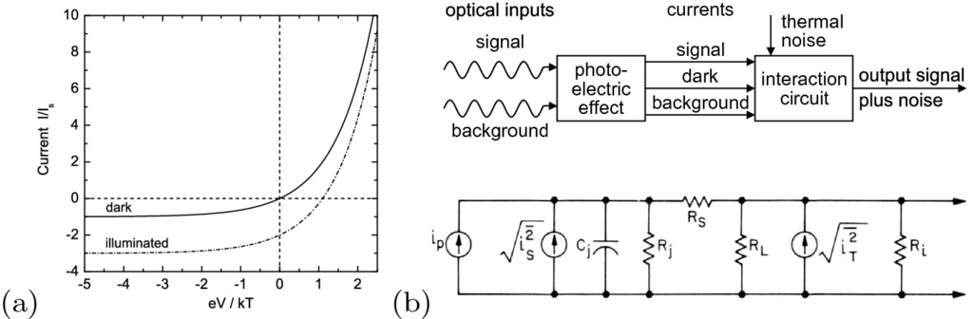

Fig. 22.15

**a** Schematic dark and illuminated *I*–*V*-characteristics of a photodiode (for the case

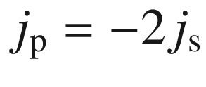

). **b** Schematic representation of currents in a photodiode and equivalent circuit.

Part **b** adapted from [1838]

#### 22.3.2 Pn Photodiodes

The most important figures of merit are the quantum efficiency, responsivity, noise equivalent power (NEP) and the response speed.

If the depletion layer is hit by a photon flux with a generation rate

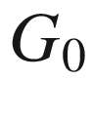

(i.e. electron-hole pairs per unit volume per unit time) the photogenerated current is added to the diffusion current. The photocurrent density

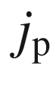

(per unit area) is

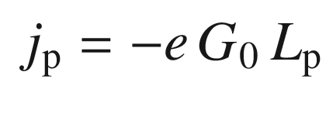

(22.22)

for a p

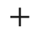

n-diode. In order to obtain this result the diffusion and continuity equations have to be solved for the depletion region.[6](#u116076_4_En_22_Chapter-Fn6) Equation ([22.22](#u116076_4_En_22_Chapter-Equ24)) means that the dark *I*–*V* characteristic is shifted by

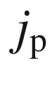

as shown in Fig. [22.15](#u116076_4_En_22_Chapter-Fig15)a. The number of electron-hole pairs that are generated per photon of energy

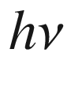

by the absorption of the (monochromatic) light power

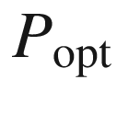

 is

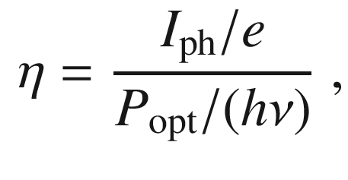

(22.23)

where

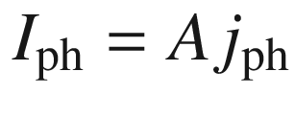

is the photogenerated current over the surface *A*. The *responsivity*



of the photodiode (for monochromatic radiation) is defined as

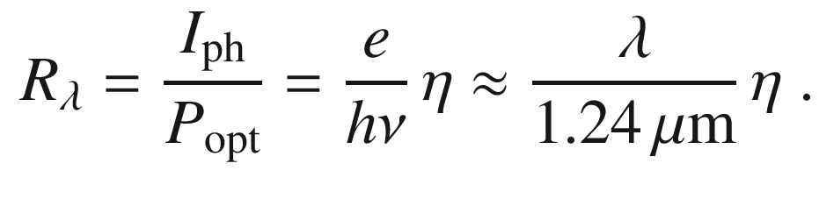

(22.24)

For a modulated light intensity

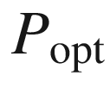

must be replaced by

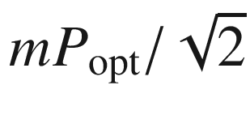

. The equivalent circuit including noise sources for a photodiode is shown in Fig. [22.15](#u116076_4_En_22_Chapter-Fig15)b.

Random processes lead to shot noise

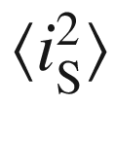

(Sect. K.3.3). Besides the photocurrent

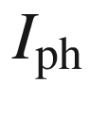

itself, the background radiation (

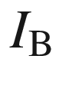

, in particular for infrared detectors) and the thermal generation (dark current,

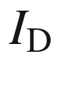

) of carriers contribute:

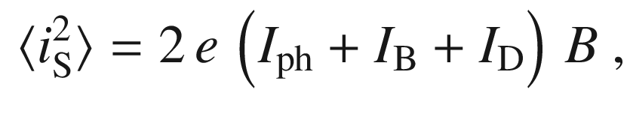

(22.25)

with *B* being the bandwidth. Additionally, the parallel resistances cause thermal noise

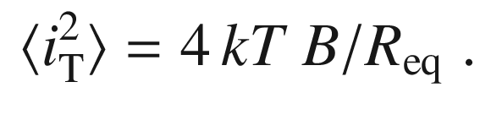

(22.26)

The resistance

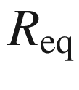

is given by the resistance of the depletion layer (junction)

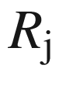

, the load

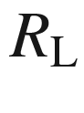

and the input of the amplifier

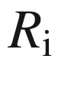

as

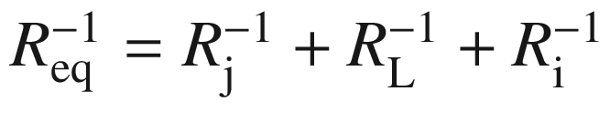

. The series resistance

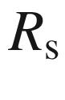

of the photodiode can be usually ignored in this context.

For a fully modulated signal the signal-to-noise ratio of the photodiode is given by

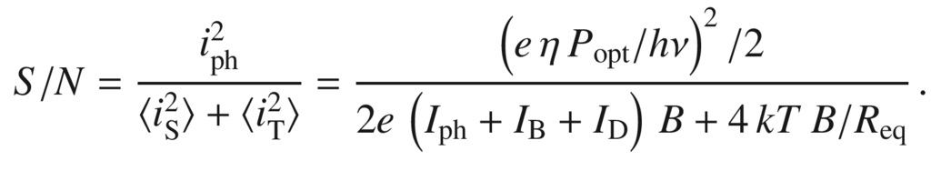

(22.27)

Therefore the NEP is given by

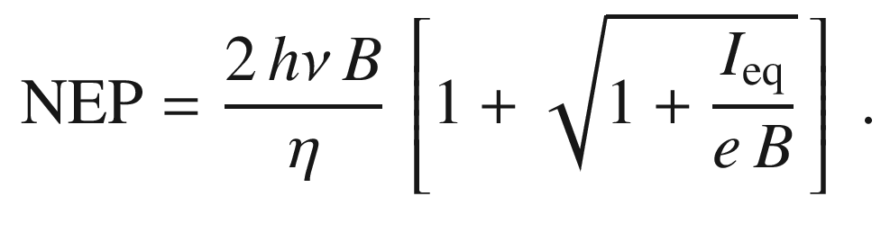

(22.28)

The current

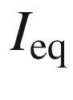

is given by

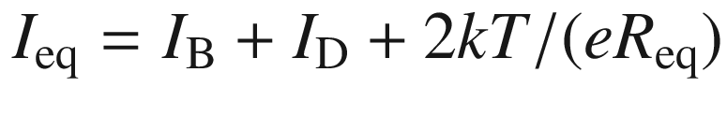

. If

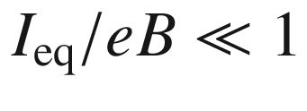

, the NEP is determined by the shot noise of the signal itself. In the other limit

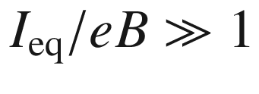

the detection is limited by the background radiation or thermal noise. In this case, the NEP is (for

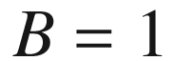

 Hz, in W cm

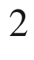

 Hz

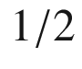

)

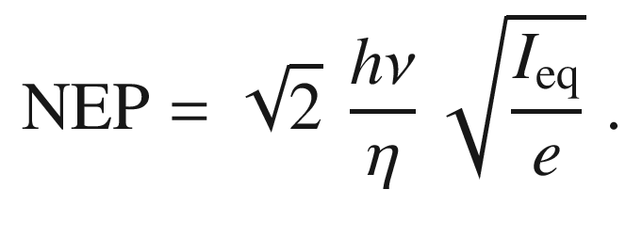

(22.29)

In Fig. [22.16](#u116076_4_En_22_Chapter-Fig16) the situation is shown for a silicon photodiode as a function of

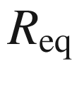

. The diode has a quantum efficiency of 75% at

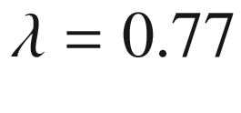

 µm. A high value of

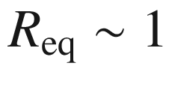

 G

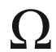

is necessary to ensure detection limited by dark current.

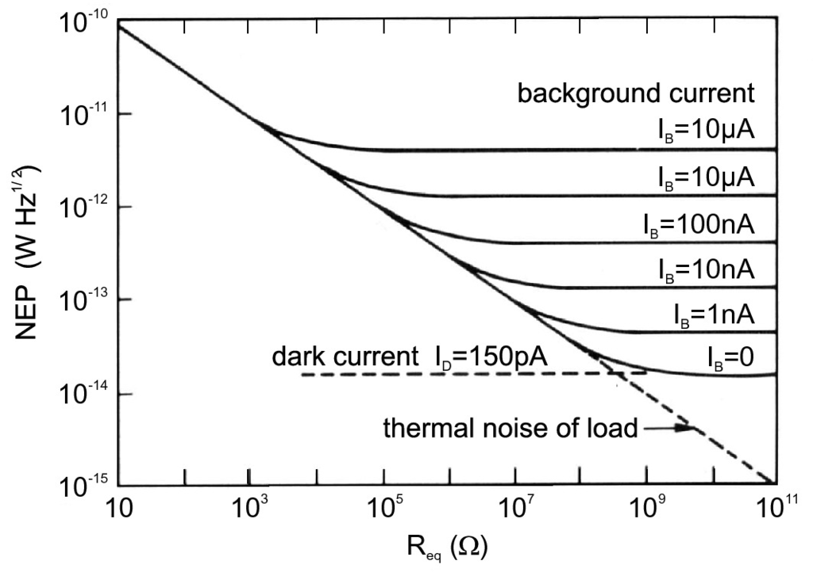

Fig. 22.16

NEP as a function of the resistance

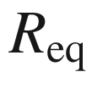

for a Si photodiode.

From [1838]

#### 22.3.3 Pin Photodiodes

The depletion layer in pn-diodes is relatively thin such that the incident light is not completely absorbed. An almost complete absorption of light can be achieved by using a thick intrinsic absorption layer. The field in the intrinsic region is constant or slowly varying linearly (Fig. [21.​72](#u116076_4_En_21_Chapter-Fig72)). The generation rate per unit area decreases exponentially following the Lambert-Beer law ([9.​16](The_Physics_of_Semiconductors00004.docx#u116076_4_En_9_Chapter)) as shown in Fig. [22.17](#u116076_4_En_22_Chapter-Fig17)c:

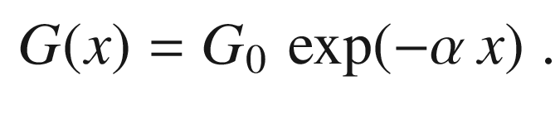

(22.30)

The initial generation rate

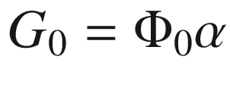

is given by the incident photon flux per unit area

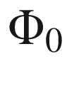

and the reflectance of the surface *R* as

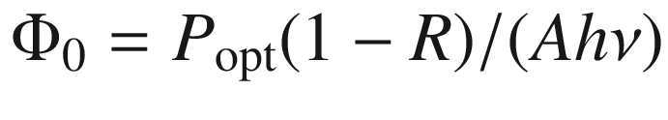

.

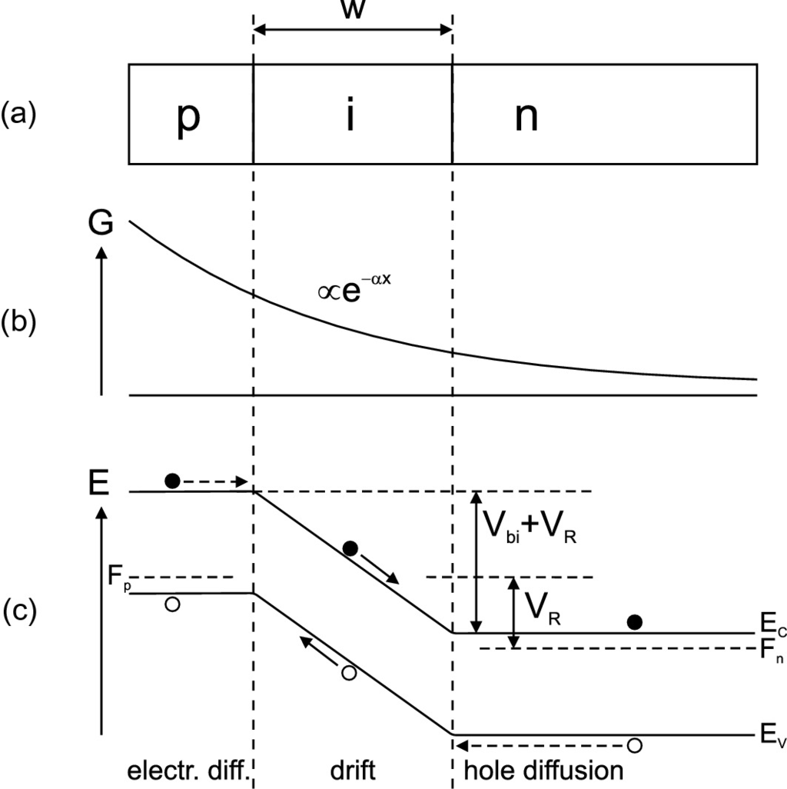

Fig. 22.17

**a** Schematic cross section of pin-diode, **b** profile of carrier generation due to light absorption and **c** schematic band structure under reverse bias. The generation of three electron-hole pairs is shown; subsequent drift (diffusive) transport is indicated with *solid* (*dashed*) *arrows*

The drift current in the i-region collects all those carriers (if recombination in the depletion layer is neglected). The electron drift current is given by

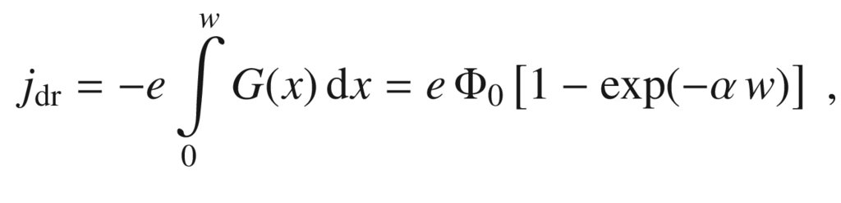

(22.31)

with *w* being the thickness of the depletion layer that is approximately the same as the thickness of the i-region. In the bulk (neutral) region (

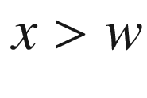

) the minority-carrier density is determined by drift and diffusion[7](#u116076_4_En_22_Chapter-Fn7) ([10.​78](The_Physics_of_Semiconductors00005.docx#u116076_4_En_10_Chapter)). The diffusion current density at

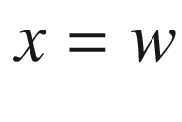

is thus given by

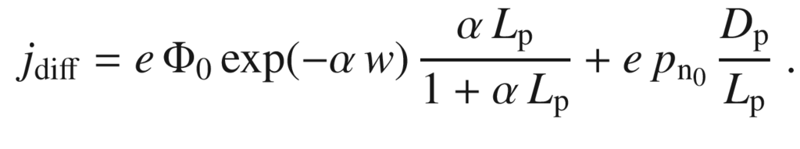

(22.32)

The first term is due to the diffusion current of photo-generated carriers ([10.​78](The_Physics_of_Semiconductors00005.docx#u116076_4_En_10_Chapter)), the second term due to thermally generated carriers ([21.​133](The_Physics_of_Semiconductors00007.docx#u116076_4_En_21_Chapter)). The total current

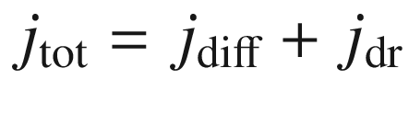

is given by

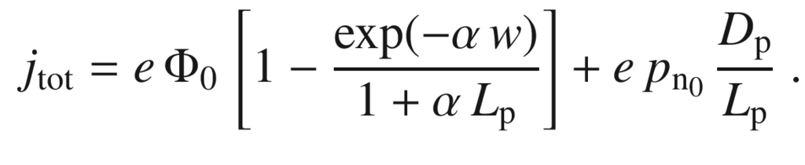

(22.33)

The first term is due to the photocurrent, the second term is due to the diffusion current known from the p



n-diode. In normal operation, the second can be neglected compared to the first. The quantum efficiency is

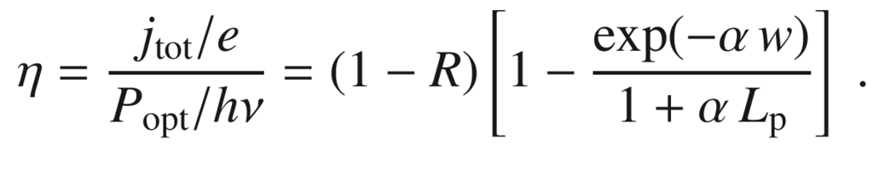

(22.34)

For a high quantum efficiency, of course low reflectance and high absorption coefficient, i.e.

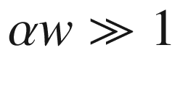

, are necessary.

However, for

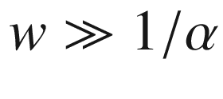

the transit time through the depletion layer

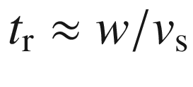

(at sufficiently high field,

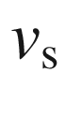

being the drift-saturation velocity) increases too much. The 3 dB cutoff frequency

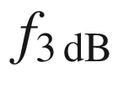

(Fig. [22.18](#u116076_4_En_22_Chapter-Fig18)) is

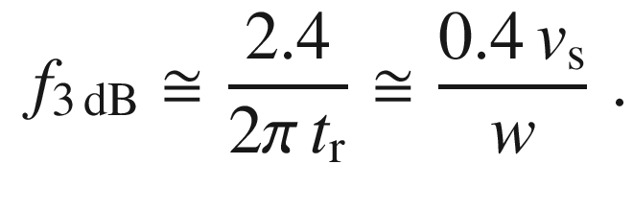

(22.35)

Therefore a tradeoff exists between the quantum efficiency and the response speed of the pin-photodiode (Fig. [22.18](#u116076_4_En_22_Chapter-Fig18)). Choosing

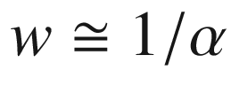

is a good compromise.

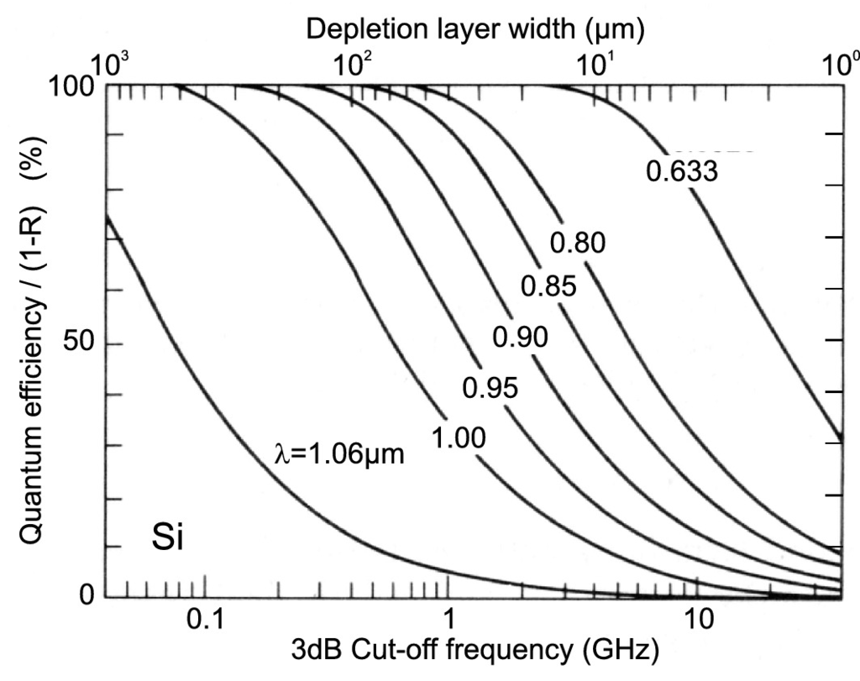

Fig. 22.18

Quantum efficiency and 3 dB cutoff frequency of a Si pin-diode at

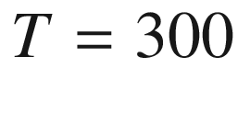

 K for various wavelengths of input radiation.

Adapted from [1838]

#### 22.3.4 Position-Sensing Detector

In a position-sensing detector (PSD) two electrodes are placed at opposite edges of a photodetector. The current output depends linearly on the beam position in between the electrodes, similar to a voltage divider. If two pairs of electrodes, one on the front and one on the back of the detector, are fabricated in orthogonal directions (Fig. [22.19](#u116076_4_En_22_Chapter-Fig19)a), the beam position can be measured in both *x* and *y* directions.

#### 22.3.5 MSM Photodiodes

A MSM photodiode consists of a piece of semiconductor between two Schottky contacts (MS contacts). These are typically arranged laterally (as shown in Fig. [22.24](#u116076_4_En_22_Chapter-Fig24)b) but will first be considered at the front and back of the semiconductor [1840]. The band structure in thermodynamic equilibrium is shown in Fig. [22.20](#u116076_4_En_22_Chapter-Fig20).

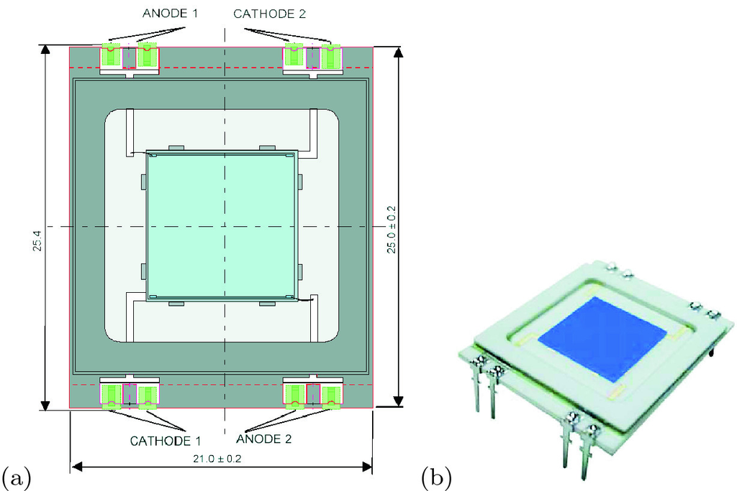

Fig. 22.19

**a** Scheme of two-dimensional position-sensing detector (PSD), **b** image of PSD.

From [1839]

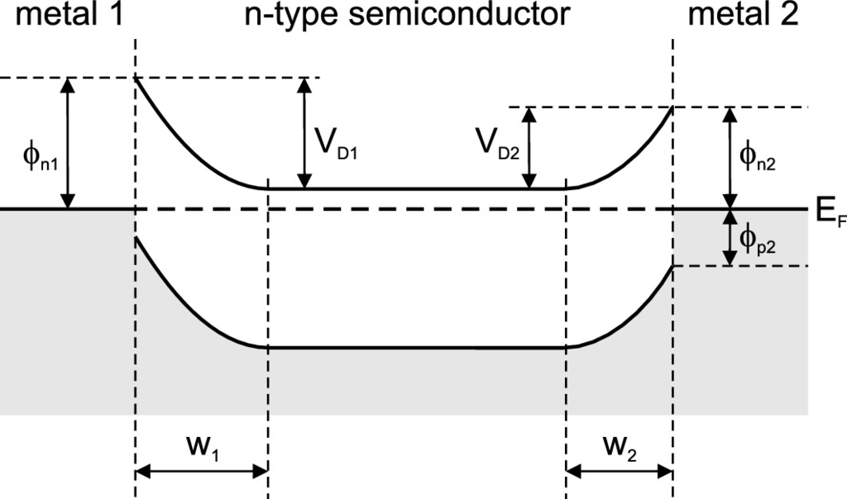

Fig. 22.20

Band diagram of a MSM structure with an n-type semiconductor in thermal equilibrium. In the general case, two different metals cause two different Schottky barrier heights and related depletion layer widths.

Adapted from [1840]

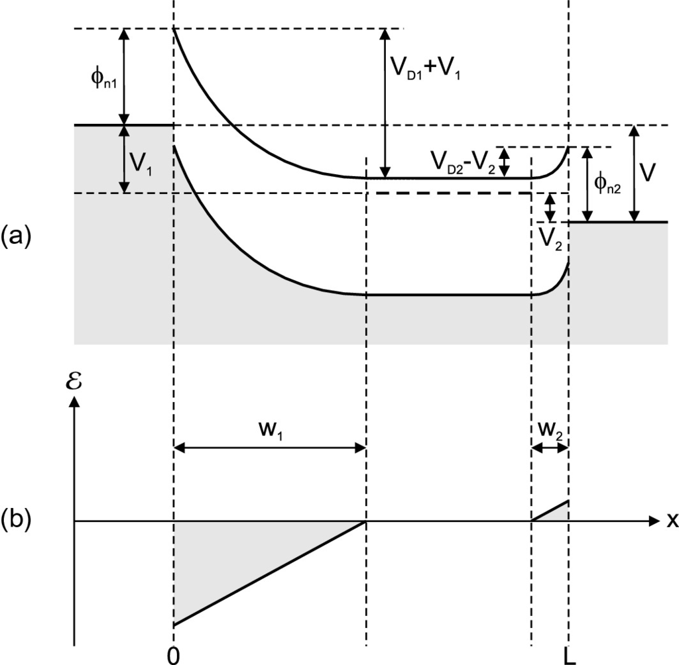

Fig. 22.21

**a** Band diagram for a MSM structure under bias (

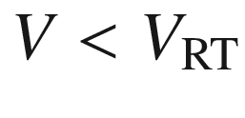

), **b** electric field distribution.

Adapted from [1840]

In the general case two different metals with two different barriers

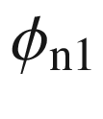

,

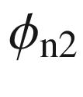

and built-in voltage

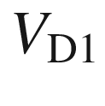

,

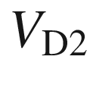

are considered. If a voltage is applied across the MSM diode, one of the junctions is biased in the forward, the other in the reverse direction. We assume in Fig. [22.21](#u116076_4_En_22_Chapter-Fig21) that the voltage biases the first contact in the reverse direction, i.e. the ‘+’ pole is on the left contact. The applied voltage *V* is split between the two contacts, the larger voltage will drop at the reverse-biased contact (here:

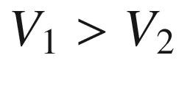

)

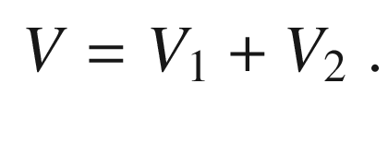

(22.36)

The electron current arises from thermionic emission at contact 2. Due to current continuity (without recombination since we inject majority charge carriers) this is also the current through contact 1, i.e.

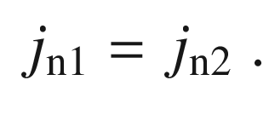

(22.37)

The reverse current at contact 1 is



(22.38)

where

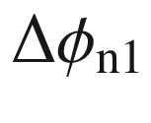

is the barrier reduction due to the Schottky effect (Sect. [21.​2.​3](The_Physics_of_Semiconductors00007.docx#u116076_4_En_21_Chapter) and ([21.​27](The_Physics_of_Semiconductors00007.docx#u116076_4_En_21_Chapter))). The forward current at contact 2 is



(22.39)

For a symmetric structure, i.e.

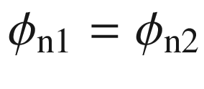

and

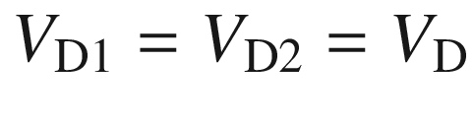

, ([22.37](#u116076_4_En_22_Chapter-Equ39))–([22.39](#u116076_4_En_22_Chapter-Equ41)) yield together with ([21.​27](The_Physics_of_Semiconductors00007.docx#u116076_4_En_21_Chapter))

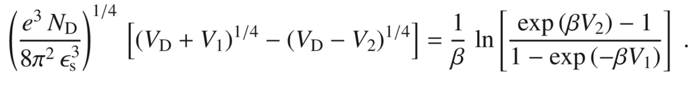

(22.40)

Together with ([22.36](#u116076_4_En_22_Chapter-Equ38)) a numerical or graphical solution can be found. Initially (for small voltages) the injected hole current (from contact 2) is much smaller than the electron current and diffusion occurs in the neutral region.

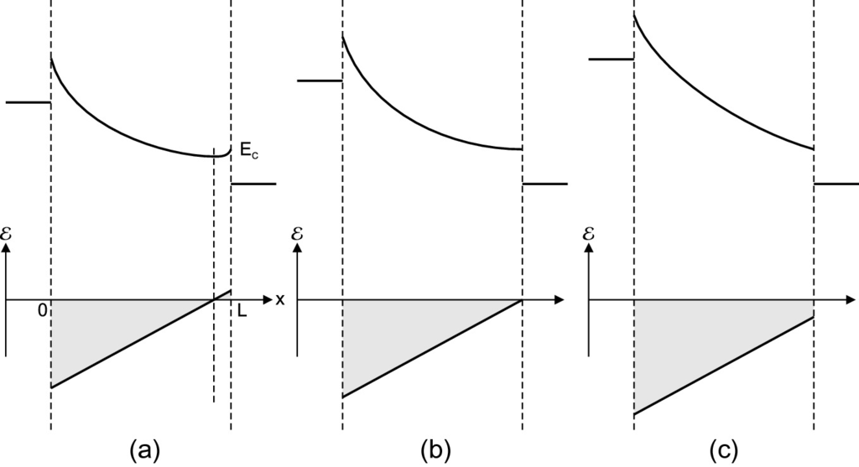

Fig. 22.22

Band diagram (*upper parts*) and electric field distribution (*lower parts*) in a MSM diode for various bias conditions: **a** at reach-through voltage

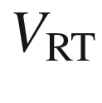

, **b** at flat-band voltage

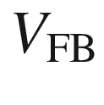

and **c** for

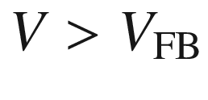

.

Adapted from [1840]

The reach-through voltage

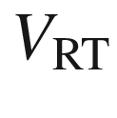

is reached when the width of the neutral region is reduced to zero (Fig. [22.22](#u116076_4_En_22_Chapter-Fig22)a). At the juncture of the two depletion regions inside the semiconductor material the electric field is zero and changes sign. For a larger voltage

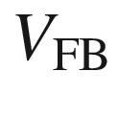

flat-band conditions are present at contact 2, i.e. the electric field is zero at contact 2 (Fig. [22.22](#u116076_4_En_22_Chapter-Fig22)b). At even larger voltage

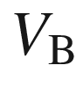

breakdown occurs.

At

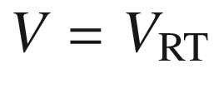

we have

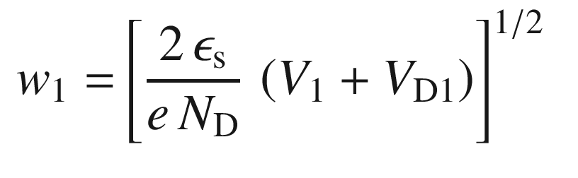

(22.41a)

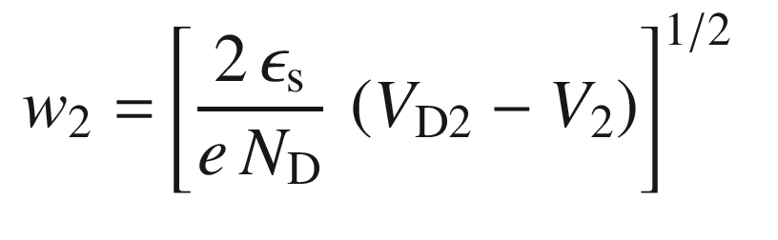

(22.41b)

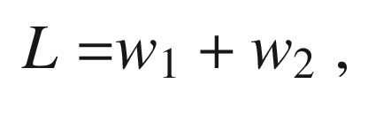

(22.41c)

and therefore (with ([22.36](#u116076_4_En_22_Chapter-Equ38)))

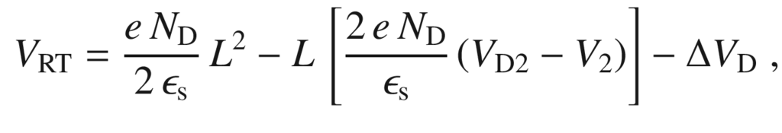

(22.42)

with

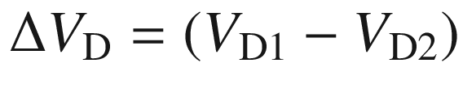

, vanishing for a symmetric MSM structure. At and after reach-through the electric field varies linearly from 0 to *L* within the semiconductor. The point of zero electric field shifts towards contact 2. At the flat-band voltage this point has reached the contact 2 and the width of the depletion layer at contact 2 is zero. This condition leads (as long as no breakdown occurred) to

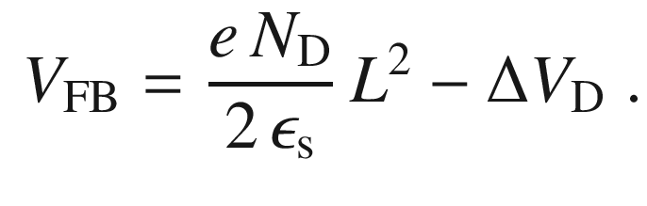

(22.43)

The maximum electric field is at contact 1 and is given (for

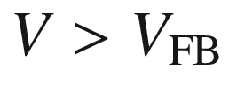

) by

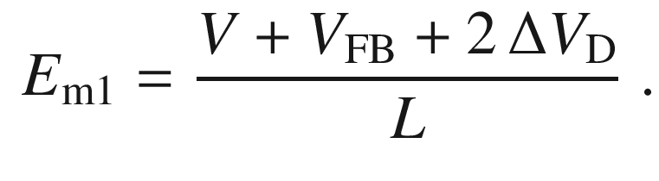

(22.44)

If in a part of the structure the critical field

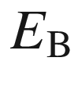

for impact ionization is reached (this will be at contact 1, since the field is highest there), the diode breaks down. Therefore the breakdown voltage is given by

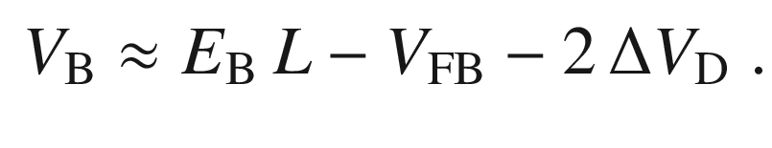

(22.45)

The current-voltage characteristic for a Si-MSM structure is shown in Fig. [22.23](#u116076_4_En_22_Chapter-Fig23). At small voltages only small currents flow since one contact is in reverse bias. The hole current is much smaller than the electron current. Only those holes that diffuse through the neutral region contribute to the hole current. After reach-through the barrier

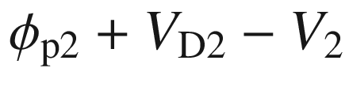

for hole injection is strongly reduced that leads to strong hole injection. Beyond the flat-band voltage the hole current increases only weakly since a lowering of the barrier occurs only via the Schottky effect. For high fields (

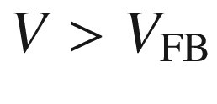

, before breakdown) the hole current is

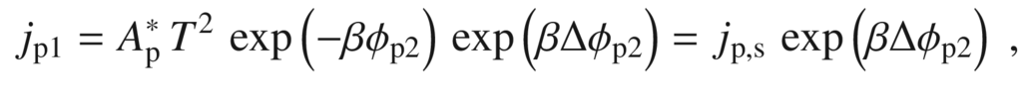

(22.46)

and the total current is

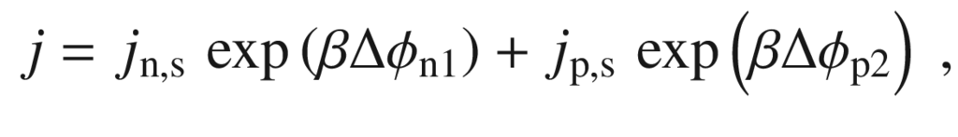

(22.47)

with

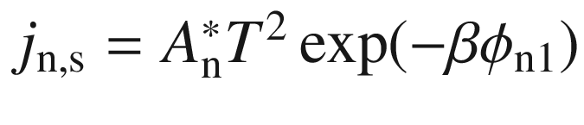

and

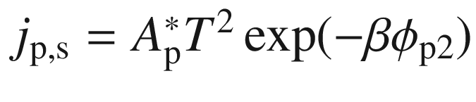

.

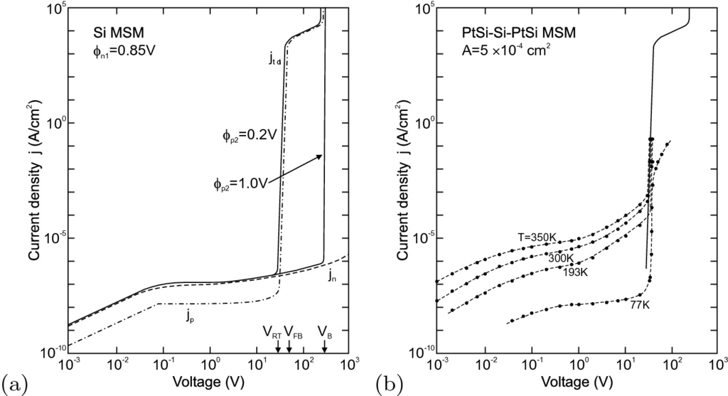

Fig. 22.23

Current-voltage characteristics of a Si MSM structure,

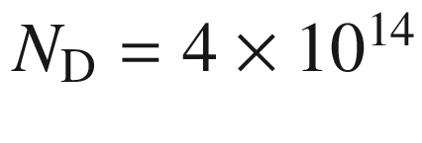

 cm

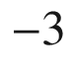

,

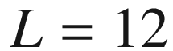

  µ m (thin, polished,

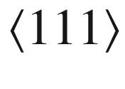

-oriented wafer),

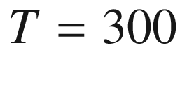

 K. **a** Theory for two different values of

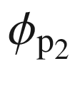

, **b** experiment (for

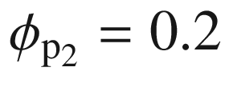

 V).

Adapted from [1840]

In a MSM photodetector the metal contacts are typically formed in an interdigitated structure on the semiconductor surface (Fig. [22.24](#u116076_4_En_22_Chapter-Fig24)). These contacts shield some of the active area from photons. An increase in quantum efficiency can be achieved with transparent contacts (e.g. ZnO or ITO) and an antireflection (AR) coating.

The dark current is given by ([22.47](#u116076_4_En_22_Chapter-Equ51)) and is minimal when electron and hole saturation currents are identical. This conditions leads to the optimal barrier height

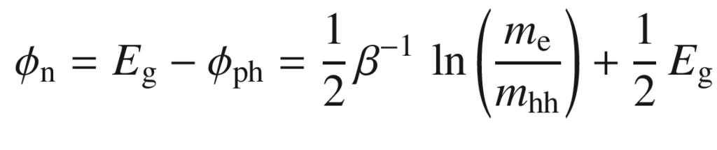

(22.48)

close to middle of the band gap. For InP and optimal barrier

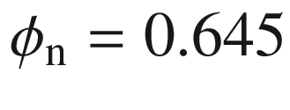

 eV a dark current of 0.36 pA/cm

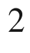

is expected for a field of 10 V/ µ m. For deviating barrier height the current increases exponentially. The current-voltage characteristic of an InGaAs:Fe MSM photodetector is shown in Fig. [22.25](#u116076_4_En_22_Chapter-Fig25) for a dark environment and various illumination levels.

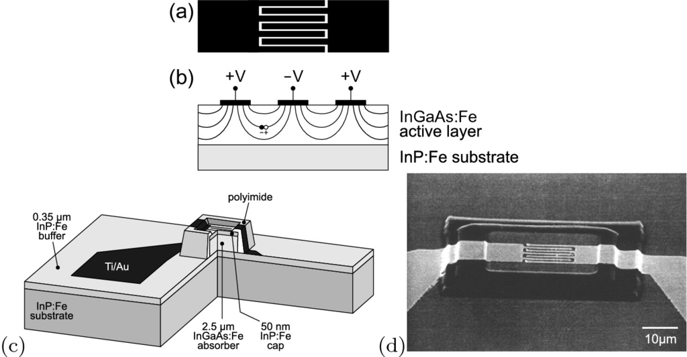

Fig. 22.24

Scheme of MSM photodetector with interdigital contacts in **a** plan view and **b** cross section. In part (**b**), the electric field lines are shown schematically together with an electron-hole pair ready to be separated. **c** Scheme of a MSM mesa structure, **d** SEM image of an InGaAs/InP MSM mesa photodetector. Parts **c** and **d** adapted from [1841]

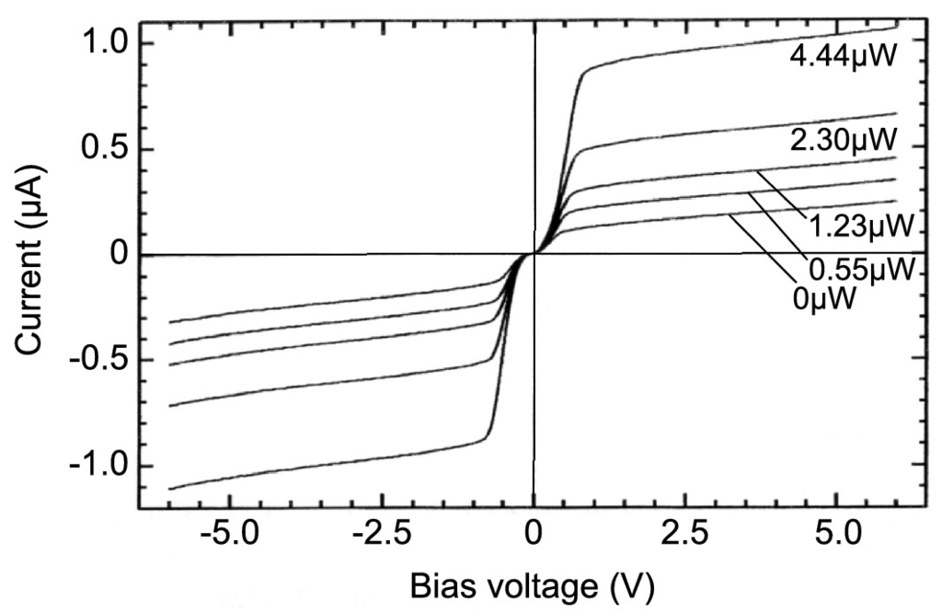

Fig. 22.25

dc *I*–*V* characteristic of an InGaAs/InP MSM photodetector (InP:Fe/InGaAs:Fe/InP:Fe, finger separation 1  µ m,

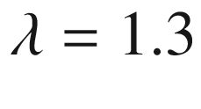

  µ m) under illumination for dark environment (0  µ W) and various illumination levels as labeled.

Adapted from [1841]

The time-dependent response of a MSM photodetector depends on the drift time of the carriers, i.e. the time that a created electron and hole need to arrive at their respective contacts. In Fig. [22.26](#u116076_4_En_22_Chapter-Fig26) a simulation is shown for a MSM detector. The current has two components, a fast one due to the electrons and a slow one due to the holes that have the lower mobility and smaller drift saturation velocity. A similar dependence is found in experiment (Fig. [22.27](#u116076_4_En_22_Chapter-Fig27)a). For longer wavelengths the detector is slower since they penetrate deeper into the material and thus the charge carriers have a longer path to the contacts (cf. scheme in Fig. [22.24](#u116076_4_En_22_Chapter-Fig24)b). An important role is played by the finger separation; smaller finger separation ensures a more rapid carrier collection (Fig. [22.27](#u116076_4_En_22_Chapter-Fig27)b). In [1842] a bandwidth of 300 GHz was demonstrated for 100 nm/100 nm finger width and separation for LT-GaAs[8](#u116076_4_En_22_Chapter-Fn8) and bulk GaAs, limited by the *RC* time constant. For 300 nm/300 nm fingers and a LT-GaAs a bandwidth of 510 GHz (pulsewidth of 0.87 ps) was reported, which is faster than the intrinsic transit time (1.1 ps) and not limited by the *RC* time constant (expected pulse width 0.52 ps), due to the recombination time (estimated to be 0.2 ps).

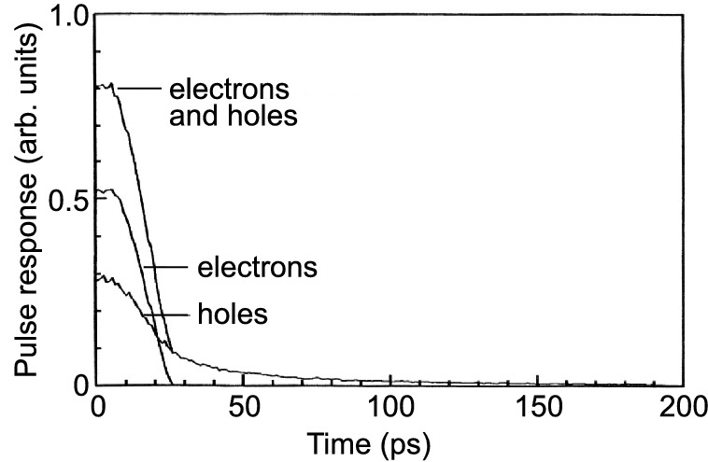

Fig. 22.26

Simulation of the time-dependent response of an InGaAs:Fe MSM photodetector to a short light pulse.

Adapted from [1841]

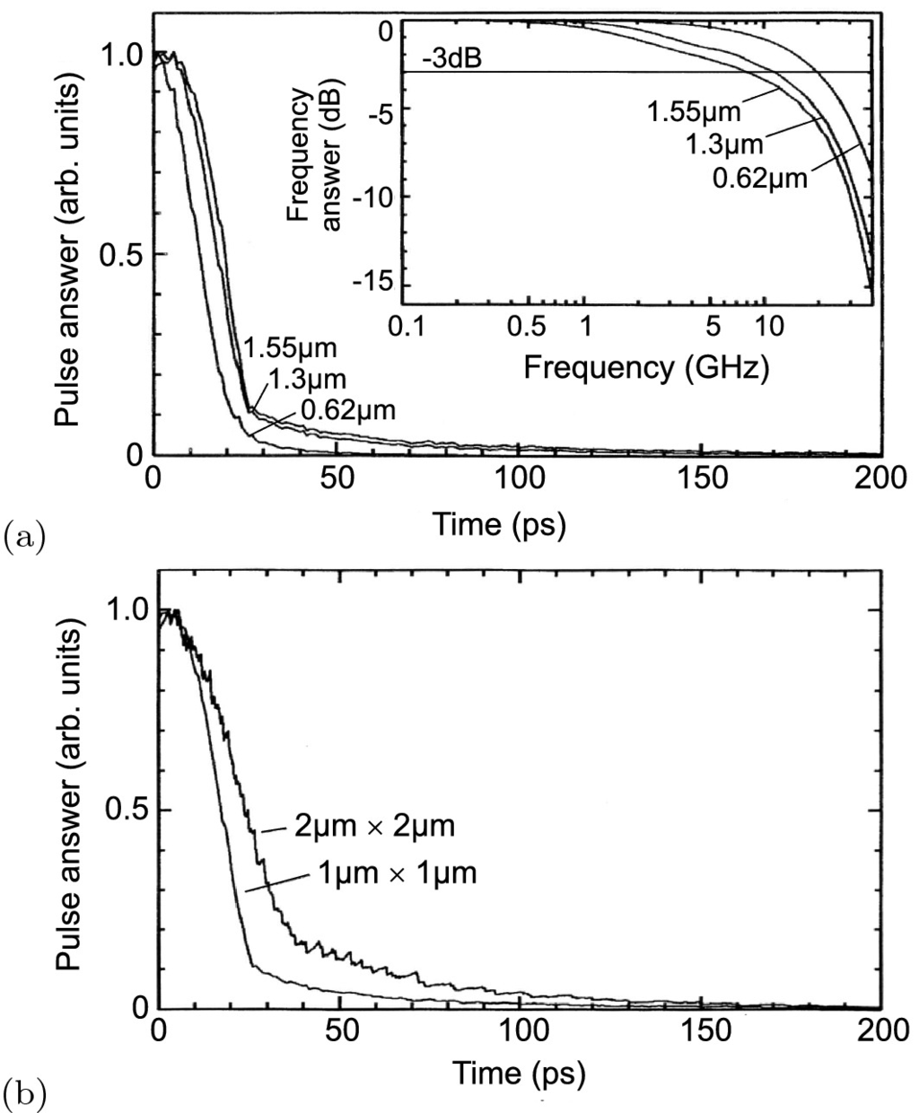

Fig. 22.27

**a** Experimental time-dependent response of an InGaAs:Fe MSM photodetector to a short light pulse for three different wavelengths, *inset* shows the frequency response from a Fourier transform. **b** Response of the MSM for two different finger widths and separations (both 1 or 2  µ m, respectively), InGaAs layer thickness 2  µ m,

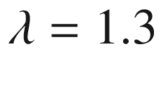

  µ m and bias voltage 10 V.

Adapted from [1841]

#### 22.3.6 Avalanche Photodiodes

In an avalanche photodiode (APD) intrinsic amplification due to carrier multiplication (through impact ionization) in a region with high electric field is used to increase the photocurrent. The field is generated by a high reverse bias in the diode. In an ideal APD only one type of carrier is multiplied, resulting in the lowest noise. If electrons are injected into the field region at

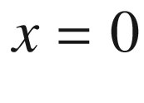

(Fig. [22.28](#u116076_4_En_22_Chapter-Fig28)a), the multiplication factor for electrons is

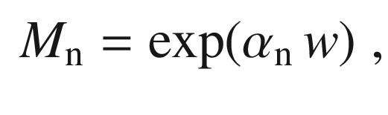

(22.49)

for

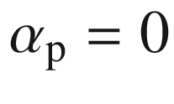

. Typically, both carrier types suffer multiplication. If the electron and hole impact ionization coefficients are the same (

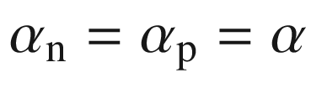

), the multiplication factor for electrons and holes *M* is given by

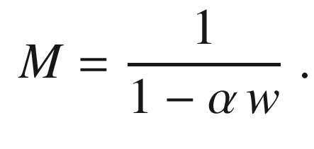

(22.50)

The rms value of the current noise is the same as in the case of the pn-diode ([22.25](#u116076_4_En_22_Chapter-Equ27)), only that now the gain *M* is added

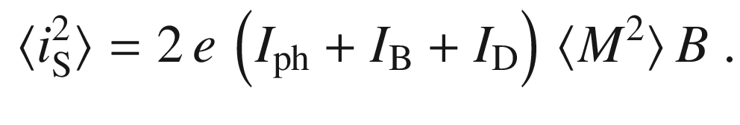

(22.51)

The term

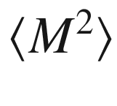

is written as

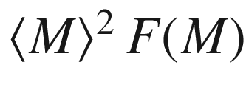

with

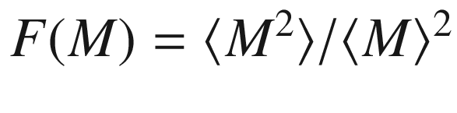

being the excess noise factor that describes the additional noise introduced by the random nature of the impact ionization. For multiplication started with electron injection, it is given by [1843]

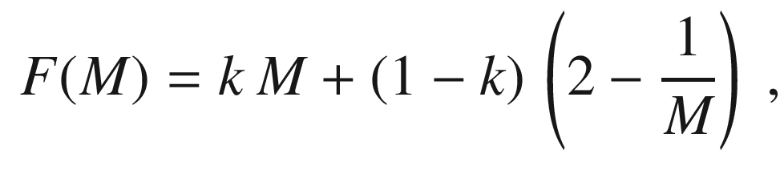

(22.52)

with

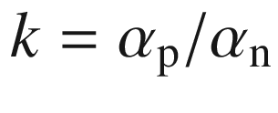

. For hole injection starting the multiplication ([22.52](#u116076_4_En_22_Chapter-Equ56)) holds with *k* substituted by

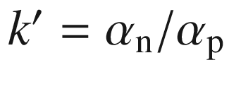

. In Fig. [22.29](#u116076_4_En_22_Chapter-Fig29)a the excess noise factor is shown vs. the average multiplication for various values of *k* and

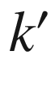

.

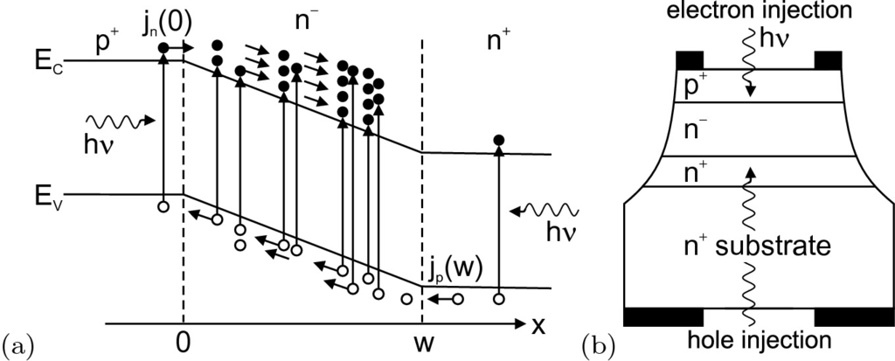

Fig. 22.28

Schematic band structure **a** and schematic device setup **b** of an avalanche photodiode (APD).

From [1185]

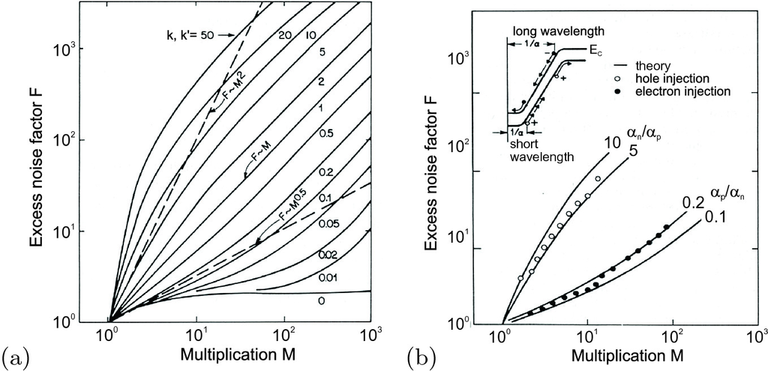

Fig. 22.29

**a** Excess noise factor for various values of the ratio of ionization coefficients *k* or

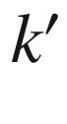

. Adapted from [1843]. **b** Experimental results for *F* for a Si APD with 0.1  µ A primary current. The *empty* (*full*) symbols are for short (long) wavelengths [primary hole (electron) current]. The *inset* shows the schematic band diagram of the np-diode under reverse bias.

Adapted from [1844]

Experimental data are shown in Fig. [22.29](#u116076_4_En_22_Chapter-Fig29)b for a Si APD. For short wavelengths absorption is preferential at the surface (n-region) and we have the case of hole injection. The data for the excess noise factor are fairly well fit with

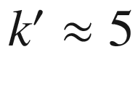

. For longer wavelengths, the data for electron injection are fit by

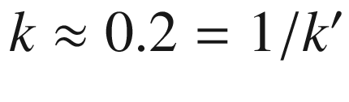

.

For a fully modulated signal the signal-to-noise ratio is given by

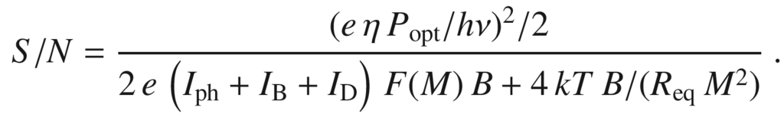

(22.53)

If *S*/*N* is limited by thermal noise, the APD concept leads to a drastic improvement of noise.

The APD can used for single photon detection; then the variation in pulse height (with reasonable limits) plays no role for the count rate. The number of dark counts can be reduced by cooling the APD. Using constant fraction triggering, also the arrival time of the photon can be determined, allowing time resolution typically in the 100 ps regime.

A particular APD structure is known as a *solid-state multiplier*. It has separate absorption and amplification regions (SAM structure). In the low-field region the light is absorbed. One type of carrier is transported with the drift field

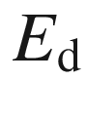

to the multiplication region in which a large field

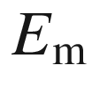

is present and multiplication occurs. In Fig. [22.30](#u116076_4_En_22_Chapter-Fig30)a a homo-APD with SAM structure is shown. Regions with different electric field are created by a special doping profile.[9](#u116076_4_En_22_Chapter-Fn9) A

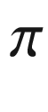

-p-

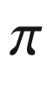

structure leads to regions with homogeneous low and high field strengths.

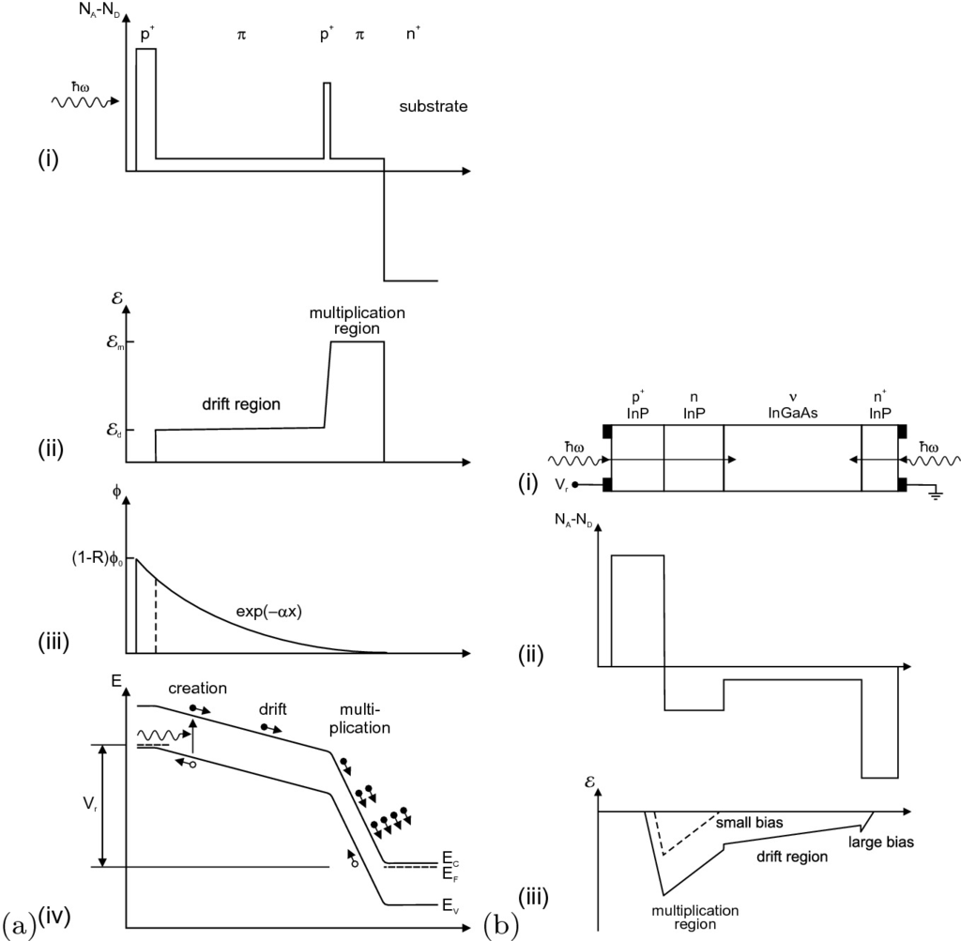

Fig. 22.30

**a** Homo-APD with SAM structure. (**i**) doping profile, (**ii**) electric field, (**iii**) photon flux or electron-hole pair generation rate and (**iv**) schematic band diagram under reverse voltage

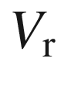

with charge-carrier transport. The multiplication is for

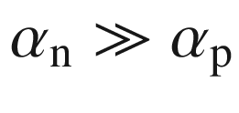

. Adapted from [574]. **b** (**i**) Scheme of an InP/InGaAs hetero-APD with SAM structure, (**ii**) doping profile and (**iii**) electric field for small (*dashed line*) and large (*solid line*) reverse bias



.

Adapted from [1185]

The performance of a commercial silicon APD is depicted in Fig. [22.31](#u116076_4_En_22_Chapter-Fig31). With increasing reverse bias, both the dark current and the multiplication factor increase. Before breakdown at about 77 V, the best ratio of *M* and

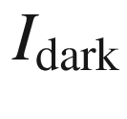

is found. This particular diode has a typical excess noise factor of

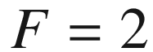

for

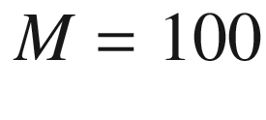

. Using ([22.52](#u116076_4_En_22_Chapter-Equ56)), this shows that only one kind of carriers is multiplied.

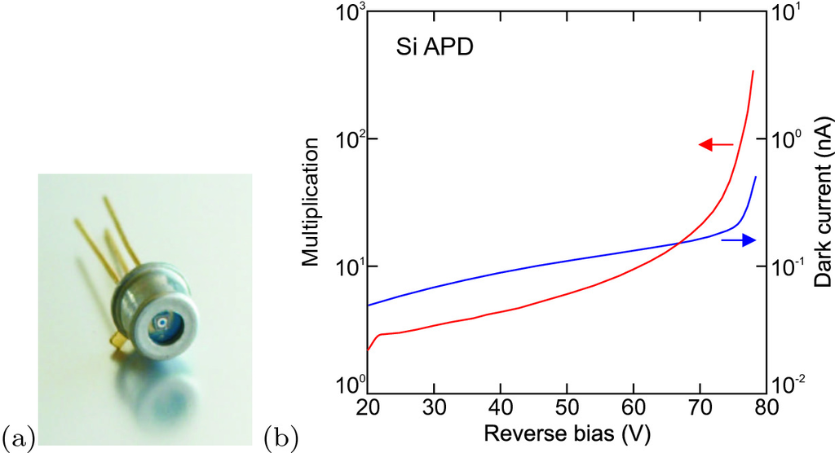

Fig. 22.31

**a** TO casing of Si APD. **b** Dark current (*blue*) (active area 0.2 mm

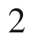

) and multiplication factor (*red*) as a function of reverse bias (at 23

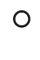

C).

Adapted from [1845]

In the case of a heterostructure-APD with SAM structure (Fig. [22.30](#u116076_4_En_22_Chapter-Fig30)b) absorption (of light with sufficiently long wavelength with an energy smaller the the InP band gap) takes place only in the InGaAs layer. Since no light is absorbed in the multiplication region, the device functions similarly for front and back illumination. In [1846] a multi-stage InGaAs-based APD on InP is described that is optimized for electron multiplication in ten subsequent gain sections; a total gain of

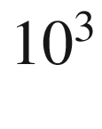

is achieved with an excess noise factor *F* of about 40, belonging to an effective ionization ratio of

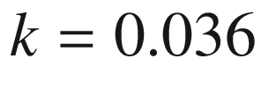

.

#### 22.3.7 Traveling-Wave Photodetectors

In a standard photodetector there was a tradeoff between the thickness of the absorption layer and the speed of the detector. In a traveling-wave photodetector the light absorption occurs in a waveguide such that for sufficient length *L* all incident light is absorbed. Complete absorption is achieved (‘long’ waveguide) if

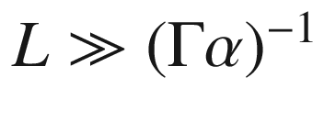

,

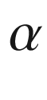

being the absorption coefficient and

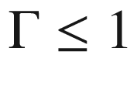

being the optical confinement factor, the geometrical overlap of the optical mode with the cross section of the absorbing medium (cf. also Sect. [23.​4.​4](#u116076_4_En_23_Chapter)).

The electrical connections are designed along this waveguide on the sides (coplanar layout, Fig. [22.32](#u116076_4_En_22_Chapter-Fig32)). The bandwidth limitation due to a *RC* time constant is now replaced by the velocity match of the light wave

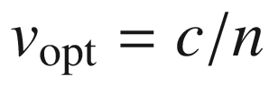

and the traveling electric wave in the contact lines

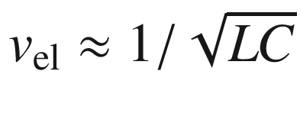

. While the two waves travel along the waveguide, energy is transferred from the light wave to the electric wave. The 3 dB bandwidth due to velocity mismatch



(for impedance- matched, long waveguides) is given by [1847]

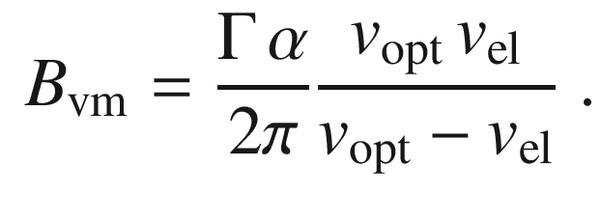

(22.54)

For a MSM structure, whose electrode separation has been designed with a self-aligned process (without extensive effort in lateral patterning) by an etch depth of a few 100 nm (Fig. [22.33](#u116076_4_En_22_Chapter-Fig33)), 3 dB cutoff frequencies beyond 500 GHz have been achieved (Fig. [22.34](#u116076_4_En_22_Chapter-Fig34)). The quantum efficiency of this detector was still 8.1%.

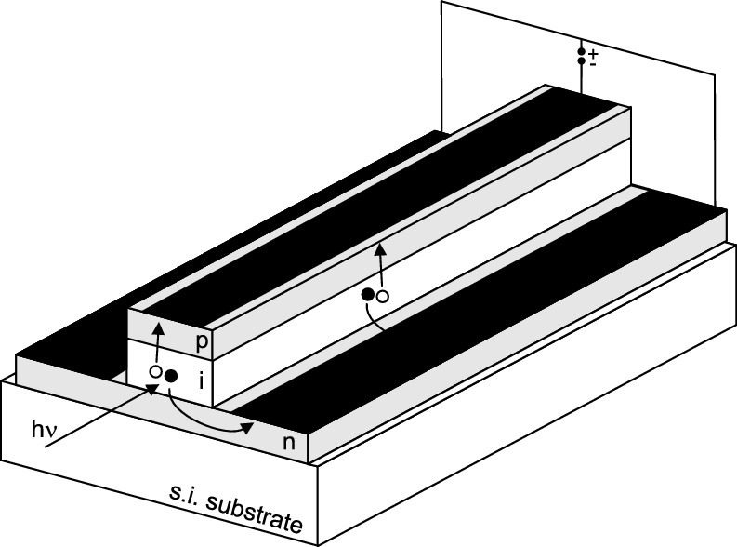

Fig. 22.32

Scheme of a traveling-wave photodetector with pin structure and coplanar contacts

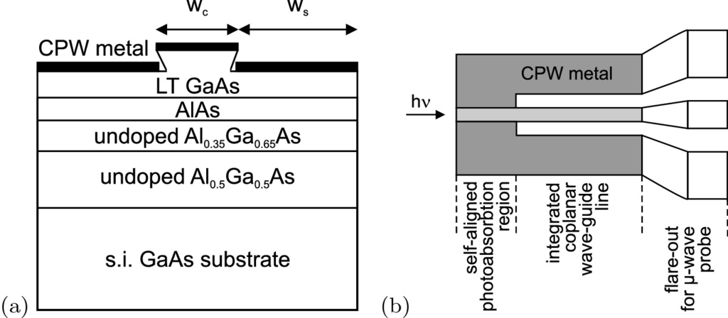

Fig. 22.33

Scheme of a MSM traveling-wave photodetector in **a** cross section and **b** plan view.

Adapted from [1848]

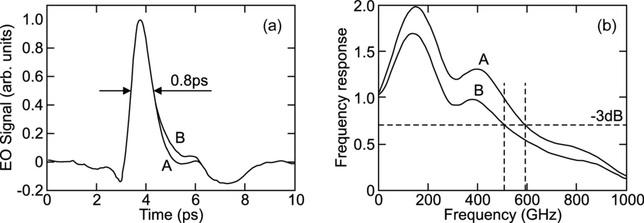

Fig. 22.34

**a** Pulse response (FWHM=0.8 ps) and **b** frequency response (Fourier transform of time response) of a MSM traveling-wave photodetector (bias 5 V) for various illumination intensities, A: 1 mW, B: 2.2 mW.

Adapted from [1848]

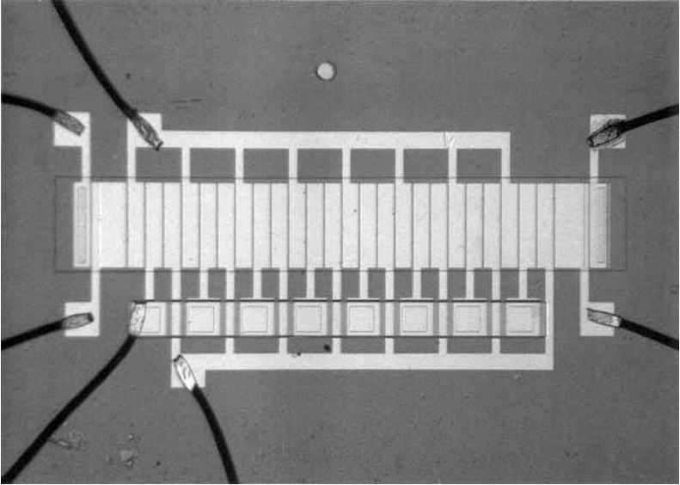

Fig. 22.35

First 8-bit charge coupled device (1970). The chip (size: 1.5



2.5 mm



) consists of 24 closely packed MOS capacitors (narrow rectangles in the center grid). The thick rectangles at either end of the grid are input/output terminals

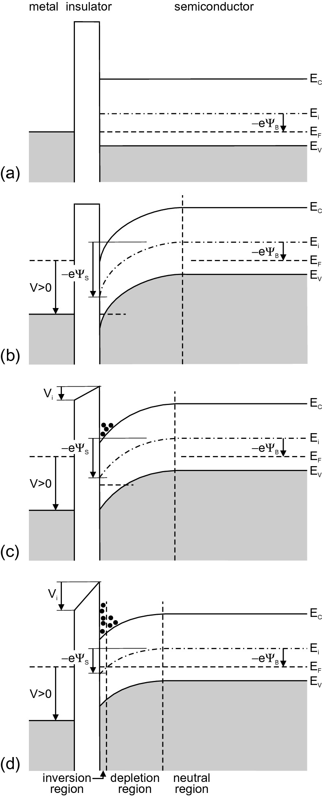

Fig. 22.36

Ideal MIS-diode (with p-type semiconductor) as photodetector (principle of a CCD pixel). **a** Without bias (see Fig. [21.​30](The_Physics_of_Semiconductors00007.docx#u116076_4_En_21_Chapter-Fig30)b). **b** Immediately after an external (reversely poled) voltage

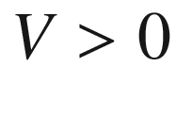

has been applied, the surface potential is

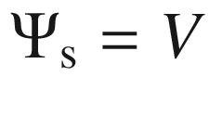

and no charges have moved yet. **c** Strong depletion (still not in thermodynamic equilibrium) with signal charge and reduced surface potential

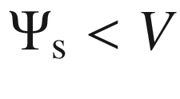

. **d** The semiconductor in equilibrium (

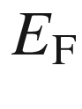

is constant) with depletion and inversion layer (see Fig. [21.​34](The_Physics_of_Semiconductors00007.docx#u116076_4_En_21_Chapter-Fig34)). For all diagrams,

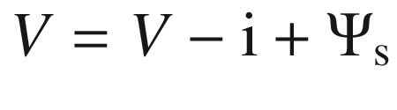

#### 22.3.8 Charge Coupled Devices

The concept of the charge coupled device (CCD), an array of connected photodetectors serving as an image sensor, was devised by W.S. Boyle and G.E. Smith [143] (Fig. [22.35](#u116076_4_En_22_Chapter-Fig35)) and realized [144]. As textbook for further details [1849, 1850] may serve.

A MIS diode (mostly a silicon-based MOS diode) can be designed as a light detector. The diode is operated in deep depletion. When a large reverse voltage is applied, initially a depletion layer is formed and the bands are strongly bent as shown in Fig. [22.36](#u116076_4_En_22_Chapter-Fig36)b. We note that in this situation the semiconductor is not in thermodynamic equilibrium (as it is in Fig. [22.36](#u116076_4_En_22_Chapter-Fig36)d) when the quasi-Fermi level  is constant throughout the semiconductor. The inversion charge has yet to build up.

There are three mechanisms to generate the inversion charge. (a) generation-recombination, (b) diffusion from the depletion-layer boundary and (c) carrier generation by light absorption. Mechanisms (a) and (b) represent dark currents for the photodetector. The conductivity due to these two processes is shown in Fig. [22.37](#u116076_4_En_22_Chapter-Fig37) and slowly builds up the inversion charge. Two temperature regimes are obvious; at low temperatures the generation dominates (

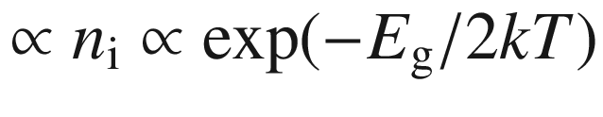

), at high temperatures the diffusion (

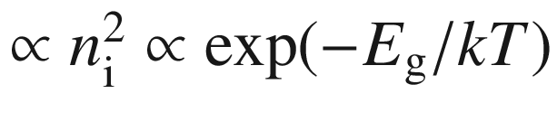

). The latter process can be strongly suppressed by cooling the device.

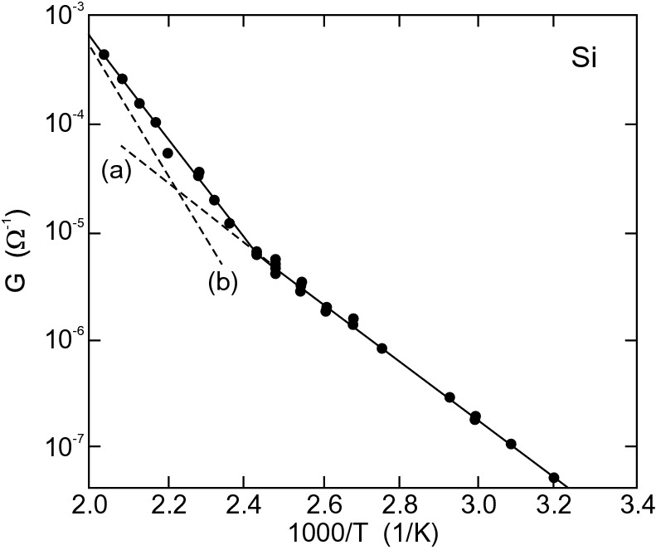

Fig. 22.37

Conductivity of a n-Si/SiO



-diode as a function of temperature (1/*T*). The slope of the *dashed lines* is (a)

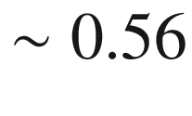

 eV (

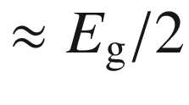

) and (b)

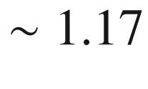

 eV (

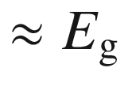

).

Adapted from [1851]

The gate voltage

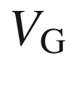

and the surface potential

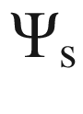

are related to each other via

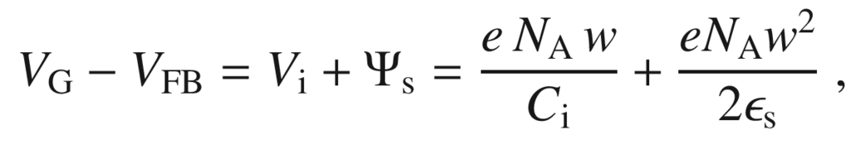

(22.55)

where *w* is the width of the depletion layer. *w* will be larger than

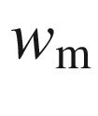

in thermodynamic equilibrium. The first term in the sum is

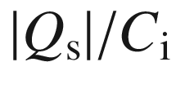

and the second is obtained by integrating the Poisson equation for the constant charge density

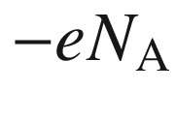

across the depletion layer. The elimination of *w* yields

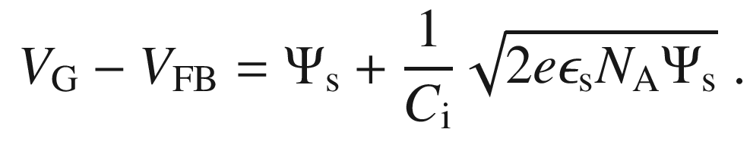

(22.56)

If light is absorbed in the depletion layer (process (c)), the hole (for p-Si) drifts towards the bulk material. The electron is stored as part of the signal charge



close to the oxide semiconductor interface (Fig. [22.36](#u116076_4_En_22_Chapter-Fig36)b).

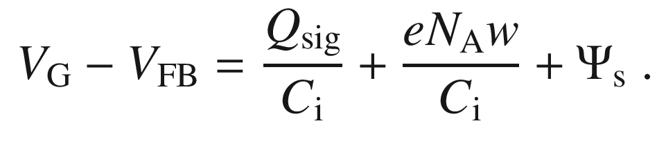

(22.57)

As a consequence of the increase in signal charge the potential well becomes shallower ([22.57](#u116076_4_En_22_Chapter-Equ61)). For each gate voltage there is a maximum charge (well capacity). The maximum signal charge is reached for

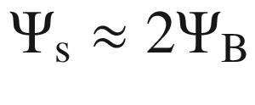

(Fig. [22.38](#u116076_4_En_22_Chapter-Fig38)).

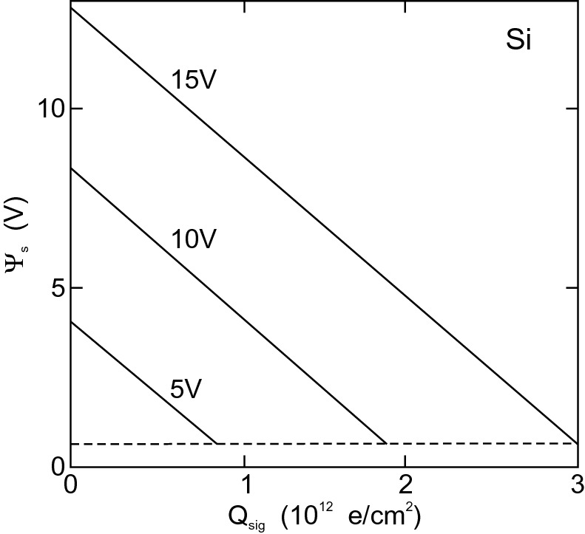

Fig. 22.38

Surface potential as a function of the signal charge



for various values of the bias

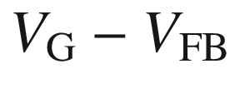

as labeled for a SiO



/p-Si diode with

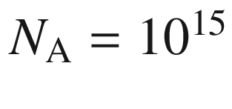

 cm



and an oxide thickness of 100 nm. The *dashed line* represents the limit for inversion given by

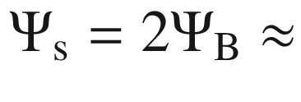

0.6 V.

Adapted from [1852]

In a charge coupled device (CCD) many light-sensitive MIS diodes, as described above, are fabricated in matrix form to create an image sensor. Upon application of a gate voltage they accumulate charge depending on the local exposure to light. The read out of this charge occurs by shifting the charge through the array to a read-out circuit. Therefore charge is transferred from one pixel to the next. Several schemes have been developed for this task. The three-phase clocking is shown schematically in Fig. [22.39](#u116076_4_En_22_Chapter-Fig39). Other clocking schemes involve four, two or only one electrode per pixel [1853].

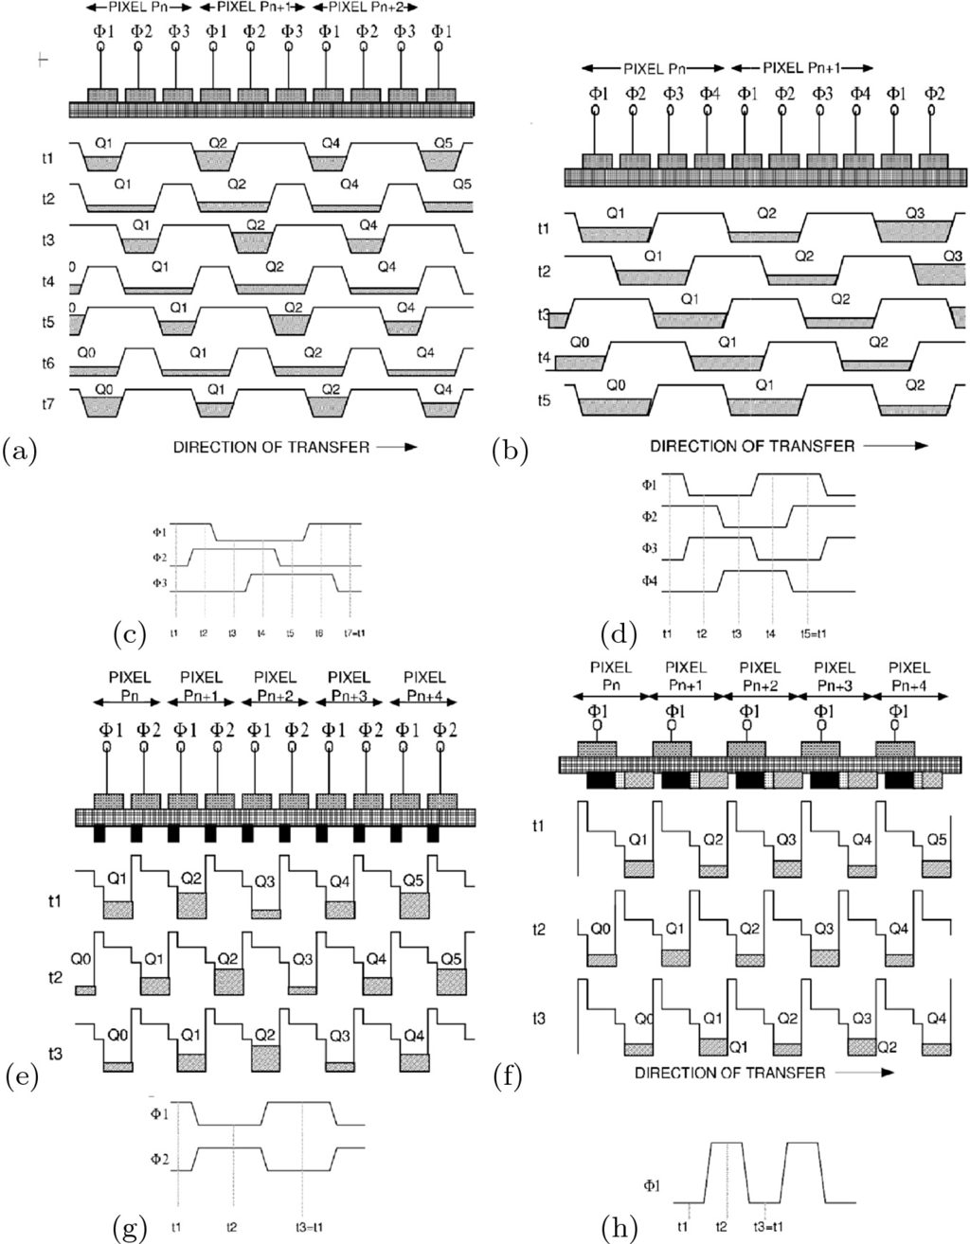

Fig. 22.39

**a** Three-phase CCD. Each pixel has three electrodes that can be switched independently (phases 1–3). **b**, **e**, **f** Schematic of CCDs with four, two or one phase, respectively. **c** (t



) Charge accumulated after light exposure. A lateral potential well is formed along the row of pixels by the voltages at the three electrodes, e.g.

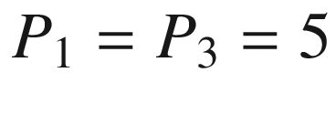

 V,

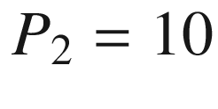

,V. (

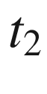

–

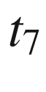

) transfer of charge, (

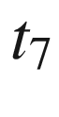

) has the same voltages as (

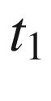

), the charge has been moved one pixel to the right. **d**, **g**, **h** Timing schemes for 4-, 2- and 1-phase CCDs, respectively.

From [1853]

Since the CCD sensor has many pixels (e.g. up to 4096) along a line, the charge transfer must be highly efficient. The transfer of charge carriers occurs via thermal (regular) diffusion, self-induced drift and the effect of the fringing field (inset of Fig. [22.40](#u116076_4_En_22_Chapter-Fig40)). The time constant with which the charge carriers move due to diffusion (in a p-type semiconductor) is

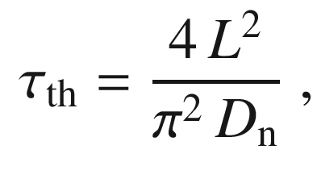

(22.58)

where *L* is the length of the electrode. For a sufficiently large charge packet the self-induced drift due to Coulomb repulsion is important. The decay of charge is then given by

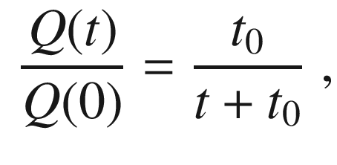

(22.59)

with

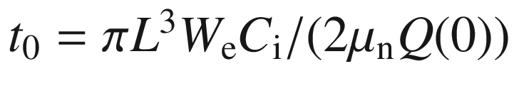

.



is the width of the electrode. This dependence is shown as a dashed line in Fig. [22.40](#u116076_4_En_22_Chapter-Fig40)a. The last electrons are efficiently transferred by the drift induced by the fringing field of the electrodes (solid line in Fig. [22.40](#u116076_4_En_22_Chapter-Fig40)a). The origin of the fringing field is schematically shown in Fig. [22.40](#u116076_4_En_22_Chapter-Fig40)b; the minimum fringing field shown is

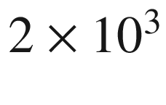

 V/cm. In about 1–2 ns practically all (

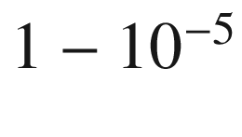

) charges are transferred. This enables clock rates of several 10 MHz.

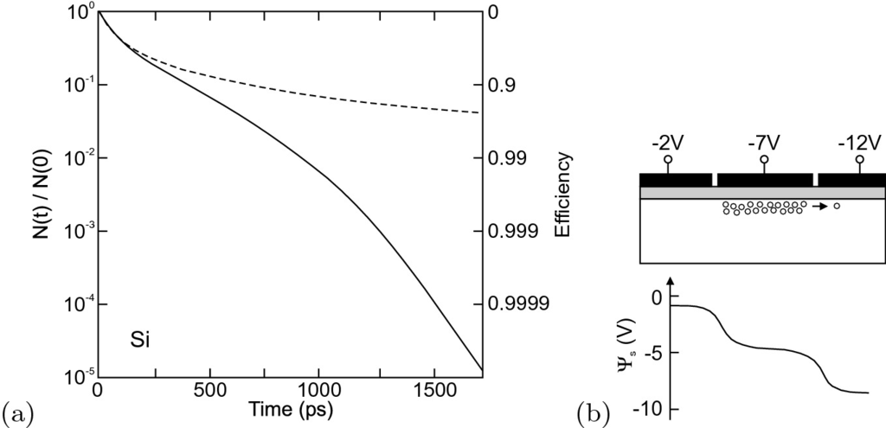

Fig. 22.40

**a** Efficiency of charge transfer with (*solid* line) and without (*dashed* line) the effect of the fringing field. **b** Schematic plot of the CCD electrodes and bias with the fringing field for a three-electrode CCD, oxide thickness 200 nm, doping

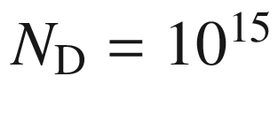

 cm

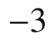

. The electrode pitch is 4  µ m and the gap between electrodes is 200 nm wide.

Adapted from [1854]

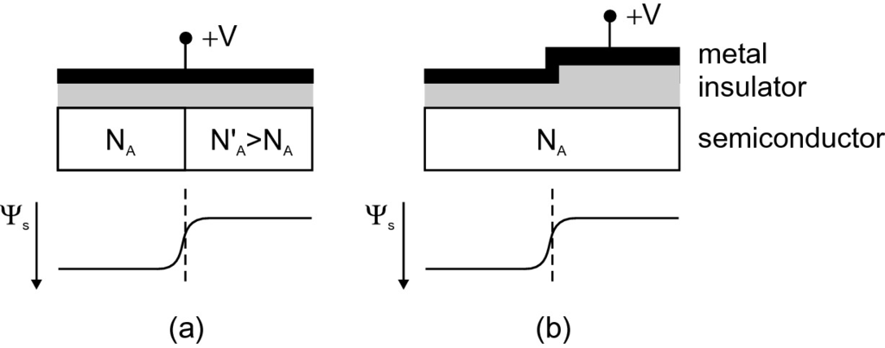

Fig. 22.41

Creation of a lateral potential well (barrier) in a MIS structure with **a** varying doping via diffusion or implantation and **b** varying (stepped) oxide thickness. *Upper row* shows schematic geometry, *lower row* depicts schematic lateral variation of the surface potential

For the clocking of the CCD the lateral variation of potential depth with the applied gate voltage is used. In Fig. [22.41](#u116076_4_En_22_Chapter-Fig41) it is shown how a lateral variation of doping or oxide thickness creates a lateral potential well. Such structures are used to confine the row of pixels against the neighboring rows (channel stops, Fig. [22.42](#u116076_4_En_22_Chapter-Fig42)). In order to avoid carrier loss at the interface between the oxide and the semiconductor a buried-channel structure is used (Fig. [22.43](#u116076_4_En_22_Chapter-Fig43)).

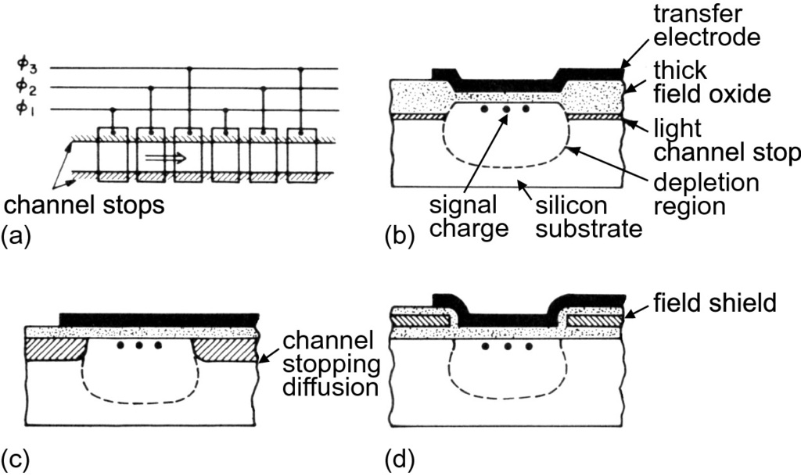

Fig. 22.42

**a** Schematic image of channel isolation. Cross section for channel isolation by **b** variation of oxide thickness, **c** highly doped region and **d** field effect.

Adapted from [1855]

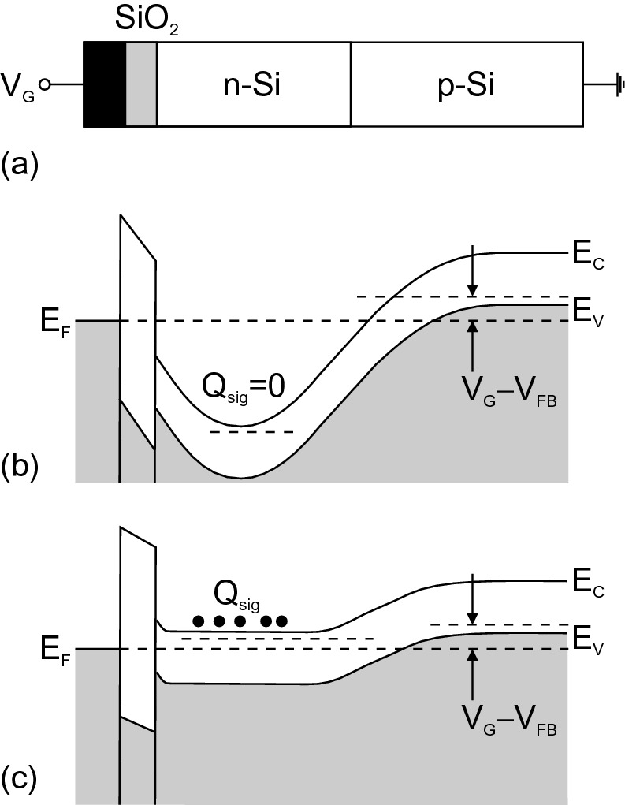

Fig. 22.43

**a** Schematic layers of MIS diode with buried-channel structure. Band diagram **b** after application of reverse voltage

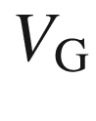

and **c** with signal charge



.

Adapted from [1856]

For front illumination parts of the contact electrodes shield the active area of the device. Higher sensitivity (in particular in the UV) is achieved for back illumination. For this purpose the chip is thinned (polished). This process is expensive and makes the chip mechanically less stable. For red/infrared wavelengths typically interference fringes occur for such thinned chips due to the small thickness. An increase in efficiency for front illumination can be achieved with an on-chip microlens (Fig. [22.44](#u116076_4_En_22_Chapter-Fig44)).

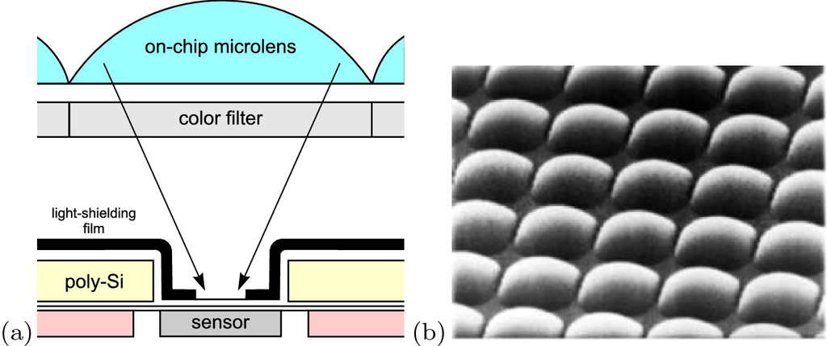

Fig. 22.44

**a** Scheme for enhancement of CCD efficiency for front illumination by application of an onchip microlens. **b** SEM image of an array of such microlenses.

From [1857]

For color imaging the CCD is covered with a three-color Bayer mask [1858] (Fig. [22.45](#u116076_4_En_22_Chapter-Fig45)a). On average there are one blue and one red pixel and two green pixels since green is the most prominent color in typical lighting situations. Thus each pixel delivers monochromatic information; RGB images are generated using suitable image software. Alternatives in high-end products are the use of a beam splitter, static color filters and three CCD chips, one for each color (Fig. [22.45](#u116076_4_En_22_Chapter-Fig45)b), or the time-sequential recording of three monochromatic images using one CCD chip and a rotating color-filter wheel (Fig. [22.45](#u116076_4_En_22_Chapter-Fig45)c). Another method is to shift (by piezoelectric actors) the CCD by half or full pixels and take sequential exposures, increasing spatial and color resolution for still objects.

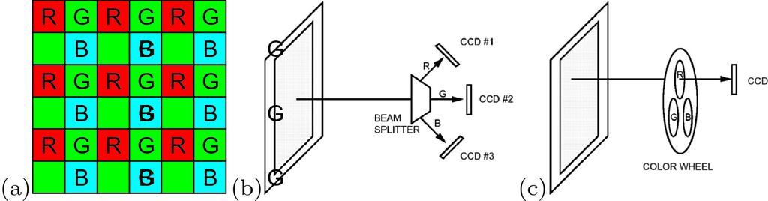

Fig. 22.45

**a** Arrangement of colors in a CCD Bayer [1858] color filter (‘R’: red, ‘G’: green, ‘B’: blue). Color splitting with **b** static color filters and **c** rotating color wheel. Parts **b** and **c** from [1853]

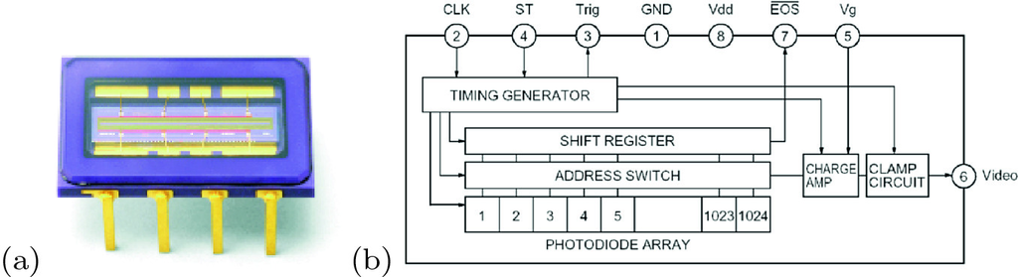

Fig. 22.46

(**a**) CMOS linear array sensor in a 8-pin package. **b** Block diagram, the built-in timing generator allows operation only with start and clock pulse inputs.

Reprinted with permission from [1861]

#### 22.3.9 Photodiode Arrays

An array of photodiodes is also suitable to create an image sensor. During illumination each diode charges a capacitor that is read out with suitable electronics. Based on CMOS technology (cf. Sect. [24.​5.​4](The_Physics_of_Semiconductors00009.docx#u116076_4_En_24_Chapter)), economic image sensors can be made (CMOS image sensors, CIS) [1859, 1860]. For a long time they exhibited inferior performance to CCDs but progress in readout and noise suppression has made them the image sensor of choice for many camera applications including the smart phone market. The built-in electronics allows simple outward connections (Fig. [22.46](#u116076_4_En_22_Chapter-Fig46)) and with several transistors per pixel even on-chip image processing.

The three-color CCD image sensor does not offer RGB color information at each pixel. Therefore the spatial resolution of a color image is not directly given by the pixel distance. This is not a very dramatic drawback since human vision is more sensitive to intensity contrast than color contrast. However, RGB color information for each pixel would be desirable, giving higher resolution, in particular in professional photography. Such a sensor has been fabricated employing the wavelength dependence of the silicon absorption coefficient (Fig. [22.13](#u116076_4_En_22_Chapter-Fig13)). Blue light has the shortest and red light the largest penetration depth. By stacking three photodiodes on top of each other (Fig. [22.47](#u116076_4_En_22_Chapter-Fig47)) photocurrents at different penetration depth are recorded that can be used to generate a RGB value for each pixel.

In Fig. [22.48](#u116076_4_En_22_Chapter-Fig48)a a 16-channel array of silicon avalanche photodiodes is shown. It features a quantum efficiency of

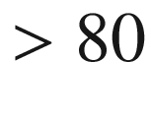

% between 760 and 910 nm. The pixel size is

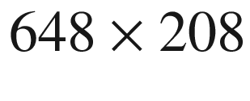

 µm

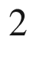

on a 320  µ m pitch. The gain is 100 and the rise time 2 ns.

The InGaAs photodiode array in Fig. [22.48](#u116076_4_En_22_Chapter-Fig48)b is hybridized with CMOS read-out integrated circuits. It is useful for detection in the spectral range 0.8–1.7  µ m. The asymmetric diode size of

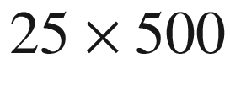

 µm is designed for use in the focal plane of a monochromator.

Another special type of photodiode array is the four-quadrant detector. A light beam generates four photocurrents

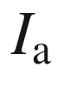

,

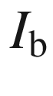

,

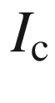

,

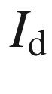

of the respective parts (Fig. [22.49](#u116076_4_En_22_Chapter-Fig49)a). A beam deviation in the horizontal or vertical direction can be detected from the (signed) signals

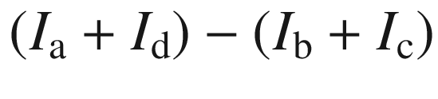

or

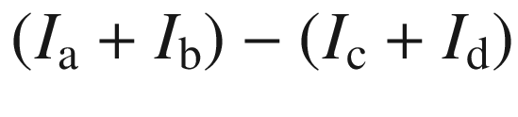

, respectively. We note that these signals can also be normalized to the total beam intensity

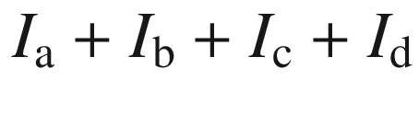

.

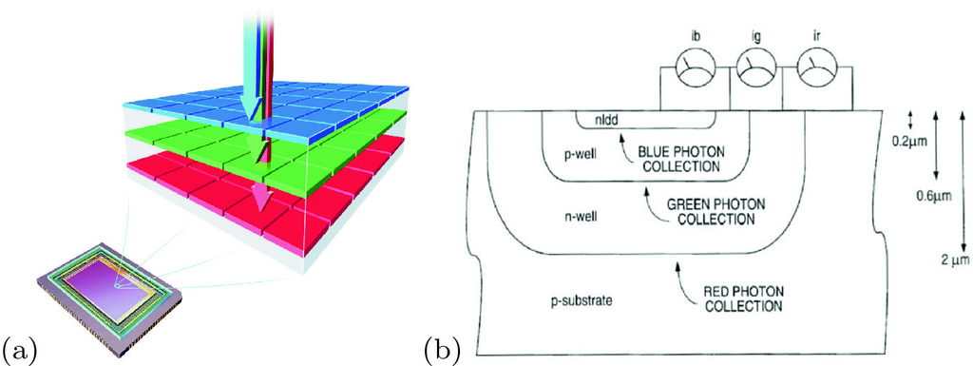

Fig. 22.47

**a** Scheme of image sensor with depth-dependent light detection. From [1862]. **b** Schematic layer sequence for three-color pixel.

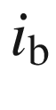

,

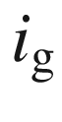

and

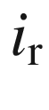

denote the photocurrents for blue, green and red light, respectively.

Adapted from [1863]

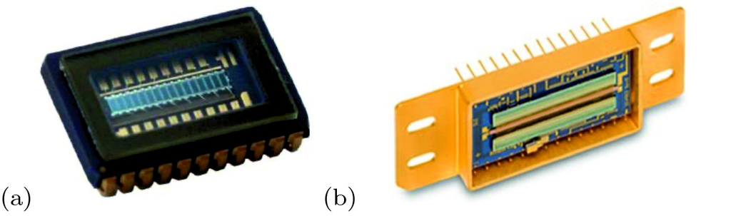

Fig. 22.48

**a** Array of 16-pixel (

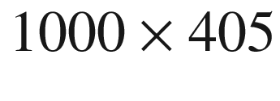

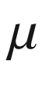

m

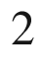

) silicon APDs (width of housing: 15 mm). From [1864]. **b** 1024-pixel (

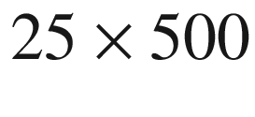

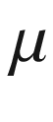

m

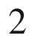

) InGaAs photodiode array (width of array: 1 inch).

From [1865]

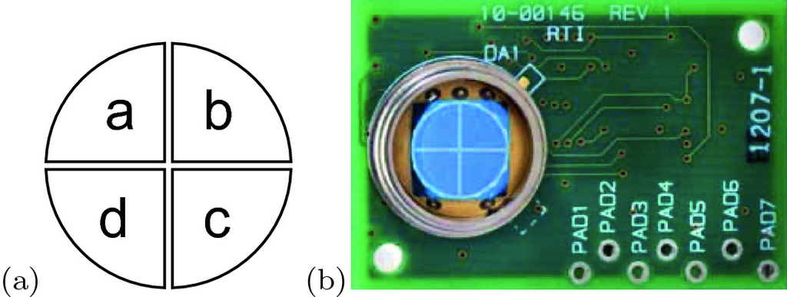

Fig. 22.49

**a** Scheme of four-quadrant photodetector with sections ‘a’, ‘b’, ‘c’ and ‘d’. **b** image of four-quadrant silicon photodetector with circuit board (diameter of active area: 8 mm, gap between sectors: 0.2 mm).

From [1866].

A further improvement of the microlens technology (cmp. Fig.[22.44](#u116076_4_En_22_Chapter-Fig44)) is achieved with additional tapered light pipes [1867], guiding obliquely incoming light to the photo-sensitive pixel in an optimized fashion (Fig. [22.50](#u116076_4_En_22_Chapter-Fig50)). This so-called ’global shutter’ pixel is connected to a local memory cell that allows simultaneous intermediate signal storage of all individual pixels in order to enable high framerate (slow-motion) video operation without spatio-temporal distortions due to a sequential read-out sequence. For such fast signal management, a three-layer scheme has been developed fusing three wafers for the photodiodes, the dynamic random access memory (DRAM) and the logic layer for the image signal processing (Fig. [22.51](#u116076_4_En_22_Chapter-Fig51)) [1868].

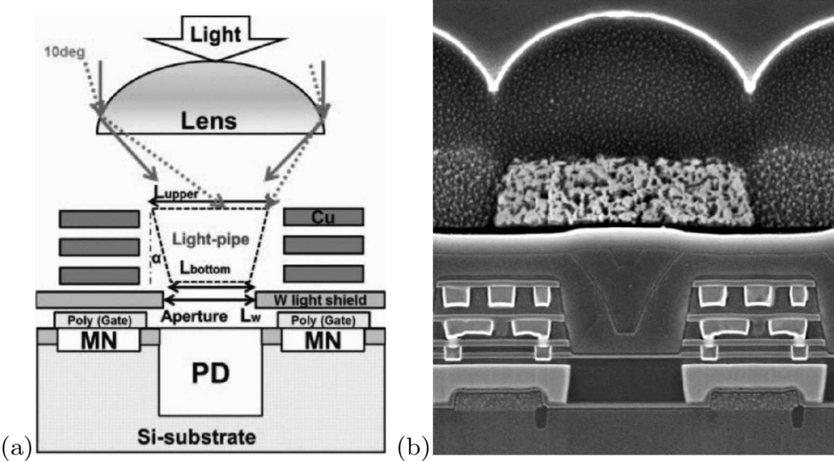

Fig. 22.50

**a** Schematic cross-section of global shutter pixel with light pipe for optimized collection.

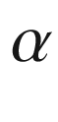

denotes the taper angle, PD: photodiode, MN: buried memory node to store the charges until readout. **b** Cross-section SEM image of such pixel.

Adapted from [1867]

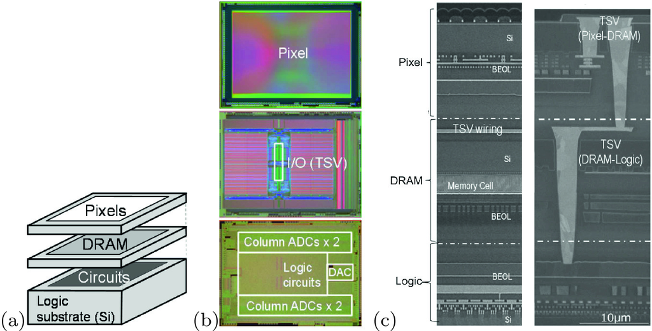

Fig. 22.51

**a** Scheme of stacking three wafers for global shutter CMOS image sensor. **b** Plane-view of the three chips, back-illuminated photodiodes, DRAM (30  nm process), and Logic (40  nm process). **c** Cross-section SEM image of the structure at position of pixel (left) and periphery (right).

Adapted from [1868]

A special CMOS image sensor has built-in grating structures to allow detection of the linear polarization state [1869]. As depicted in Fig. [22.52](#u116076_4_En_22_Chapter-Fig52), each pixel is subdivided in four with gratings in

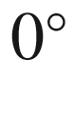

,

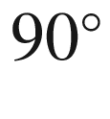

, and

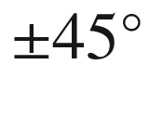

directions between the on-chip lenses and the photodiodes to create sensitivity to the linear polarization state of the incoming light.

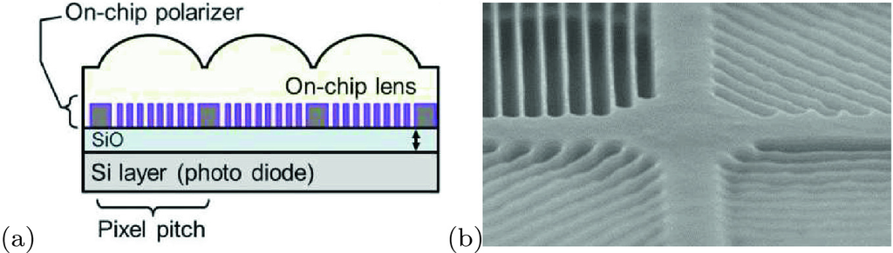

Fig. 22.52

**a** Scheme of polarization sensitive CMOS image sensor and **b** SEM image of grating pattern in SONY Polarsens™sensor.

Adapted from [1869]

### 22.4 Solar Cells

Solar cells are light detectors, mostly photodiodes, that are optimized for the (large-area) conversion of solar radiation (light) into electrical energy. A 1993 review of the historic development of photovoltaics is given in [1870]. The latest data on solar cell efficiencies are compiled in the Solar Cell Efficiency Tables [1871].

#### 22.4.1 Solar Radiation

The sun has three major zones, the core with a temperature of

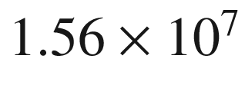

 K and a density of 100 g/cm

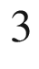

in which 40% of the mass is concentrated and 90% of the energy is generated, the convective zone with a temperature of

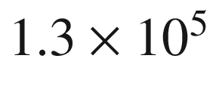

 K and a density of 0.07 g/cm

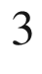

, and the photosphere with a temperature of 5800 K and low density (



10

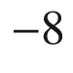

g/cm



). The radius is

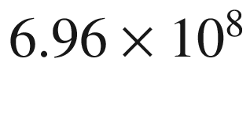

 m and is about 100 times larger than that of the earth (

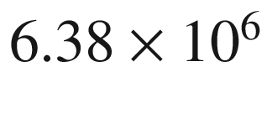

 m). The distance sun–earth is

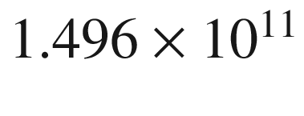

 m. The angle under which the sun disk appears on earth is 0.54



. An energy density of

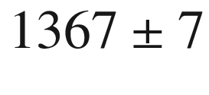

 W/m

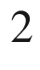

arrives at the earth in front of its atmosphere.

This value and the according spectrum of the sun’s emission, which is similar to a blackbody with temperature 5800 K (Fig. [22.53](#u116076_4_En_22_Chapter-Fig53)), is termed air mass zero (AM0). The total energy that reaches the earth from the sun is

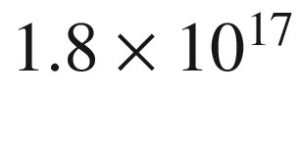

 W per year. This value is

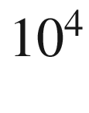

times the world’s primary energy need.

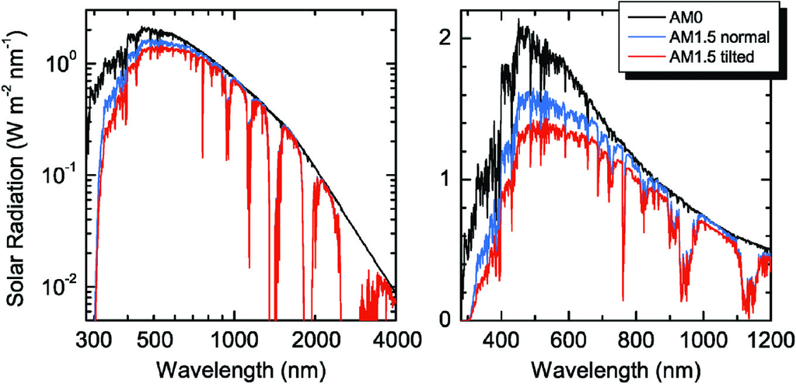

Fig. 22.53

Solar spectra (power per area and wavelength interval) for AM0 (*black line*, extraterrestrial irradiance) and AM1.5 (sun at 41.8

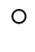

elevation above horizon) for direct normal irradiance (*blue line*) and global total irradiance (*red line*) on a sun facing surface (tilted 37

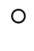

towards the equator). Left (right) graph in log-log (linear) scales

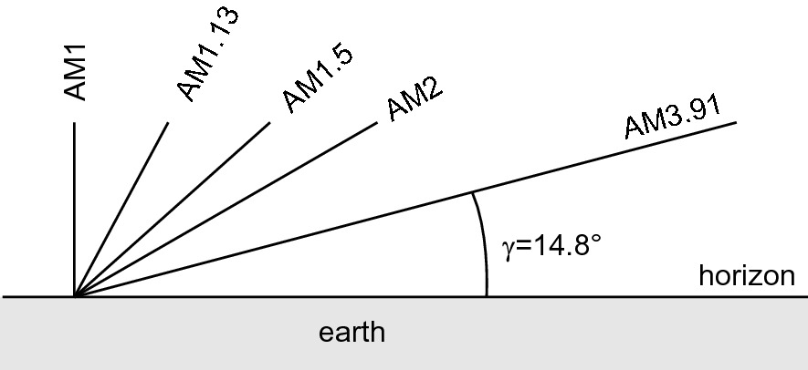

Fig. 22.54

Schematic path of sunlight through the atmosphere and definition of the air mass AM*x*

Air mass zero (AM0) is important for solar cells in satellites. When the solar spectrum passes the earth’s atmosphere, it is changed with regard to its shape and the total energy density due to gas absorption (ozone, water, CO



,



). Depending on the meridian of the sun

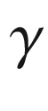

(Fig. [22.54](#u116076_4_En_22_Chapter-Fig54)), the spectrum on the surface of the earth is termed AM*x* with

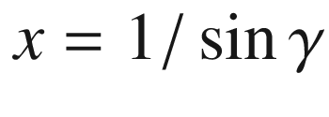

. In spring and fall (March 21st and September 21st), Leipzig (51

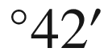

N latitude) has about AM1.61. At the summer (June 21st) and winter (December 21st) solstices the air mass in Leipzig is AM1.13 (

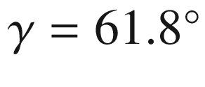

) and AM3.91 (

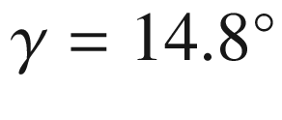

), respectively. Additionally, the duration of sunshine and thus the light power density is regionally different across the earth due to climate and weather (Fig. [22.55](#u116076_4_En_22_Chapter-Fig55)). For AM1.5, the incident power density is 844 W/m

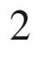

.

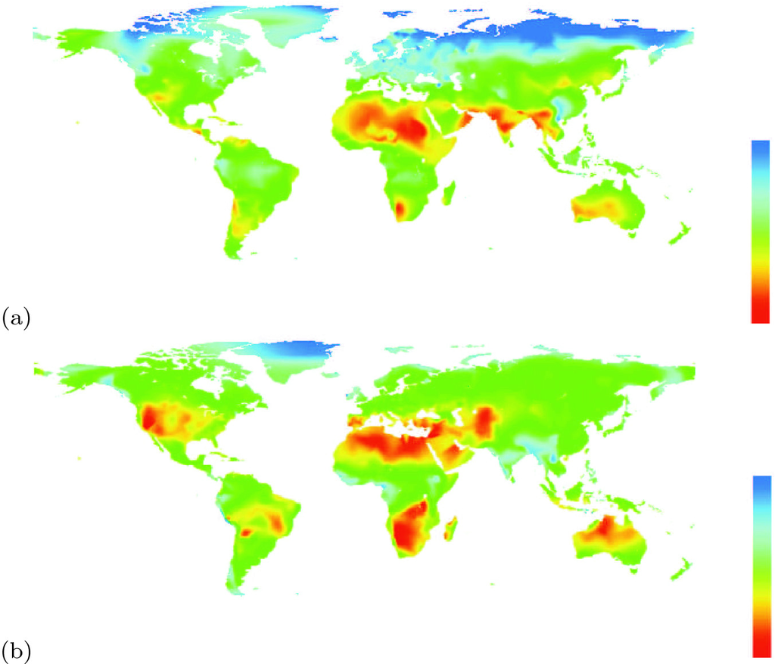

Fig. 22.55

Global sunshine distribution in **a** January and **b** July. The sunshine fraction is the actual number of bright sunshine hours over the potential number, and is thus expressed as a percentage figure. The color scale reaches from 0 to 100%. The sunshine data are in a 0.5 degree grid based on data from [1872]

The global radiation reaching a photovoltaic cell has three components: (i) the direct radiation, (ii) diffuse radiation and (iii) reflected radiation. The relative amounts and their spectra depend on details such as the climate (e.g. humidity) or the environment (e.g. outdoors vs. urban).

#### 22.4.2 Ideal Solar Cells

When a solar cell made from a semiconductor with a band gap

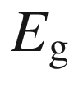

is irradiated by the sun, only photons with

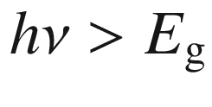

contribute to the photocurrent and the output power. The *I*–*V* characteristic under illumination (Fig. [22.56](#u116076_4_En_22_Chapter-Fig56)) is given by

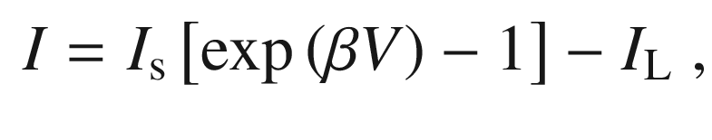

(22.60)

with

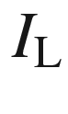

being the current due to generation of excess carriers by the absorption of the sunlight. Assuming a simple n

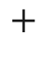

p-diode solar cell model, the current consists of two components: the depletion layer current



from carriers absorbed in the depletion layer (field region) and the diffusion current

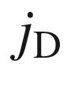

from absorption in the neutral region (

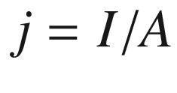

).

For the drift current out of the depletion layer of width *w* it can be assumed that it is collected fast and recombination plays no role. Thus (cmp. ([22.31](#u116076_4_En_22_Chapter-Equ33)))

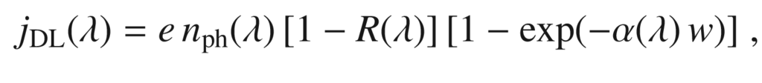

(22.61)

where

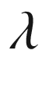

is the wavelength of the incident radiation, *R* the reflectance of the surface,

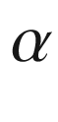

the absorption coefficient and

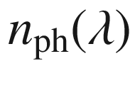

the photon flux (number of photons per area and time) at the given wavelength. For a solar spectrum, an integral needs to be performed over the spectral distribution:

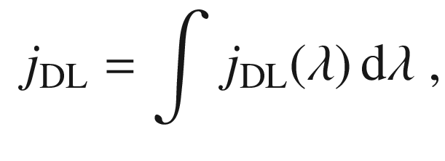

(22.62)

the total photon flux being

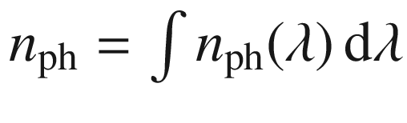

.

The diffusion current collected at the back contact is obtained from solving ([10.​73](The_Physics_of_Semiconductors00005.docx#u116076_4_En_10_Chapter)) (now for electrons in p-type material) with the appropriate boundary conditions (reversely bias depletion layer,

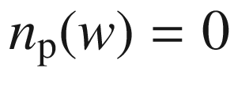

,

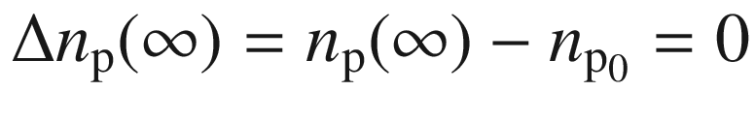

 [1873]):

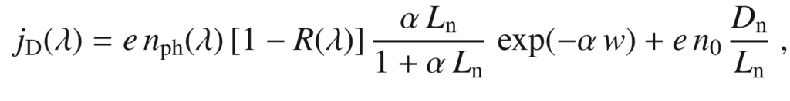

(22.63)

Dropping the wavelength dependence and neglecting the dark term, the usual formula is obtained,

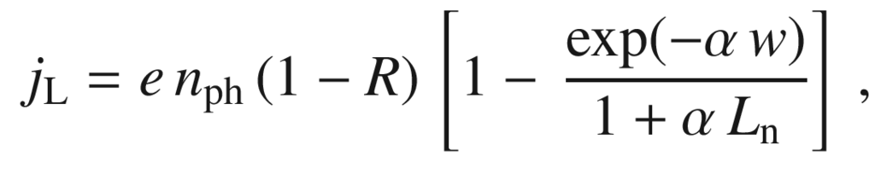

(22.64)

The last bracket represents the quantum efficiency [1874]. The model can be extended for taking into account a non-zero surface recombination velocity at the back contact at finite distance [1875].

Here a voltage *independent* photo-generated current

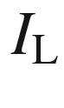

is assumed. If the diffusion length is small compared to the transport path, the carrier collection efficiency

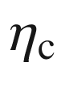

becomes voltage dependent [1874]. The reduction of the diffusion potential for forward voltage decreases the carrier collection efficiency [1876], possibly to zero close to the built-in voltage.

The saturation current density is given by ([21.​132](The_Physics_of_Semiconductors00007.docx#u116076_4_En_21_Chapter)) and ([21.​133](The_Physics_of_Semiconductors00007.docx#u116076_4_En_21_Chapter))

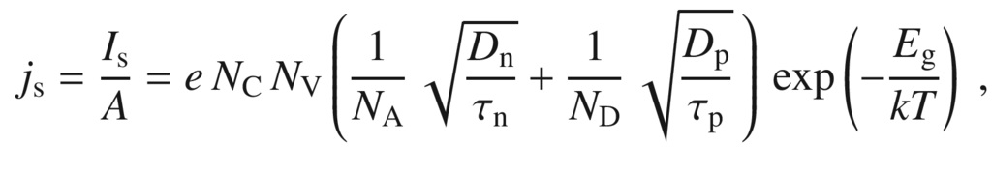

(22.65)

with *A* being the cell area.

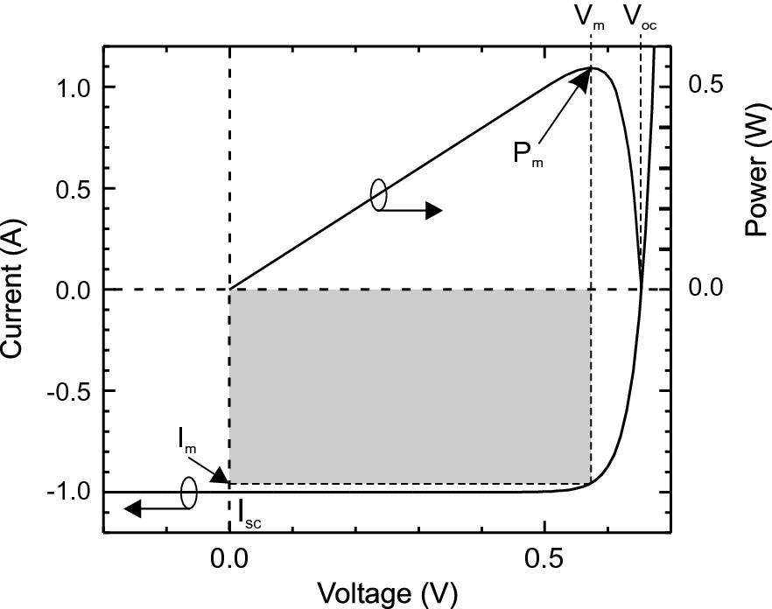

Fig. 22.56

Schematic *I*–*V* characteristics of a solar cell under illumination (*left scale*) and extracted power (*right scale*). The *grey area* is the maximum power rectangle with

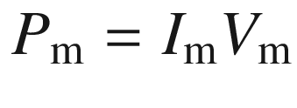

The voltage at

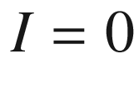

is termed the *open-circuit* voltage

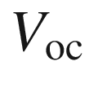

, the current at

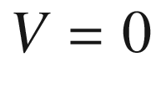

is termed the *short-circuit* current

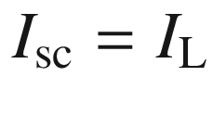

(Fig. [22.56](#u116076_4_En_22_Chapter-Fig56)). Only a part of the rectangle

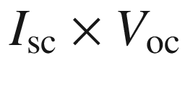

can be used for power conversion. By choice of the load resistance

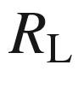

, the work point is set. At

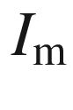

and

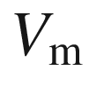

, the generated power

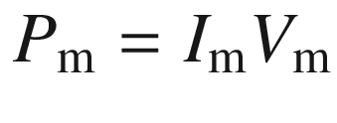

is maximal. The filling factor *F* is defined as the ratio

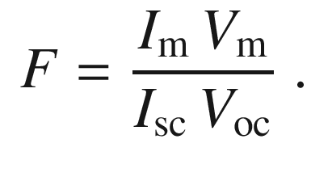

(22.66)

The open-circuit voltage is given by

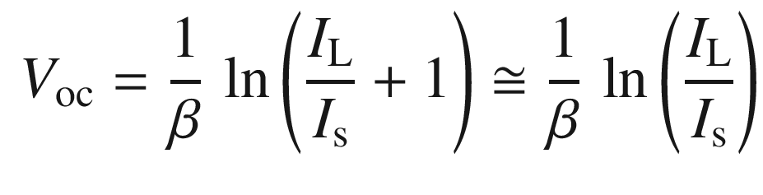

(22.67)

and increases with increasing light power and decreasing dark current. The output power is

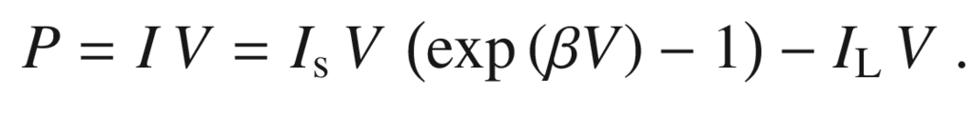

(22.68)

The condition

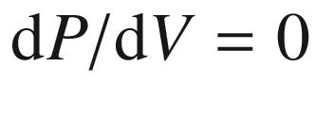

yields the optimal voltage at which the solar cell has to be operated and is given by the implicit equation

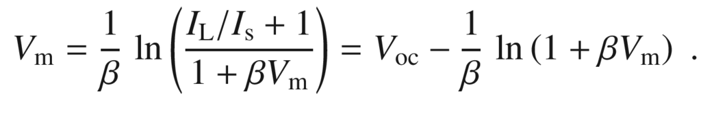

(22.69)

The current at maximum power is

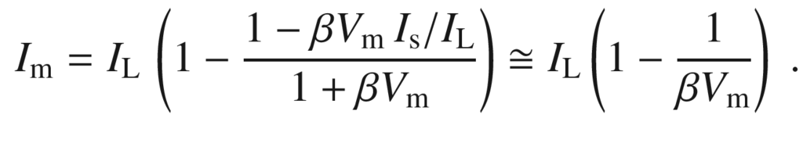

(22.70)

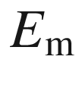

is the energy that is delivered per photon at the load resistor at the power maximum. The maximum power is

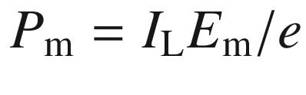

and

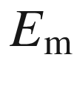

is given by

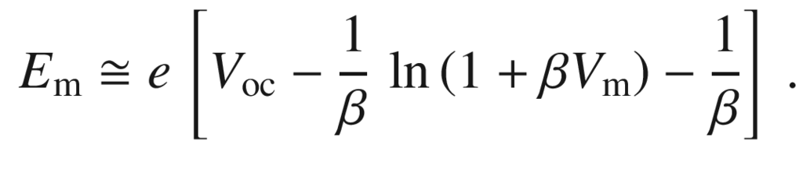

(22.71)

The ideal solar cell has a (power) conversion efficiency

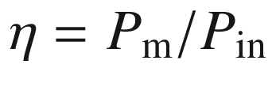

that can be determined from Fig. [22.57](#u116076_4_En_22_Chapter-Fig57)a.

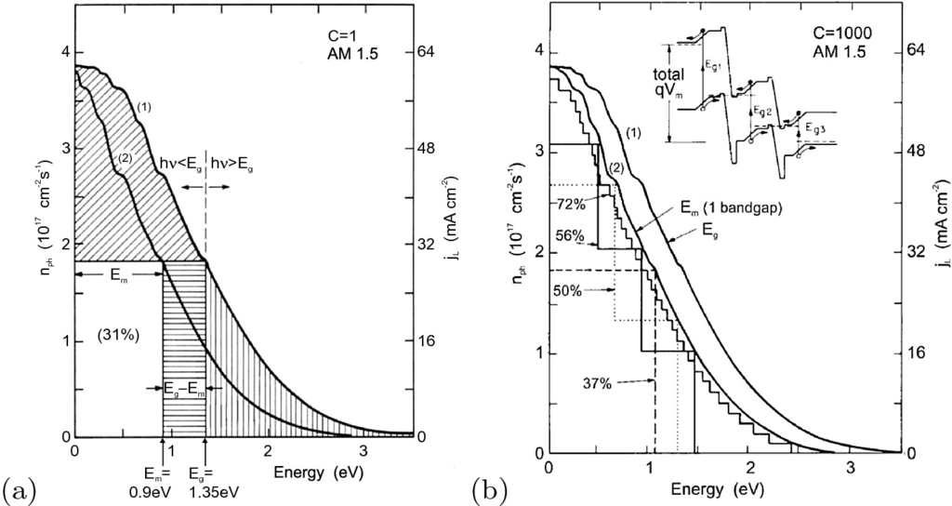

Fig. 22.57

**a** Number of photons

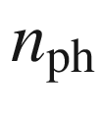

per area and time in the sun spectrum (AM1.5,

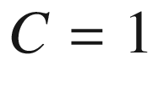

 sun) with an energy larger than a cutoff energy (*curve* 1) and graphical method to determine the quantum efficiency (from *curve* 2). Adapted from [1877]. **b** Number of photons in concentrated solar spectrum (AM1.5,

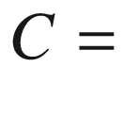

1000 sun) with an energy larger than a given energy and graphical method to determine the quantum efficiency of multi-junction solar cells.

Adapted from [574] after [1877]

The right curve (1) in Fig. [22.57](#u116076_4_En_22_Chapter-Fig57)a shows the integral number

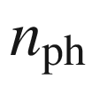

of photons in the solar spectrum (per area and time) with an energy larger than a given one (



). For a given value of

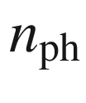

, the left curve (2) represents the value of

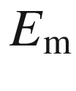

. The efficiency is the ratio of

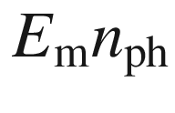

and the area under curve (1). The efficiency as a function of the band gap is shown in Fig. [22.58](#u116076_4_En_22_Chapter-Fig58)a. It has a fairly broad maximum such that many semiconductors can be used for solar cells, in principle. The maximum theoretical efficiency for a single junction is 31% for nonconcentrated sunlight (AM1.5). This limit corresponds to the classic Shockley-Queisser limit [1878–1880], assuming radiative recombination as the only charge-carrier recombination mechanism. In [1881], the limit for a single material is found to be 43% for an optimally tailored band structure that allows carrier multiplication by optically excited hot carriers. The solar cell as a heat engine is dicussed in [1882].

When the sunlight is concentrated, e.g. by a lens, the efficiency increases (Fig. [22.58](#u116076_4_En_22_Chapter-Fig58)b). The short-circuit current increases linearly. The effect is mostly due to the increase of the open-circuit voltage. For

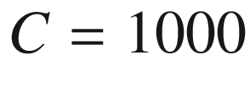

, the maximum theoretical efficiency for a single-junction solar cell is 38%.

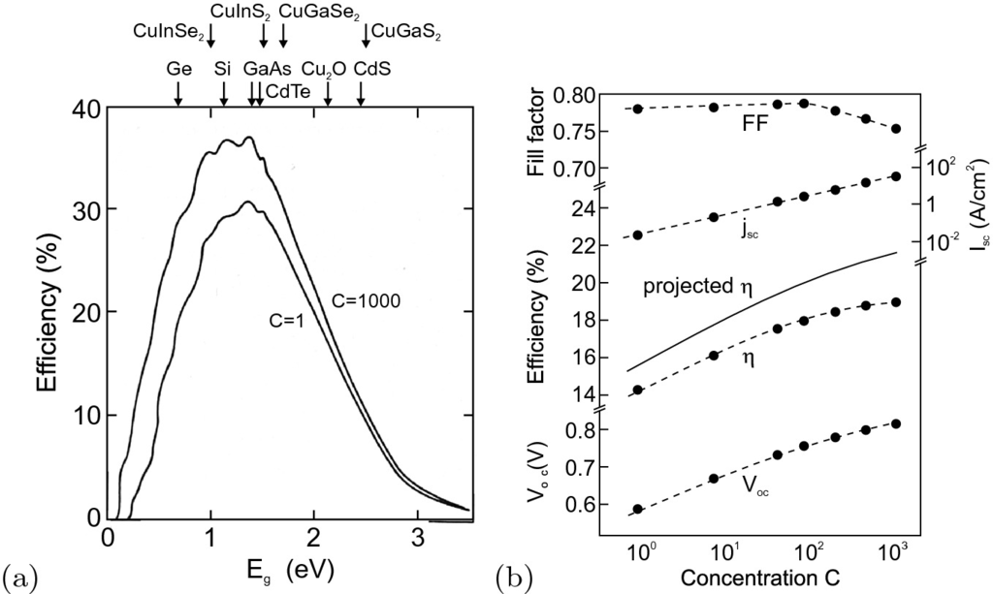

Fig. 22.58

**a** Ideal quantum efficiency of solar cells (single junction) as a function of band gap and light concentration *C*. The band gaps of some important semiconductors are denoted by *arrows*. Adapted from [1877]. **b** Properties of a silicon solar cell (water cooled) as a function of light concentration. *Solid line* is theoretically projected efficiency, *dashed lines* are guides to the eye.

Adapted from [574]

A further increase of efficiency can be achieved with multiple junctions using various materials for absorption. In a tandem cell (two junctions), the upper layer absorbs the higher-energy photons in a wide band gap material. The material with the lower band gap makes use of the low-energy photons. Thus, the cell works with two different values of

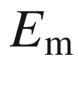

(Fig. [22.57](#u116076_4_En_22_Chapter-Fig57)b). With band gaps of 1.56 eV and 0.84 eV, an efficiency of 50% can be reached theoretically. With three materials 56%, and for a large number of materials 72% is the limit. Between the junctions, tunneling diodes (Sect. [21.​5.​9](The_Physics_of_Semiconductors00007.docx#u116076_4_En_21_Chapter)) must be used to allow carrier transport through the entire structure. It is a nontrivial task to fabricate multiple heterojunctions due to incompatibilities of the lattice constants. Besides heteroepitaxy, wafer bonding can also be used for fabrication. A lattice-matched InGaP/GaAs/InGaAsN cell seems a viable solution for high-efficiency solar cells.

#### 22.4.3 Real Solar Cells

For a real solar cell, the effect of parallel resistance

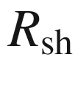

(shunt resistance due to leakage current, e.g. by local shorts of the solar cell) and serial resistance

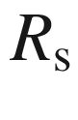

(due to ohmic loss) must be considered. The *I*–*V* characteristic is then (cf. ([21.​158](The_Physics_of_Semiconductors00007.docx#u116076_4_En_21_Chapter)))

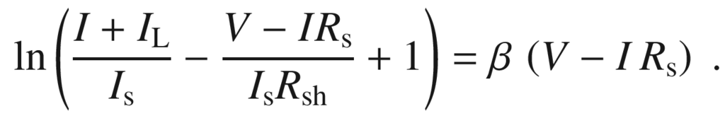

(22.72)

The serial resistance affects the efficiency more strongly than the shunt resistance (Fig. [22.59](#u116076_4_En_22_Chapter-Fig59)). Therefore, it is frequently enough to consider



only and use (cf. ([21.​157](The_Physics_of_Semiconductors00007.docx#u116076_4_En_21_Chapter)))

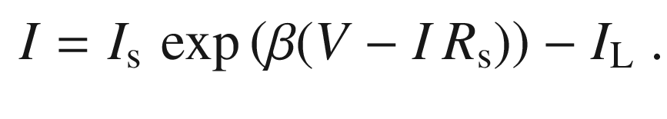

(22.73)

In the example of Fig. [22.59](#u116076_4_En_22_Chapter-Fig59), a serial resistance of 5

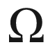

reduces the filling factor by a factor of about four.

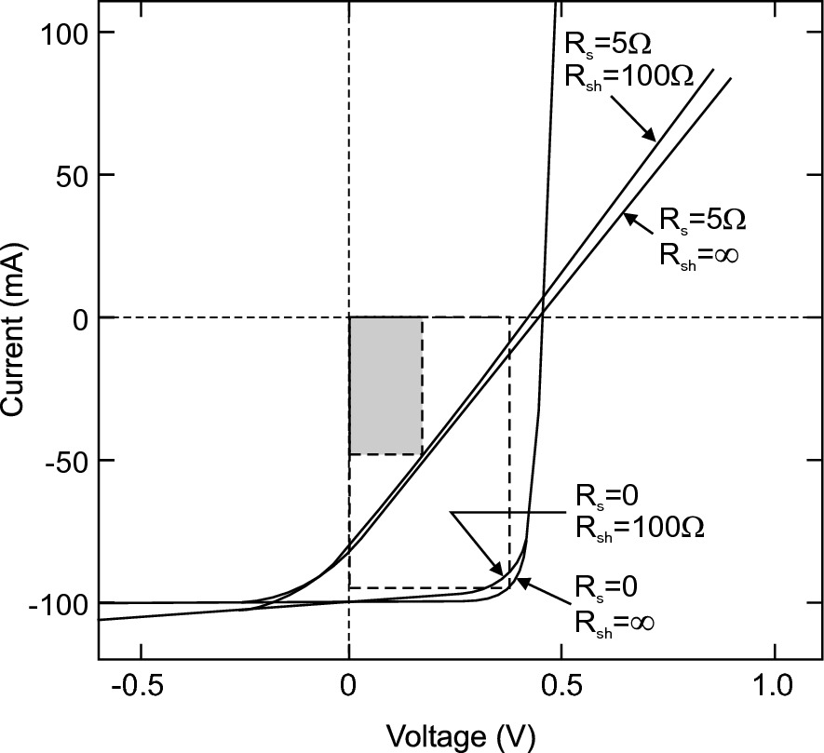

Fig. 22.59

*I*–*V* characteristics of a solar cell considering shunt and series resistances



and

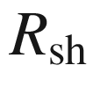

, respectively. The efficiency of the real cell (*shaded* power rectangle) is less than 30% of that of the ideal cell.

Adapted from [1883]

At open circuit voltage the photo-generated carriers have nowhere to go; in an ideal solar cell, the only process is the radiative recombination and the photon escape. Certainly, the internal quantum efficiency should be high and the non-radiative recombination rate small compared to the radiative one (cf. Sect. [10.​10](The_Physics_of_Semiconductors00005.docx#u116076_4_En_10_Chapter)). The open circuit voltage and thus the energy conversion efficiency depends also on the light extraction efficiency

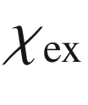

which will be discussed in greater detail in the context of LEDs (Sect. [23.​3.​3](#u116076_4_En_23_Chapter)). Based on [1884, 1885], the open circuit voltage

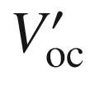

of a real solar cell is *reduced* (

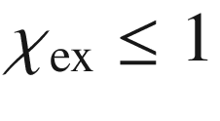

) from the ideal value

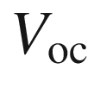

given in ([22.​67](#u116076_4_En_22_Chapter)),

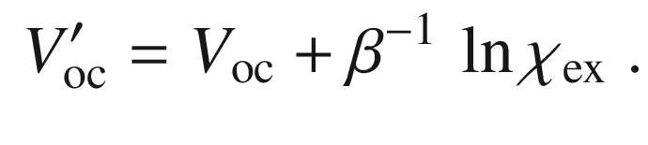

(22.74)

#### 22.4.4 Design Refinements

In order to collect electrons most efficiently, a back surface field is used (Fig. [22.60](#u116076_4_En_22_Chapter-Fig60)). A higher-doped region at the back contact creates a potential barrier and reflects electrons back to the front contact.

An important point for optimization is the management of the reflection at the solar cell surface. First, a dielectric antireflection (AR) layer (or multi-layers) can be used. These layers should have a broad AR spectrum. Additionally, a textured surface reduces reflection (Fig. [22.61](#u116076_4_En_22_Chapter-Fig61)d), giving reflected photons a second chance for penetration (Fig. [22.61](#u116076_4_En_22_Chapter-Fig61)c). The reflectance of bare Si, 35%, can be reduced to 2%. An AM0 efficiency of over 15% was reached using textured multi-crystalline cells. Alkaline KOH-based etches attack Si (001) anisotropically and yield pyramidal structures (Fig. [22.61](#u116076_4_En_22_Chapter-Fig61)b) with

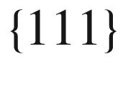

facets. Recently an acidic HF/HNO



-based process has been established [1887], resulting in a worm-like surface pattern on multi-crystalline silicon wafers (Fig. [22.61](#u116076_4_En_22_Chapter-Fig61)a) with superior anti-reflection properties.

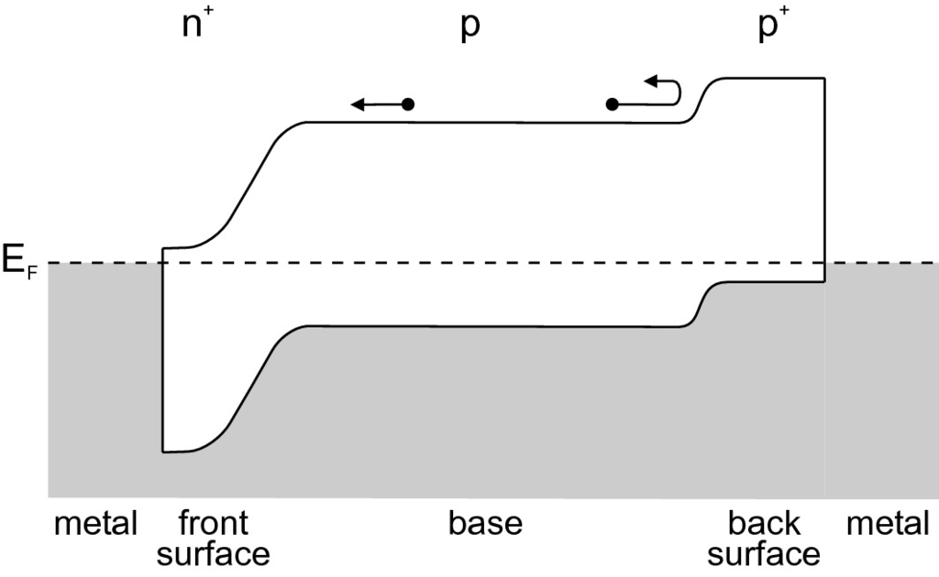

Fig. 22.60

Increase of the carrier collection efficiency by a back surface field.

Adapted from [1886]

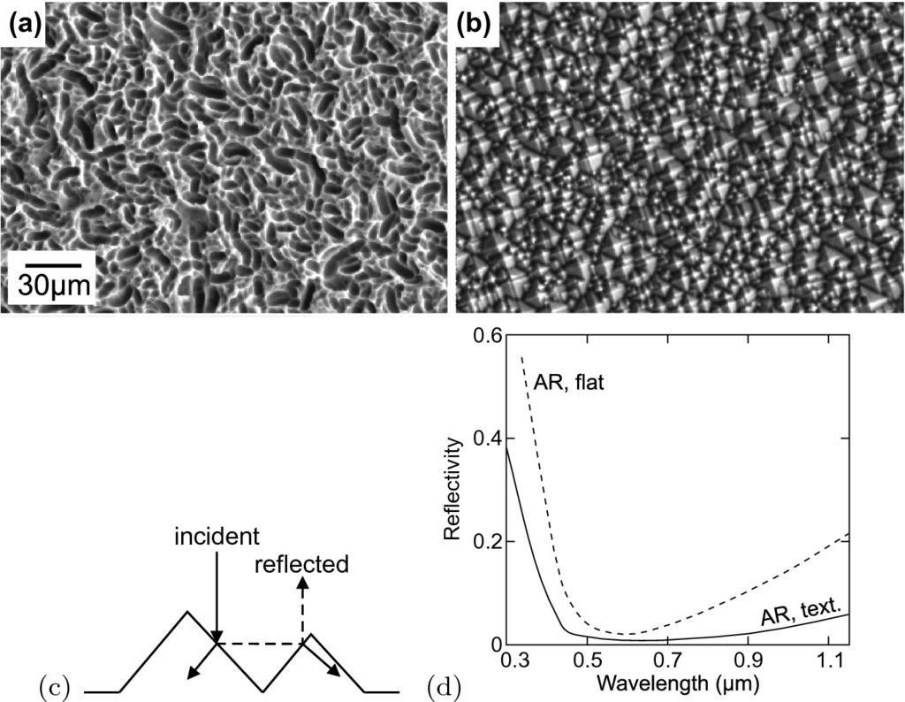

Fig. 22.61

**a** SEM image of topology of acidically etched multi-crystalline silicon wafer. **b** SEM image of alkaline etched mono-crystalline silicon wafer. **c** Exemplary light path. **d** Reflectance of antireflection-coated flat (*dashed line*) and textured (*solid line*) surface).

Parts **a** and **b** adapted from [1888], part **d** adapted from [1889]

During its course over the sky during the day, the sun changes its angle towards a fixed solar cell.[10](#u116076_4_En_22_Chapter-Fn10) A tracking mechanism can optimize the angle of incidence during the day and increase the overall efficiency of the solar cell (Fig. [22.62](#u116076_4_En_22_Chapter-Fig62)).

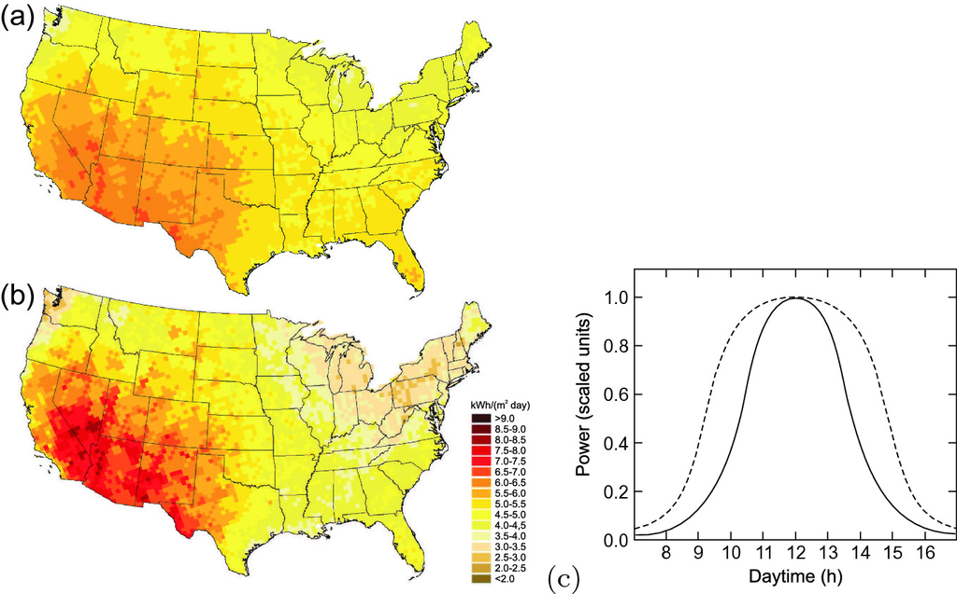

Fig. 22.62

Annual average solar energy (in kWh/(m



 day)) for **a** an optimally tilted south-facing fixed panel and **b** an optimally two-axis tracked panel (in mainland US). Adapted from [1890]. **c** Power generation of a solar cell vs. time (in daytime hours) for a stationary setup facing the sun at constant angle (*solid line*) and mounting with tracking (*dashed line*) to optimize the angle towards the sun.

Adapted from [1891]

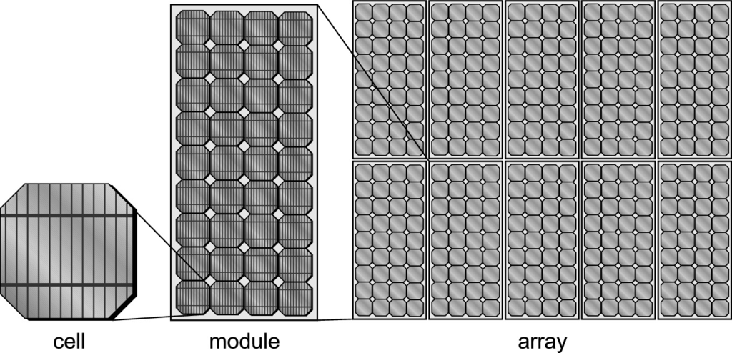

Fig. 22.63

Schematic drawing of a solar cell (with contact grid), a module (36 cells) and an array of ten modules

#### 22.4.5 Modules

In order to cover a large area and supply certain values of output voltage and current, several solar cells are connected into modules. Arrays are built up from several modules (Fig. [22.63](#u116076_4_En_22_Chapter-Fig63)). If solar cells are connected in parallel, the total current increases; if they are connected in series, the output voltage increases. We note that in partially shadowed modules the reverse characteristics of solar cells are important [1892, 1893]; local breakdown can lead to hot spots and irreversible degradation.

#### 22.4.6 Solar-Cell Types

##### 22.4.6.1 First Generation Photovoltaics

Silicon is the most frequently used material for solar cells. Cells based on single-crystalline silicon (wafers) have the highest efficiency but are the most expensive (Fig. [22.65](#u116076_4_En_22_Chapter-Fig65)a). The state-of-the-art industrial crystalline silicon solar cells technology and achievements (in 2014) has been reported in [1894]. The efficiencies of various solar cells are compiled in Table [22.1](#u116076_4_En_22_Chapter-Tab1). Polycrystalline (for large grains also called multi-crystalline) silicon (Fig. [22.65](#u116076_4_En_22_Chapter-Fig65)b) is cheaper but offers less performance. Material design is oriented towards increasing the grain size and/or reducing their electrical activity. Grain boundaries act as recombination centers with a surface (i.e. interface) recombination velocity of

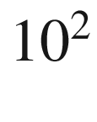

 cm/s [1895] for particular, electrically fairly inactive grain boundaries, several

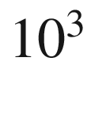

 cm/s [1896], several

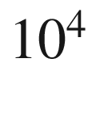

 cm/s [1897] or even

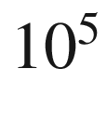

–

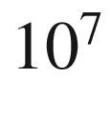

 cm/s [1898]. The grain boundaries reduce the effective diffusion length and thus carriers recombine before they can reach the contacts. A detailed theory of solar cell performance for polycrystalline material has been worked out in [1897] and explains the reduction of efficiency with decreasing grain size as shown in Fig. [22.64](#u116076_4_En_22_Chapter-Fig64).

These solar cells are also called ‘first-generation’ photovoltaics. Thin sheets of crystalline silicon drawn from a melt between two seed crystals in a modified CZ growth (sheet silicon or ribbon silicon) allow cheaper production compared to cells based on ‘traditional’ polished wafers cut from a large silicon rod. Silicon made particularly for solar cell use is called ‘solar-grade’ silicon.Table 22.1

Record efficiency of various solar cells (AM1.5, 1000 W/cm



, 25



unless noted otherwise). Most data from [1871], additional data for 3J (conc.) [1899, 1900]. Date is that of (mostly certified) measurement

| Cell material/type | Efficiency | $$V_{\mathrm {oc}}$$ | $$j_{\mathrm {sc}}$$ | FF | date |
| --- | --- | --- | --- | --- | --- |
|  | (%) | (V) | (mA/cm  $$^2$$  ) | (%) | m/y |
| Si (crystalline) | $$26.7 \pm 0.5$$ | 0.738 | 42.65 | 84.9 | 3/2017 |
| Si (multicrystalline) | $$22.3 \pm 0.4$$ | 0.6742 | 41.08 | 80.5 | 8/2017 |
| Si (amorphous) | $$10.2 \pm 0.3$$ | 0.896 | 16.36 | 69.8 | 7/2014 |
| GaAs (crystalline) | $$25.9 \pm 0.8$$ | 1.038 | 29.4 | 84.7 | 12/2007 |
| GaAs (thin film) | $$29.1 \pm 0.6$$ | 1.1272 | 29.78 | 86.7 | 10/2018 |
| GaAs (multicrystalline) | $$18.4 \pm 0.5$$ | 0.994 | 23.2 | 79.7 | 11/1995 |
| CIGS | $$22.9 \pm 0.5$$ | 0.744 | 38.77 | 79.5 | 11/2017 |
| CdTe | $$21.0 \pm 0.4$$ | 0.8759 | 30.25 | 79.4 | 8/2014 |
| perosvkite | $$20.9 \pm 0.7$$ | 1.125 | 24.92 | 74.5 | 7/2017 |
| dye sensitized | $$11.9 \pm 0.4$$ | 0.744 | 22.47 | 71.2 | 9/2012 |
| organic (thin film) | $$11.2 \pm 0.3$$ | 0.780 | 19.3 | 74.2 | 10/2015 |
| 2J (GaInP/GaAs) | $$32.8 \pm 1.4$$ | 2.568 | 14.56 | 87.7 | 9/2017 |
| 3J (GaInP/GaAs/Ge) | $$32.0 \pm 1.5$$ | 2.622 | 14.4 | 85.0 | 1/2003 |
| 3J (GaInP/GaAs/InGaAs) | $$37.9 \pm 1.2$$ | 3.065 | 14.27 | 86.7 | 2/2013 |
| 5J (bonded) | $$38.8 \pm 1.2$$ | 4.767 | 9.564 | 85.2 | 7/2013 |
| 2J (conc., 38 suns) | $$35.5 \pm 1.2$$ |  |  |  | 10/2017 |
| 3J (conc., 240 suns) | $$40.7 \pm 2.4$$ | 2.911 | 3832 | 87.5 | 9/2006 |
| 3J (conc., 306 suns) | 43.5 |  |  |  | 5/2012 |
| 4J (conc., 508 suns) | $$46.0 \pm 2.2$$ | 4.227 | 6498 | 85.1 | 10/2014 |

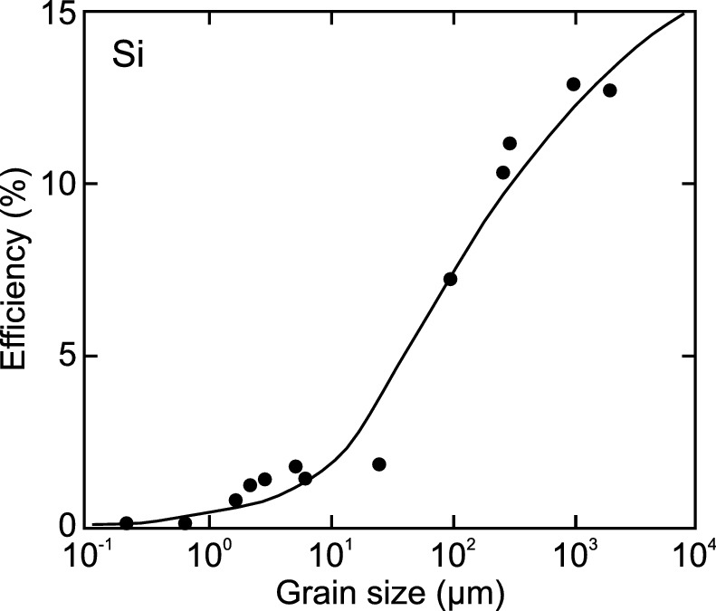

Fig. 22.64

Theoretical dependence of the effect of grain size on efficiency of polycrystalline solar cells (*solid line*) with experimental data points (*circles*).

Adapted from [1897]

##### 22.4.6.2 Second Generation Photovoltaics

Even cheaper are solar cells from amorphous silicon (Fig. [22.65](#u116076_4_En_22_Chapter-Fig65)c). Since silicon is an indirect semiconductor, a fairly thick layer is needed for light absorption. If direct band gap semiconductors are used, a thin layer (

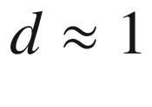

  µ m) is sufficient for complete light absorption. Such cells are called thin-film solar cells [1901]. A typical material class used in this type of cell are chalcopyrites, such as CuInSe



(CIS). The band gap is around 1 eV, which is not optimal. An improvement can be achieved by adding Ga and/or S which increases the band gap, Cu(In,Ga)(Se,S)



(CIGS), to 1.2–1.6 eV. Using CIGS, an efficiency of over 19% has been reported in laboratory samples; 12–13% seeming realistic for production [1902]. Also CdTe is a viable absorber mostly sputtered on glass with over 16% efficiency demonstrated and 9–10% realistic in production. Thin-film solar cells can be fabricated on glass substrate or on flexible polymer substrate such as Kapton[11](#u116076_4_En_22_Chapter-Fn11) (Fig. [22.66](#u116076_4_En_22_Chapter-Fig66)a, b). Also here, optimization of the grain size is important (Fig. [22.66](#u116076_4_En_22_Chapter-Fig66)b). As the front contact, a transparent conductive oxide (TCO), such as ITO (InSnO



) or ZnO:Al, is used. If the front surface is given by the glass substrate, as can be the case for CdTe/glass solar cells, the glass is actually termed ‘superstrate’. Thin-film and amorphous silicon solar cells are also termed ‘second-generation’ photovoltaics. Also organic materials can be used for solar cells [1903], promising low-cost production at acceptable performance, in 2004 2.5% [1904] and in 2006 about 4% maximum efficiency [1905].

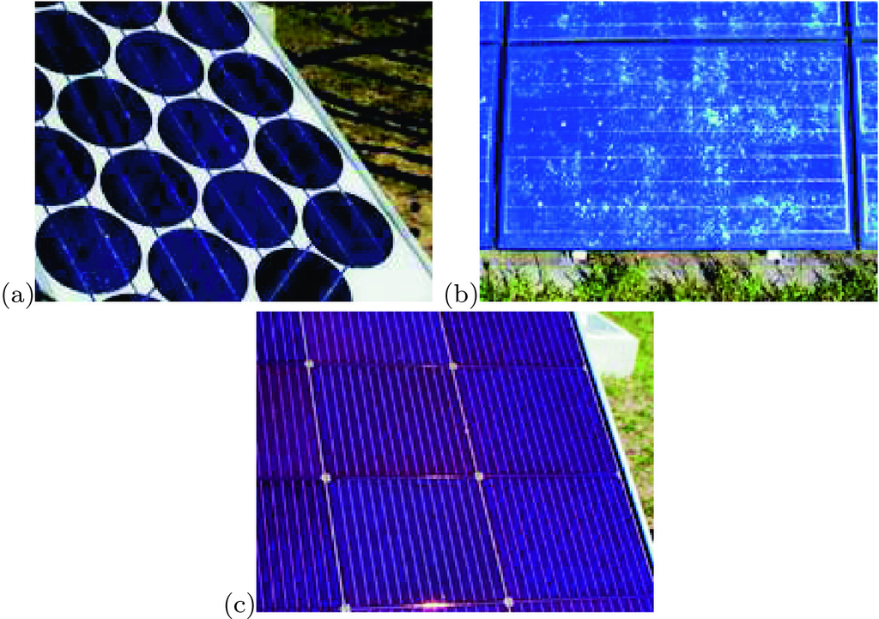

Fig. 22.65

Various types of solar cells: **a** monocrystalline silicon solar cell, **b** polycrystalline solar cell, **c** amorphous silicon solar cell.

From [1891]

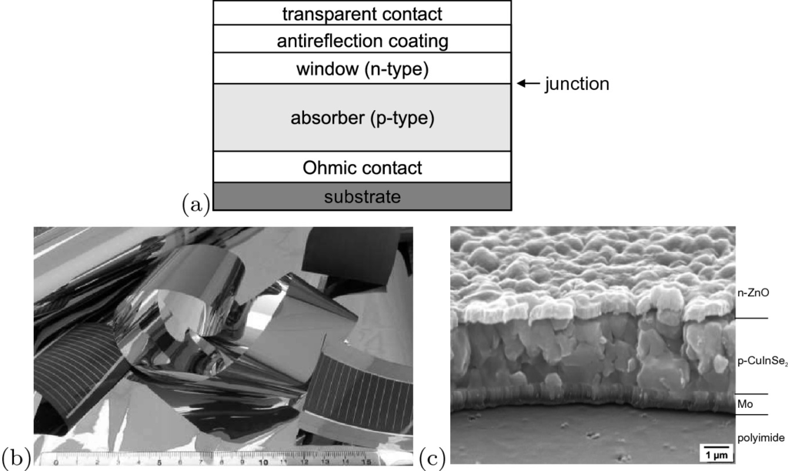

Fig. 22.66

**a** Schematic cross section of a polycrystalline thin-film solar cell. **b** Rolled sheets of CIS thin film solar cell on flexible Kapton foil. **c** SEM cross section of CIS thin-film solar cell.

Parts **b** and **c** reprinted with permission from [1906]

##### 22.4.6.3 Third Generation Photovoltaics

‘Third-generation’ photovoltaics attempt to go beyond the 30% limit and comprise of multi-junction solar cells, concentration of sunlight, use of hot-carrier excess energy as discussed above and possibly other concepts including photon conversion [1907, 1908], intermediate band absorption [1909–1911], multi-exciton generation [1912] or the use of quantum dots [1913].

In multi-junction cells the different absorber layers are stacked on the substrate with increasing band gap and connected via (highly doped) tunneling junctions (Sect. [21.​5.​9](The_Physics_of_Semiconductors00007.docx#u116076_4_En_21_Chapter)). Under 500-fold AM1.5 illumination a three junction (3J) cell (GaInP/GaInAs/Ge) is expected to exhibit up to 41% efficiency, for 5J 42% or up to 55% using GaInNAs and with 6J up to 59% [1914, 1915] (Fig. [22.67](#u116076_4_En_22_Chapter-Fig67)). For a 3J cell the record efficienvy is 40.7% (240 suns) using the layer structure as shown in Fig. [22.68](#u116076_4_En_22_Chapter-Fig68) [1899]. Details on modeling of III–V multi-junction solar cells can be found in [1916]. In a monolithic cell the absorbers must be tuned such that the same current (Kirchhoff’s law) can pass through all layers. Multi-junction solar cells are heteroepitaxial devices and thus expensive; the use of concentration is economically mandatory.

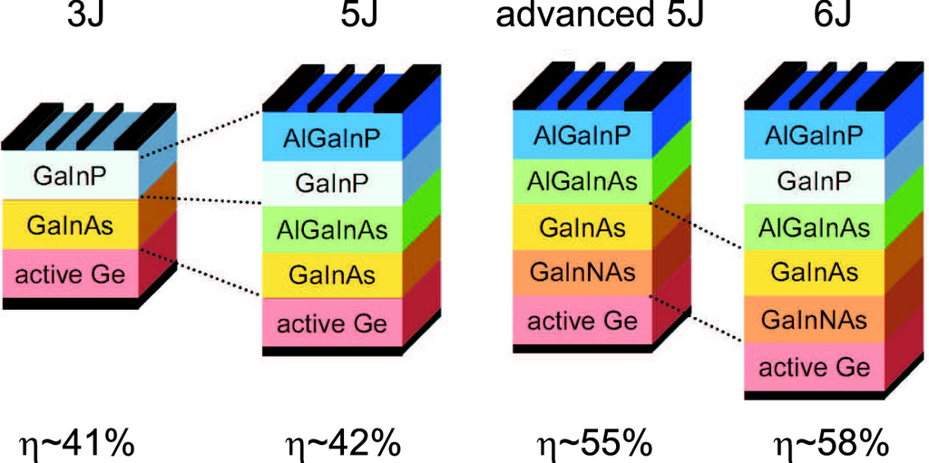

Fig. 22.67

Schematic layer stacking of multi-junction solar cells and expected efficiency.

Adapted from [1914]

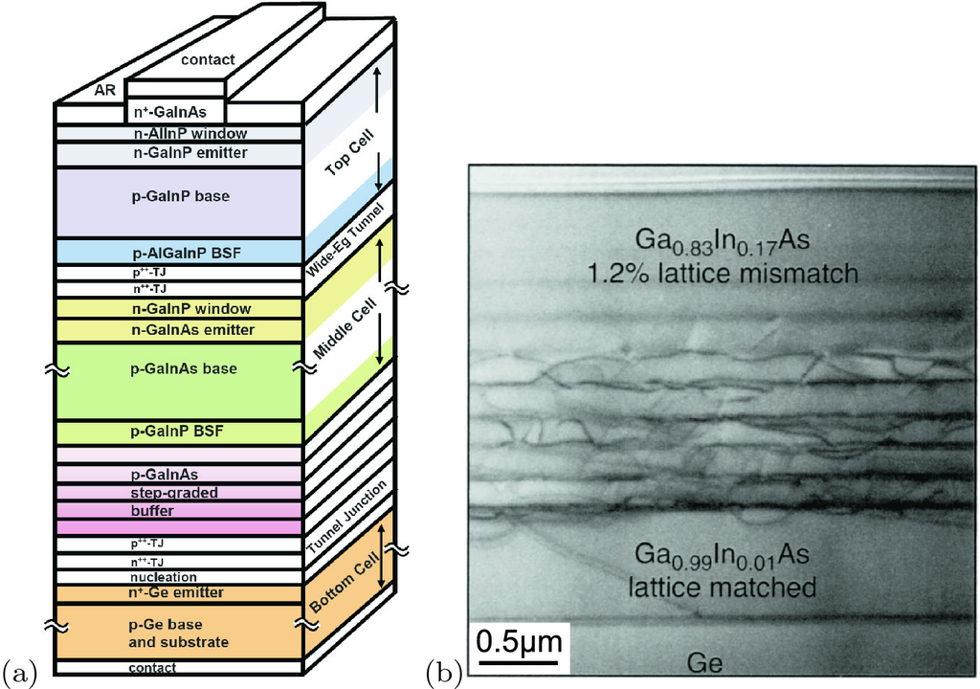

Fig. 22.68

**a** Schematic layer stacking of three-junction (3J) solar cell. The step-graded buffer (metamorphic buffer) changes the in-plane lattice constant for the following layers. Adapted from [1917]. **b** Cross-section TEM image of metamorphic InGaAs buffer on Ge.

Adapted from [1918]

A recent novel route is a tandem cell comprising of a bottom silicon cell and a top perovskite cell. Organo-metal halide peroskites, e.g. of the ammonium trihalogen plumbates type, R-N



PbI



, have exhibited quite high conversion efficiencies [1919, 1920] and can be tuned with regard to their absorption range.

Another concept targeting increased efficiency ands better use of otherwise wasted photons is the ’intermediate band’ solar cell. Here, levels within the band gap of the host, e.g. created by a high doping with suitable elements or quantum dot levels, shall help absorb below band gap photons and pump them into the conduction band of the host. A review on this concept and experimental, results can be found in [1921].

#### 22.4.7 Economic Issues

The cost[12](#u116076_4_En_22_Chapter-Fn12) of producing photovoltaic (PV) modules, in constant dollars, has fallen from as much as $50 per peak watt in 1980 to as little as 3$/Wp in 2004. The cost of about 0.2 $/Wp in 2020, a third of the cost in 2012, is realistic and competitive in many applications (Fig. [22.69](#u116076_4_En_22_Chapter-Fig69)). The price of solar power followed for a while Swanson’s law [1925], i.e. a reduction in price by 22% for a doubling of the installed (cumulated) solar power (dashed line in Fig. [22.69](#u116076_4_En_22_Chapter-Fig69)). After 2005, a rise in silicon cost has lead to a deviation for a few years, but recently the trend has shown even faster cost reductions.

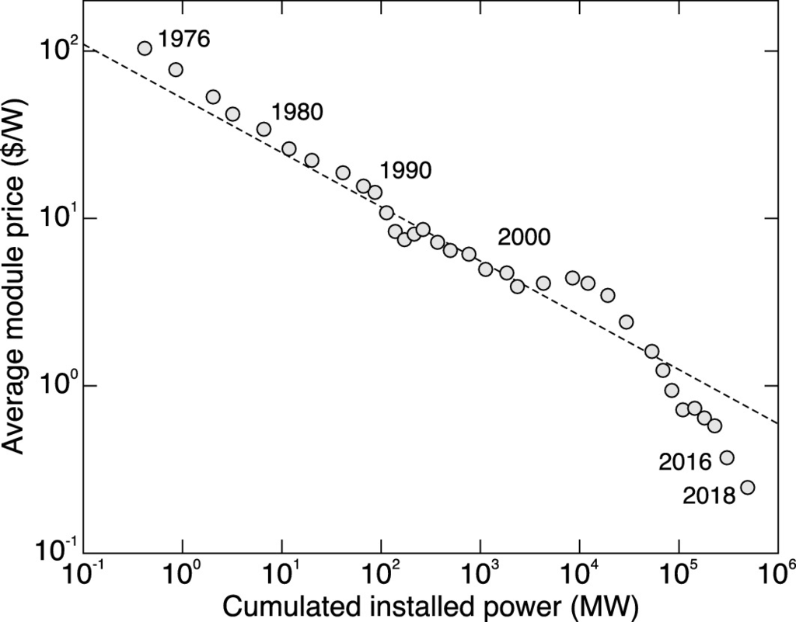

Fig. 22.69

Photovoltaic module price (US$/W) (adjusted to 2002 dollars) vs. the cumulated production. The *dashed line* represents Swanson’s law. Most data from [1924]; data for 2016 and 2018 added from various sources

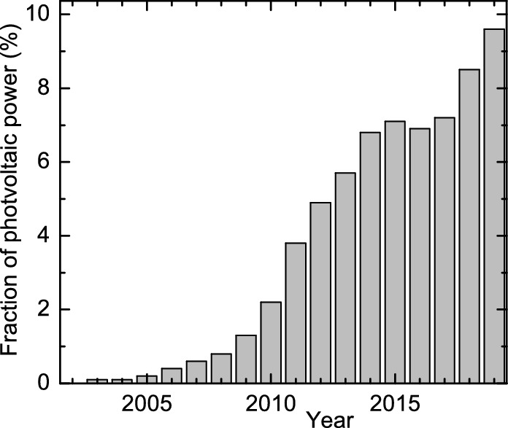

Fig. 22.70

Fraction of photovoltaic power of the total energy from power plants in the public grid in Germany.

Data from [1927]

The energy payback period is also dropping rapidly. For example, it took 2010 typical crystalline silicon module about 4 years to generate more energy than went into making the module in the first place. The next generation of silicon modules, employing a different grade of silicon and use thinner layers of semiconductor material, had 2011 an energy payback of about 2 years [1926]; energy payback time of course also depends on solar irradiation and it reduces from about 2 years in northern Europe to 1.5 y or less in southern Europe [1927]. Thin-film modules bring the payback down to one year or less [1926, 1927]. However, market growth of thin-film modules is currently not faster than the total marker. This means that these modules will produce ‘free’ and clean energy for the remaining 29 years of their expected life.

PV technology can meet electricity demand on any scale. The solar energy resource in a 100 mile-square area of Nevada could supply the United States with all its electricity (about 800 GW), using modestly efficient (10%) commercial PV modules. A more realistic scenario involves distributing these same PV systems throughout the 50 states. Currently available sites, such as vacant land, parking lots, and rooftops, could be used. The land requirement to produce 800 GW would average out to be about

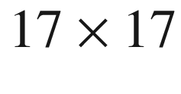

 miles per state. Alternatively, PV systems built in the ‘brownfields’, the estimated 5 million acres of abandoned industrial sites in the US, could supply 90% of America’s current electricity. Solar power is expected to contribute 10% of the US energy need in 2030. For Germany, more than 2% in 2020 was predicted (in 2004) to be probable. In the first half of 2019, photovoltaics actually contributed a total of 9.5% (25.05 TWh); the historic increase is depicted in Fig.[22.70](#u116076_4_En_22_Chapter-Fig70). In June 2019, solar power represented the largest fraction of all anergy carriers with 19.1% (7.17 TWh) in Germany [1927]. The maximum harvested solar power was 33.4 GW (52.4%) on June 29, 2019.

In 2001, PV module shipments in the US approached the 400 MW mark, representing a $2.5 to $3 billion market. The US-based industry itself is now approaching $1 billion per year and provides 25 000 jobs. It is expected to grow to the $10–$15 billion level in the next 20 years, providing 300 000 jobs by 2025. The actual number of jobs in 2018 was 242,000. The newly installed power in 2016 was almost 15 GW for a total of just above 40 GW. In 2017, a total of 50 GW were installed. In 2018, solar power provided 1.66% of total US electricity.

Footnotes

[1](#u116076_4_En_22_Chapter-Fn1_source)

‘Small’ is here in relation to the diffusion length and does not need to be in the range where quantization effects (quantum dots) are present.

[2](#u116076_4_En_22_Chapter-Fn2_source)

The rms value is the square root of the time average of the square of the power,

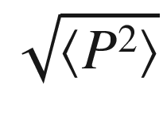

.

[3](#u116076_4_En_22_Chapter-Fn3_source)

For frequencies

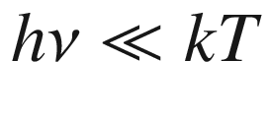

; at room temperature *kT*/*h* is in the THz regime.

[4](#u116076_4_En_22_Chapter-Fn4_source)

The formula for thermal noise ([22.7](#u116076_4_En_22_Chapter-Equ7)) is the fluctuation-dissipation theorem in statistical physics, providing a general relation between the response of an equilibrium system to small external perturbations and its spontaneous fluctuations.

[5](#u116076_4_En_22_Chapter-Fn5_source)

In 1947 the Haloid company bought the rights to this process, renamed itself XeroX and brought the first copy machine to the market in 1958 based on amorphous selenium. The word ‘xerography’ stems from the Greek word

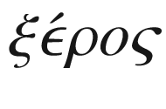

(dry). The last ‘X’ in XeroX was added to mimic the name of the KodaK corporation.

[6](#u116076_4_En_22_Chapter-Fn6_source)

This derivation is done in Sect. [22.3.3](#u116076_4_En_22_Chapter-Sec11). Equation ([22.22](#u116076_4_En_22_Chapter-Equ24)) is obtained from ([22.33](#u116076_4_En_22_Chapter-Equ35)) for vanishing thickness *w* and

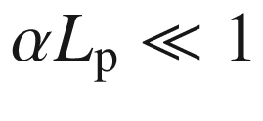

.

[7](#u116076_4_En_22_Chapter-Fn7_source)

At the edge of the depletion layer,

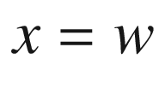

, all photo-generated carriers are transported away instantly, thus the excess carrier density from photo-generated carriers is zero there and ([10.​78](The_Physics_of_Semiconductors00005.docx#u116076_4_En_10_Chapter)) applies.

[8](#u116076_4_En_22_Chapter-Fn8_source)

LT: grown at *low temperature*, i.e. containing many defects that reduce the carrier lifetime.

[9](#u116076_4_En_22_Chapter-Fn9_source)

Employing spatially inhomogeneous Poisson’s equation

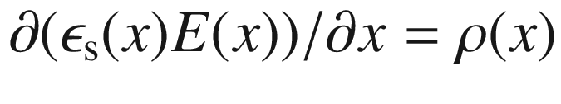

.

[10](#u116076_4_En_22_Chapter-Fn10_source)

We are of course aware that the earth rather rotates around the sun.

[11](#u116076_4_En_22_Chapter-Fn11_source)

Kapton



is a polyimide and a product and registered trademark of DuPont.

[12](#u116076_4_En_22_Chapter-Fn12_source)

Some of the following information is based on [1922–1924].

© Springer Nature Switzerland AG 2021

M. Grundmann

The Physics of Semiconductors

Graduate Texts in Physics

<https://doi.org/10.1007/978-3-030-51569-0_23>

## 23. Electricity-to-Light Conversion

Marius Grundmann[1](#u116076_4_En_23_Chapter-Aff11)

(1)

Felix Bloch Institute for Solid State Physics, Universität Leipzig, Leipzig, Germany

Marius Grundmann

Email:

[grundmann@physik.uni-leipzig.de](mailto:grundmann@physik.uni-leipzig.de)

## Abstract

Light emitting diodes (LEDs) and laser diodes are the focus of this chapter. For LEDs materials choices, the concepts of internal and external quantum efficiency as well as device design are treated. Special devices such as white LEDs, quantum dot and organic LEDs are introduced. For laser diodes the concepts of gain, loss and threshold, various heterostructures for modern device design and laser emission properties such as mode spectrum, far field, dynamics and tunability are discussed. Finally special devices such as the hot hole laser, the cascade laser and semiconductor optical amplifiers are mentioned.

### 23.1 Radiometric and Photometric Quantities

#### 23.1.1 Radiometric Quantities

The radiometric quantities are derived from the radiant flux (power)

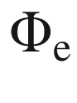

(or usually simply

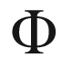

) that is the total power (energy per time) emitted by a source, measured in Watts. The radiant intensity

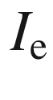

is the radiant flux emitted by a point source into a solid angle,[1](The_Physics_of_Semiconductors00009.docx#u116076_4_En_23_Chapter-Fn1) measured in Watts per steradian (or W/sr). The irradiance

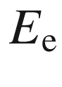

is the radiant flux per area incident on a given plane, measured in W/m

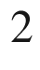

. The radiance

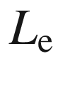

is the radiant flux per area and solid angle as, e.g., emitted by an extended source, measured in W/(m



 sr).

#### 23.1.2 Photometric Quantities

The photometric quantities are related to the visual impression and are derived from the radiometric quantities by weighting them with the

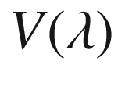

curve.

The luminous flux (luminosity or visible brightness)

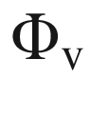

of a source with the radiant flux (spectral power distribution)

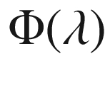

is given by

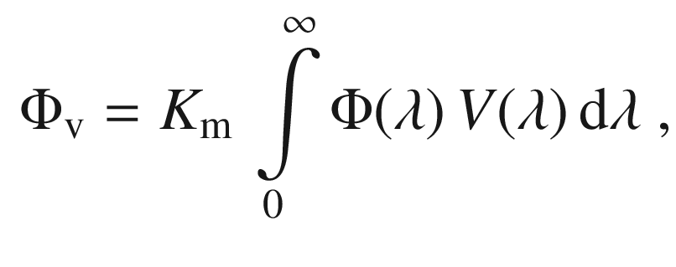

(23.1)

with

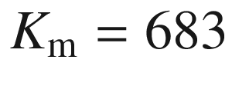

 lm/W. This formula is also the definition of the unit ‘lumen’. In Fig. [23.1](#u116076_4_En_23_Chapter-Fig1)b, the conversion function[2](The_Physics_of_Semiconductors00009.docx#u116076_4_En_23_Chapter-Fn2)

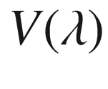

is shown for light and dark adapted vision.[3](The_Physics_of_Semiconductors00009.docx#u116076_4_En_23_Chapter-Fn3)

Further derived photometric quantities are luminous intensity (luminous flux per solid angle), measured in candela (cd), the illuminance (luminous flux per area), measured in lux (lx), and the luminance (luminous flux per area and solid angle). The latter is particularly important if the radiation enters an optical system, e.g. for refocusing. The radiometric and photometric quantities are summarized in Table [23.1](#u116076_4_En_23_Chapter-Tab1).

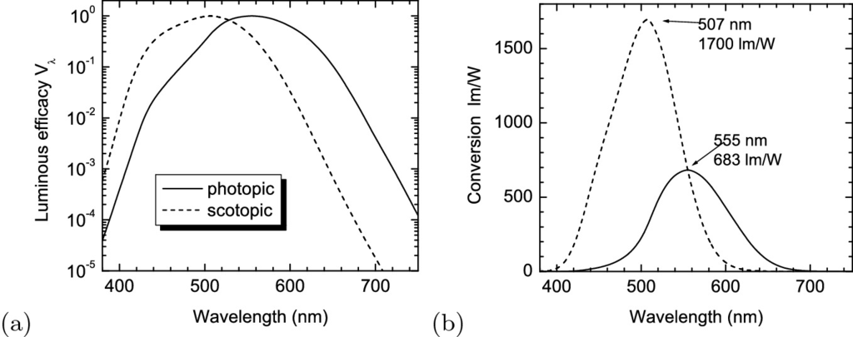

Fig. 23.1

**a** Relative eye sensitivity curves for photopic (light adapted, *solid line*) and (dark adapted, *dashed line*) vision. **b** Conversion of lumen to Watt for light- and dark-adapted vision

Table 23.1

Radiometric and photometric quantities and units. The photometric units are lumen (lm), lux (lx = lm/m

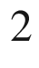

) and candela (cd = lm/sr)

| Radiometric | | | Photometric | | |
| --- | --- | --- | --- | --- | --- |
| Quantity | Symbol | Unit | Quantity | Symbol | Unit |
| Radiant flux | $$\Phi _{\mathrm {e}}$$ | W | Luminous flux | $$\Phi _{\mathrm {v}}$$ | lm |
| Radiant intensity | $$I_{\mathrm {e}}$$ | W/sr | Luminous intensity | $$I_{\mathrm {v}}$$ | cd |
| Irradiance | $$E_{\mathrm {e}}$$ | W/m  $$^2$$ | Illuminance | $$E_{\mathrm {v}}$$ | lx |
| Radiance | $$L_{\mathrm {e}}$$ | W/m  $$^2$$  /sr | Luminance | $$L_{\mathrm {v}}$$ | lm/m  $$^2$$  /sr |

### 23.2 Scintillators

A scintillator (or phosphor) is a material that converts impacting high-energy radiation into photons [1928]. Besides a high conversion efficiency, the spectrum and decay time constant of the scintillator are important for display applications. For display purposes, the photons are directly used for forming the image for the observer. For radiation detection, the photons are fed to a photomultiplier tube and counted.

The most prominent applications, involving the conversion of electrons, are the screens of cathode ray tubes (CRT) (acceleration voltage

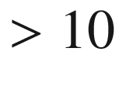

 kV) and of flat panel devices, such as field-effect displays (using a low voltage for excitation, typically

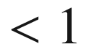

 kV) or plasma displays (using the UV light from the discharge of a plasma placed between two electrodes for excitation). Further details on electroluminescent displays can be found in [1929]. Other forms of radiation detected with scintillators are

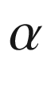

-,

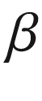

-, and

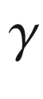

-radiation, X-rays and neutrons [1930]. Different excitation conditions require different phosphors for optimal performance.

#### 23.2.1 CIE Chromaticity Diagram

The CIE[4](The_Physics_of_Semiconductors00009.docx#u116076_4_En_23_Chapter-Fn4) procedure converts the spectral power distribution (SPD)  of light from an object into a brightness parameter *Y* and two chromaticity coordinates *x* and *y*. The chromaticity coordinates map the color[5](The_Physics_of_Semiconductors00009.docx#u116076_4_En_23_Chapter-Fn5) with respect to hue and saturation on the two-dimensional CIE chromaticity diagram. The procedure for obtaining the chromaticity coordinates for a given colored object involves determination of its spectral power distribution

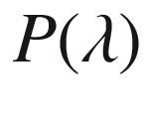

at each wavelength, multiplication by each of the three color-matching functions

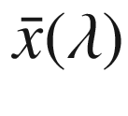

,

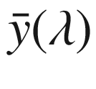

, and

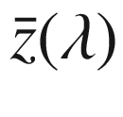

(Fig. [23.2](#u116076_4_En_23_Chapter-Fig2)a) and integration (or summation) of the three tristimulus values *X*, *Y*, *Z*

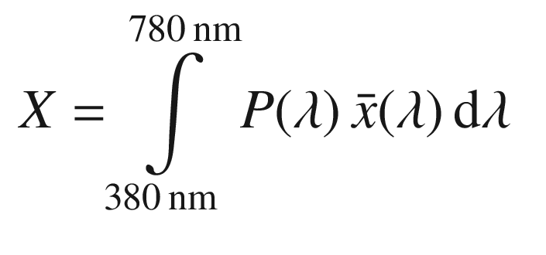

(23.2a)

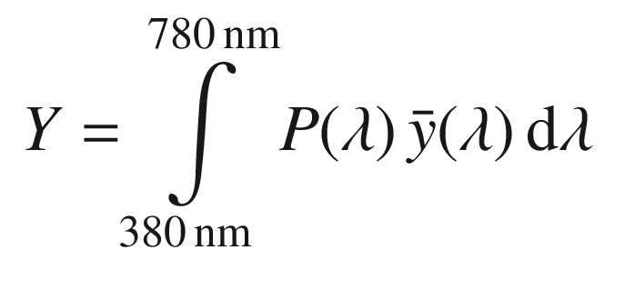

(23.2b)

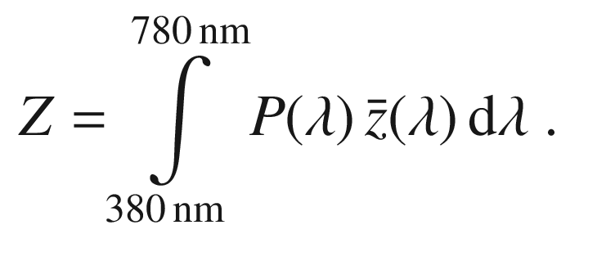

(23.2c)

*Y* gives the brightness. The tristimulus values are normalized to yield the chromaticity coordinates, e.g.

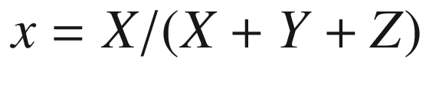

. *x* and *y* obtained in this way are the chromaticity coordinates. The third coordinate

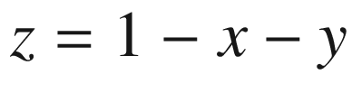

offers no additional information and is redundant. Therefore, the color is represented in a two-dimensional diagram, the CIE chromaticity diagram[6](The_Physics_of_Semiconductors00009.docx#u116076_4_En_23_Chapter-Fn6) as shown in Fig. [23.3](#u116076_4_En_23_Chapter-Fig3)a. White is represented by

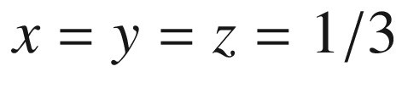

. In order to relate the differences between colors as perceived by the human eye more closely to the geometrical distance in the chart, a revision was made (Fig. [23.3](#u116076_4_En_23_Chapter-Fig3)b) with new coordinates

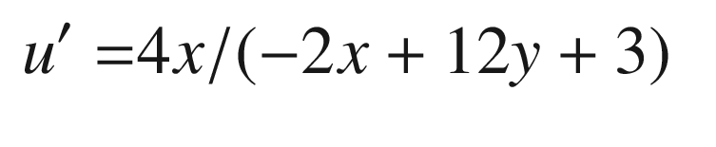

(23.3a)

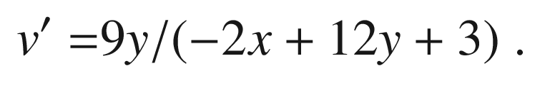

(23.3b)

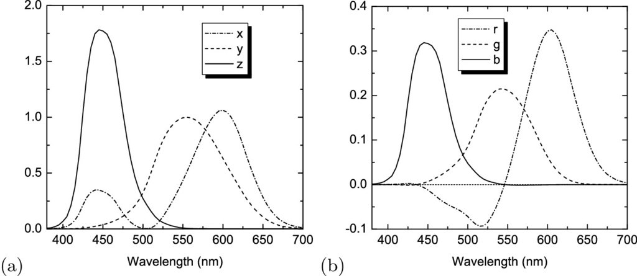

Fig. 23.2

**a** Color-matching functions

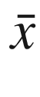

,

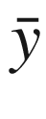

, and

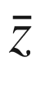

for the calculation of the CIE chromaticity, **b** color-matching functions

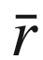

,

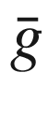

, and

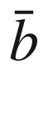

for the calculation of RGB values

For CRTs the red-green-blue (RGB) color space is used.[7](The_Physics_of_Semiconductors00009.docx#u116076_4_En_23_Chapter-Fn7) The color matching functions for RGB values are shown in Fig. [23.2](#u116076_4_En_23_Chapter-Fig2)b. The RGB values are related to the XYZ values according to

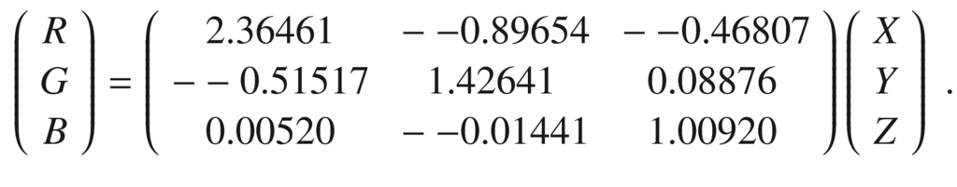

(23.4)

The CIE RGB primaries from 1931 are at 700, 546.1, and 435.8 nm with the relative intensities 1.0, 4.5907, and 0.0601. A display device using three phosphors can only display colors in the triangular area of the CIE chart between the three chromaticity coordinates. For sRGB,[8](The_Physics_of_Semiconductors00009.docx#u116076_4_En_23_Chapter-Fn8) the 1931 CIE primaries and the NTSC[9](The_Physics_of_Semiconductors00009.docx#u116076_4_En_23_Chapter-Fn9) norm the coordinates are given in Table [23.2](#u116076_4_En_23_Chapter-Tab2) and visualized in Fig. [23.3](#u116076_4_En_23_Chapter-Fig3)c. An optimal coverage of the CIE chart involves monochromatic sources (for laser TV or LED displays) at about 680, 520 and 440 nm.

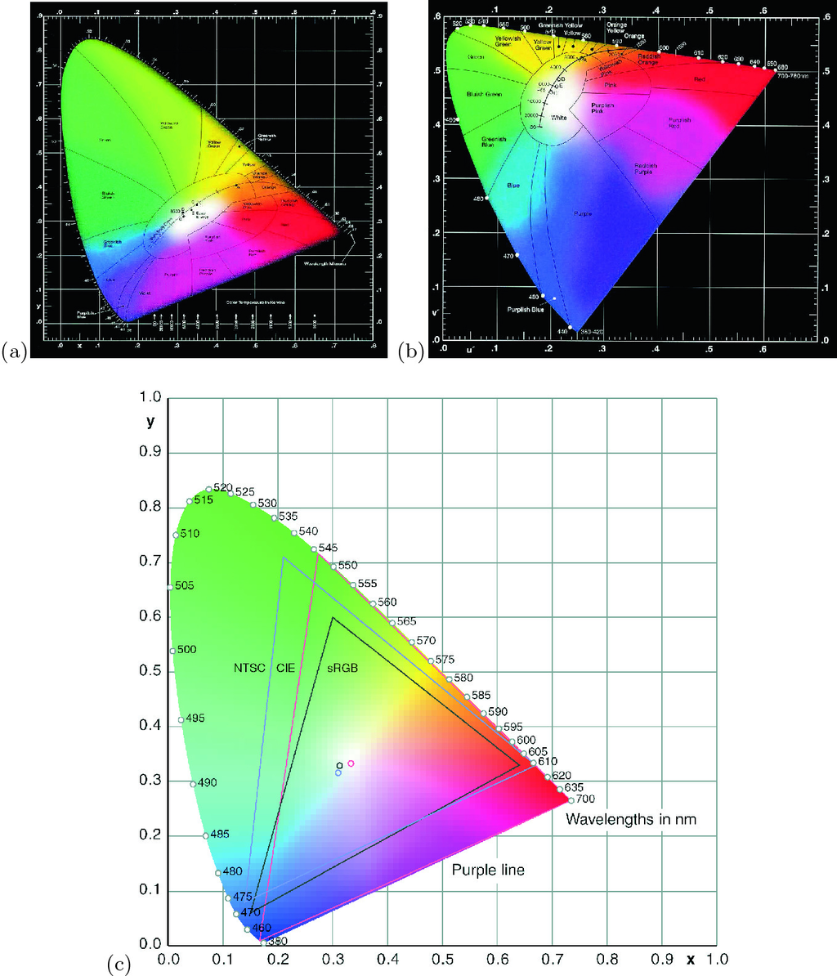

Fig. 23.3

CIE chromaticity diagram from 1931 **a** in the coordinates *x* and *y* and from 1976 **b** in the coordinates

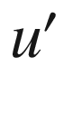

and

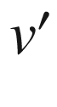

([23.3b](#u116076_4_En_23_Chapter-Equ6)). The curved upper boundary is called the ‘spectrum locus’ and contains monochromatic colors, the straight line at the lower left is termed the ‘purple boundary’. In the graph also the color of blackbody radiation is given,

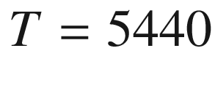

 K corresponds to

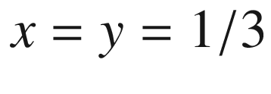

. ‘A’, ‘B’, ‘C’, and ‘E’ are standard illuminants, ‘D65’ denotes daylight with color temperature

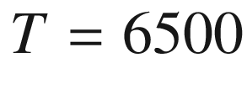

 K. **c** CIE chart with the color ranges of sRGB, CIE and NTSC.

Part **c** adapted from [1931]

Table 23.2

Primaries and white points for sRGB, CIE and NTSC

| Primary | Red | | Green | | Blue | | White | |
| --- | --- | --- | --- | --- | --- | --- | --- | --- |
| CIE | 0.73467 | 0.26533 | 0.27376 | 0.71741 | 0.16658 | 0.00886 | 0.33333 | 0.33333 |
| NTSC | 0.6700 | 0.3300 | 0.2100 | 0.7100 | 0.1400 | 0.0800 | 0.3100 | 0.3160 |
| sRGB | 0.6400 | 0.3300 | 0.3000 | 0.6000 | 0.1500 | 0.0600 | 0.3127 | 0.3290 |

#### 23.2.2 Display Applications

The once ubiquitous amber-colored monochrome displays are mostly fabricated using ZnS:Mn [1929], having broad emission (540–680 nm) with its spectral peak at 585 nm (

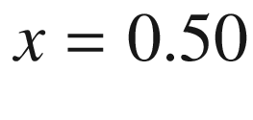

,

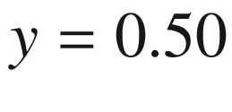

) with an efficiency of 2–4 lm/W. In color television (and similar applications such as color computer monitors, tubes for aviation use, projection television) the image is reproduced by selective and time-multiplexed cathode excitation of three phosphors (blue, green and red) deposited on the internal face of the screen. The chromaticity coordinates of the standard CRT phosphors P-22B, P-22G and P-22R are given in Table [23.3](#u116076_4_En_23_Chapter-Tab3). They cover about the color range labeled ‘sRGB’ in Fig. [23.3](#u116076_4_En_23_Chapter-Fig3)c. For blue and green ZnS:Ag (

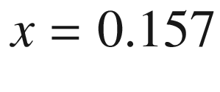

,

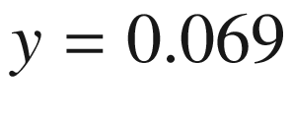

), ZnS:Ag,Cl, ZnS:Ag,Al and ZnS:Cu,Al (

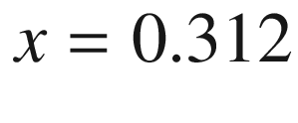

,

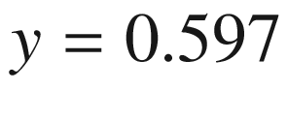

), ZnS:Cu,Au,Al are used as phosphors, respectively. Y



O



S:Eu (

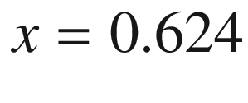

,

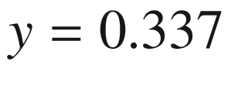

) activated with trivalent europium (Eu

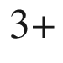

) facilitated such a gain in the brilliance of red over ZnS:Ag (more than doubled it) that it has totally replaced it at about one fifth of the cost. For reproducible image quality, precise grain-size control (median size for CRT phosphors is about 8 µm), dispersion control and surface treatment are necessary. Flat-panel displays with their lower excitation voltage require different phosphors for optimal efficiency.Table 23.3

CIE color coordinates, peak emission wavelength and decay time (10%) of standard CRT phosphors

| Phosphor | *x* | *y* | $$\lambda _{\mathrm {p}}$$  (nm) | Decay time |
| --- | --- | --- | --- | --- |
| P-22B | 0.148 | 0.062 | 440 | $$\sim $$  20 µs |
| P-22G | 0.310 | 0.594 | 540 | $$\sim $$  60 µs |
| P-22R | 0.661 | 0.332 | 625 | 1 ms |

#### 23.2.3 Radiation Detection

The most commonly used scintillation detector for alpha measurements is ZnS activated with silver, ZnS:Ag. This material is not very transparent to light and is usually prepared as a large number of crystals with sub-mm size attached with an adhesive to a flat piece of plastic or other material. The flat screen is optically coupled to a photomultiplier tube that is attached to associated electronics. The voltage and discriminator levels are selected so that the detector is sensitive to the rather large pulses from alpha interactions but insensitive to beta- or gamma-induced pulses. The alpha particles deposit all of their energies in a small thickness of material compared to beta and gamma radiations.

Scintillation detectors for beta radiation are often made from organic materials. In an organic scintillator, the light emission occurs as a result of fluorescence when a molecule relaxes from an excited level following excitation by energy absorption from ionizing radiation. Molecules such as anthracene, trans-stilbene, para-terphenyl, and phenyl oxazole derivatives are among the many organic species that have useful scintillation properties. The organic molecules are dissolved in organic solvents and used as liquid scintillators. A classic application is in the measurement of low-energy beta radiation from, e.g. tritium,

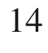

C, or

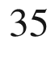

S. In such cases, the sample containing the radioactive beta emitter is dissolved in, or in some cases suspended in, the liquid scintillation solution. The emitted beta radiation transfers energy through the solvent to the scintillator molecule that emits light, subsequently detected by photomultiplier tubes. Organic scintillator molecules can also be dissolved in an organic monomer that can then be polymerized to produce a plastic scintillator in a wide variety of shapes and sizes. Very thin scintillators have been used for alpha detection, somewhat thicker scintillators for beta detection. Large-volume plastic scintillators have been used in gamma detection, particularly for dose-related measurements.

Other inorganic crystalline scintillators, especially sodium iodide activated with thallium, NaI:Tl, have been used for gamma-ray energy measurements. Such detectors can be grown as large single crystals that have a reasonably high efficiency for absorbing all of the energy from incident gamma rays. There exists a rather large number of inorganic scintillators; some examples of these include cesium iodide activated with thallium, CsI:Tl, bismuth germanate, Bi



Ge



O

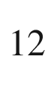

, and barium fluoride, BaF



. These are mostly used for gamma measurements but can also be prepared with thin windows and have been used for charged particle (e.g. alpha and beta) counting. A number of scintillator materials including tungstates like CdWO



has been reviewed in [1932].

In Table [23.4](#u116076_4_En_23_Chapter-Tab4), the peak emission wavelength and the characteristic decay time are listed for a variety of scintillator materials. Direct semiconductors, although not offering the highest efficiency, are particularly useful for high time resolution in, e.g., time-of-flight measurements or fast scanning electron microscopy.Table 23.4

Emission peak wavelength and decay time of various scintillator materials

| Material | $$\lambda _{\mathrm {p}}$$  (nm) | Decay time |
| --- | --- | --- |
| Zn  $$_2$$  SiO  $$_4$$  :Mn | 525 | 24 ms |
| ZnS:Cu | 543 | 35–100 µs |
| CdWO  $$_4$$ | 475 | 5 µs |
| CsI:Tl | 540 | 1 µs |
| CsI:Na | 425 | 630 ns |
| Y  $$_3$$  Al  $$_5$$  O  $$_{12}$$  :Ce | 550 | 65 ns |
| Lu  $$_2$$  SiO  $$_5$$  :Ce | 400 | 40 ns |
| YAlO  $$_3$$  :Ce | 365 | 30 ns |
| ZnO:Ga | 385 | 2 ns |

#### 23.2.4 Luminescence Mechanisms

**Self-Trapped Excitons**

In a strongly ionic crystal, such as NaI, a hole becomes localized to an atomic site via the polaron effect. A spatially diffuse electron is attracted, and a self-trapped exciton is formed that can recombine radiatively.

**Self-Activated Scintillator**

In such material, the luminescent species is a constituent of the crystal. The emission involves an intraionic transition, e.g. 6p

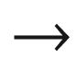

6s in Bi

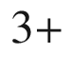

of Bi



Ge



O

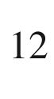

, or a charge-transfer transition in the case of (WO



)

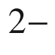

in CaWO



. At room temperature, nonradiative competing processes limit the efficiency.

**Activator Ions**

For dopant ions such as Eu

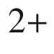

in YO



S:Eu, Ce

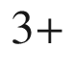

in YAlO



:Ce or Tl

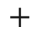

in NaI:Tl, the hole and electron excited by the radiation are sequentially trapped by the same ion that then undergoes a radiative transition, in the case of Eu and Ce[10](The_Physics_of_Semiconductors00009.docx#u116076_4_En_23_Chapter-Fn10) 5d

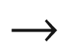

4f, for Tl

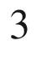

P

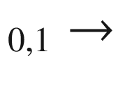

S



. CsI:Tl has one of the highest efficiencies of 64.8 photons/keV [1933].

**Core–Valence Luminescence**

In some materials, e.g., BaF



, CsF, BaLu



F



the energy gap between the valence band and the top core band is less than the fundamental band gap. A radiative transition occurs when an electron from the valence band fills a hole in the top core band that has been created by the radiation. The light yield is limited to about 2 photons/keV.

**Semiconductor Recombination Processes**

Free excitons or excitons bound to impurities can recombine radiatively. This process is most efficient at low temperatures. At room temperature, the emission is typically much weaker (

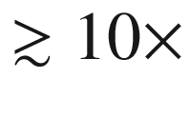

) since excitons become unbound or dissociated. Highly doped n-type semiconductors, e.g. CdS:In, exhibit recombination between donor-band electrons and holes. ZnO:Ga has an efficiency of about 15 photons/keV and a fast response (with 2.4 photons/keV emitted in the first 100 ps). Luminescence can also stem from donor–acceptor pair transitions, e.g. in PbI



with an efficiency of 3 photons/keV at 10 K. Isoelectronic impurities such as nitrogen in GaP:N and tellurium in CdS:Te attract an electron and subsequently a hole. In ZnS:Ag and ZnS:Cu (conduction) band to trap recombination is dominant. In a codoping scheme like CdS:In,Te, In supplies electrons in an impurity band that can recombine with holes trapped at Te.

### 23.3 Light-Emitting Diodes

#### 23.3.1 Introduction

Light-emitting diodes (LEDs) are semiconductor devices in which injected carriers recombine radiatively. The recombination process leading to light emission can be of intrinsic nature, i.e. band–band recombination, or extrinsic, e.g. impurity-bound excitons. Impurity-related luminescence can also be excited via impact excitation. For an extensive treatment of LEDs see [1934, 1935], for a review of the early field [1936] and for recent reviews [1937, 1938]. Mostly LEDs are pn-diodes although also some MIS-based devices have been reported [1939, 1940].

#### 23.3.2 Spectral Ranges

Applications for LEDs can be sorted by the color of emission. In Fig. [23.4](#u116076_4_En_23_Chapter-Fig4), the standard sensitivity

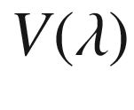

of the human eye is shown (see Fig. [23.1](#u116076_4_En_23_Chapter-Fig1)a). In the visible spectral region (about 400–750 nm) the perceived brightness of the LED depends on the eye sensitivity. It is largest in the green (at 555 nm) and drops strongly towards the red and blue.

The most important spectral regions and applications are:

infrared (

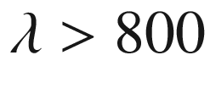

 nm): remote controls, optocouplers, low-cost data transmission, IR interface

visible: indicator LED, lighting[11](The_Physics_of_Semiconductors00009.docx#u116076_4_En_23_Chapter-Fn11) (room, buildings, cars), white LED for broad spectrum

ultraviolet (

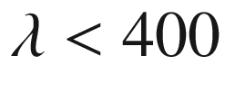

 nm): pumping of phosphors for white LEDs, biotechnology

In Fig. [23.4](#u116076_4_En_23_Chapter-Fig4), potentially useful semiconductors for the various spectral regions are shown. The semiconductors that are currently used for the various colors of the visible spectrum are

red–yellow: Ga(As,P)/GaAs, now (Al,In,Ga)P/GaP

yellow–green: GaAsP:N, GaP:N

green–blue: SiC, now GaN, (In,Ga)N

violet: GaN

ultraviolet: (Al,Ga)N

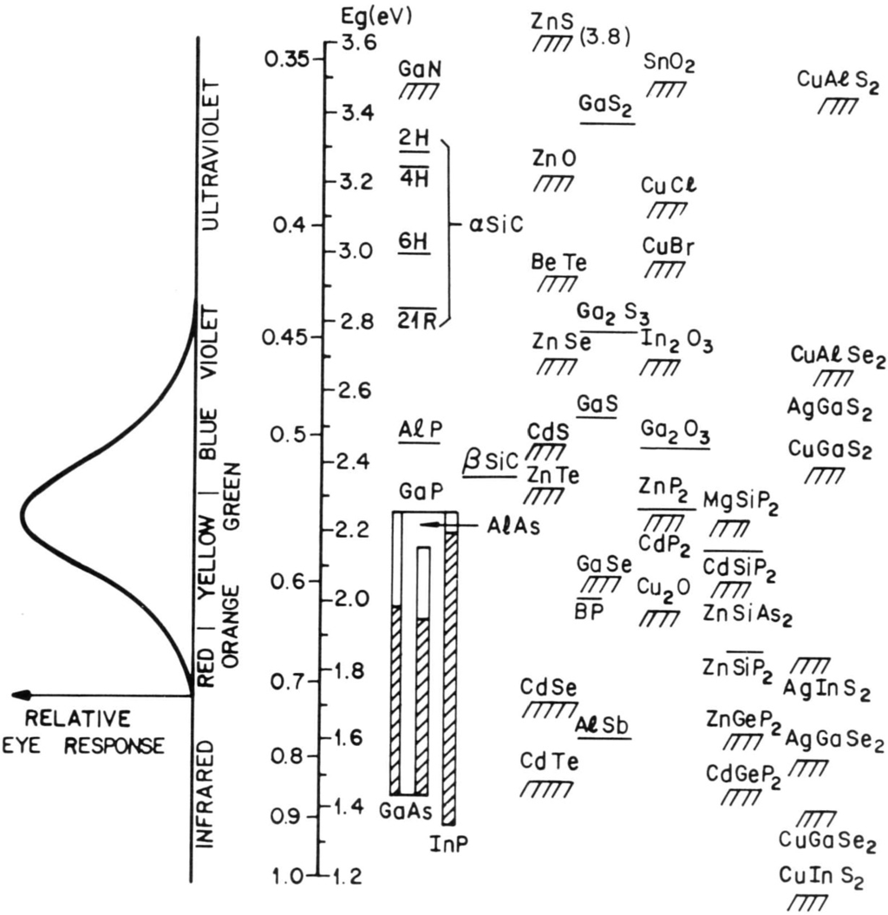

Fig. 23.4

Spectral coverage by various semiconductor materials.

Reprinted with permission from [574], ©1981 Wiley

#### 23.3.3 Efficiencies

**External Quantum Efficiency**

The *external* (or total) quantum efficiency

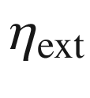

is the number of photons emitted from the device per injected electron–hole pair. It is given by the product of the *internal* quantum efficiency

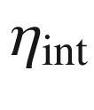

and the light extraction efficiency

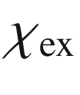

:

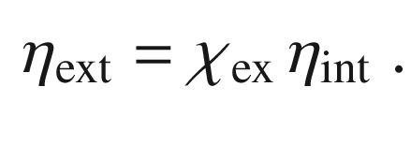

(23.5)

In a commercial device another factor, the packaging efficiency may enter which accounts for photon loss due to packaging the LED dice into its housing.

**Wall-Plug Efficiency**

The wall-plug efficiency

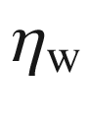

is the power conversion ratio of the electrical power and the light output

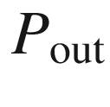

,

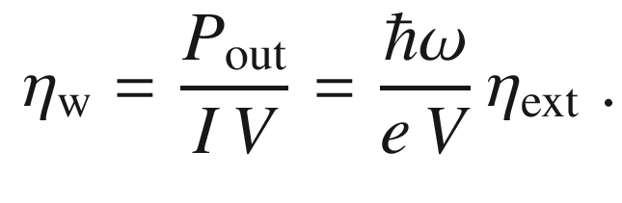

(23.6)

At first it seems reasonable to assume that always

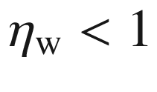

. However, it has been reported that at small current and at elevated temperature the wall-plug efficiency is found larger than 100% due to the electrical work pumping heat from the lattice to the photon field in a GaSb-based diode[1941]. The groundwork for such effect was laid in [1942], essentially predicting that

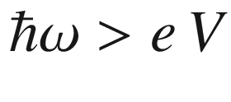

is possible.

**Internal Quantum Efficiency**

The internal quantum efficiency is the number of photons generated (inside the semiconductor) per injected electron–hole pair. High material quality, low defect density and low trap concentration are important for a large value of

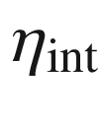

. The recombination current in the pn-diode is given in ([21.​136](The_Physics_of_Semiconductors00007.docx#u116076_4_En_21_Chapter)).

**Light Extraction Efficiency**

The light extraction efficiency of the LED chip is ratio of the number of photons leaving the device and the total number of generated photons.[12](The_Physics_of_Semiconductors00009.docx#u116076_4_En_23_Chapter-Fn12) The geometry of the LED is of prime importance to optimize

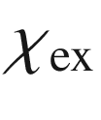

. Due to the large index of refraction of the semiconductors (

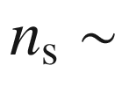

2.5–3.5), light can leave the semiconductor only under a small angle

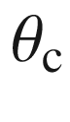

from the surface normal due to total reflection (cf. ([9.​11](The_Physics_of_Semiconductors00004.docx#u116076_4_En_9_Chapter)) and see right part of Fig. [9.​4](The_Physics_of_Semiconductors00004.docx#u116076_4_En_9_Chapter-Fig4)). Against air (

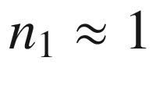

) the critical angle is

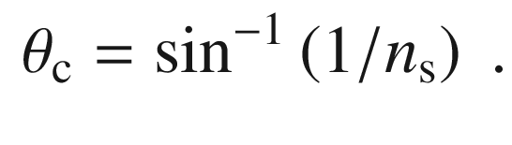

(23.7)

The critical angle for total reflection is 16

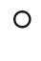

for GaAs and 17

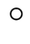

for GaP. Additionally, a portion of the photons that do not suffer total reflection is reflected back from the surface with the reflectance *R* given by (cf. ([9.​15](The_Physics_of_Semiconductors00004.docx#u116076_4_En_9_Chapter)))

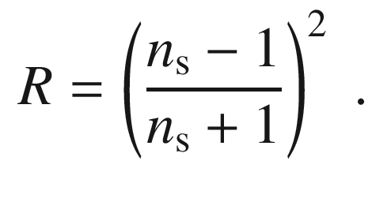

(23.8)

We note that the above formula is valid strictly for vertical incidence. For the GaAs/air interface, the surface reflectance (for normal incidence) is about 30%. Thus, the light extraction efficiency for a LED is given by (1–*R*) and the critical angle by

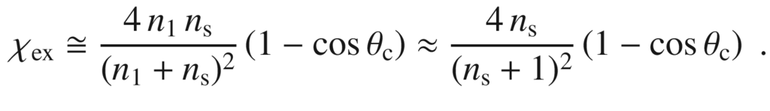

(23.9)

The latter approximation is valid when the outer medium is air. For GaAs, the light extraction efficiency is

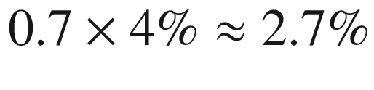

. Thus, for this simple geometry, only a small fraction of generated photons can leave the device and contribute to the LED emission.

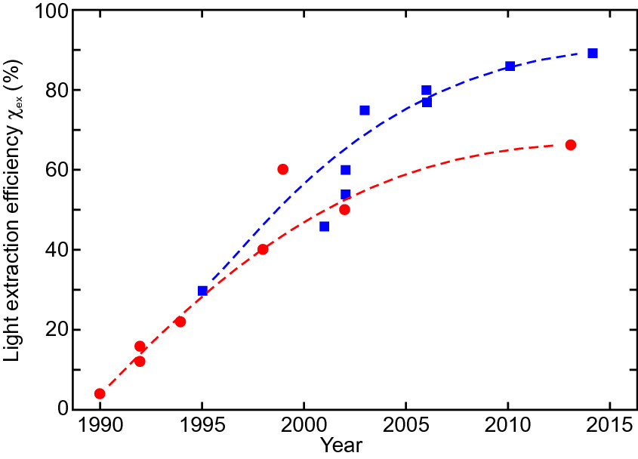

Fig. 23.5

Historic development of maximum light extraction efficiency for AlGaInP (*red circles*) and (In,Ga)N (*blue squares*) LEDs. *Dashed lines* are guides to the eye.

Adapted from [1938, 1944]

#### 23.3.4 Device Design

In the following subsections the strategies that have allowed significant improvement of the extraction efficiency (Fig. [23.5](#u116076_4_En_23_Chapter-Fig5)) and thus LED performance are briefly discussed. The record by 2014 for light extraction efficiency is 89% [1943], however not for a mass-produced device.

**Nonplanar Surfaces**

With curved surfaces, the problem of total reflection can be (partially) circumvented (Fig. [23.6](#u116076_4_En_23_Chapter-Fig6)). Spherically polished chips are feasible, but, very expensive. The epoxy seal of the standard LED case (Fig.[23.7](#u116076_4_En_23_Chapter-Fig7)a) and its shape play a similar role, however, with a smaller index of refraction than the semiconductor, and are important for the beam shape.

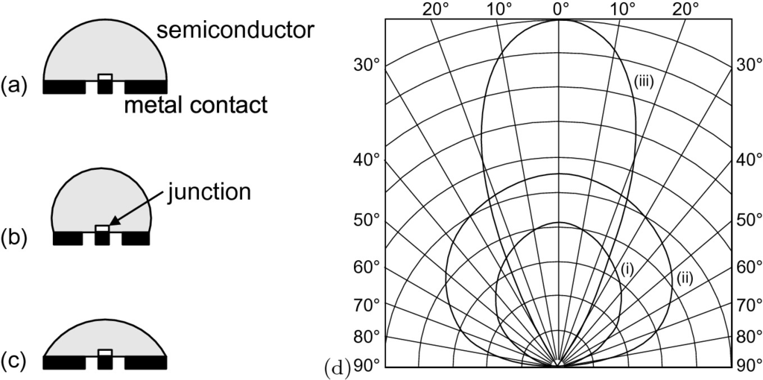

Fig. 23.6

Form of various LED casings with **a** hemispherical, **b** truncated sphere and **c** parabolic geometry. Adapted from [1945]. **d** Emission characteristics for rectangular (**i**), hemispheric (**ii**) and parabolic (**iii**) geometry.

Adapted from [1946]

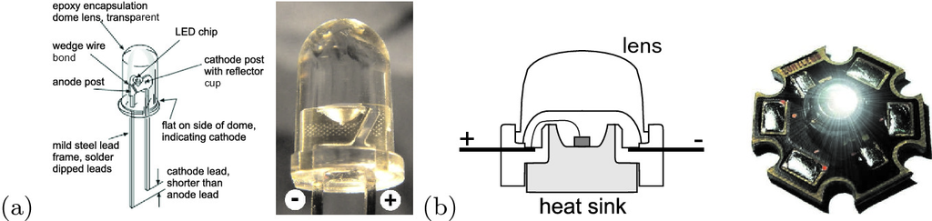

Fig. 23.7

**a** Standard LED casing (schematic drawing and macrophoto), **b** high-power mounting (schematic drawing and image of Luxeon



LED)

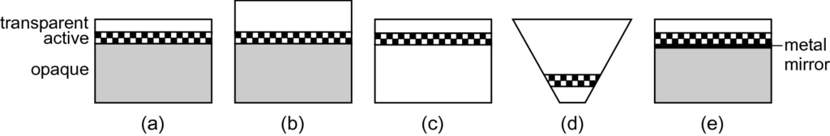

Fig. 23.8

**a** Standard LED layer sequence with opaque substrate (*grey*), active layer (*checkered*) and transparent top, **b** thick window design with thick top layer (50–70 µm). **c** Transparent substrate (by rebonding, see Fig. [23.9](#u116076_4_En_23_Chapter-Fig9), **d** chip shaping (cf. also Fig. [23.11](#u116076_4_En_23_Chapter-Fig11)). **e** Thin-film LED with metal mirror (*black*) and rebonding (cf. also Fig. [23.12](#u116076_4_En_23_Chapter-Fig12))

**Thick-Window Chip Geometry**

An increase in light extraction efficiency to about 10–12% can be achieved if the top layer is fabricated with a much larger thickness (Fig. [23.8](#u116076_4_En_23_Chapter-Fig8)b) of 50–70 µm instead of a few µm. However, such approach is not scalable since larger device area would demand even larger thickness.

**Transparent Substrate**

Reflection of photons is not so detrimental if they are not lost later due to absorption in the substrate. In Fig. [23.8](#u116076_4_En_23_Chapter-Fig8), the evolution of LED chip design is shown schematically. In Fig. [23.9](#u116076_4_En_23_Chapter-Fig9), the light path is compared for opaque and transparent substrates. The latter provides higher light extraction efficiency due to the ‘photon recycling’ effect. Efficiencies of 20–25% are possible. In Fig. [23.10](#u116076_4_En_23_Chapter-Fig10), the technological steps are shown to fabricate a GaP LED with an AlGaInP active layer. The active layer is initially grown on GaAs due to lattice-match conditions.

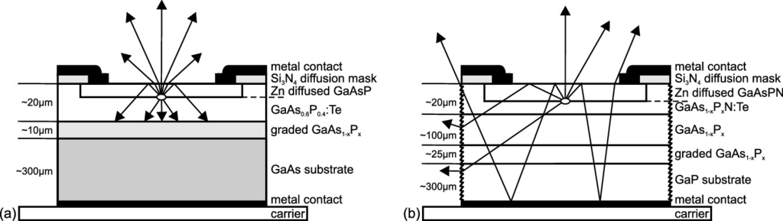

Fig. 23.9

Comparison of light paths in a GaAsP-based LED with **a** opaque (GaAs) and **b** transparent (GaP) substrate (side facets roughened).

Adapted from [1947]

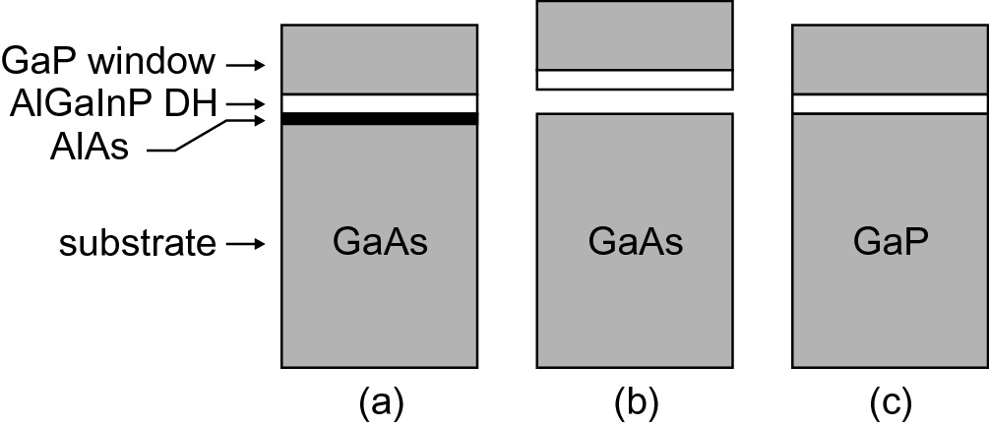

Fig. 23.10

Scheme of fabrication for red high brightness LED: **a** AlGaInP double heterostructure (DH) with GaP window on GaAs substrate (growth with MOCVD). **b** Lift-off using HF etch of sacrificial AlAs layer. **c** Wafer bonding on GaP (transparent for red light)

**Nonrectangular Chip Geometry**

If the chip is made with an inverted structure and mounted on a mirror, a high light extraction efficiency (

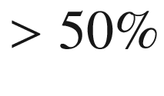

) can be achieved. Typical commercial designs are shown in Fig. [23.11](#u116076_4_En_23_Chapter-Fig11).

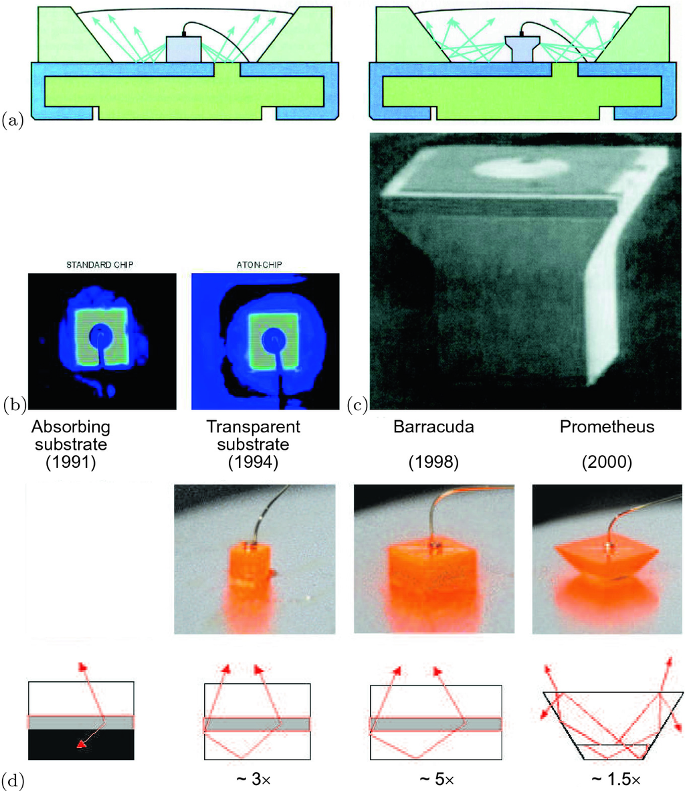

Fig. 23.11

Optimization of light exit by 3D design of the LED chip, **a** scheme, **b** emission pattern comparison and **c** SEM image of the ATON chip. Reprinted with permission from [1948]. **d** Development stages towards the truncated inverted pyramid (Prometheus) chip. From [1949]

The increase in quantum efficiency allows the devices to run on much higher output power. While initially LEDs delivered power only in the mW regime, now output power in the

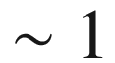

 W regime is possible (high brightness LEDs). The higher currents made a redesign of the LED mount towards better heat sinks necessary (Fig. [23.7](#u116076_4_En_23_Chapter-Fig7)b). While the standard case has a thermal resistance of 220 K/W (chip size (0.25 mm)

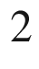

for 0.05–0.1 W and 0.2–2 lm), the high-power case has 15 K/W (chip size (0.5 mm)

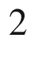

for 0.5–2 W and 10–100 lm). An epoxy-free technique for encapsulation also enhances the color uniformity and maintains the brightness.

**Thin-Film LED**

In the thin-film LED design [1950], as schematically shown in Fig. [23.12](#u116076_4_En_23_Chapter-Fig12)a, a metal mirror is evaporated on the LED layers. In a flip-chip design, subsequently the metal side is wafer bonded to another metallized substrate and the original substrate is removed. Additionally, the LED surface can be patterned (before bonding) into an (hexagonal) array of (hexagonal) microprism mesas with an insulating (e.g. silicon nitride) layer with openings in order to optimize the current path. The microprisms are optimized to allow efficient reflection of light towards the emitting surface. This technology is scalable to large areas without loss in efficiency.

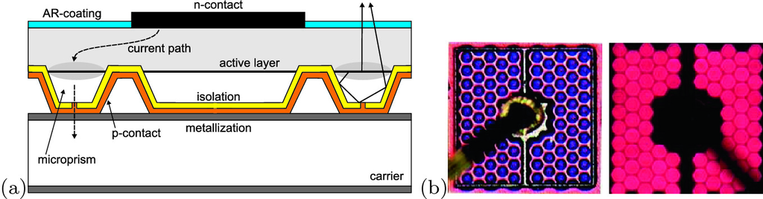

Fig. 23.12

**a** Scheme of thin-film flip-chip LED with microprisms. **b** image and luminescence image of thin film AlInGaP LED (chip length: 320 µm).

Reprinted with permission from [1951]

In order to avoid bonding from the top which leads to partial shielding of the emitted radiation and is a mechanical process, contact schemes for flip-chip LEDs have been devised for contacting both the n- and the p-layer from the same side [1952]. In Fig. [23.13](#u116076_4_En_23_Chapter-Fig13) a schematic cross-section and an emission image are shown. Here, the n-contact runs through a via hole with insulated side walls. In the emission image the array of via holes can be seen.

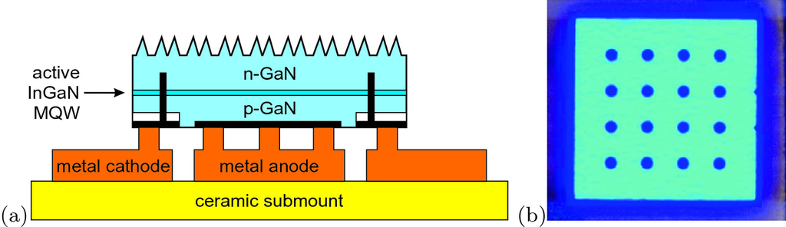

Fig. 23.13

**a** Scheme of thin-film flip-chip LED with rough surface and contacts from one side. **b** Emission image of

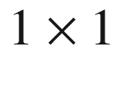

 cm

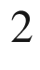

chip.

Adapted from [1952]

**Bulk Flip-Chip**

In the GaN material system a LED based on a triangular chip with 400 µm side length using a bulk substrate with 150 µm thickness has been presented that exhibits the so far highest extraction efficiency of almost 90% (Fig.[23.14](#u116076_4_En_23_Chapter-Fig14)) [1943, 1953]. The top and all side facets are rough.

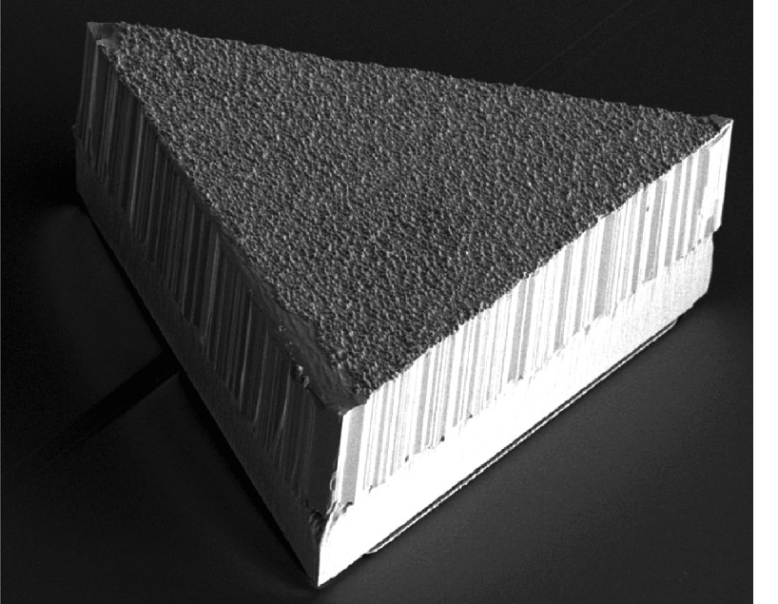

Fig. 23.14

Triangular GaN LED chip with high extraction efficiency. Both the p- and n-contact are on the bottom.

Adapted from [1943]

**Cascaded LEDs**

Similar to the use of tunneling junctions in multi-junction solar cells (Sect. [22.​4.​6](#u116076_4_En_22_Chapter)), the monolithic serial connection of several LED layers has been proposed [1954] (Fig. [23.15](#u116076_4_En_23_Chapter-Fig15)). For a given output power *P* at forward voltage

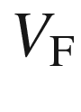

and current density *j* of a single junction LED, ideally a LED with *N* identical stacks and

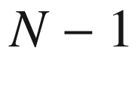

tunneling junctions provides the same output power *P* at the *N*-fold forward voltage, as reported for

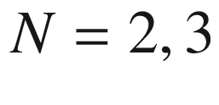

in [1955], and the current density *j*/*N*. Since the internal quantum efficiency of LEDs decreases with increasing current density (*droop*), such stacked LED design holds promise for increased wall-plug efficiency if the series resistance of the tunneling junctions is small. The quantum efficiency of such device is then larger than *N* times the efficiency of the single stack LED and thus way larger than 100% (similar to quantum cascade lasers, Sect. [23.4.16](The_Physics_of_Semiconductors00009.docx#u116076_4_En_23_Chapter-Sec33)).

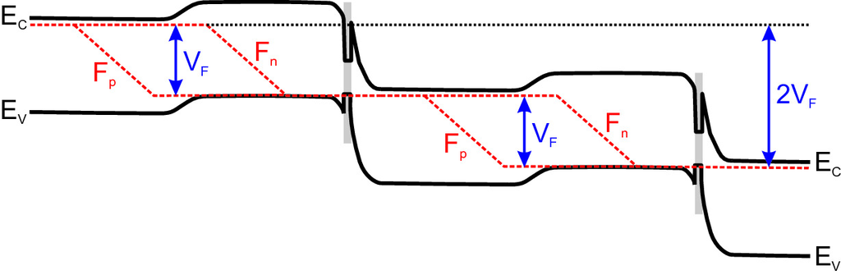

Fig. 23.15

Schematic band structure of cascaded LED. The *grey area* denotes an additional heterostructure for reduction of the series resistance of the tunnel junctions.

Adapted from [1954]

**Historic Development**

In Fig. [23.16](#u116076_4_En_23_Chapter-Fig16), the historic development of the LED luminous efficacy (luminous flux per electrical input power) is shown for various material systems. While the luminosity has increased by a factor of 20 per decade in the last 40 years, the price has decreased by a factor of ten per decade (Fig. [23.17](#u116076_4_En_23_Chapter-Fig17)). Currently, there is a need for the development of more efficient LEDs in the green spectral range [1956] since their luminosity is small compared to devices for the blue and red spectral regions (Fig. [23.18](#u116076_4_En_23_Chapter-Fig18)).

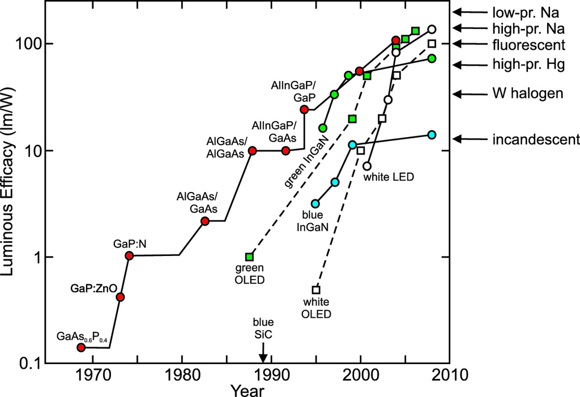

Fig. 23.16

Historic development of the luminous efficacy of semiconductor LEDs and OLEDs. Based on [1957] with the addition of data on OLEDs and recent data on LEDs. The arrows on the right indicate efficacy of various other light sources

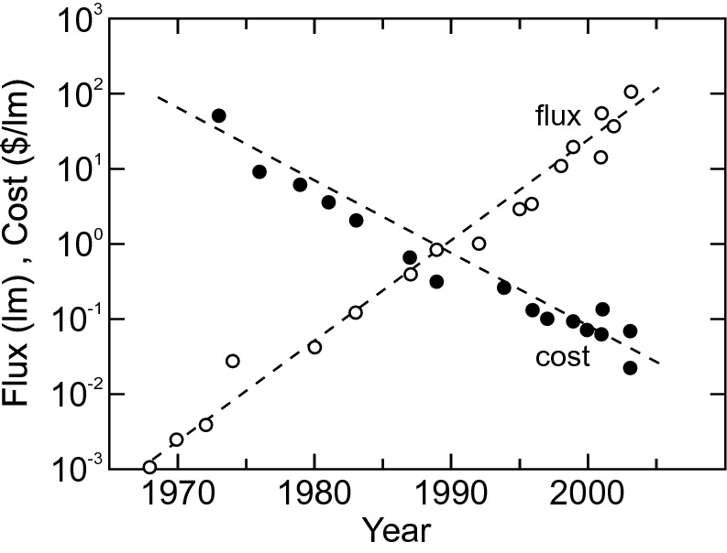

Fig. 23.17

Historic development of the flux (in lumen) and cost (in $/lm) for semiconductor LEDs.

Data from [1949]

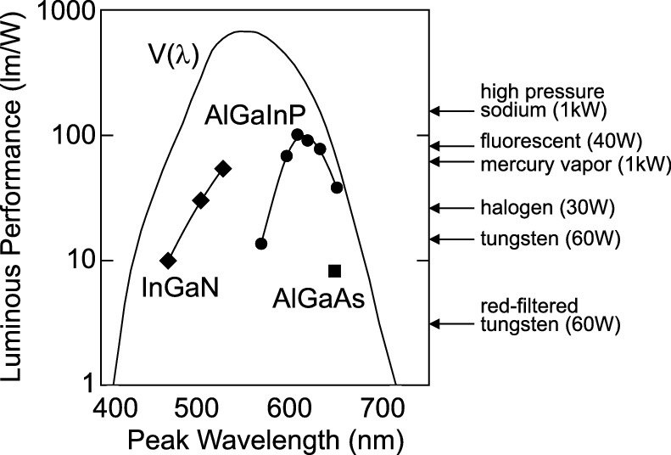

Fig. 23.18

Luminous performance of various LED materials in comparison with other light sources.

Adapted from [1957]

#### 23.3.5 White LEDs

There are different possibilities to generate white light with an LED as shown schematically in Fig. [23.19](#u116076_4_En_23_Chapter-Fig19). The highest color gamut and a tunable white point can be achieved by combining a red, a green and a blue LED (Fig. [23.19](#u116076_4_En_23_Chapter-Fig19)a). Using a blue LED and a yellow phosphor (Figs. [23.19](#u116076_4_En_23_Chapter-Fig19)b and [23.20](#u116076_4_En_23_Chapter-Fig20)a,b), a white spectrum can be achieved that is, however, not very close to a blackbody spectrum (Fig. [23.20](#u116076_4_En_23_Chapter-Fig20)c). A better color rendering can be obtained with the combination of two phosphors [1958]. With an UV LED that is itself invisible (and must be shielded so no UV radiation leaves the LED), phosphors with various colors can be pumped (Fig. [23.19](#u116076_4_En_23_Chapter-Fig19)c). The mix of phosphors determines the white point.

Using a blue-emitting LED based on (In,Ga)N material, phosphors (similar to those used in fluorescence lamps) can be pumped. Blue light is converted into green, yellow or red light such that the resulting total spectrum appears white to the human eye. Also, a broad range of other colors can be designed (color on demand), e.g. pink or particular corporate colors.

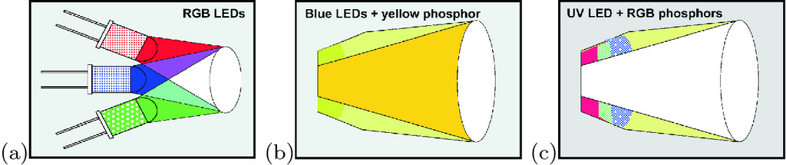

Fig. 23.19

Different strategies to generate white light with LEDs. **a** Additive mixing of R, G, and B LEDs, **b** blue LED and yellow phosphor, **c** UV LED (invisible) and R, G, and B phosphors.

From [1949]

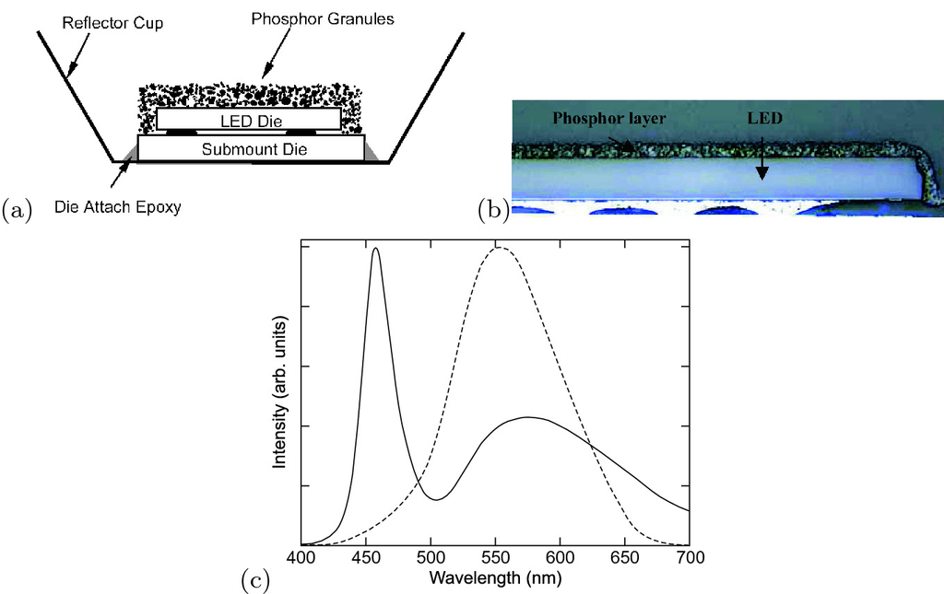

Fig. 23.20

**a** Scheme and **b** image of color conversion Luxeon



LED. From [1949]. **c** Spectrum (*solid line*) of white LED with blue LED pumping a yellow phosphor together with eye-sensitivity curve

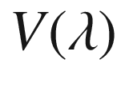

(*dashed line*).

Adapted from [1951]

The color of a white LED depends on the operation conditions. In Fig. [23.21](#u116076_4_En_23_Chapter-Fig21)a the intensity vs. dc driving current characteristic of a white LED is shown. In Fig. [23.21](#u116076_4_En_23_Chapter-Fig21)b the chromaticity coordinates are shown for various dc currents. A change of wavelength with forward voltage occurs for the blue-emitting (In,Ga)N material due to filling of low-energy states (Fig. [23.22](#u116076_4_En_23_Chapter-Fig22)). In order to avoid this effect, the LED is driven with pulses of a fixed current amplitude and a repetition frequency that is high enough to provide a flicker-free image to the human eye, e.g. 100 Hz. The intensity of the LED is modulated via the pulse width, i.e. between 0–10 ms in this case (PWM, pulsewidth modulation).

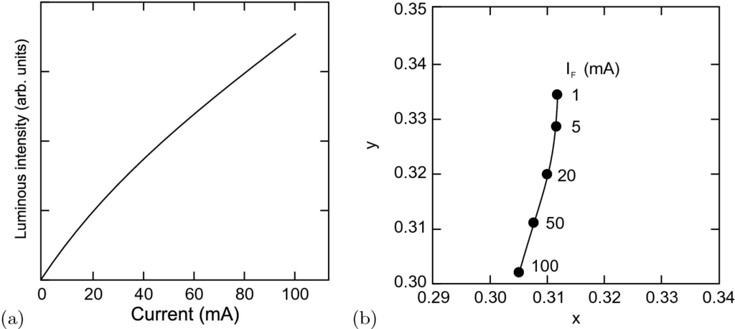

Fig. 23.21

**a** Luminous intensity of white LED (NSCW215) vs. dc forward current. **b** CIE chromaticity coordinates for various dc driving conditions as labeled.

Data taken from [1959]

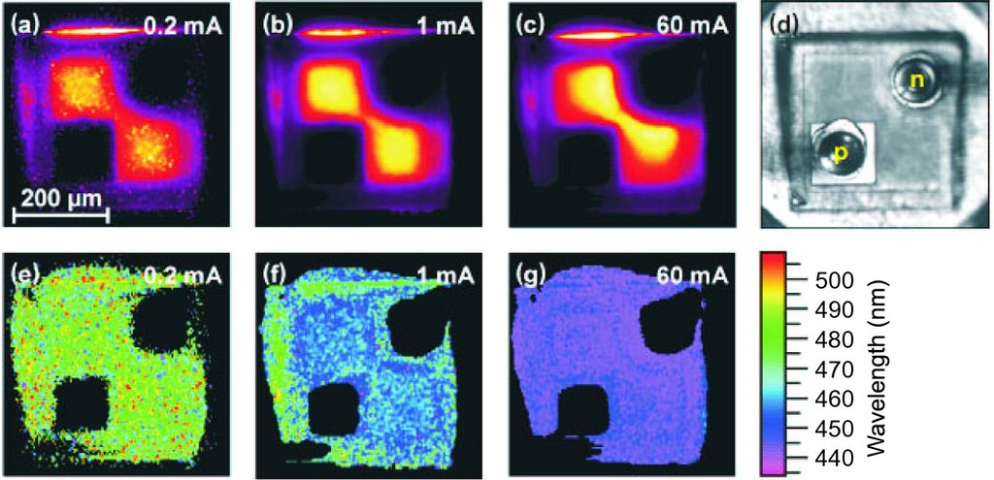

Fig. 23.22

**a**–**c** Electroluminescence intensity map of (In,Ga)N LED at different currents as labeled. **d** Optical image of the LED chip (top view). **e**–**g** Wavelength images (wavelength of spectral emission maximum) for different currents.

Adapted from [1960]

The direct light from white LEDs is visually appealing and cannot be distinguished from a blackbody source of matching temperature. But since the spectral power distribution of white LEDs is different from natural light, objects illuminated by such light source can appear in ‘wrong’ colors. For the spectrum of Fig. [23.20](#u116076_4_En_23_Chapter-Fig20)c, in particular green is reproduced poorly. A quantitative measure for the ability of a light source to reproduce the colors of an illuminated object faithfully compared with a natural (blackbody) light source is the *color rendering index* (CRI).

A major advantage of LEDs for display and lighting applications is their long lifetime compared to halogen (about 2000 h), xenon (10,000 h) or fluorescent (6000–10,000 h) lights. Philips Lumileds projects (for white LUXEON® K2 LEDs) 70% lumen maintenance at given current (1 A) at 50,000 h for junction temperature

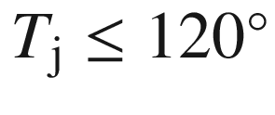

[1961]. Similar values are given by OSRAM [1964] for white high power LEDs (Fig. [23.23](#u116076_4_En_23_Chapter-Fig23)). A current problem is the decrease of efficiency with increasing current density termed *droop*, probably due to Auger recombination [1962, 1963].

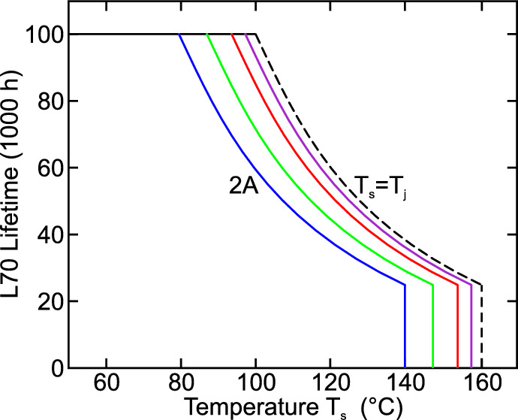

Fig. 23.23

Lifetime for 70% lumen as a function of solder temperature

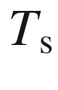

(for white Diamond Dragon® LED) for various driving currents (0.3, 0.7, 1.4 and 2.0 A, *solid lines* from right to left). The *dashed line* is for low driving current and

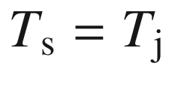

.

Adapted from [1964]

#### 23.3.6 Quantum Dot LEDs

Quantum dots are an interesting active medium for LEDs due to their spectroscopic properties (Sect. [14.​4.​4](The_Physics_of_Semiconductors00006.docx#u116076_4_En_14_Chapter)).

**Ultranarrow Spectral Emission**

A LED based on a single QD exhibits a rather unique spectrum consisting of a single spectral line, at least at low temperatures [1965], due to exciton recombination as shown in Fig. [23.24](#u116076_4_En_23_Chapter-Fig24). Such device can deliver single photons on demand and be a photon source for quantum cryptographic communication. At higher current also biexciton recombination appears. In [1966, 1967] the triggered emission of photon pairs from cascade-like XX and X recombination in a single dot and their polarization entanglement is reported. Entanglement is related to degenerate X and XX emission energy [1968] (cmp. Fig. [14.​44](The_Physics_of_Semiconductors00006.docx#u116076_4_En_14_Chapter-Fig44)).

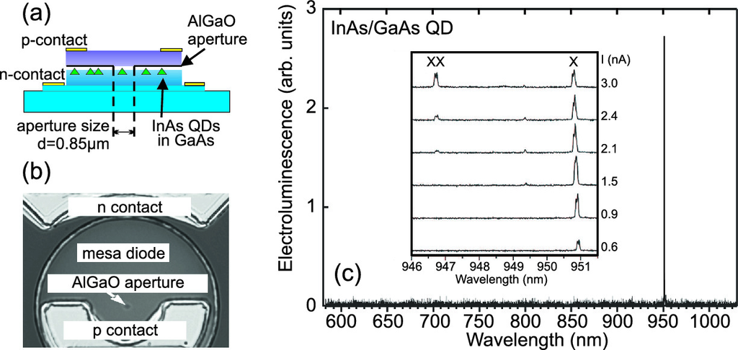

Fig. 23.24

**a** Schematic cross-section of QD LED. Current is fed to a single QD via an oxide aperture. **b** Plan-view SEM image of QD LED. **c** Electroluminescence (EL) spectrum (

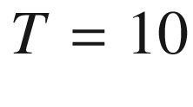

 K,

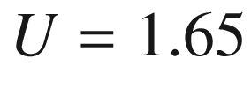

 V,

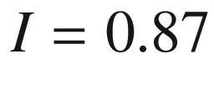

 nA) of single InGaAs/GaAs QD LED (diameter of oxide aperture 0.85 µm, thickness 60 nm). The single line is due to (neutral) exciton recombination. The *inset* shows dependence of EL spectrum on injection current; at higher currents a second peak due to biexciton recombination (XX

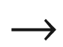

X) appears.

Adapted from [1969]

**Ultrabroad Spectral Emission**

An LED based on the emission from a quantum dot ensemble exhibits a fairly broad spectrum because of inhomogeneous broadening due to size fluctuations of the quantum dots (cmp. Fig. [14.​47](The_Physics_of_Semiconductors00006.docx#u116076_4_En_14_Chapter-Fig47)). Additionally several ensembles of QDs with different mean emission wavelength can be incorporated in a device, e.g. in stacked layers [1970]. This way ultrabroad electroluminescence spectra can be realized (Fig. [23.25](#u116076_4_En_23_Chapter-Fig25)). Also emission on the ground and excited state can be used for broad spectral emission.

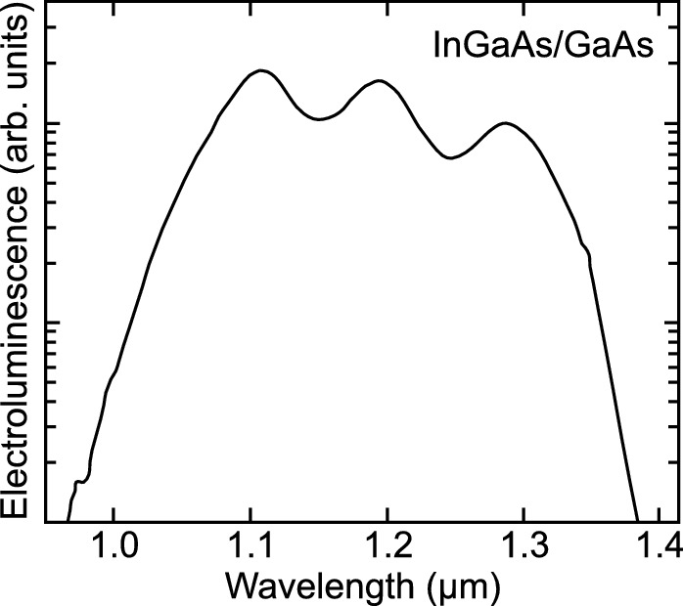

Fig. 23.25

Electroluminescence spectrum of a quantum dot LED designed for broad spectral range (at 5 kA/cm

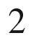

).

Adapted from [1971]

#### 23.3.7 Organic LEDs

An organic light emitting diode (OLED) is made from organic semiconductors. The pioneering work was made by Tang and Van Slyke [1789, 1972]. Typical layer sequences are depicted in Fig. [21.​62](#u116076_4_En_21_Chapter-Fig62). The light emission occurs through the anode (and the transparent ITO layer) while the metal cathode is opaque. Two major configurations are possible, emission through the transparent substrate (glass) or top emission (Fig. [23.26](#u116076_4_En_23_Chapter-Fig26)).

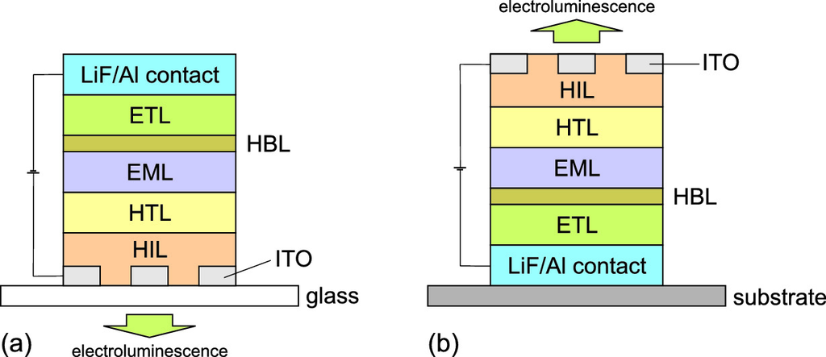

Fig. 23.26

Typical OLED design for **a** bottom and **b** top emission

The optimization of materials for the various functional layers is ongoing. The emission layer (EML) is optimized for efficient radiative recombination for the design wavelength or wavelength range. The highest efficacy of over 100 lm/W (Fig. [23.16](#u116076_4_En_23_Chapter-Fig16)) is achieved using phosphorescent materials (Sect. [18.​6](The_Physics_of_Semiconductors00006.docx#u116076_4_En_18_Chapter)). The contacts are optimized for high carrier injection efficiency and the transport layers are optimized for high conductivity.

End of 2007 a transparent white OLED panel was introduced [1973] (Fig. [23.27](#u116076_4_En_23_Chapter-Fig27)a). Its transparency is 55% and shall be improved in the future. A crucial point is the protection of the organic films against moisture and air. The encapsulation by glass is very good. Flexible OLED panels with polymer substrate and encapsulation have been demonstrated (Fig. [23.27](#u116076_4_En_23_Chapter-Fig27)b). OLED technology is currently used for small displays in digital cameras and cellular phones. It enables very thin TV panels, only a few mm thick (Fig. [23.27](#u116076_4_En_23_Chapter-Fig27)c) entering the mass market in 2010. An increase of the lifetime from 30,000 to beyond 50,000 h is expected.

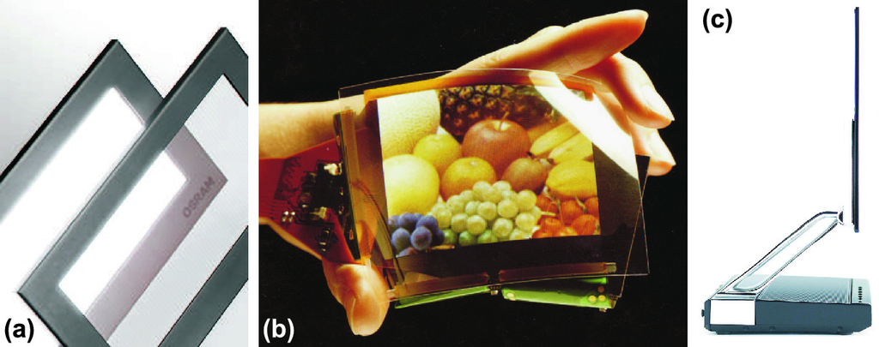

Fig. 23.27

**a** Transparent OLED panel. From [1973]. **b** Flexible OLED display. From [1974]. **c** 3 mm thin, 11 inch diagonal OLED TV.

From [1975]

### 23.4 Lasers

#### 23.4.1 Introduction

Semiconductor lasers[13](The_Physics_of_Semiconductors00009.docx#u116076_4_En_23_Chapter-Fn13) [1976, 1977] contain a zone (mostly called the *active layer*) that has gain if sufficiently pumped and that overlaps with an optical wave. The wave bounces back and forth in an optical cavity that leads to optical feedback. The part of the wave that exits the semiconductor forms the laser beam. Some of the first semiconductor lasers and a mounting design are shown in Fig. [23.28](#u116076_4_En_23_Chapter-Fig28).

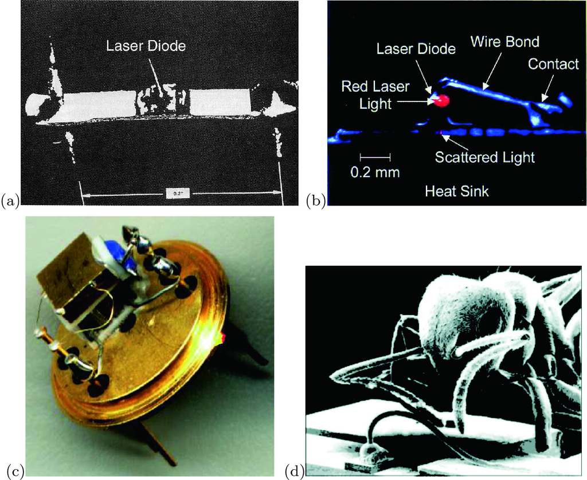

Fig. 23.28

Images of the first semiconductor lasers, 1962: **a** GaAs laser, Lincoln Laboratories and **b** GaInP laser, N. Holonyak and S.F. Bevacqua, Urbana Champaign. **c** Laser (at the end of gold bond wire) mounted on Peltier heat sink and a TO chip, Universität Leipzig. **d** Size comparison of an ant with a laser chip (underneath the bond wire)

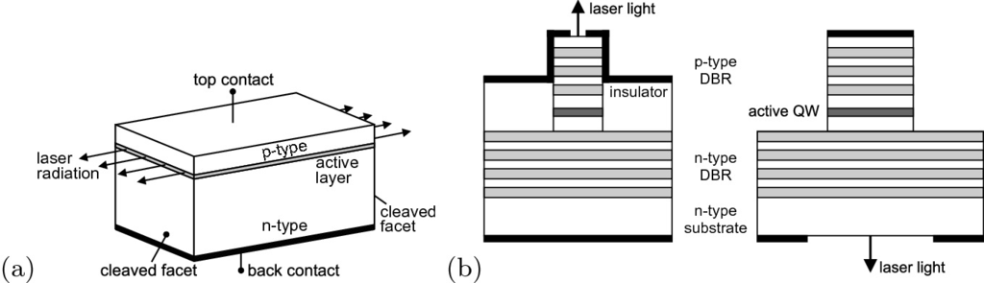

Fig. 23.29

**a** Schematic drawing of edge-emitting semiconductor laser. **b** Schematic drawings of vertical-cavity surface-emitting lasers with top emission (*left*) and emission through the substrate (*right*). *Black areas* are metal contacts

Generally, two main geometrical laser types, *edge* emitters (Fig. [23.29](#u116076_4_En_23_Chapter-Fig29)a) and *surface* emitters (Fig. [23.29](#u116076_4_En_23_Chapter-Fig29)b), are distinguished. The emission of the edge emitter exits through cleaved

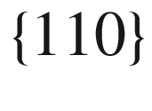

side facets[14](The_Physics_of_Semiconductors00009.docx#u116076_4_En_23_Chapter-Fn14) (

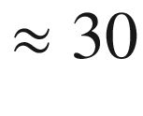

% reflectance), of which an opposite pair acts as a Fabry–Perot optical cavity. The surface emission is directed along (001), since this is the (standard) growth direction  of the heterostructure sequence making up the laser. The mirrors in a vertical-cavity surface-emitting laser (VCSEL) are made from dielectric Bragg mirrors (cf. Sect. [19.​1.​4](The_Physics_of_Semiconductors00007.docx#u116076_4_En_19_Chapter)) with typically

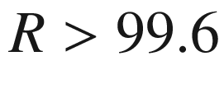

%. Using antireflection coating on one facet, semiconductor lasers can be set up with an external cavity.[15](The_Physics_of_Semiconductors00009.docx#u116076_4_En_23_Chapter-Fn15) If both facets are antireflection coated, feedback is missing and the chip can be used as an optical amplifier (cf. Sect. [23.5](The_Physics_of_Semiconductors00009.docx#u116076_4_En_23_Chapter-Sec35)).

Most lasers are pn-diodes and are then called laser diodes. They rely on the gain of interband transitions and the emission wavelength is determined and (more or less) given by the band gap of the semiconductor. The cascade laser [149] (Sect. [23.4.16](The_Physics_of_Semiconductors00009.docx#u116076_4_En_23_Chapter-Sec33)) is a unipolar structure with a superlattice as active layer. Here, the intersubband transitions (mostly in the conduction band but also in the valence band) carry the gain. The emission wavelength depends on the subband separation and lies typically in the far- and mid-infrared. Extensions to the THz regime and also to shorter wavelengths are possible. A third type of laser is the ‘hot-hole’ laser (Sect. [23.4.17](The_Physics_of_Semiconductors00009.docx#u116076_4_En_23_Chapter-Sec34)), typically fabricated with p-doped Ge, which can be viewed as unipolar and functions only in a magnetic field; its emission is in the THz regime.